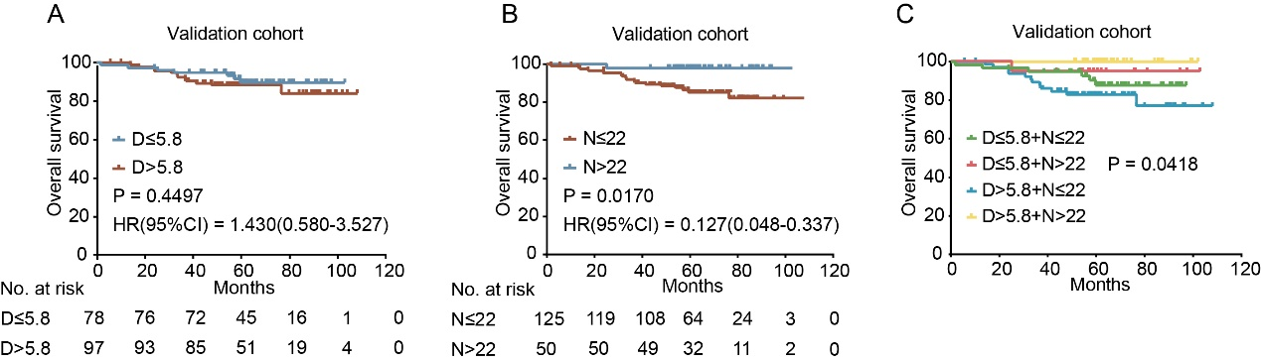
Supplemental Figure 1. Kaplan-Meier analysis of OS in the validation cohort. OS according to SLNs (A); OS according to NLNs (B); OS according to integration of SLNs and NLNs (C). P values were obtained from the log-rank test and hazard ratio (HR) is calculated using GraphPad Prism.

