Supplemental Table 1. List of investigators and institutional review boards
Principal Investigator | Affiliation | Institutional Review Board
Louis Lacombe | CHU de Quebec-Universite Laval-Hotel Dieu de Quebec, Quebec, QC Canada | Medical Biomedical Research Ethics Committee, Montreal, Canada
Georg Bjarnason | Sunnybrook Health Sciences, Odette Cancer Centre, Toronto, ON, Canada | OCREB - Ontario Cancer Research Ethics Board, Toronto, Canada
Andrew Robinson | Kingston Health Sciences Centre, Kingston ON, Canada | OCREB – Ontario Cancer Research Ethics Board, Toronto, Canada
Jean Sebastien Aucoin | CIUSSS de la Mauricie et du Centre du Quebec, Trois-Rivieres, ON, Canada | Medical Biomedical Research Ethics Committee, Montreal, Canada
Daniel Heng | Tom Baker Cancer Centre, Calgary, AB, Canada | Health Research Ethics Board of Alberta – HREBA, Edmonton Canada
Wilson H Miller | Jewish General Hospital, Montreal, QC Canada | Medical Biomedical Research Ethics Committee, Montreal, Canada
Alan Berg | Southeast Nebraska Hematology & Oncology Consultants, P.C., Lincoln NE, USA | Copernicus Group Independent Review Board, Cary, NC, USA
Daniel Vaena | The West Clinic, P.C., Germantown, TN, USA | Western IRB, Puyallup, WA, USA
Stephan DiSean | Kendall  Utah Cancer Specialists, Salt Lake City, UT, USA | Copernicus Group Independent Review Board, Cary, NC, USA
Robert Matthew Graham | University of Tennessee Erlanger Oncology & Hematology, Chattanooga, TN, USA | Western IRB, Puyallup, WA, USA
Steven McCune | Northwest Georgia Oncology Centers PC, Marietta, GA, USA | Western IRB, Puyallup, WA, USA
Primo Lara | UC Davis Comprehensive Cancer Center, Sacramento, CA, USA | UC Davis IRB, Sacramento, CA, USA
Neeraj Agarwal, | Huntsman Cancer Institute, Salt Lake City, UT, USA | University of Utah Institutional Review Board, Salt Lake City, UT, USA
Michael S. Gordon | Scottsdale Healthcare, Scottsdale, AZ, USA | Western IRB, Puyallup, WA, USA
Ruth McGinn/Ray McDermott | Adelaide & Meath Hospital, Dublin, Ireland | Clinical Research Ethics Committee – University College Cork, Cork, Ireland
Emmet Jordan | University Hospital Waterford, Waterford, lreland | Clinical Research Ethics Committee – University College Cork, Cork, Ireland
Daniel Heinrich | Akershus University Hospital, Nordbyhagen, Norway | REK soer-oest D, Oslo, Norway
Ase Haug | Helse Bergen HF Haukeland, Bergen, Norway | REK soer-oest D, Oslo, Norway
Heidi Knobel | St Olavs Hospital, Trondheim, Norway | REK soer-oest D, Oslo, Norway
Sara Gunnestad Ribe | Sorlandet sykehus HF, Kristiansand, Norway | REK soer-oest D, Oslo, Norway
Oyvind Krohn Tennoe | Sykehuset Oestfold, Gralum Norway | REK soer-oest D, Oslo, Norway
Hege Sagstuen Haugnes | Universitetssykehuset I Nord Norge, Tromso, Norway | REK soer-oest D, Oslo, Norway
Anne Berit Rodal Erdal/Carl W Langberg | Oslo universitetssykehus, Oslo, Norway | REK soer-oest D, Oslo, Norway
Alejo Rodriguez-Vida | Hospital del Mar, Barcelona, Spain | CEIC Autonomico de Galicia (SERGAS), Santiago de Compostela, Spain
Olatz Etxaniz | Institut Catala d Oncologia Hospital Germans Trias i Pujol, Barcelona, Spain | CEIC Autonomico de Galicia (SERGAS), Santiago de Compostela, Spain
Enrique Gallardo Diaz | Hospital Parc Tauli, Sabadell, Spain | CEIC Autonomico de Galicia (SERGAS), Santiago de Compostela, Spain
Maria Jose Juan Fita | Instituto Valenciano de Oncologia, Valencia, Spain | CEIC Autonomico de Galicia (SERGAS), Santiago de Compostela, Spain
Urbano Anido Herranz | Hospital Clinico Universitario de Santiago, Santiago de Compostela, Spain | CEIC Autonomico de Galicia (SERGAS), Santiago de Compostela, Spain
Jose Angel Arranz | Hospital General Universitario Gregorio Maranon, Madrid, Spain | CEIC Autonomico de Galicia (SERGAS), Santiago de Compostela, Spain
Jesus Garcia-Donas Jimenez | Hospital Universitario HM Sanchinarro, Madrid, Spain | CEIC Autonomico de Galicia (SERGAS), Santiago de Compostela, Spain
James Larkin | The Royal Marsden Foundation Trust, London, UK | Fulham Research Ethics Committee, Manchester, UK
Lajos Geczi | Orszagos Onkologiai Intezet, Budapest, Hungary | Egeszsegugyi Tudomanyos Tanacs, Budapest, Hungary
Janos Revesz | Borsod-Abauj-Zemplen Megyei Korhaz es Egyetemi OktatoKorhaz, Miskolc, Hungary | National Institute of Pharmacy, Budapest, Hungary
Boris Yakovlevich Alekseev | National Medical Research Radiology Centre, Moscow, Russia | Independent Ethics Committee of the FSBI “Russian Scientific Center of Roentgenoradiology” Ministry of Health of the Russian Federation, Moscow, Russia
Rustem Airatovich Gafanov | Russian Scientific Center of Roentgenoradiology, Moscow, Russia | Ethics Committee of the FSBI “Central Clinical Hospital with outpatient Clinic” Administration of the President of the Russian Federation, Moscow, Russia
Dmitry Aleksandrovich Nosov | Central Clinical Hospital with outpatient Clinic, Moscow, Russia | Ethics Committee of the FSBI “Central Clinical Hospital with outpatient Clinic” Administration of the President of the Russian Federation, Moscow, Russia
Andrey Semenov | Ivanovo regional oncology dispensary, Ivanovo, Russia | Local Ethics Committee of the Regional Budget Health Care Institution Ivanovo regional oncology dispensary, Ivanovo, Russia
Vladimir Anatolyevich Kostorov | Leningrad Regional Oncology Center, Saint-Petersburg, Russia | Local Ethics Committee of the FSBI “Leningrad Regional Oncology Center,” Saint-Petersburg, Russia
Oleg Nikolaevich Lipatov | Republican Clinical Oncology Dispensary of Republic of Bashkortostan, Bashkortostan, Russia | Ethics Committee of the Republican Clinical Oncology Dispensary of Republic of Bashkortostan – Bashkortostan, Russia
Christian Caglevic/ Jose Luis Leal/Luis Villanueva | Fundacion Arturo Lopez Perez FALP, Santiago, Chile | Comite de Etica Cientifico del Servicio de Salud Metropolitano Oriente, Santiago, Chile
Alejandro Acevedo | Oncocentro, Valparaiso, Chile | Comite Etico Cientifico Hospital Gustavo Fricke Servicio de Salud Viña del Mar Quillota, Valparaiso, Chile
Carolina Ibanez | Pontificia Universidad Catolica de Chile, Santiago, Chile | Comite Etico Cientifico de Ciencias de la Salud UC, Santiago, Chile
Valentina Hornig | Clinica Alemana de Osorno, Osorno, Chile | Comite Etico Cientifico Servicio de Salud Valldivia, Valdivia, Chile
Howard Paul Gurney | Westmead Hospital, Westmead, Australia | North Sydney Local Health District HREC, St. Leonards, Australia
Craig Gedye | Calvary Mater Newcastle, Waratah, Australia | North Sydney Local Health District HREC, St. Leonards, Australia
David Pook | Cabrini Health, Melbourne, Australia | North Sydney Local Health District HREC, St. Leonards, Australia
Jae Lyun Lee | Asan Medical Center, Seoul, South Korea | Asan Medical Center IRB/IEC, South Korea
Minjeong Kim/Sun Young Rha | Severance Hospital Yonsei University Health System, Seoul, South Korea | Severance Hospital Yonsei University Health System IRB/IEC, , Seoul, South Korea
Se Hoon Park | Samsung Medical Center, Seoul, South Korea | Samsung Medical Center IRB/EC, Seoul, South Korea
Woo Kyun Bae | Chonnam National University Hwasun Hospital, Hwasun gun, South Korea | Chonnam National University Hwasun Hospital IRB, Seoul, South Korea
Chia-Chi Lin | National Taiwan University Hospital, Taipei, Taiwan | National Taiwan University Hospital. Ethics Review Committee B, Taipei, Taiwan
Tzu-Chun Wei/Tzu-Ping Lin | Taipei Veterans General Hospital, Taipei, Taiwan | Taipei Veterans General Hospital Ethics Review Committee, Taipei, Taiwan
See-Tong Pang | Chang Gung Med Foundation – Linkou, Taoyuan, Taiwan | Chang Gung Medical Foundation Institutional Review Board A, Taoyuan, Taiwan
Chao-Hsiang Chang | China Medical University Hospital, Taipei, Taiwan | China Medical University Hospital Research Ethics Committee, Taichung, Taiwan
Wen-Pin Su | National Cheng Kung University Hospital, Tainan, Taiwan | IRB Chairman: Thy-Sheng Lin, Tainan, Taiwan
Yu-Li Su | Chang Gung Med Foundation. Kaohsiung Branch, Kaohsiung, Taiwan | Chang Gung Medical Foundation Institutional Review Board, Taipei, Taiwan
Go Kimura | Nippon Medical School Hospital, Tokyo, Japan | Nippon Medical School Hospital Institutional Review Board, Tokyo, Japan
Hiroaki Matsumoto | Yamaguchi University Hospital, Ube, Japan | Yamaguchi University Hospital Institutional Review Board, Ube, Japan
Ryuichi Mizuno | Keio University Hospital, Tokyo, Japan | Keio University Hospital Institutional Review Board, Ube, Japan
Hirotsugu Uemura | Kindai University Hospital, Osaka, Japan | Kindai University Hospital Institutional Review Board, Osaka, Japan
Satoshi Anai | Nara Medical University Hospital, Nara, Japan | Nara Medical University Hospital Institutional Review Board, Nara, Japan
Naoya Masumori | Sapporo Medical University Hospital, Hokkaido, Japan | Sapporo Medical University Hospital Institutional Review Board, Hokkaido, Japan
Mustafa Erman | Hacettepe University Medical Faculty, Ankara, Turkey | Medeniyet Universitesi Klinik Aras Etik Kurulu Hacettepe University Faculty of Medicine Ethics Committee, Ankara, Turkey
Tarkan Yetisyigit | Namik Kemal Universitesi Tip Fakultesi, Tekirdas, Turkey | Medeniyet Universitesi Klinik Aras Etik Kurulu Hacettepe University Faculty of Medicine Ethics Committee, Ankara, Turkey
Erhan Gokmen | Ege Universitesi Tip Fakultesi  Ege UTF Tulay Aktas Onkoloji, Izmir, Turkey | Medeniyet Universitesi Klinik Aras Etik Kurulu Hacettepe University Faculty of Medicine Ethics Committee, Ankara, Turkey
Mert Basaran | Istanbul Universitesi Onkoloji Enstitusu, Istanbul, Turkey | Medeniyet Universitesi Klinik Aras Etik Kurulu Hacettepe University Faculty of Medicine Ethics Committee, Ankara, Turkey
Ozgur Ozyilkan | Baskent Universitesi Dr. Turgut Noyan Uygulama ve Arastirma Merkezi, Adana, Turkey | Medeniyet Universitesi Klinik Aras Etik Kurulu Hacettepe University Faculty of Medicine Ethics Committee, Ankara, Turkey
Christopher DiSimone | Arizona Oncology Associates PC- HOPE, Tucson, AZ, USA | US Oncology and Research IRB, The Woodlands, TX, USA
John T Fitzharris | Willamette Valley Cancer Institute and Research Center, Eugene, OR, USA | US Oncology and Research IRB, The Woodlands, TX, USA
Rami Owera | Woodlands Medical Specialists, PA, Pensacola, FL, USA | US Oncology and Research IRB, The Woodlands, TX, USA
William Houck,III | Shenandoah Oncology, P.C., Winchester, VA, USA | US Oncology and Research IRB, The Woodlands, TX, USA
Mark D. Kochenderfer | Oncology & Hematology Associates of Southwest Virginia, Inc., DBA Blue Ridge Cancer Care, Roanoke, VA, USA | US Oncology and Research IRB, The Woodlands, TX, USA
David R. Shaffer | New York Oncology Hematology P.C, Albany NJ, USA | US Oncology and Research, The Woodlands, TX, USA

Supplemental Figure 1. Box and whisker plot showing change from baseline to week 3 in serum kynurenine among patients in the both the pembrolizumab plus epacadostat arm and the sunitinib/pazopanib arm. Kynurenine levels at C1D1 and C2D1 were compared using paired t-tests within each treatment arm The dotted line indicates median kynurenine levels in healthy subjects (1.5 μM)[1] Epa , epacadostat, Pembro pembrolizumab, SoC standard of care
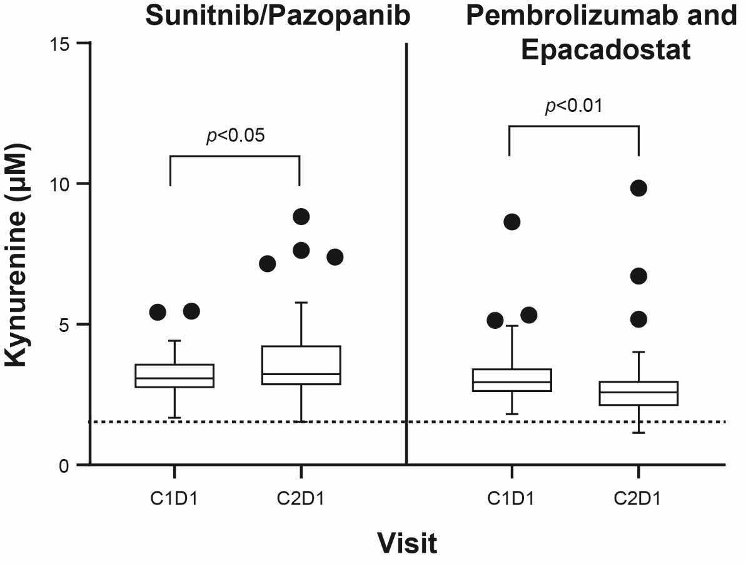

Reference
- Beatty GL, O'Dwyer PJ, Clark J, Shi JG, Bowman KJ, Scherle PA, et al. First-in-human phase I study of the oral inhibitor of indoleamine 2,3-dioxygenase-1 epacadostat (INCB024360) in patients with advanced solid malignancies. Clin Cancer Res. 2017;23(13):3269–76.

