Fig. S1 Kaplan–Meier curves for time to treatment failure of the first ARAT (received as first or second line of treatment).
ARAT androgen receptor axis-targeted agent.

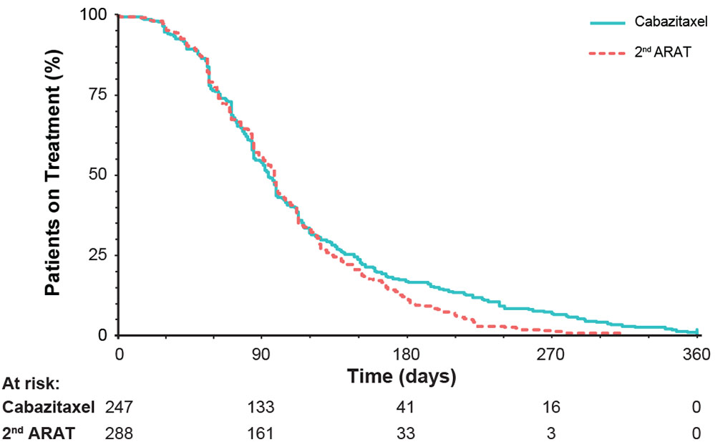

Fig. S2 Kaplan–Meier curves for time to treatment failure of abiraterone and enzalutamide as the first ARAT (a) or second alternative ARAT (b).
