Table S1 Relationship between TCP11 gene expression and age and differentiation degree of patients
Clinical features | N | The expression of TCP11 gene |  | χ²value | P value
Clinical features | N | - | + | χ²value | P value
Age | 35
<50 | 10 | 2 | 8 | 0.504 | 0.478
>50 | 25 | 8 | 17 | 0.504 | 0.478
Grade of pathology | 29
Low differentiation | 5 | 1 | 4 | 0.885 | 0.642
Moderate differentiation | 23 | 8 | 15 | 0.885 | 0.642
High differentiation | 1 | 0 | 1 | 0.885 | 0.642
Table S2 Primer sequence
Gene | Primer | Primer sequence (5´-3´)
GAPDH | Forward | ATGCGTTGCTGGTACAACTG
 | Reverse | CACGCCTCAATGTCTTCTGA
TCP11 | Forward | GCAGTGTTTTGTTTGGCTCA
 | Reverse | GGCTTTGATGGATTTCCTGA
Ki67 | Forward | ACGCCTGGTTACTATCAAAAGG
 | Reverse | CAGACCCATTTACTTGTGTTGGA
CDK1 | Forward | AAACTACAGGTCAAGTGGTAGCC
 | Reverse | TCCTGCATAAGCACATCCTGA
CyclinB1 | Forward | GACTTTGCTTTTGTGACTGACA
 | Reverse | CCCAGACCAAAGTTTAAAGCTC
ZO-1 | Forward | CGGTCCTCTGAGCCTGTAAG
 | Reverse | GGATCTACATGCGACGACAA
E-cadherin | Forward | TTGAGAATGAGGTCGGTGCC
 | Reverse | CAGAATGCCCTCGTTGGTCT

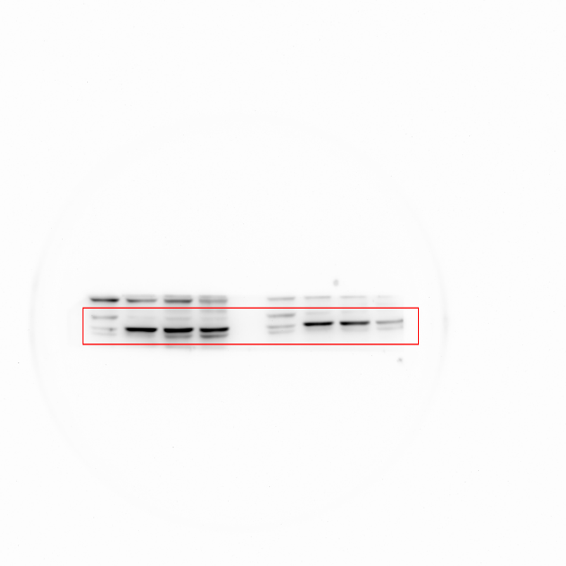
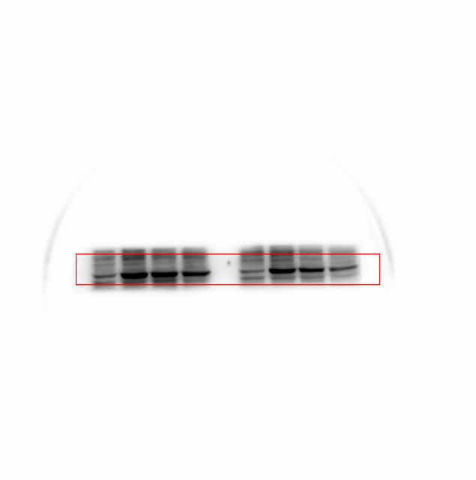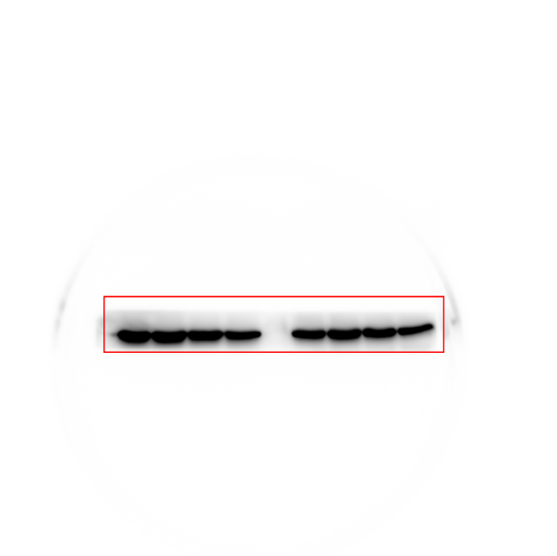
Figure S1. Full-length impression/gel of TCP11/GAPDH in Figure 1C.

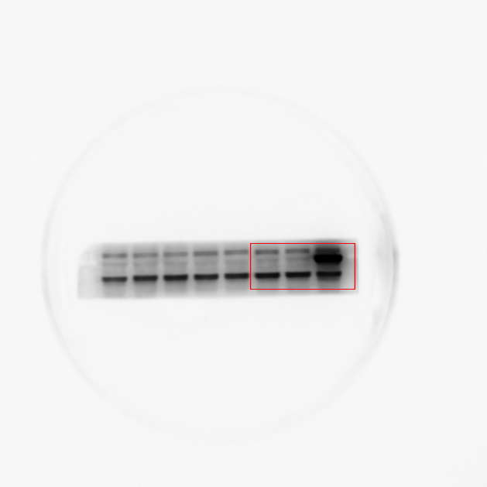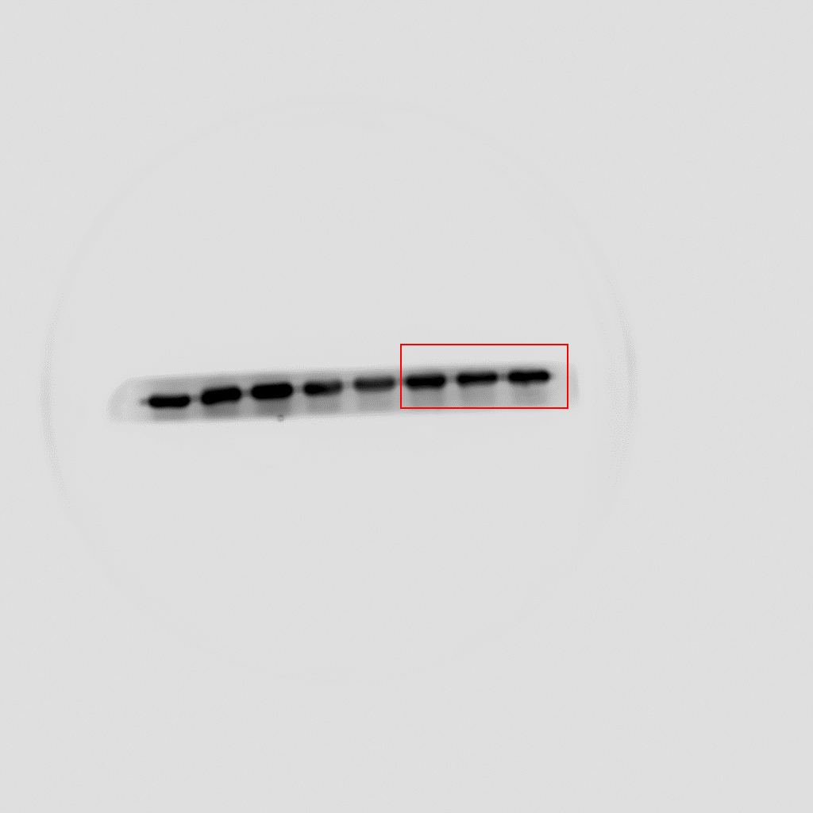
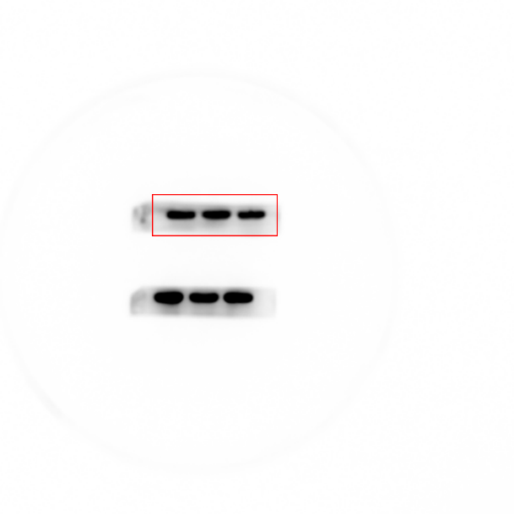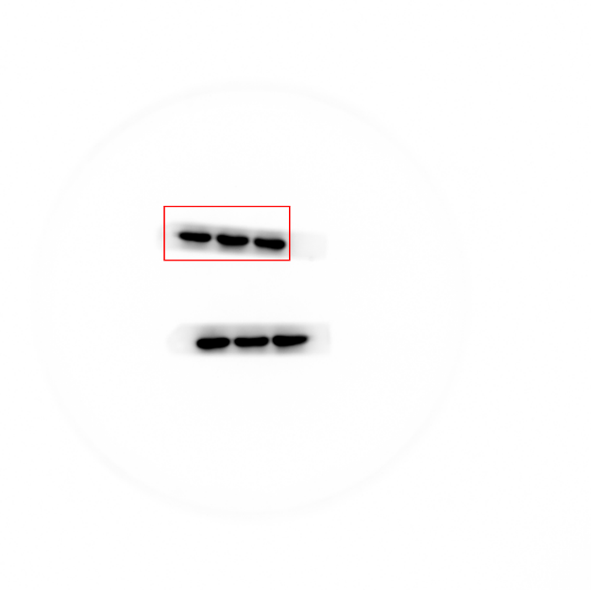
Figure S2. Full-length impression/gel of TCP11/GAPDH with HeLa cells in Figure 2A.

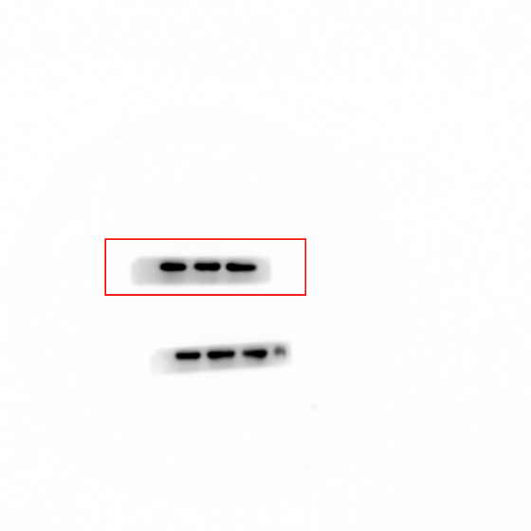
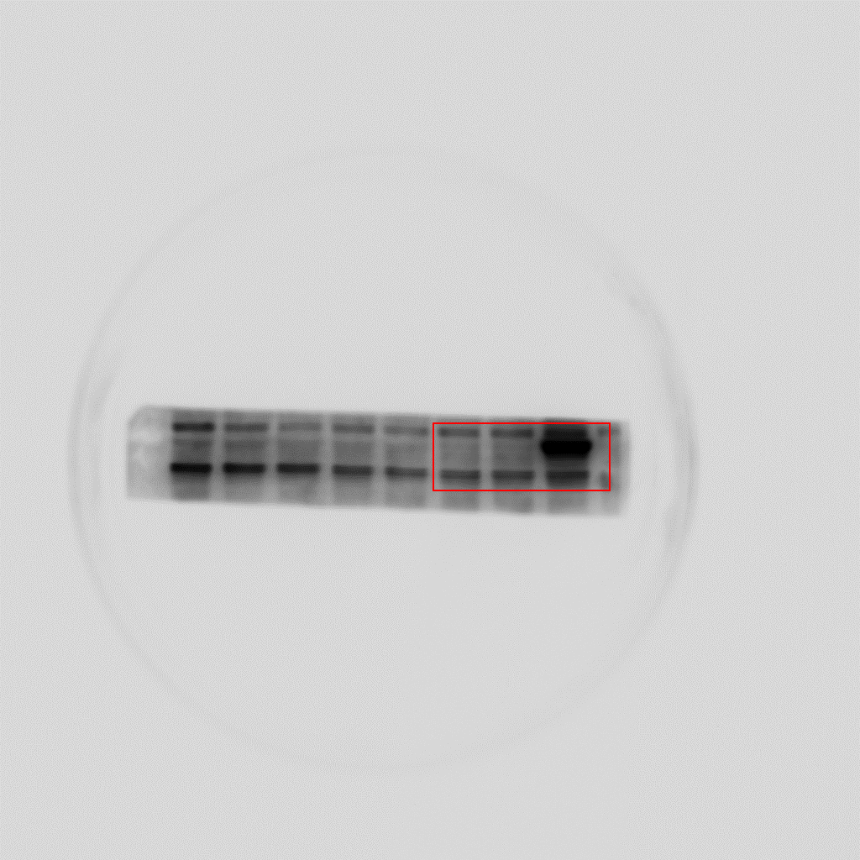
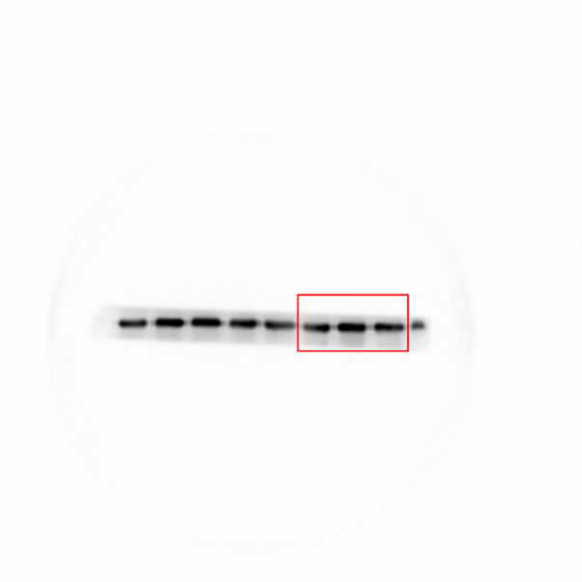
Figure S2. Full-length impression/gel of TCP11/GAPDH with SiHa cells in Figure 2A.

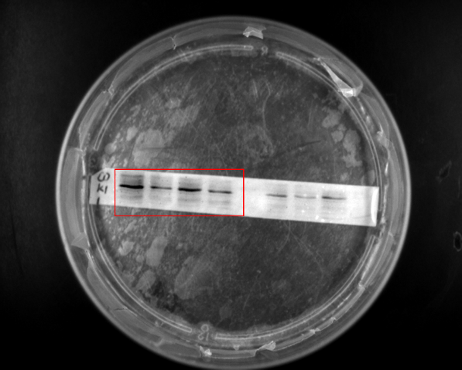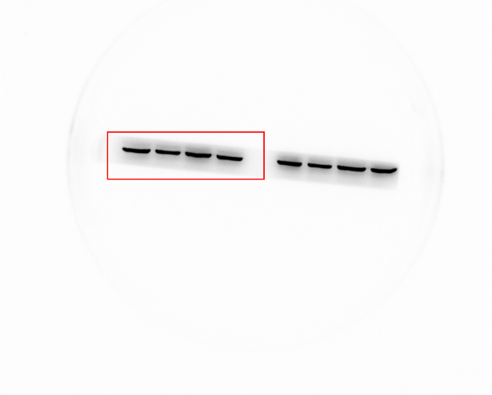
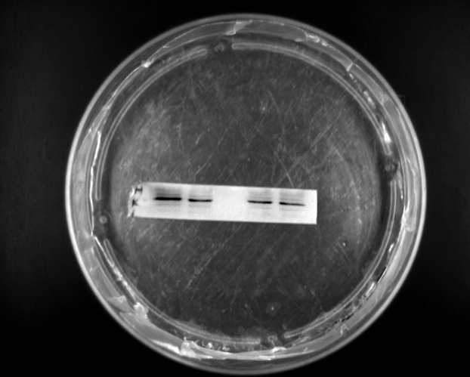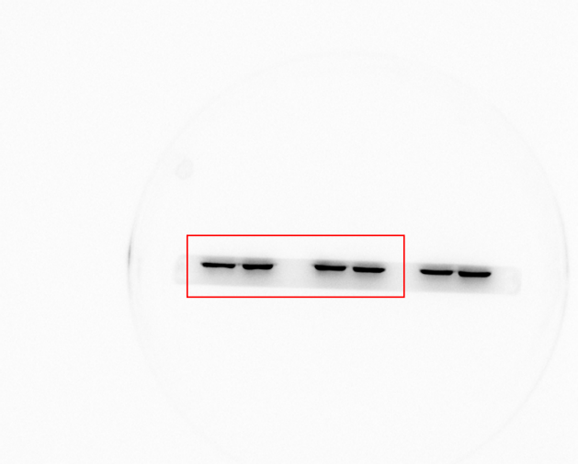
Figure S3A. Full-length imprinting/gel of CDK1/β-actin with HeLa cells in Figure 3C.

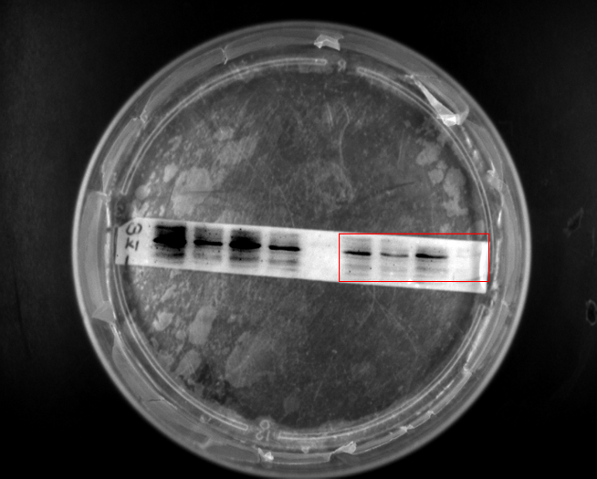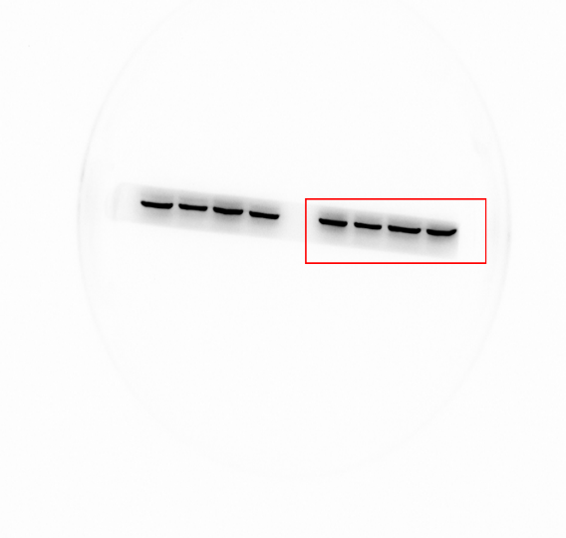
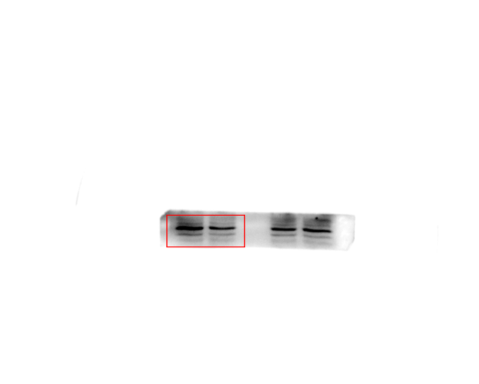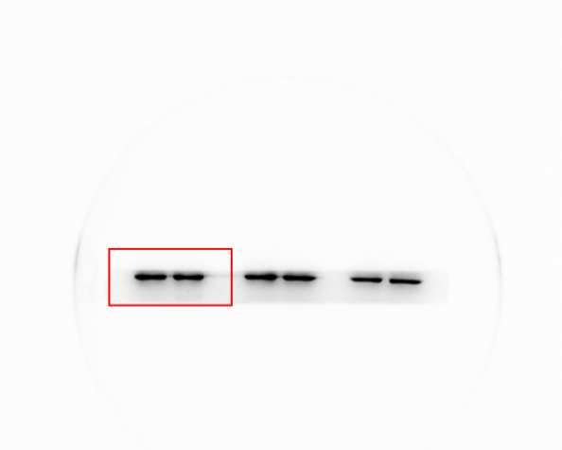
Figure S3A. Full-length imprinting/gel of CDK1/β-actin with SiHa cells in Figure 3C.

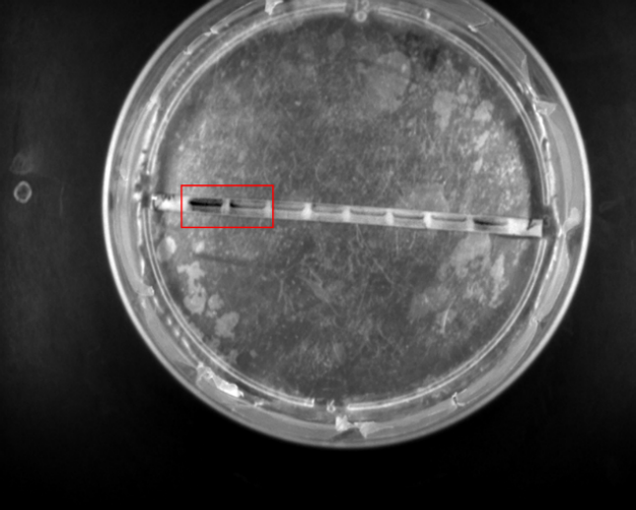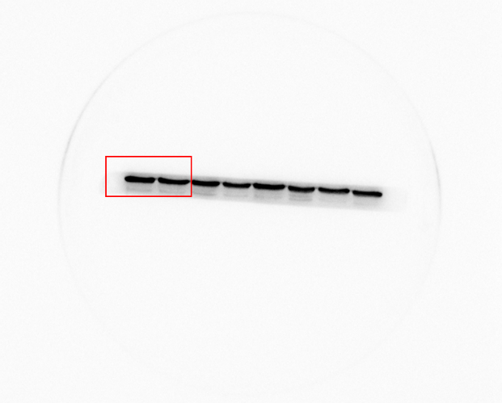
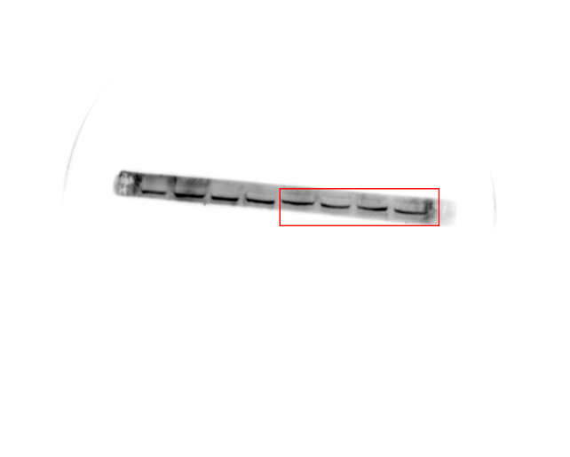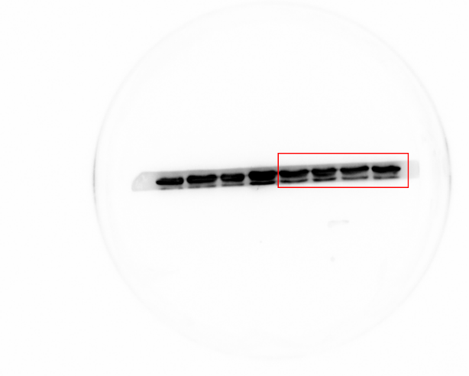
Figure S3B. Full-length imprinting/gel of CyclinB1/GAPDH in Hela cells in Figure 3C.

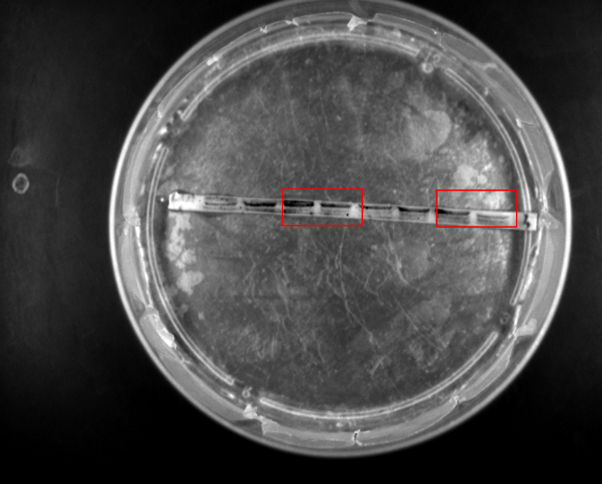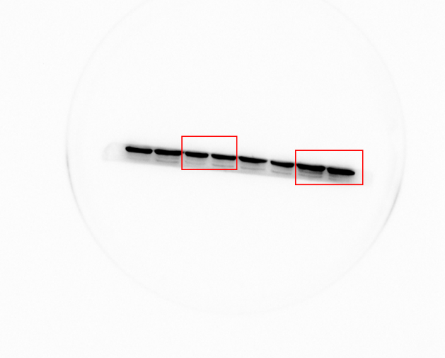
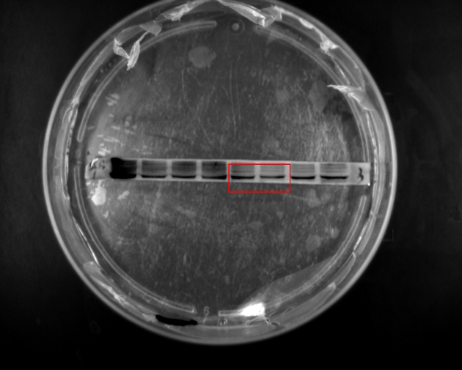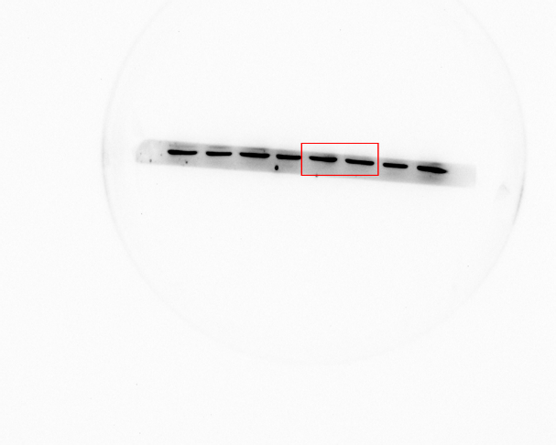
Figure S3C. Full-length imprinting/gel of CyclinB1/GAPDH in SiHa cells in Figure 3C.

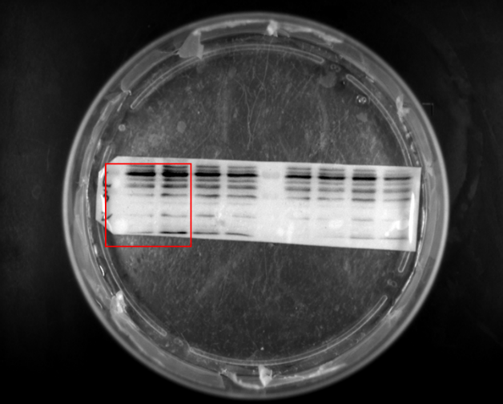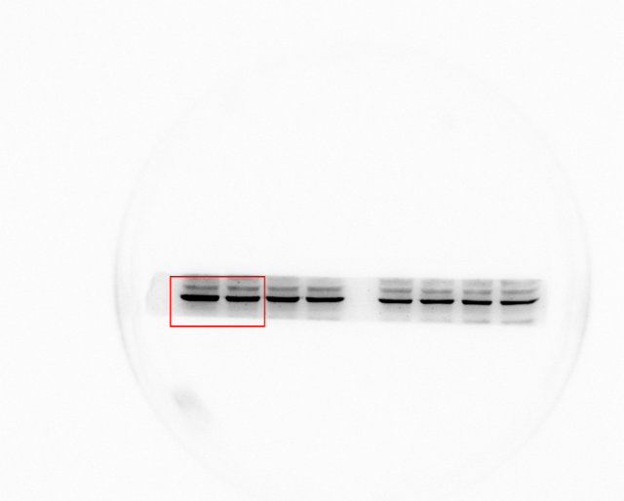
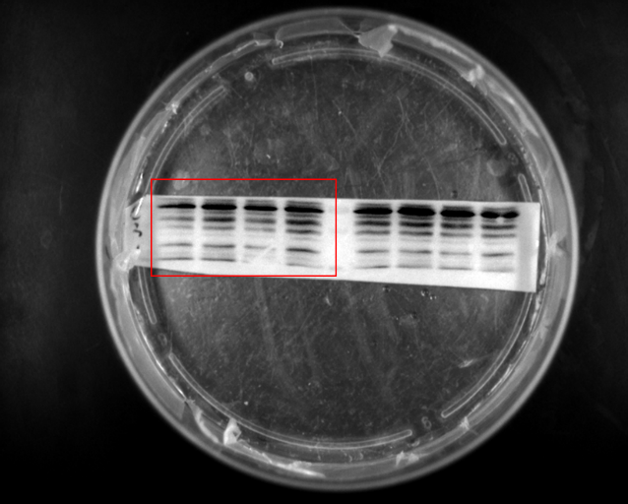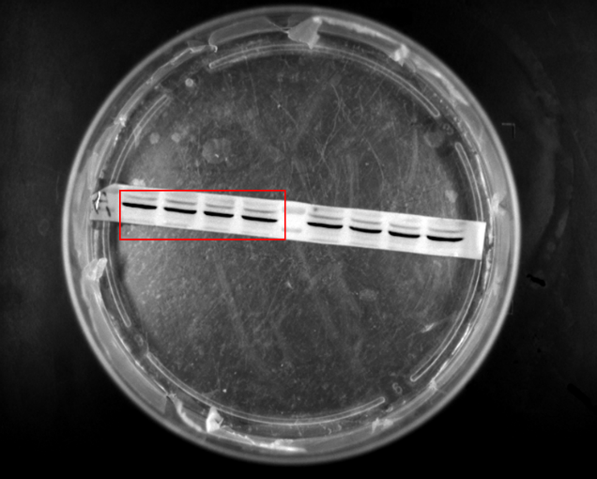
Figure S4A. Full-length imprinting/gel of caspase-3/cleaved-caspase-3 in HeLa cells in Figure 4C.
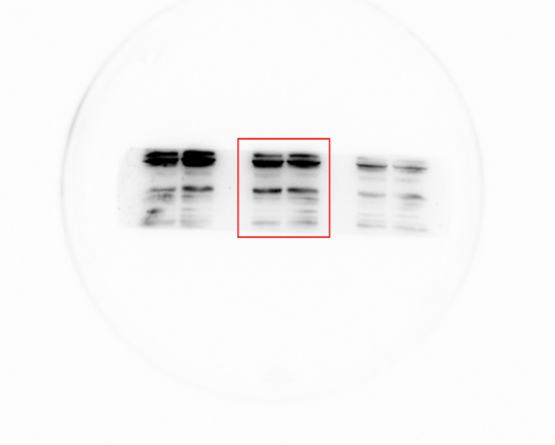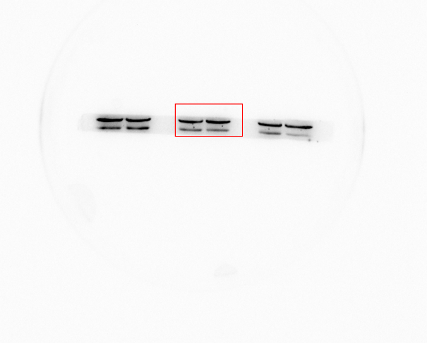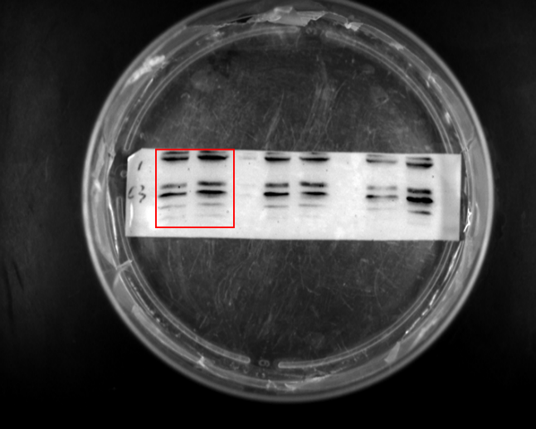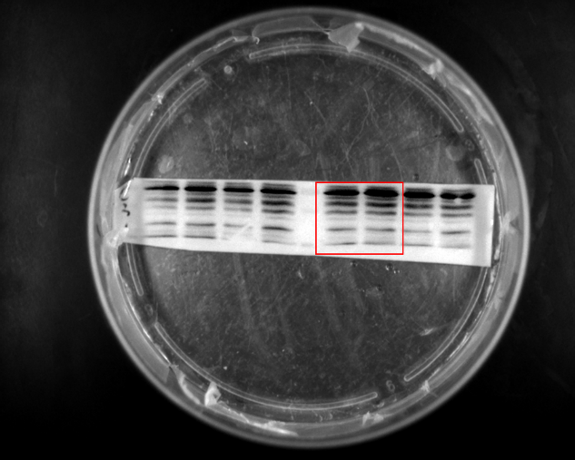
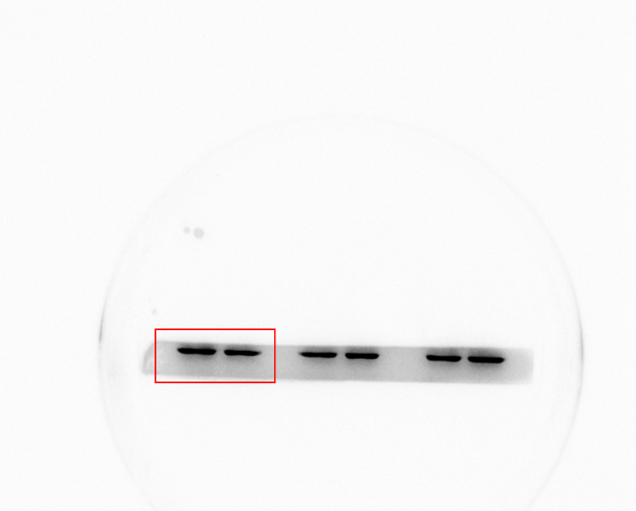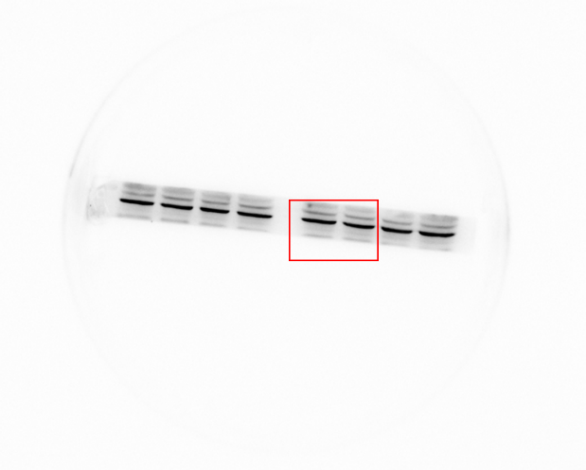

Figure S4B. Full-length imprinting/gel of caspase-3/cleaved-caspase-3/β-actin in SiHa cells in Figure 4C.
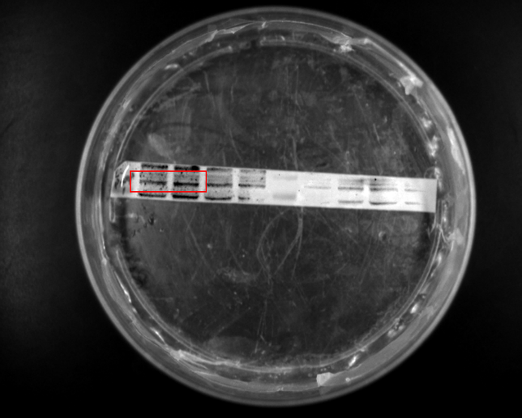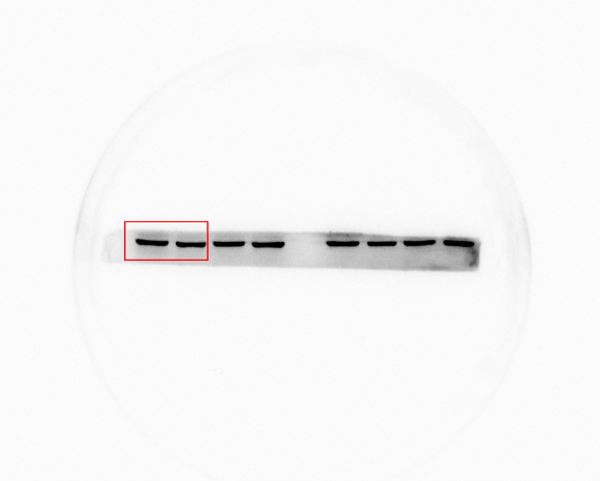
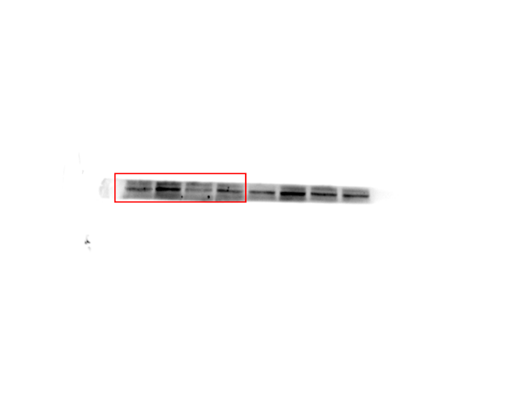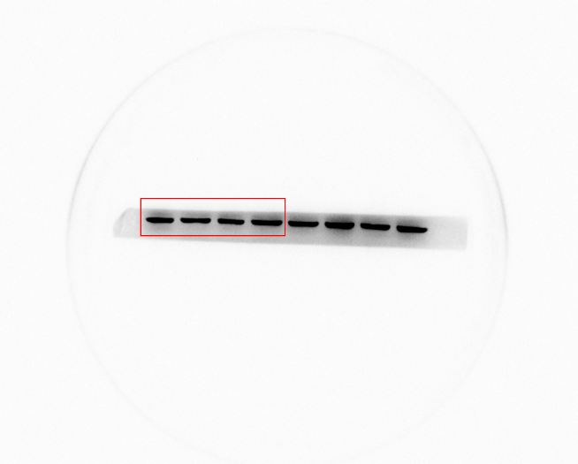
Figure S4C. Full-length imprinting/gel of Cleaved-PARP/β-actin with HeLa cells in Figure 4C.
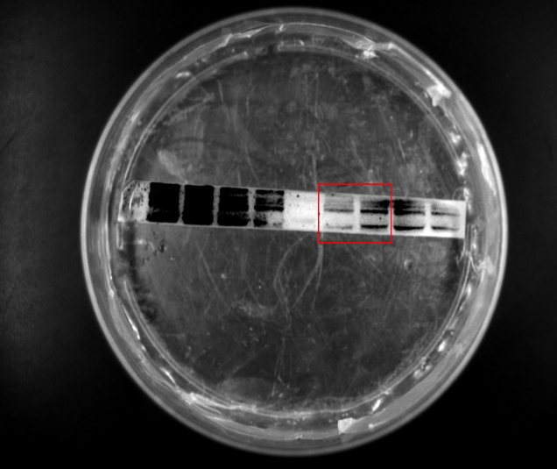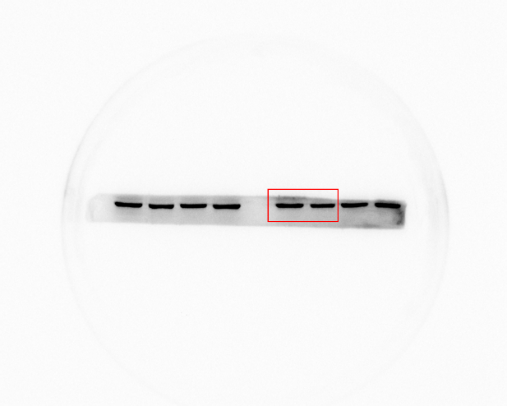
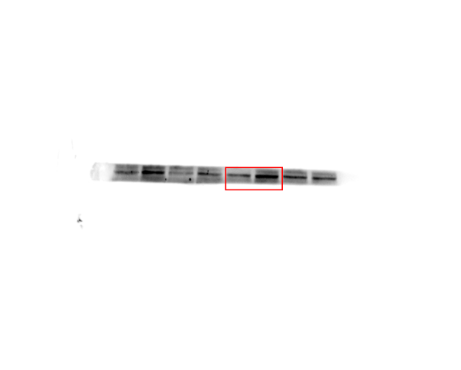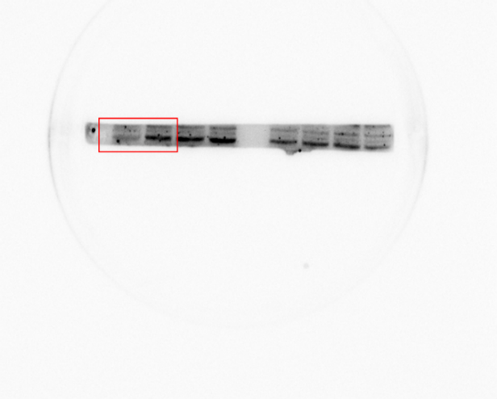
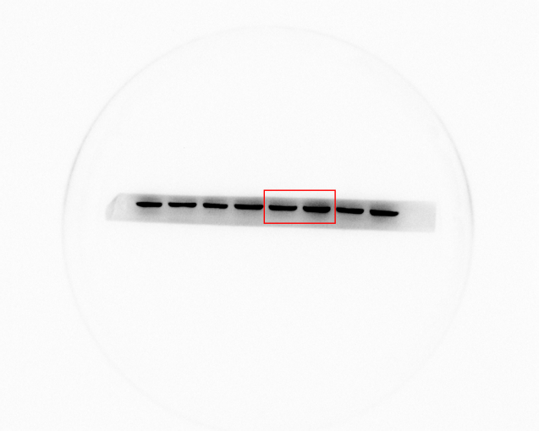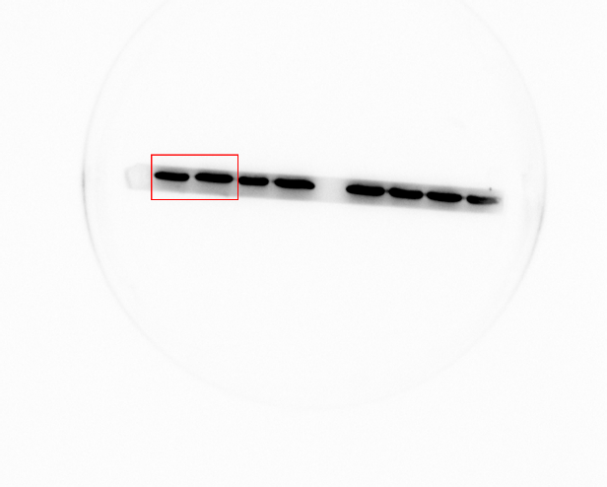
Figure S4C. Full-length imprinting/gel of Cleaved-PARP/β-actin with SiHa cells in Figure 4C.

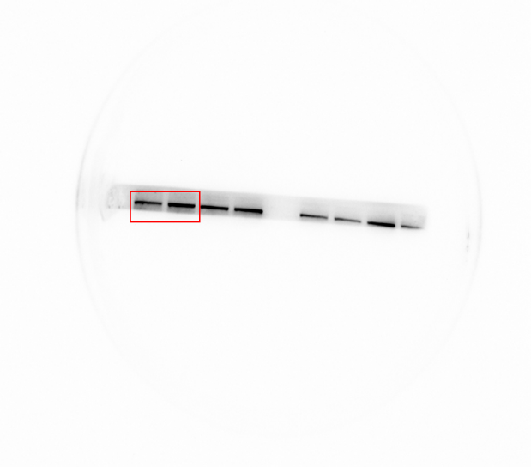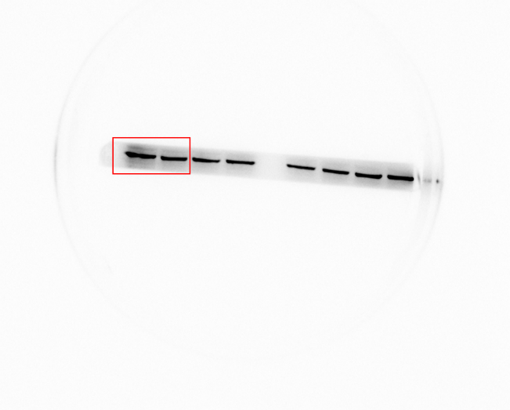
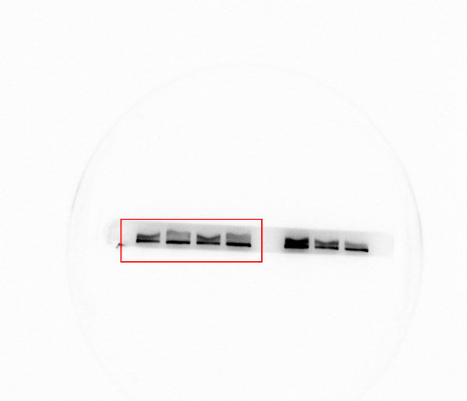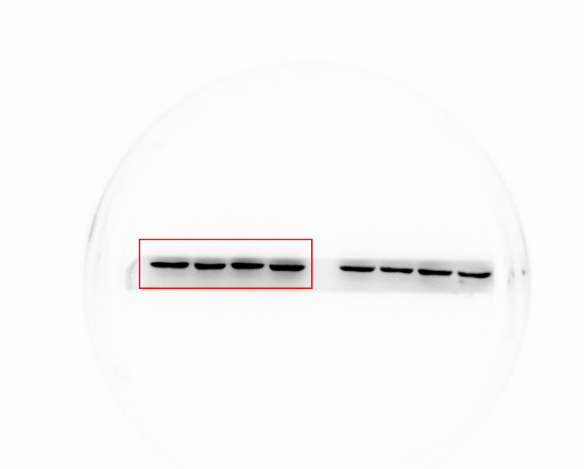

Figure S5A. Full-length imprinting/gel of E-cadherin/β-actin in HeLa cells in Figure 5E.
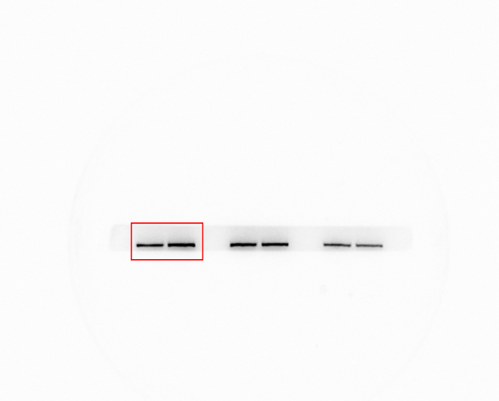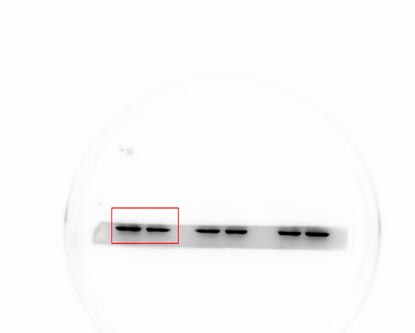
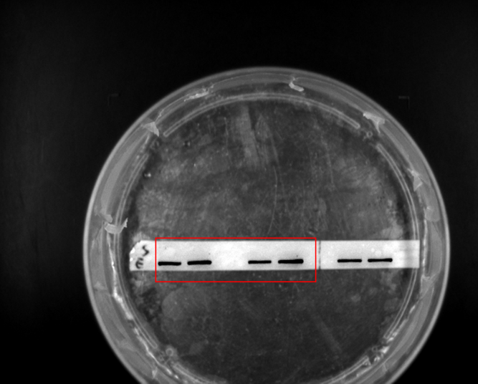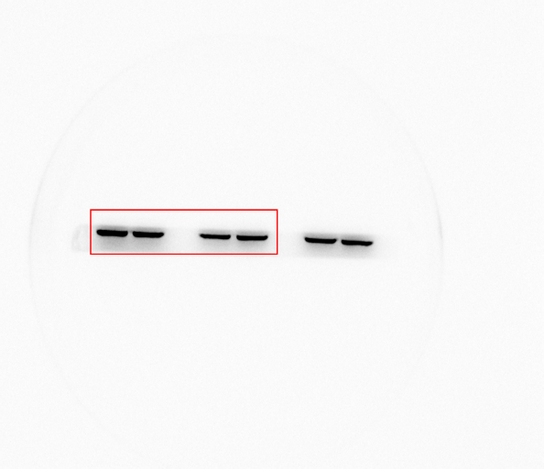
Figure S5B. Full-length imprinting/gel of E-cadherin/β-actin in SiHa cells in Figure 5E.

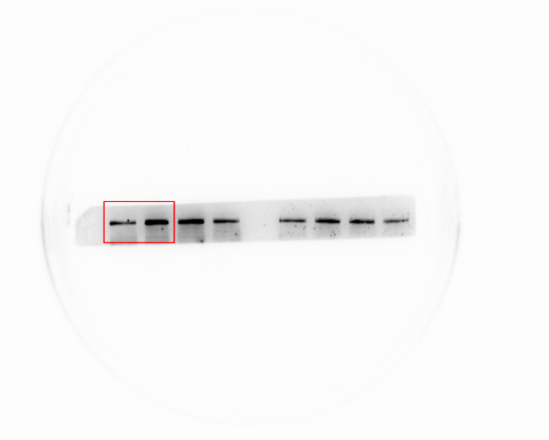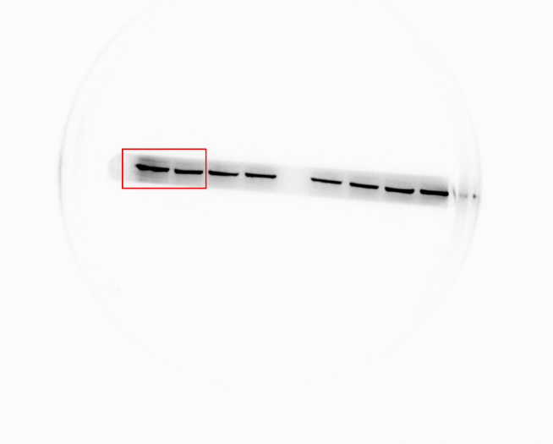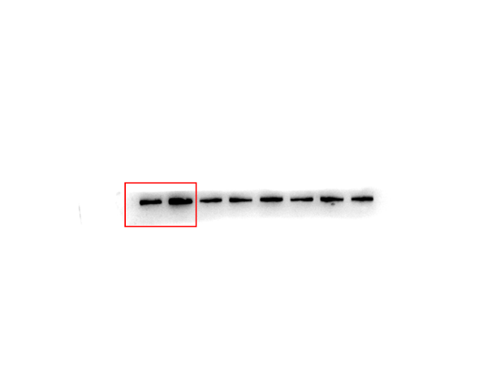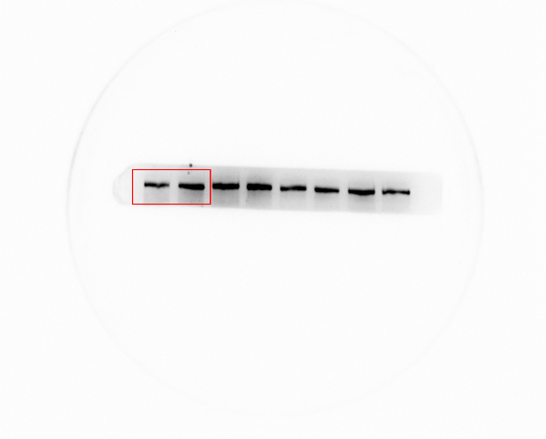
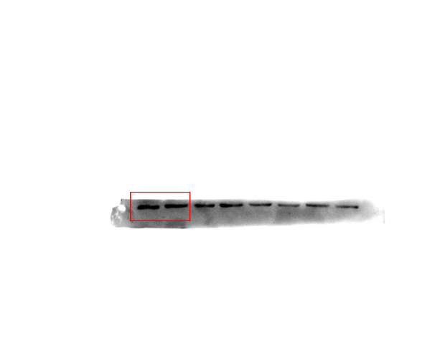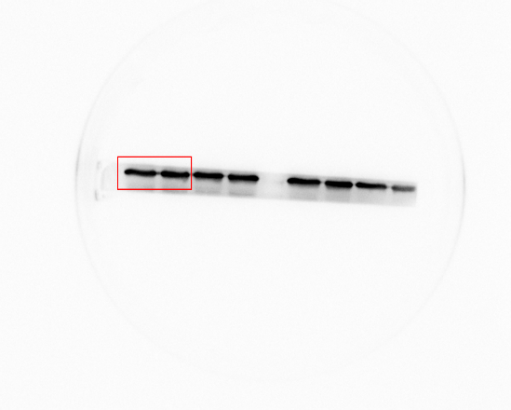
Figure S5C. Full-length imprinting/gel of ZO-1/β-actin with HeLa cells in Figure 5E.

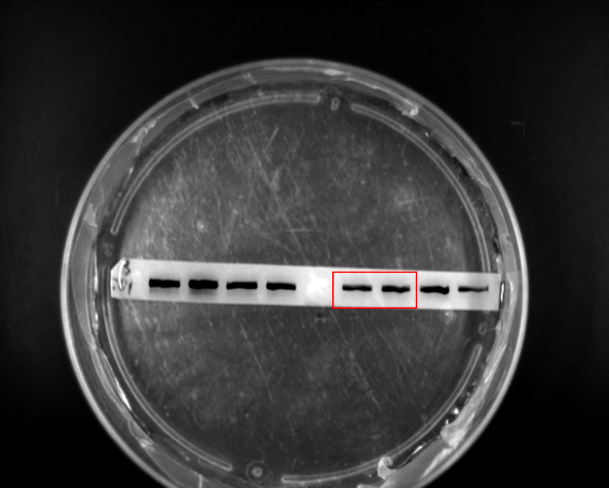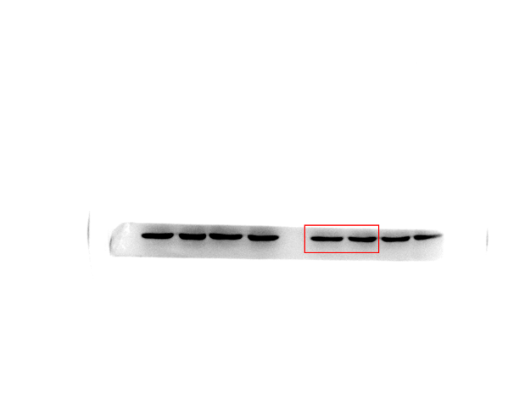
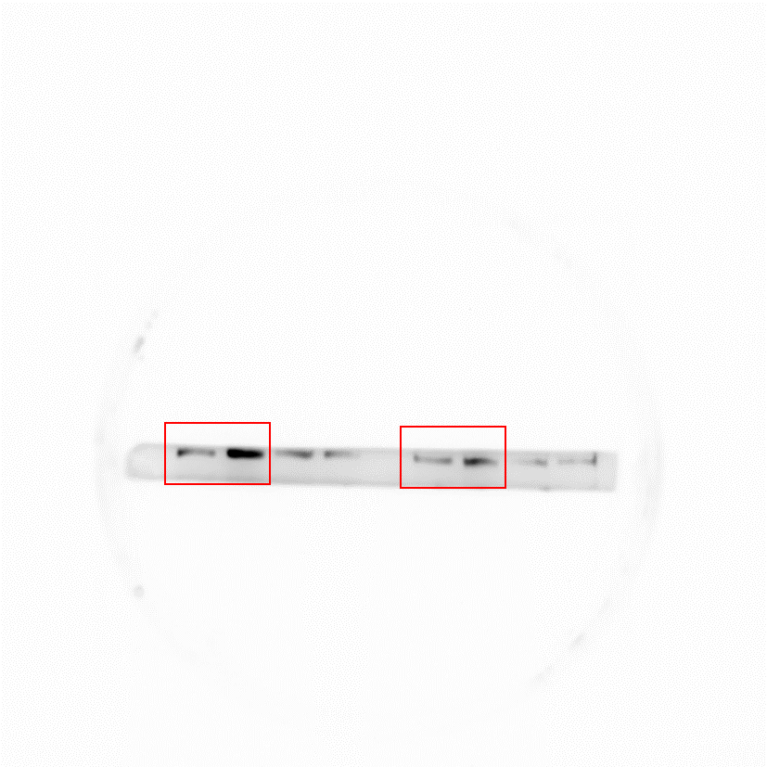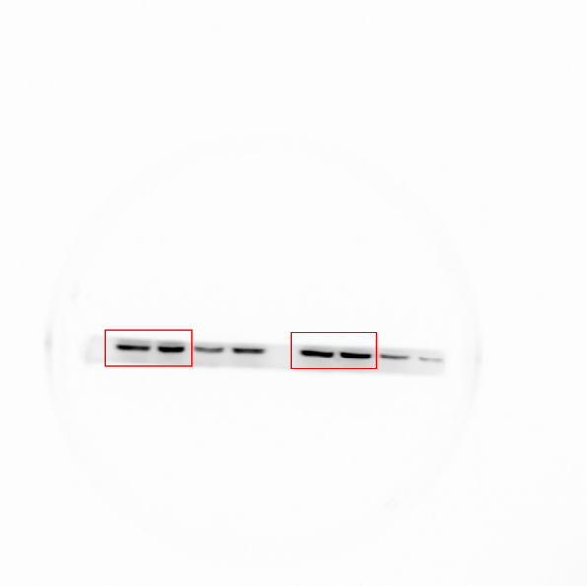
Figure S5C. Full-length imprinting/gel of ZO-1/β-actin with SiHa cells in Figure 5E.

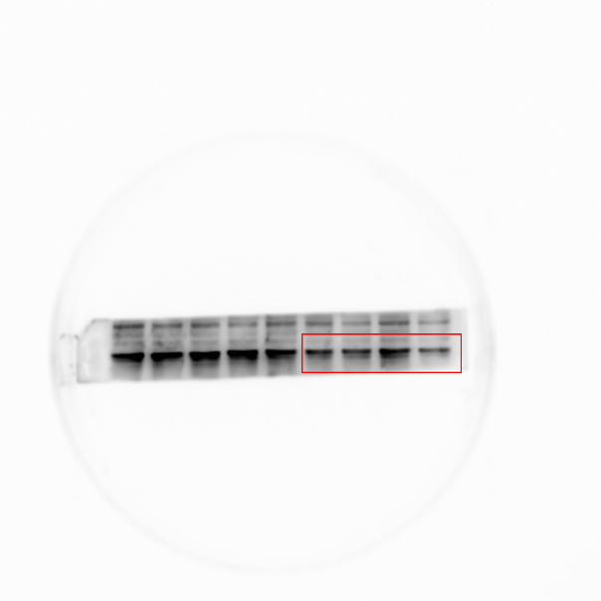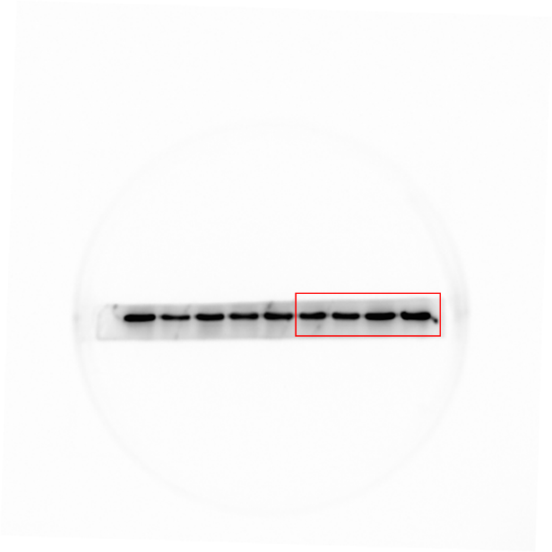
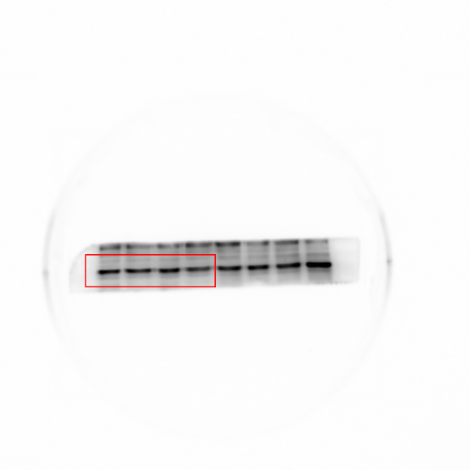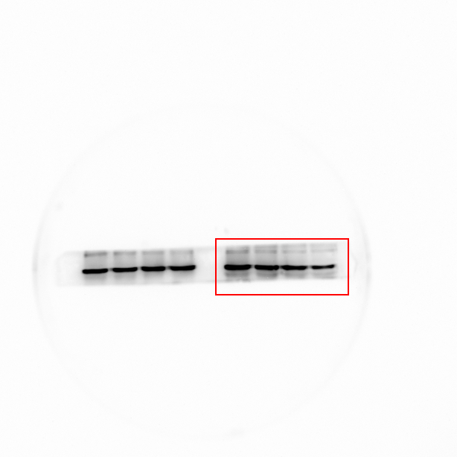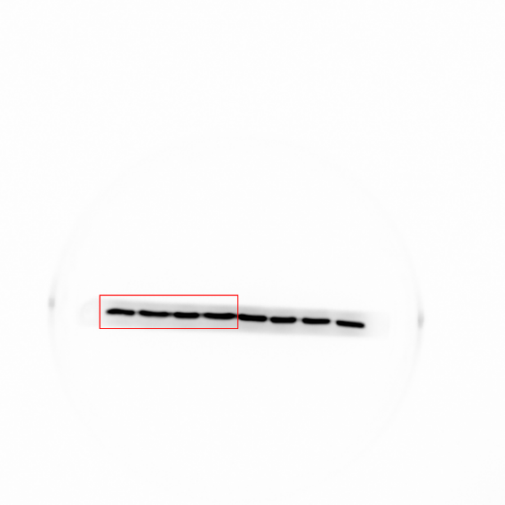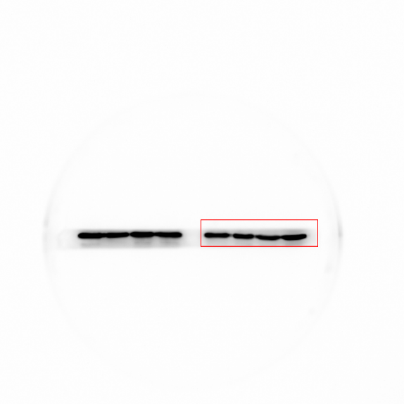

Figure S6. Full-length imprinting/gel of TCP11/GAPDH in HeLa cells in Figure 6A.

