Supplementary material
Management of Metastatic Melanoma in Texas: Disparities in the Utilization of Immunotherapy Following the Regulatory Approval of Immune Checkpoint Inhibitors

Contents

Tables
Table S1. Annual Percentage Change (APC) and Average Annual Percentage Change (AAPC) from Joinpoint regression analysis of trends of immunotherapy utilization across subgroups

Figures
Figure S1. Mapping of study variables to the Andersen Behavioral Model (ABM)
Figure S2. Joinpoint regression analysis of trends of immunotherapy utilization across subgroups

Figure S1. Mapping of study variables to the Andersen Behavioral Model (ABM)¹

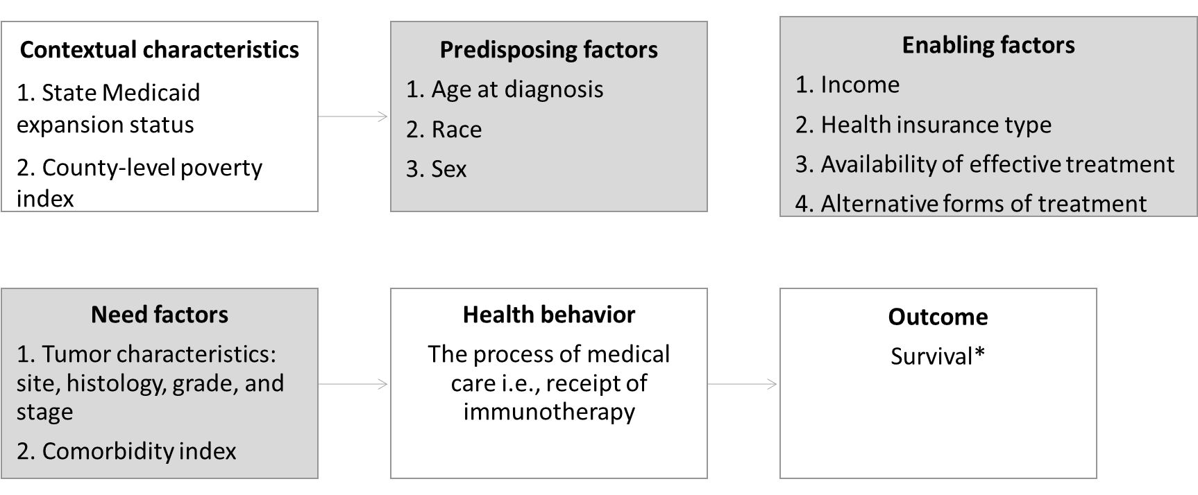
*The process of care was evaluated in this study as an intermediate outcome for prolonged survival

Table S1.
Annual Percentage Change (APC) and Average Annual Percentage Change (AAPC) from Joinpoint regression analysis of trends of immunotherapy utilization across subgroups
S/N | Variable/Joinpoint Segments | APC/AAPC ª | 95% CI ^{b} | P-value
A | All patients
 | 2011 - 2016 | 37.6 | 16.3 – 62.9 | 0.009*
 | 2016 – 2018 | 15.7 | -14.7 – 57.1 | 0.23
 | 2011 -2018 | 31.0 | 19.5 – 43.5 | 0.01*
B | Age
 | <40 years
 | 2011 – 2013 | 100.1 | -92.7 – 5384.9 | 0.55
 | 2013 – 2018 | 17.2 | -2.4 – 40.7 | 0.07
 | 2011 -2018 | 36.5 | -24.2 – 145.8 | 0.004*
 | 40 – 64 years
 | 2011 - 2016 | 46.0 | 6.9 – 99.3 | 0.03*
 | 2016 – 2018 | 10.7 | -34.7 – 87.9 | 0.58
 | 2011 -2018 | 34.9 | 14.3 – 59.2 | 0.001*
 | ≥65 years
 | 2011 - 2016 | 34.4 | 18.1 – 52.9 | 0.005
 | 2016 – 2018 | 17.8 | -8.4 – 51.5 | 0.13
 | 2011 -2018 | 29.4 | 20.4 – 39.1 | <0.001*
 | AAPC difference
 | < 40 years vs 40 – 64 years | 1.6 | -81.7 – 85.0 | 1.0
 | <40 years vs ≥65 years | 7.1 | -73.7 – 88.0 | 1.0
 | 40 – 64 years vs ≥65 years | 5.5 | -18.7 – 29.7 | 1.0
C | Sex
 | Male
 | 2011 - 2016 | 34.0 | 11.1 – 61.8 | 0.29
 | 2016 – 2018 | 11.4 | -23.0 – 61.2 | 0.11
 | 2011 -2018 | 27.1 | 14.5 – 41.3 | 0.001*
 | Female
 | 2011 - 2016 | 38.9 | 3.1 – 87.1 | 0.04*
 | 2016 – 2018 | 17.4 | -30.2 – 97.3 | 0.40
 | 2011 -2018 | 32.4 | 12.8 – 55.3 | <0.001*
 | AAPC difference | -5.2 | -30.3 – 19.8 | >0.05
D | Race
 | White
 | 2011 - 2016 | 39.5 | 19.3 – 63.1 | 0.007*
 | 2016 – 2018 | 13.4 | -14.6 – 50.6 | 0.25
 | 2011 -2018 | 31.5 | 20.8 – 43.2 | <0.001*
 | Others
 | 2011 – 2015 | 32.0 | -24.8 – 31.5 | 0.21
 | 2015 – 2018 | 24.3 | -9.5 – 70.7 | 0.11
 | 2011 -2018 | 28.6 | 3.7 – 59.4 | 0.001*
 | AAPC difference | 2.9 | -26.9 – 32.7 | 1.0
E | Insurance status
 | Not insured
 | 2011 – 2013 | 13.8 | -23.1 – 68.3 | 0.37
 | 2013 – 2018 | 25.6 | 21.8 – 29.5 | <0.001*
 | 2011 -2018 | 22.1 | 13.8 – 31.0 | <0.001*
 | Government insurance
 | 2011 - 2016 | 39.3 | -5.1 – 104.5 | 0.07
 | 2016 – 2018 | 18.5 | -36.5 – 120.8 | 0.45
 | 2011 -2018 | 30.1 | 18.2 – 43.3 | 0.001*
 | Private insurance
 | 2011 - 2016 | 44.7 | 11.9 – 87.0 | 0.02*
 | 2016 – 2018 | 7.5 | -34.4 – 16.1 | 0.68
 | 2011 -2018 | 32.9 | 15.2 – 53.2 | 0.001*
 | AAPC difference
 | Not insured vs Government | -0.1 | -32.7 – 32.9 | 1.0
 | Not insured vs Private | 10.9 | -7.2 – 39.0 | >0.05
 | Private vs Government | -10.8 | -31.6 – 10.0 | >0.05
F | Comorbidity (CCI index score)
 | 0
 | 2011 - 2016 | 31.5 | 13.3 – 52.7 | 0.01*
 | 2016 – 2018 | 15.4 | -10.1 – 48.1 | 0.17
 | 2011 -2018 | 26.7 | 17.1 – 37.1 | <0.001*
 | 1
 | 2011 - 2016 | 54.0 | -28.5 – 231.6 | 0.17
 | 2016 – 2018 | -74.2 | -99.9 – 9015.9 | 0.52
 | 2011 -2018 | -7.5 | -68.8 – 173. 9 | 0.32
 | ≥2
 | 2011 - 2016 | 20.8 | -32.0 – 114.8 | 0.37
 | 2016 – 2018 | -86.0 | -99.7 – 500.3 | 0.19
 | 2011 -2018 | -34.8 | -67.9 – 32.5 | 0.38
 | AAPC difference
 | 0 vs 1 | -34.2 | -66.7 – 135.2 | >0.05
 | 0 vs 2+ | 61.5 | 14.2 – 108.8 | <0.05*
 | 1 vs 2+ | 27.2 | -83.3 – 137.8 | >0.05
ª APC, Annual Percent Change; AAPC, Average Annual Percent Change; ^{b} CI, Confidence Interval

Figure S2
Joinpoint regression analysis of trends of immunotherapy utilization across patient subgroups.

- Overall utilization

- Age
C. Sex

- Race

- Insurance status

- Comorbidity

References
Lederle M, Tempes J, Bitzer EMApplication of Andersen’s behavioural model of health services use: a scoping review with a focus on qualitative health services researchBMJ Open 2021;11:e045018. doi: 10.1136/bmjopen-2020-045018

