The followings are from experiments using SUDHL4 cells
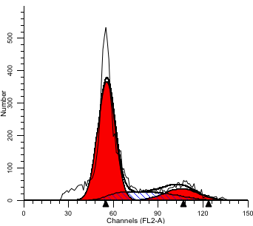

File analyzed: Data.001
Diploid: 100.00 %
Dip G1: 70.44 % at 55.65
Dip G2: 12.81 % at 105.74
Dip S: 16.74 % G2/G1: 1.90
%CV: 10.20

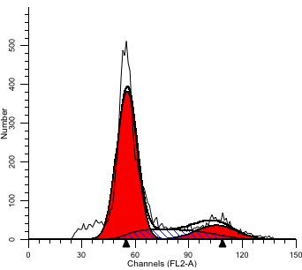
File analyzed: Data.002
Diploid: 100.00 %
Dip G1: 71.38 % at 55.50
Dip G2: 12.60 % at 105.46
Dip S: 16.02 % G2/G1: 1.90
%CV: 10.07

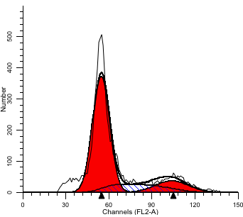
File analyzed: Data.
003Diploid: 100.00 %
Dip G1: 70.87 % at 54.79
Dip G2: 13.25 % at 104.11
Dip S: 15.87 % G2/G1: 1.90
%CV: 10.55

Parental cells
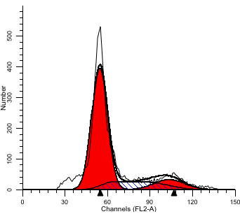
File analyzed: Data.004
Diploid: 100.00 %
Dip G1: 71.92 % at 54.66
Dip G2: 10.99 % at 103.85
Dip S: 17.09 % G2/G1: 1.90
%CV: 10.05

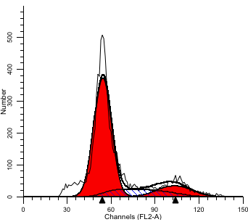
File analyzed: Data.005
Diploid: 100.00 %
Dip G1: 72.60 % at 54.44
Dip G2: 12.56 % at 103.44
Dip S: 14.84 % G2/G1: 1.90
%CV: 10.79

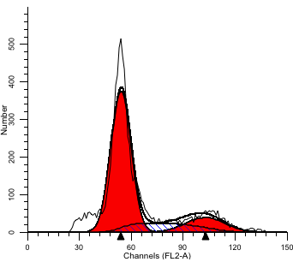
File analyzed: Data.006
Diploid: 100.00 %
Dip G1: 71.15 % at 54.23
Dip G2: 13.73 % at 103.05
Dip S: 15.12 % G2/G1: 1.90
%CV: 10.53

SUDHL4 LV-NC
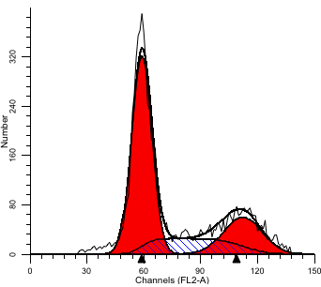
File analyzed: Data.007
Diploid: 100.00 %
Dip G1: 59.86 % at 59.12
Dip G2: 21.05 % at 112.34
Dip S: 19.09 % G2/G1: 1.90
%CV: 8.97

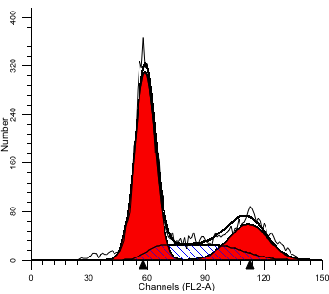
File analyzed: Data.008
Diploid: 100.00 %
Dip G1: 58.72 % at 58.97
Dip G2: 21.37 % at 112.04
Dip S: 19.91 % G2/G1: 1.90
%CV: 8.95

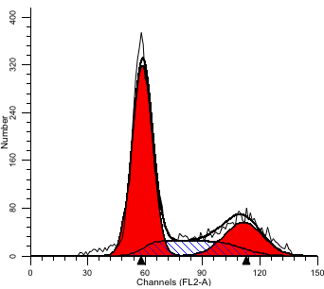
File analyzed: Data.009
Diploid: 100.00 %
Dip G1: 60.57 % at 58.69
Dip G2: 20.15 % at 111.51
Dip S: 19.27 % G2/G1: 1.90
%CV: 9.00

SUDHL4 LV-CDC6
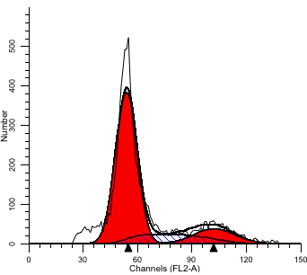
File analyzed: Data.010
Diploid: 100.00 %
Dip G1: 72.32 % at 54.02
Dip G2: 13.11 % at 102.64
Dip S: 14.58 % G2/G1: 1.90
%CV: 10.70

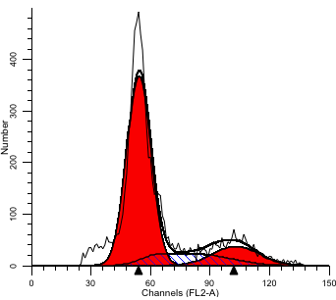
File analyzed: Data.011
Diploid: 100.00 %
Dip G1: 71.43 % at 54.33
Dip G2: 13.67 % at 103.23
Dip S: 14.90 % G2/G1: 1.90
%CV: 11.04

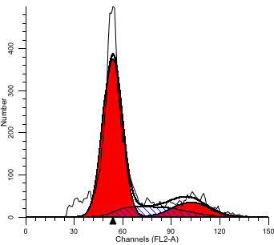
File analyzed: Data.012
Diploid: 100.00 %
Dip G1: 72.10 % at 53.86
Dip G2: 12.65 % at 102.33
Dip S: 15.26 % G2/G1: 1.90
%CV: 10.84
SUDHL4 LV-shCtrl
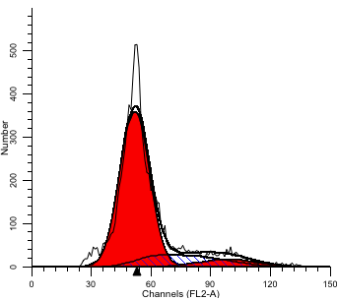
File analyzed: Data.013
Diploid: 100.00 %
Dip G1: 77.75 % at 52.05
Dip G2: 6.63 % at 98.89
Dip S: 15.62 % G2/G1: 1.90
%CV: 13.97

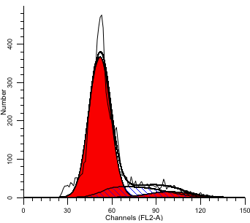
File analyzed: Data.014
Diploid: 100.00 %
Dip G1: 78.02 % at 51.97
Dip G2: 6.08 % at 98.75
Dip S: 15.89 % G2/G1: 1.90
%CV: 13.84

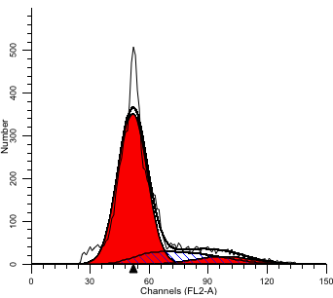
File analyzed: Data.015
Diploid: 100.00 %
Dip G1: 76.65 % at 51.72
Dip G2: 6.93 % at 98.27
Dip S: 16.42 % G2/G1: 1.90
%CV: 14.12

SUDHL4 LV-shCDC6

The followings are from experiments using OCI-LY7 cells
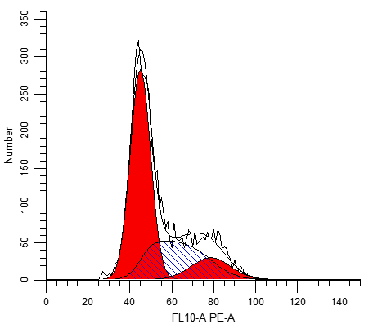
File analyzed: Tube1.fcs
Dip G1: 58.72 % at 44.91
Dip G2: 11.36 % at 87.55
Dip S: 29.92 % G2/G1: 1.95
%CV: 6.79

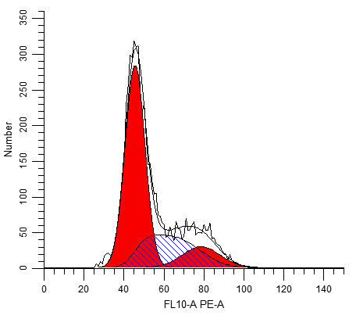
File analyzed: Tube2.fcs
Dip G1: 59.34 % at 45.44
Dip G2: 13.89 % at 87.71
Dip S: 26.77 % G2/G1: 1.93
%CV: 5.93

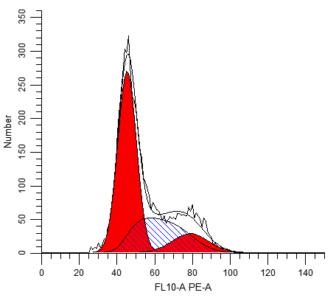
File analyzed: Tube3.fcs
Dip G1: 58.35 % at 45.27
Dip G2: 15.42 % at 87.82
Dip S: 26.23 % G2/G1: 1.94
%CV: 5.98

OCI-Ly7 parental cells
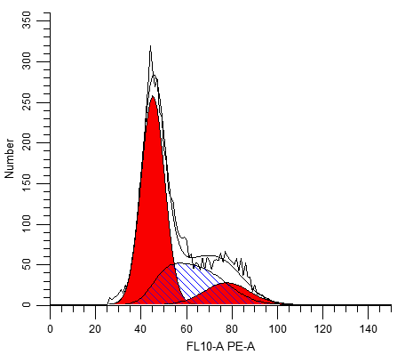
File analyzed: Tube4.fcs
Dip G1: 58.59 % at 45.14
Dip G2: 11.54 % at 86.63
Dip S: 29.87 % G2/G1: 1.92
%CV: 6.42

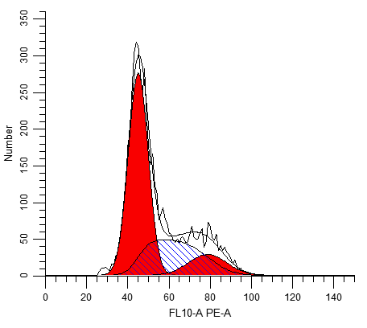
File analyzed: Tube5.fcs
Dip G1: 59.35 % at 44.97
Dip G2: 14.38 % at 87.70
Dip S: 26.27 % G2/G1: 1.95
%CV: 5.73

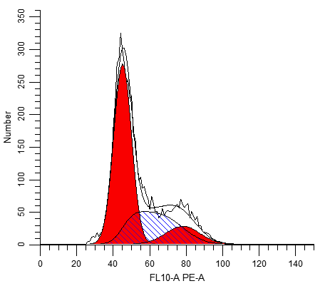
File analyzed: Tube6.fcs
Dip G1: 59.48 % at 45.07
Dip G2: 13.07 % at 86.96
Dip S: 27.45 % G2/G1: 1.93
%CV: 5.82

OCI-LY7 LV-NC

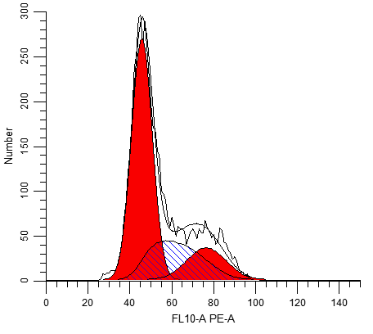
File analyzed: Tube7.fcs
Dip G1: 52.15 % at 45.64
Dip G2: 24.15 % at 90.36
Dip S: 23.70 % G2/G1: 1.98
%CV: 5.87

File analyzed: Tube8.fcs
Dip G1: 51.65 % at 45.51
Dip G2: 26.15 % at 90.12
Dip S: 22.20 % G2/G1: 1.98
%CV: 6.05

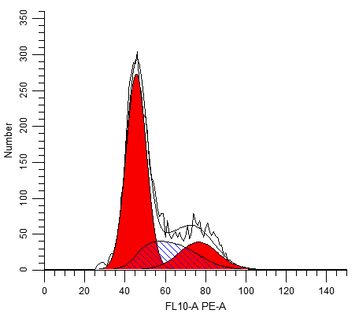

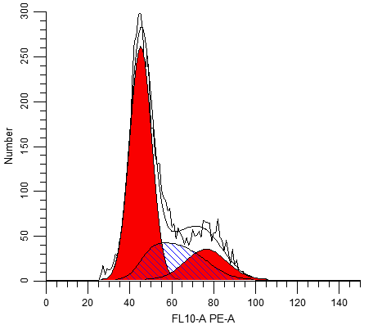
File analyzed: Tube9.fcs
Dip G1: 50.79 % at 45.08
Dip G2: 25.16 % at 88.35
Dip S: 24.05 % G2/G1: 1.96
%CV: 5.61

OCI-LY7 LV-CDC6
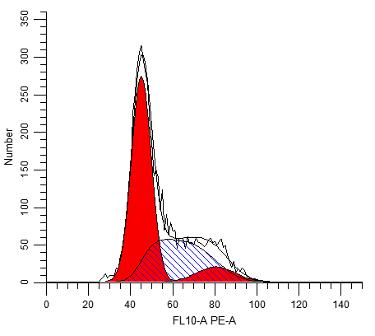
File analyzed: Tube10.fcs
Dip G1: 58.10 % at 45.03
Dip G2: 14.76 % at 88.71
Dip S: 27.14 % G2/G1: 1.97
%CV: 4.47

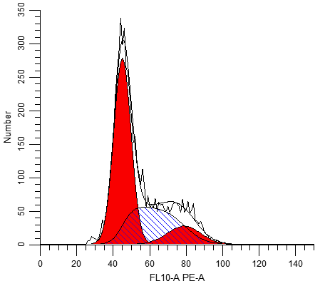
File analyzed: Tube11.fcs
Dip G1: 57.10 % at 44.96
Dip G2: 15.42 % at 87.67
Dip S: 27.48 % G2/G1: 1.95
%CV: 4.48

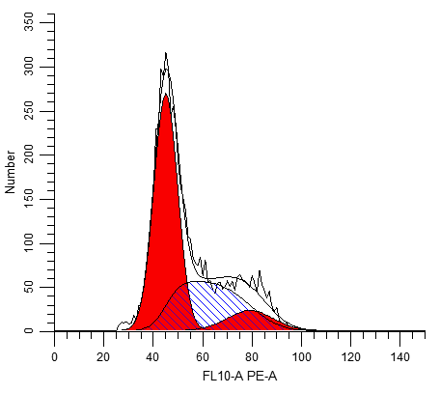
File analyzed: Tube12.fcs
Dip G1: 57.29 % at 44.97
Dip G2: 13.08 % at 88.14
Dip S: 29.63 % G2/G1: 1.96
%CV: 4.76

OCI-LY7 LV-shCtrl
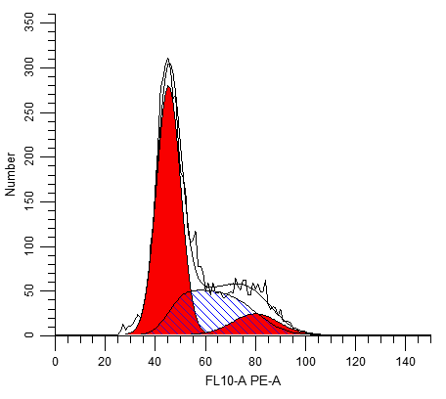
File analyzed: Tube13.fcs
Dip G1: 64.51 % at 45.20
Dip G2: 9.50 % at 89.08
Dip S: 25.99 % G2/G1: 1.97
%CV: 4.56

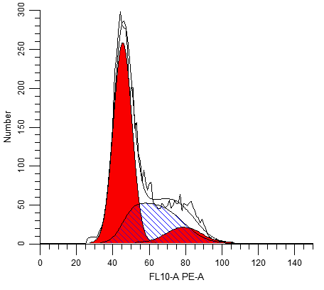
File analyzed: Tube14.fcs
Dip G1: 64.23 % at 45.34
Dip G2: 8.95 % at 87.95
Dip S: 26.81 % G2/G1: 1.94
%CV: 6.17

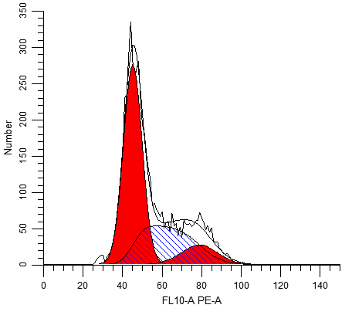
File analyzed: Tube15.fcs
Dip G1: 65.78 % at 45.06
Dip G2: 10.50 % at 87.86
Dip S: 23.72 % G2/G1: 1.95
%CV: 5.52

OCI-LY7 LV-shCDC6

SUDHL4
Group | G1(%) | S(%) | G2(%)
Control | 70.44 | 16.74 | 12.81
Control | 71.38 | 16.02 | 12.6
Control | 70.87 | 15.87 | 13.25
LV-NC | 71.92 | 17.09 | 10.99
LV-NC | 72.60 | 14.84 | 12.56
LV-NC | 71.15 | 15.12 | 13.73
LV-CDC6 | 59.86 | 19.09 | 21.05
LV-CDC6 | 58.72 | 19.91 | 21.37
LV-CDC6 | 60.57 | 19.27 | 20.15
LV-sh | 72.32 | 14.58 | 13.11
LV-sh | 71.43 | 14.90 | 13.67
LV-sh | 72.10 | 15.26 | 12.65
LV-shCDC6 | 77.75 | 15.62 | 6.63
LV-shCDC6 | 78.02 | 15.89 | 6.08
LV-shCDC6 | 76.65 | 16.42 | 6.93

OCI-LY7
Group | G1(%) | S(%) | G2(%)
CON | 58.72 | 29.92 | 11.36
 | 59.34 | 26.77 | 13.89
 | 58.35 | 26.23 | 15.42
LV-NC | 58.59 | 29.87 | 11.54
 | 59.35 | 26.27 | 14.38
 | 59.48 | 27.45 | 13.07
LV-CDC6 | 52.15 | 23.7 | 24.15
 | 51.65 | 22.2 | 26.15
 | 50.79 | 24.05 | 25.16
LV-shRNA | 58.1 | 27.14 | 14.76
 | 57.1 | 27.48 | 15.42
 | 57.29 | 29.63 | 13.08
LV-shCDC6 | 64.51 | 25.99 | 9.5
 | 64.23 | 26.82 | 8.95
 | 65.78 | 23.72 | 10.5

