Supplemental Figure 1

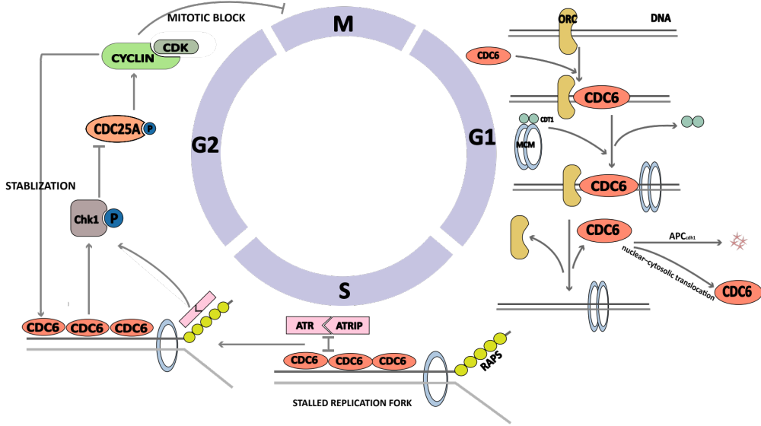

Supplemental Figure 1, The role of CDC6 in cell cycle regulation

In GSE10846 (n=414) , 233 cases were treated with R-CHOP regimen and the others were treated with CHOP regimen. We analyzed the association between CDC6 expression and patients’ prognosis in the R-CHOP subgroup. The result showed that patients with high CDC6 expression tend to have a poor overall survival than those with low CDC6 expression, although the difference was not statistically significant (p=0.104).
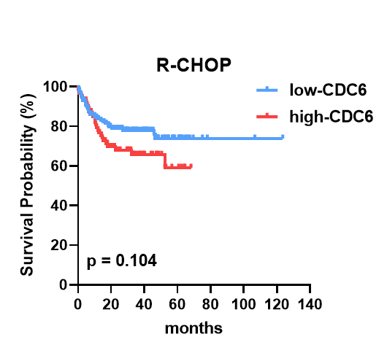
Supplemental Figure 2, OS stratified by the status of CDC6 expression in patients receiving R-CHOP

As a result, CDC6, IPI score, stage, HB, LDH, and classification were significantly associated with OS in univariate analysis (all P＜0.05). Furthermore, the multivariate analysis showed that HR values of CDC6 (positive vs. negative), HB (≥100 vs.＜100), and classification (Non-GCB vs. GCB) were 3.098 (P = 0.038), 4.042 (P = 0.002), and 3.847(P = 0.049), respectively. These results suggested that CDC6 expression was an independent risk factor affecting the prognosis of DLBCL patients.

Supplementary Table 1. Univariate and multivariate Cox regression analysis of OS in DLBCL patients.
Prognostic parameter | Univariate analysis | P-value | Multivariate analysis | P-value
Prognostic parameter | HR (95%CI) | P-value | HR (95%CI) | P-value
CDC6 (positive vs. negative) | 3.281 (1.296 -8.311) | 0.012 | 3.098 (1.064-9.020) | 0.038
Age (≥60 vs.＜60) | 1.398 (0.554 - 3.524) | 0.478 | - | -
Gender (female vs. male) | 1.426 (0.637 - 3.193) | 0.388 | - | -
IPI score (3-5 vs. 0-2) | 2.630 (1.129 - 6.127) | 0.025 | 1.245 (0.409-3.787) | 0.699
Stage (III-VI vs. I-II) | 3.345 (1.412 - 7.924) | 0.006 | 2.368 (0.735-7.628) | 0.149
HB (≥100 vs.＜100) | 4.196 (1.851 - 9.513) | 0.001 | 4.042 (1.679-9.730) | 0.002
LDH (≥245 vs.＜245) | 2.916 (1.256 - 6.769) | 0.013 | 1.378 (0.486-3.910) | 0.546
Site (Extranodal vs. Nodal) | 0.780 (0.349 - 1.742) | 0.544 | - | -
Classification (Non-GCB vs. GCB) | 7.584 (2.168 - 26.529) | 0.002 | 3.847 (1.001-14.787) | 0.049
HB: Hemoglobin (g/L); LDH: Lactate Dehydrogenase (U/L); HR: hazard ratio; CI: credible interval.

