Judgements for each risk of bias domain for included studies
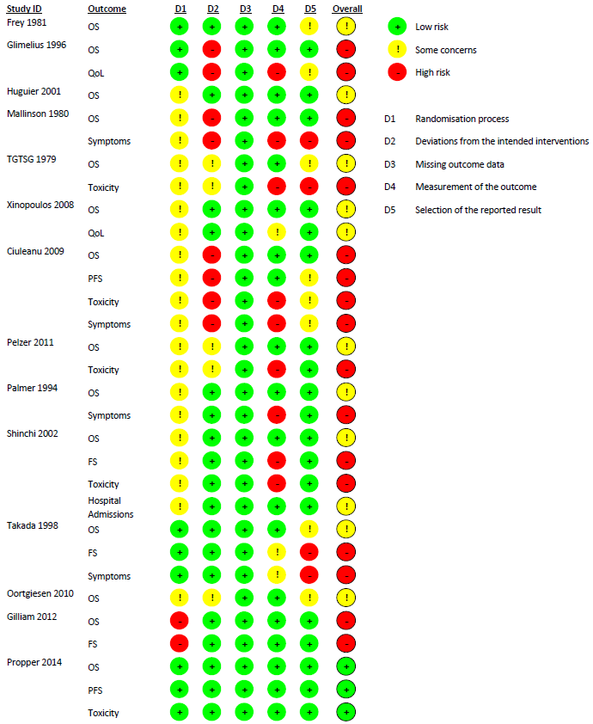
TGTSG: The Gastrointestinal Tumour Study Group

