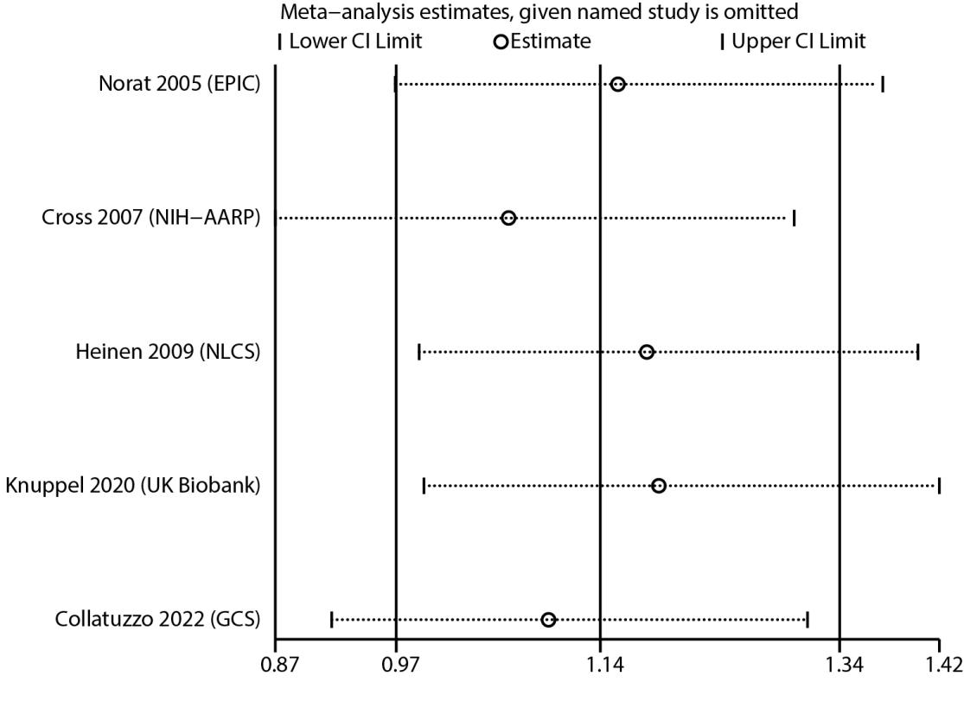
Figure S1. Sensitivity analysis for the relation between red meat intake andEC risk

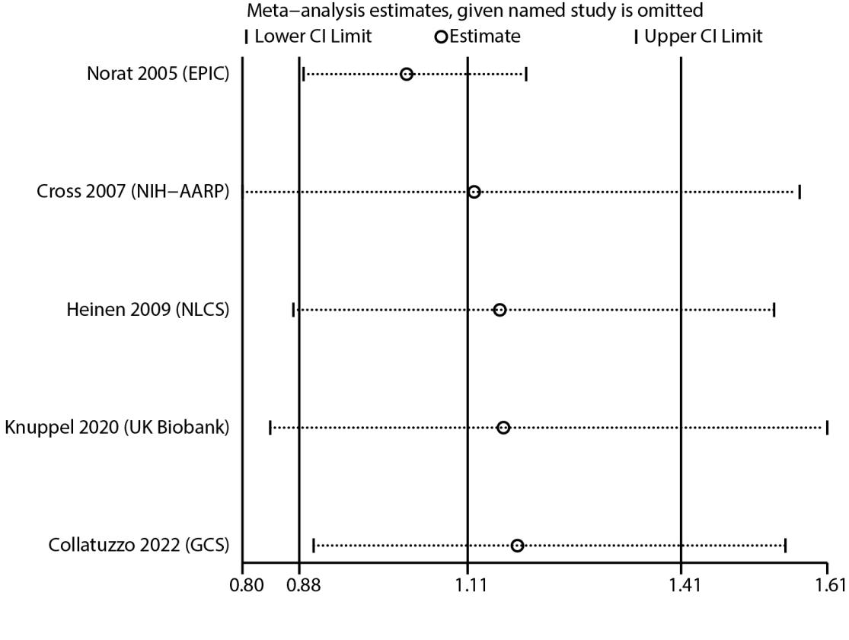
Figure S2. Sensitivity analysis for the relation between proceed meat intake andEC risk

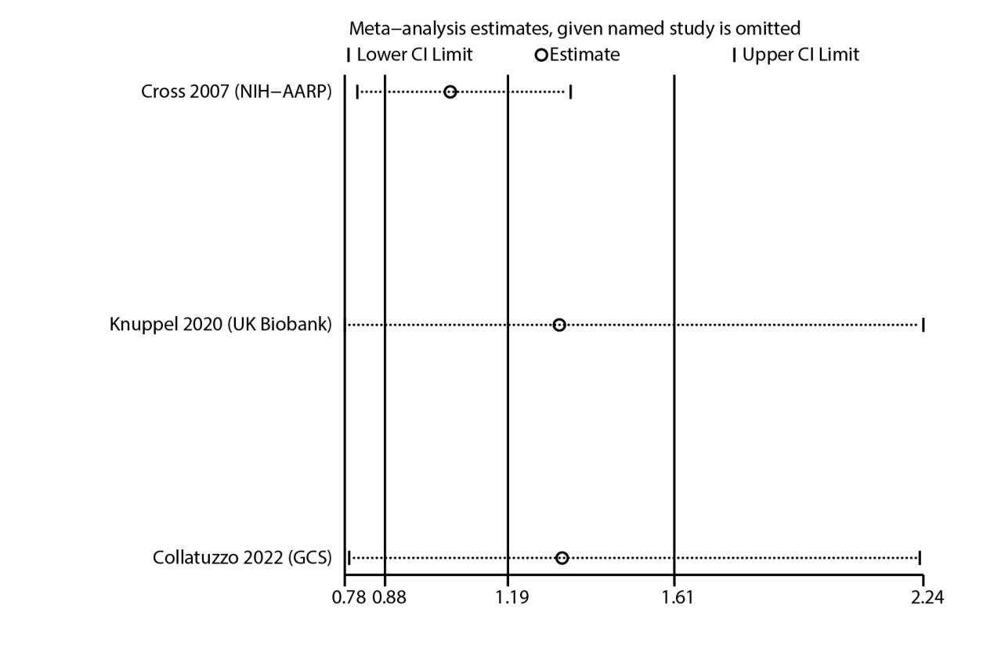
Figure S3. Sensitivity analysis for the relation betweentotal red and processed meat intake andEC risk

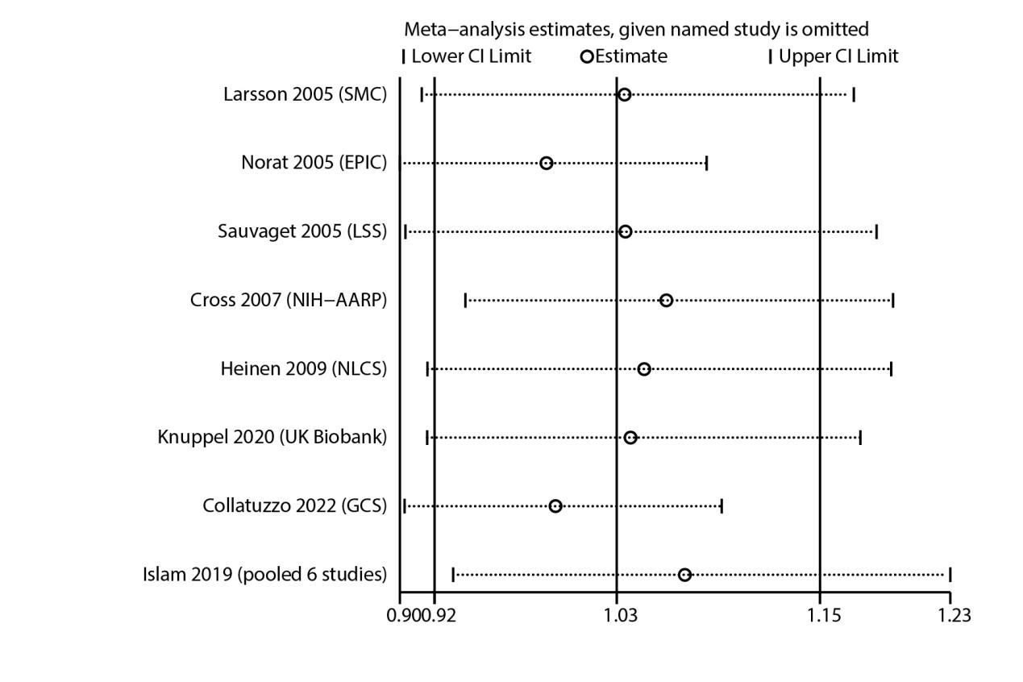
Figure S4. Sensitivity analysis for the relation between red meat intake and GC risk

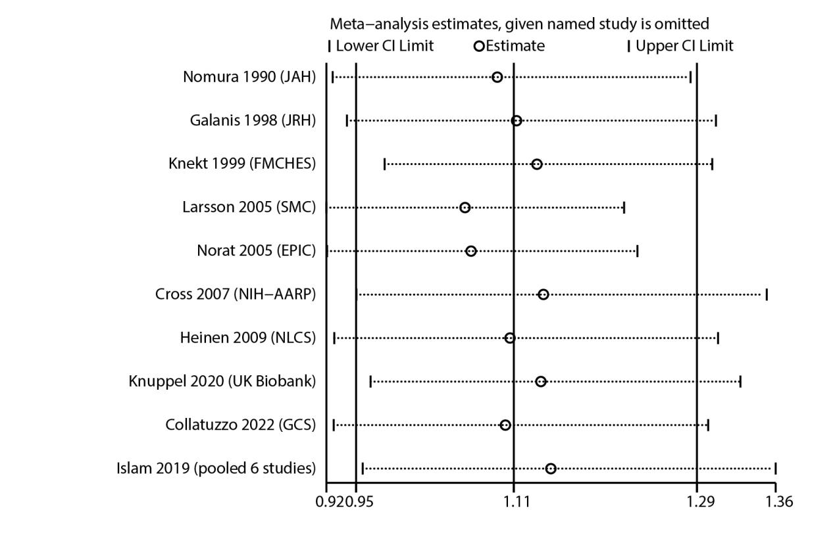
Figure S5. Sensitivity analysis for the relation between proceed meat intake and GC risk

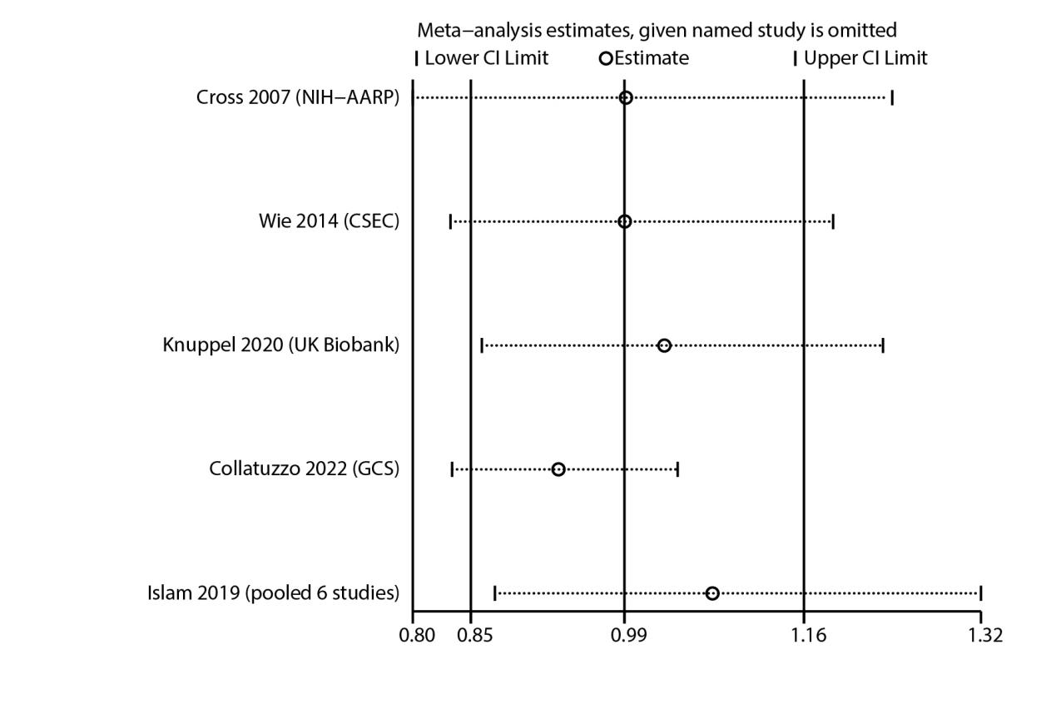
Figure S6. Sensitivity analysis for the relation betweentotal red and processed meat intake and GC risk

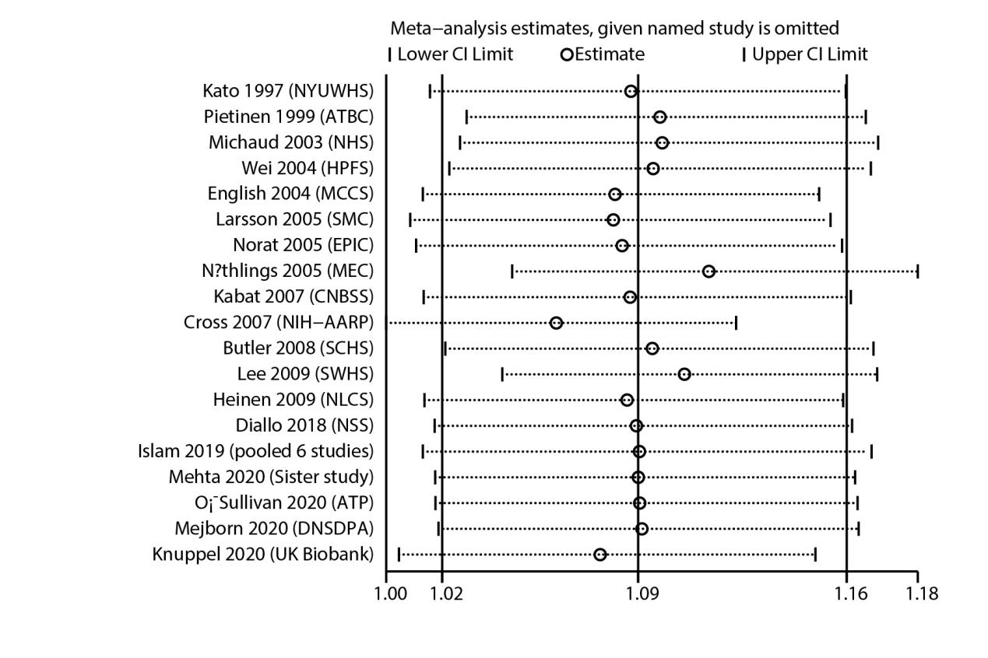
Figure S7. Sensitivity analysis for the relation between red meat intake and CRC risk

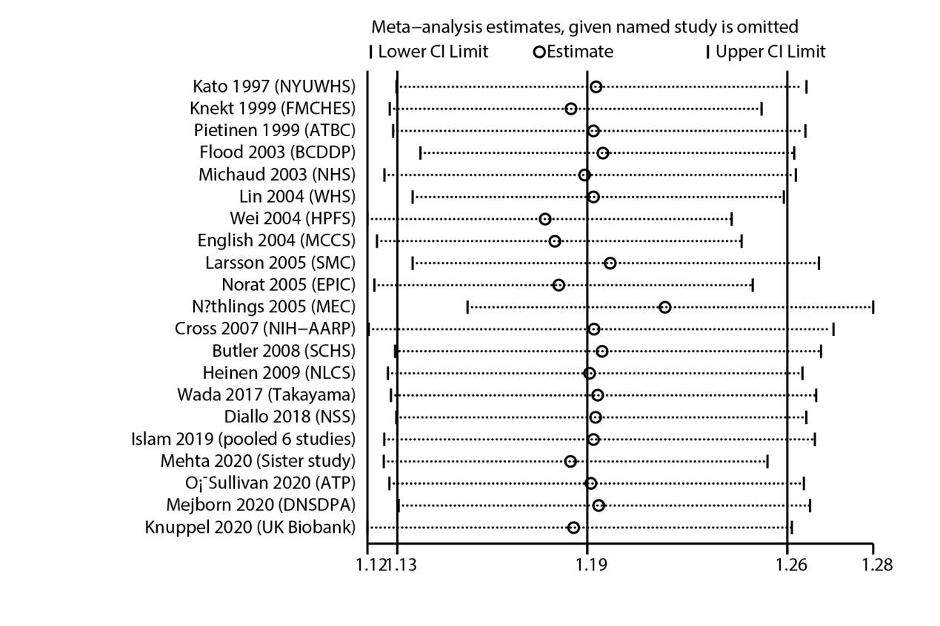
Figure S8. Sensitivity analysis for the relation between proceed meat intake and CRC risk

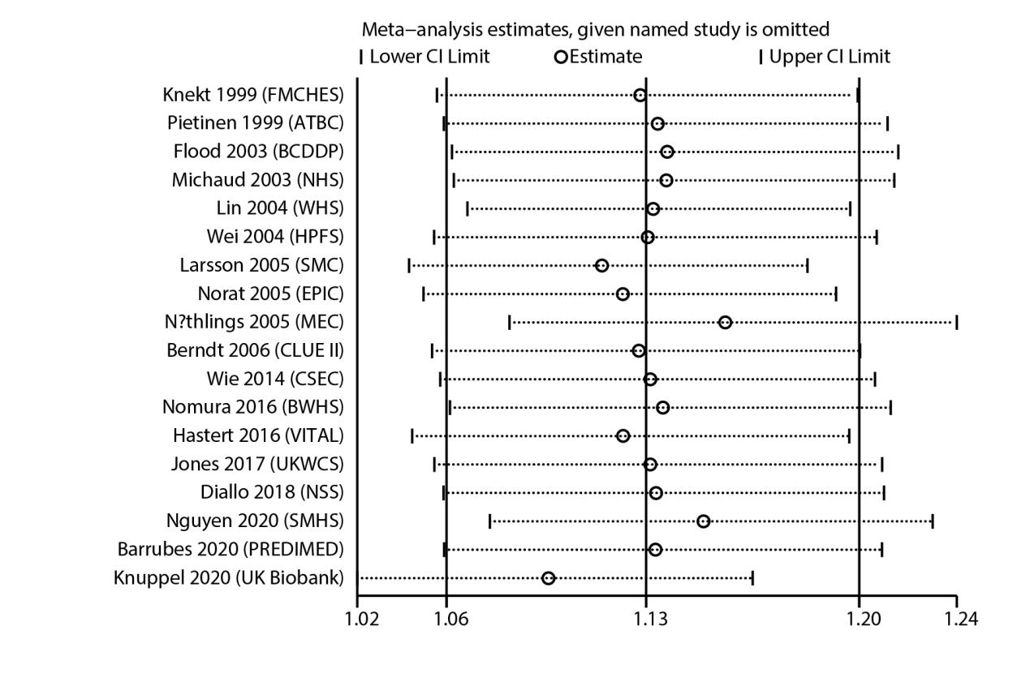
Figure S9. Sensitivity analysis for the relation betweentotal red and processed meat intake and CRC risk

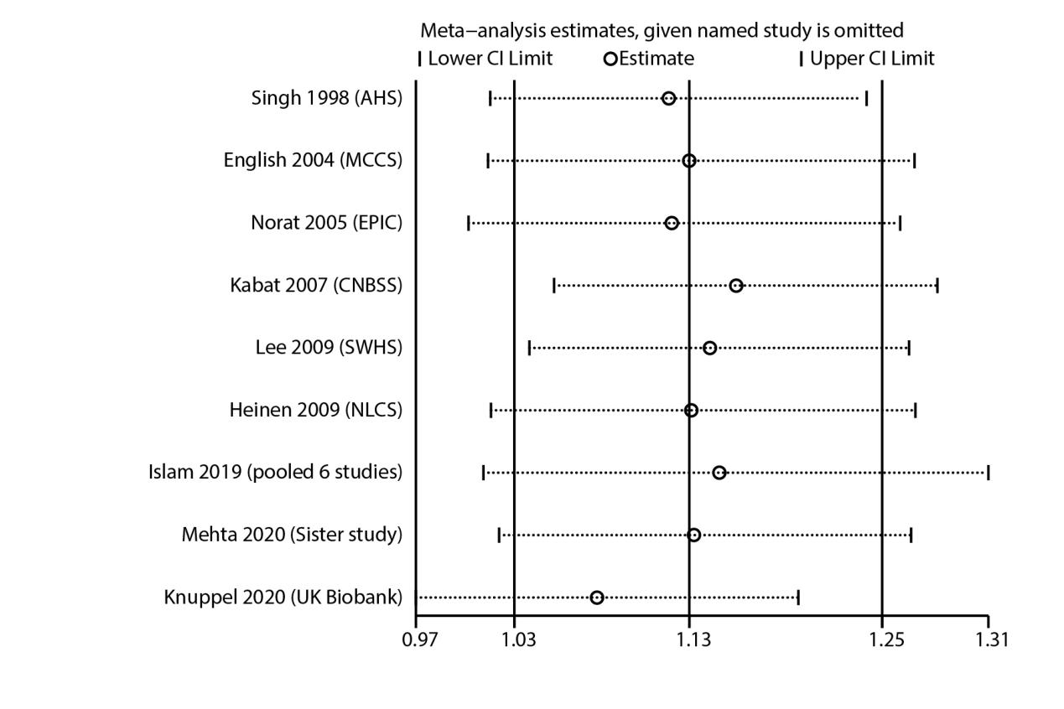
Figure S10. Sensitivity analysis for the relation between red meat intake and CC risk

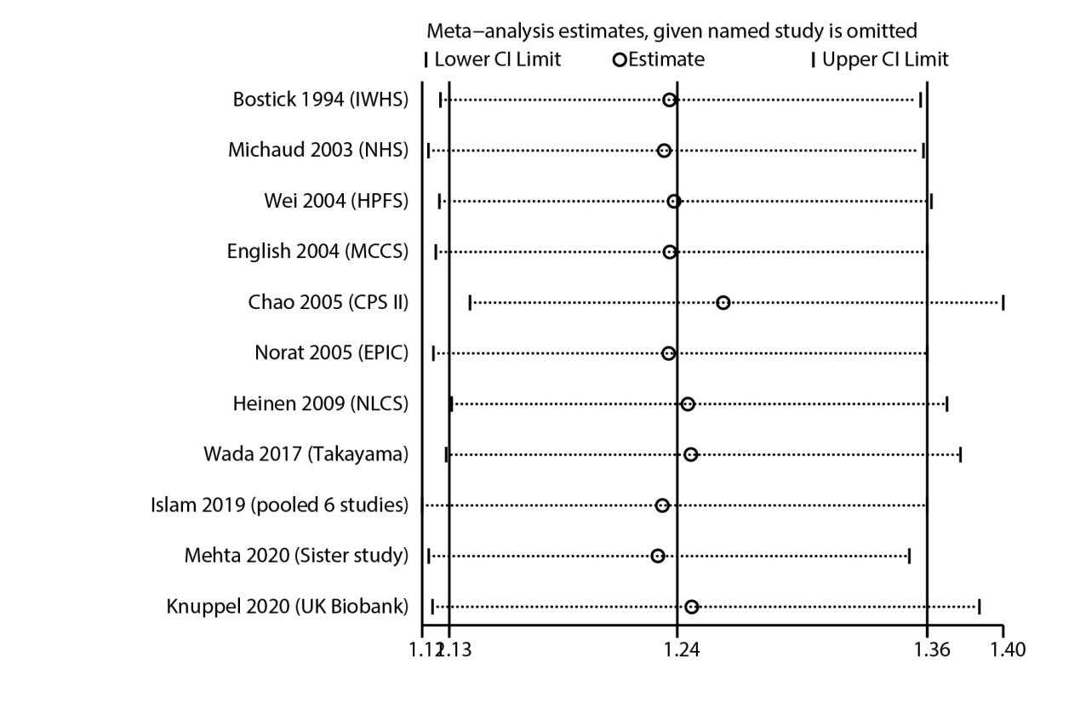
Figure S11. Sensitivity analysis for the relation between proceed meat intake and CC risk

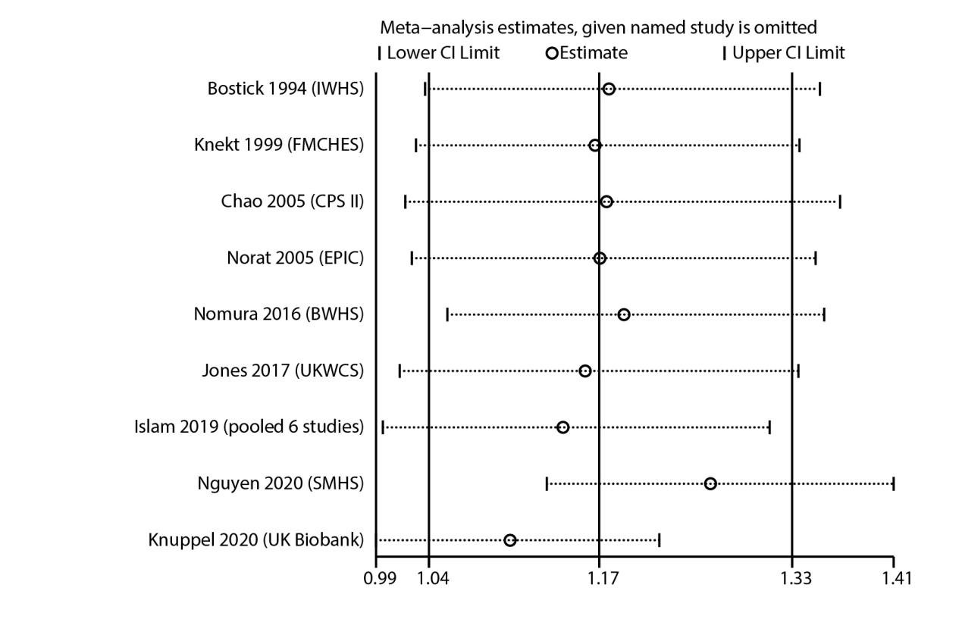
Figure S12. Sensitivity analysis for the relation betweentotal red and processed meat intake and CC risk

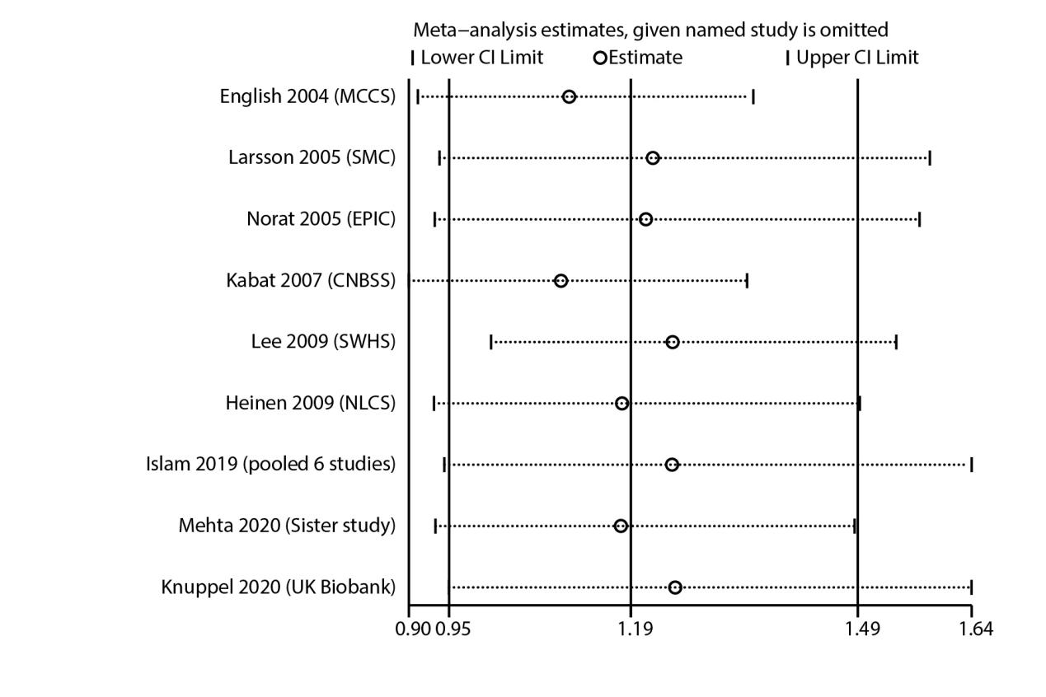
Figure S13. Sensitivity analysis for the relation between red meat intake and RC risk

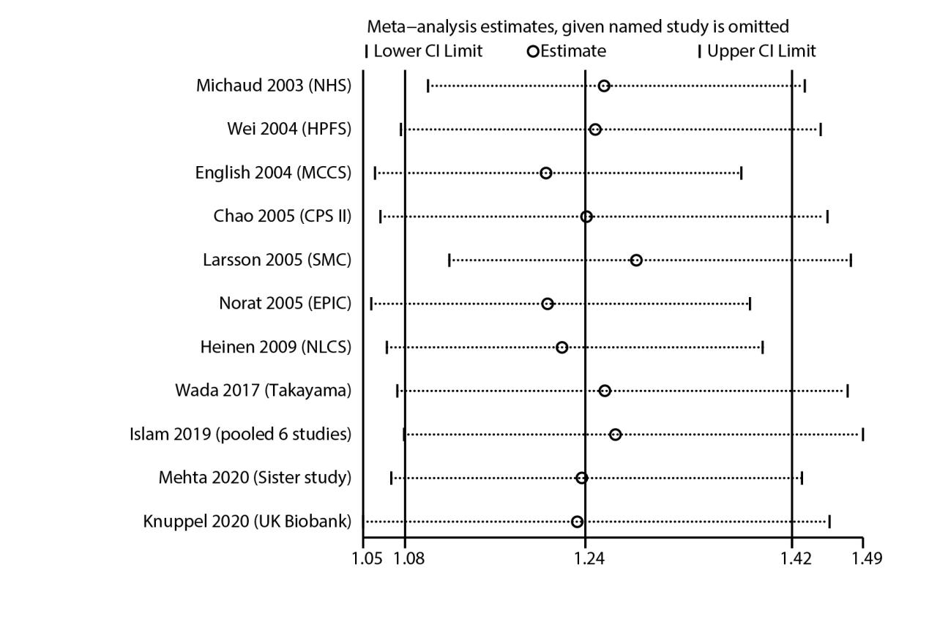
Figure S14. Sensitivity analysis for the relation between proceed meat intake and RC risk

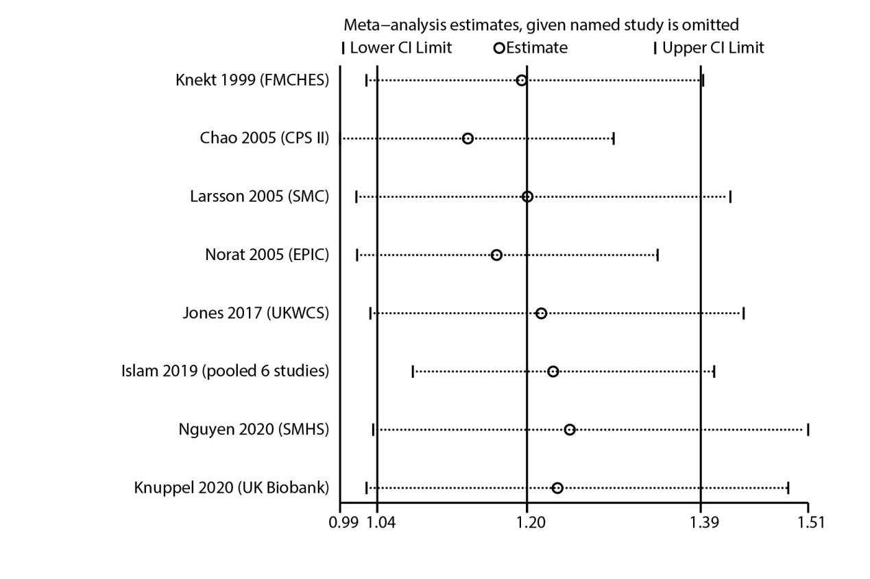
Figure S15. Sensitivity analysis for the relation betweentotal red and processed meat intake and RC risk

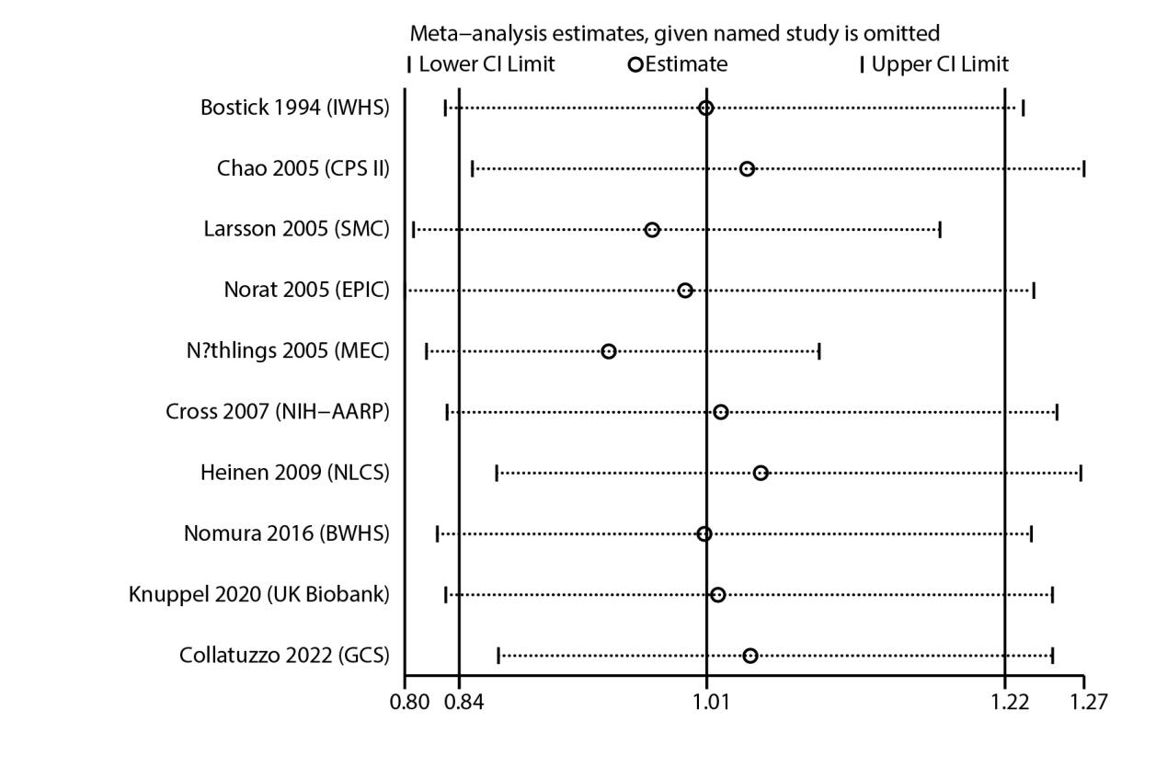
Figure S16. Sensitivity analysis for the relation between red meat intake and PC risk

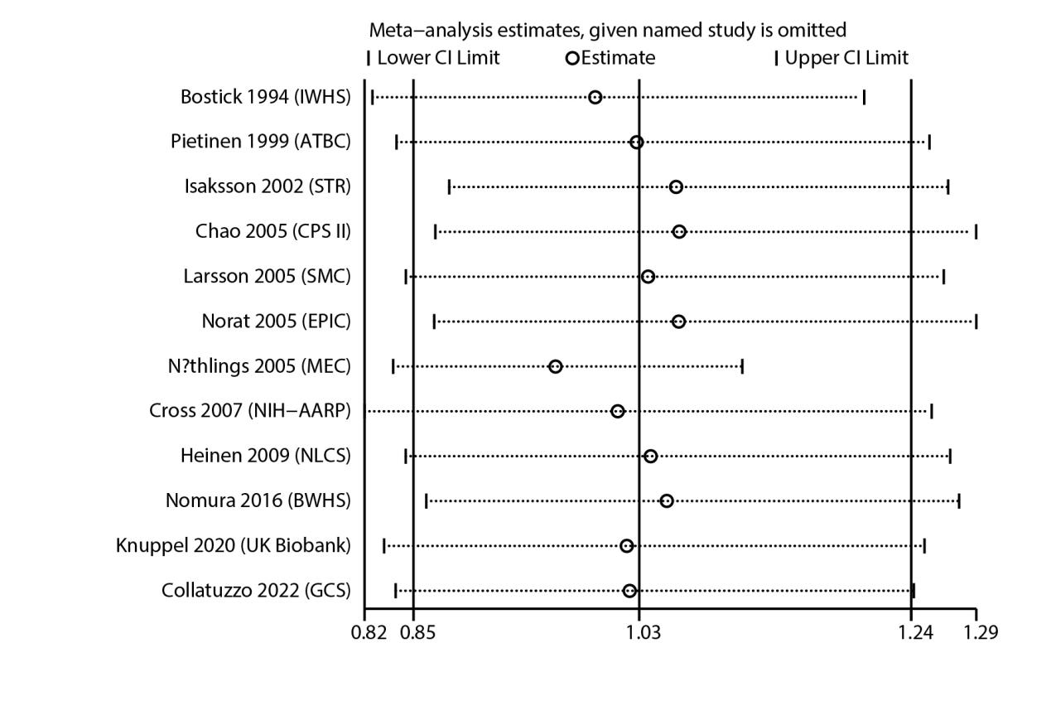
Figure S17. Sensitivity analysis for the relation between proceed meat intake and PC risk

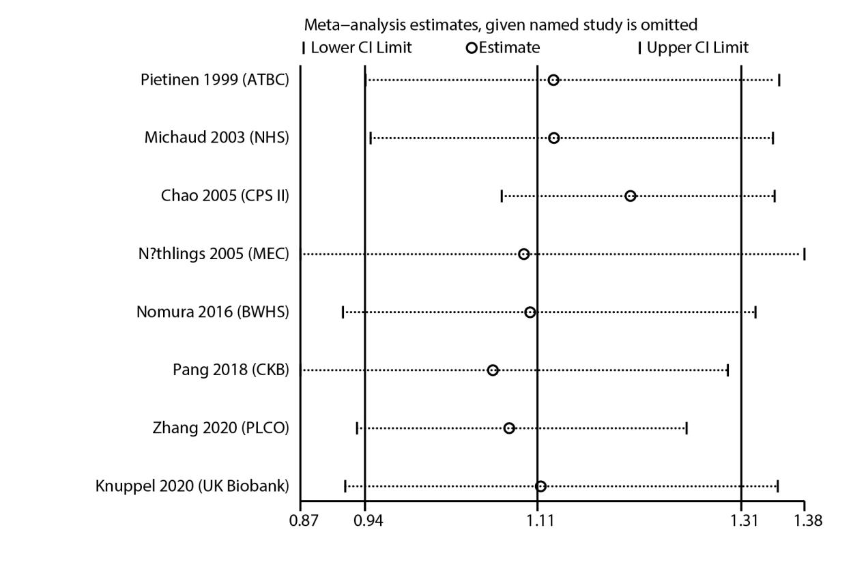
Figure S18. Sensitivity analysis for the relation betweentotal red and processed meat intake and PC risk

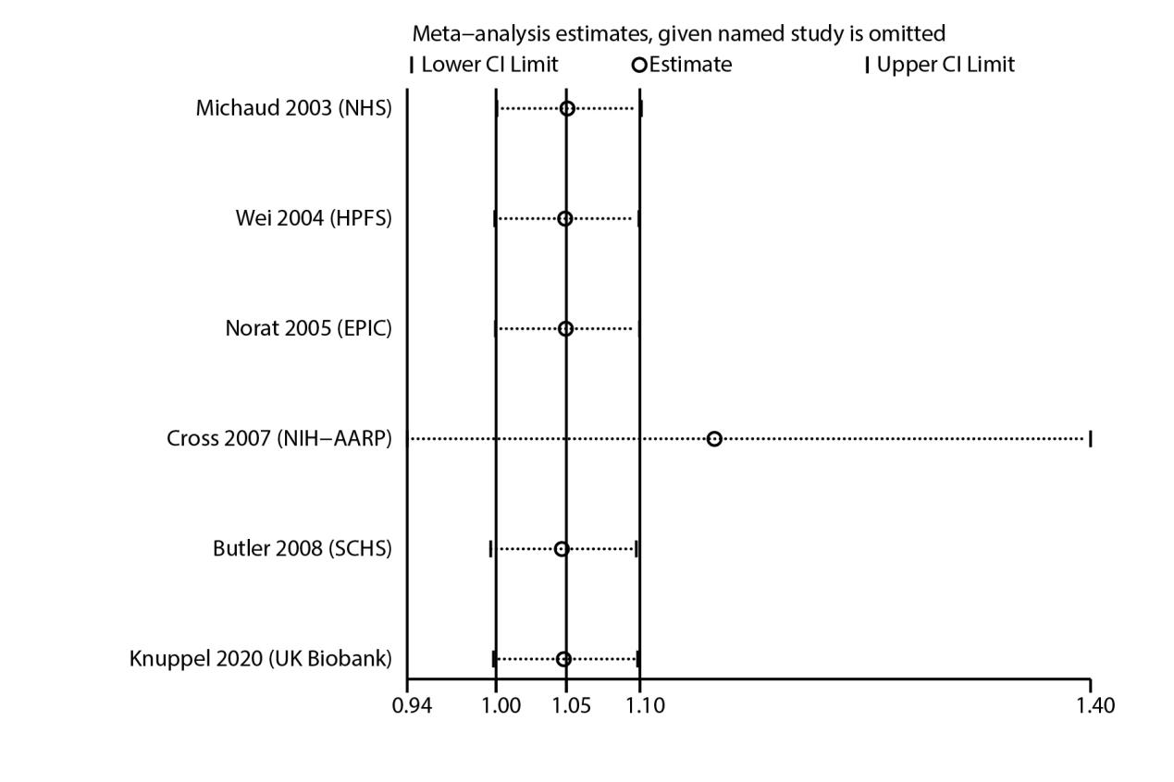
Figure S19. Sensitivity analysis for the relation between red meat intake and HCC risk

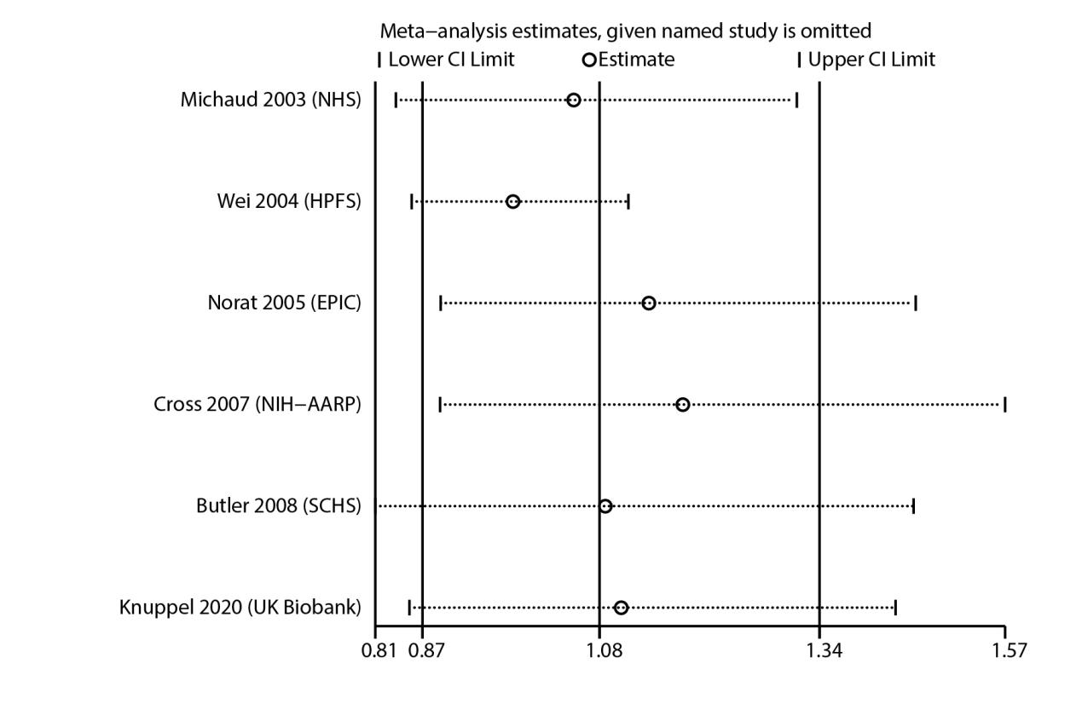
Figure S20. Sensitivity analysis for the relation between proceed meat intake and HCC risk

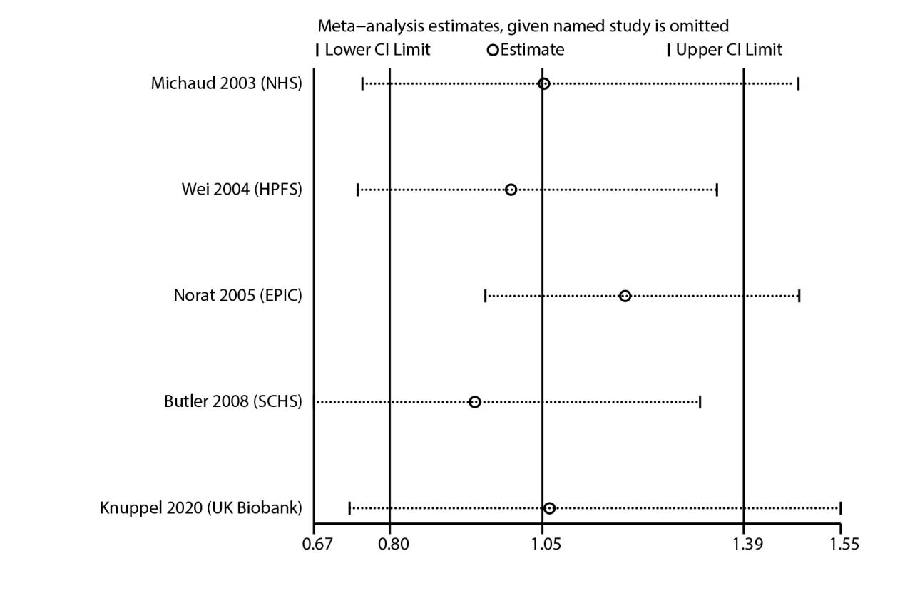
Figure S21. Sensitivity analysis for the relation betweentotal red and processed meat intake and HCC risk

