The original, uncropped Western Blot image of the Figure 8C-ZIC2.
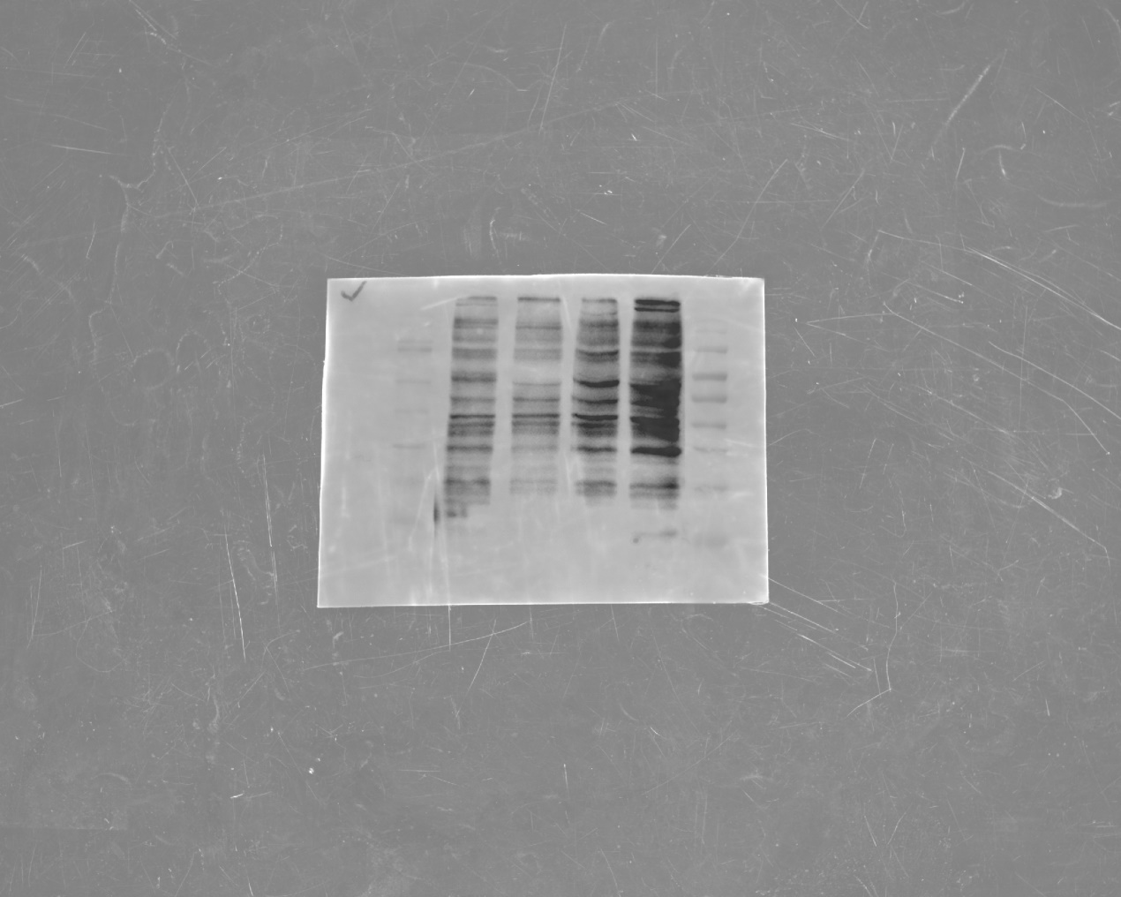

The original, uncropped Western Blot image of the Figure 8C-Actin.

The photo of the membrane for Figure 8C.

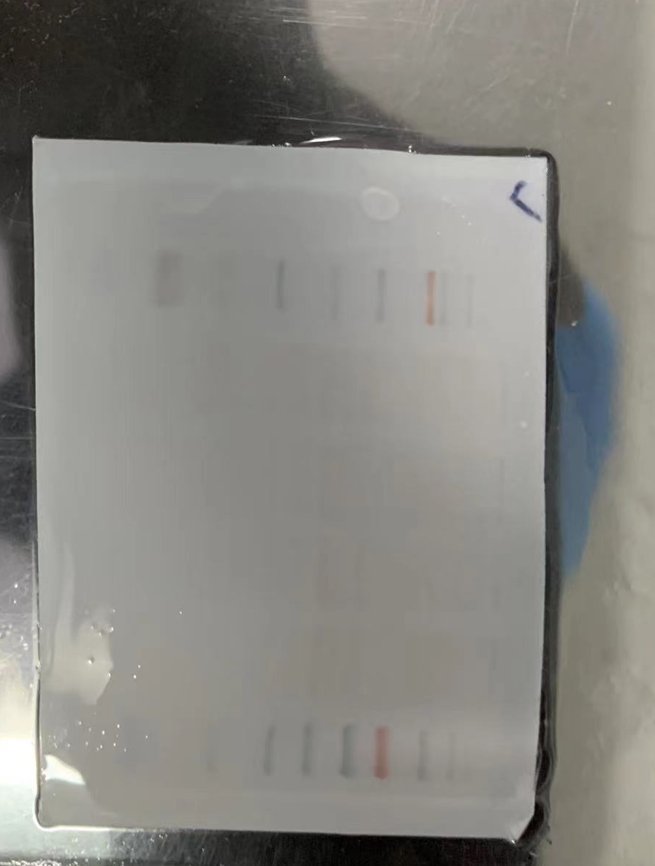

The original, uncropped Western Blot image of the Figure 8G-ZIC2. (The image in the up was the original, uncropped Western Blot image, the down was the image that has been adjusted for brightness, uncropped Western Blot image)

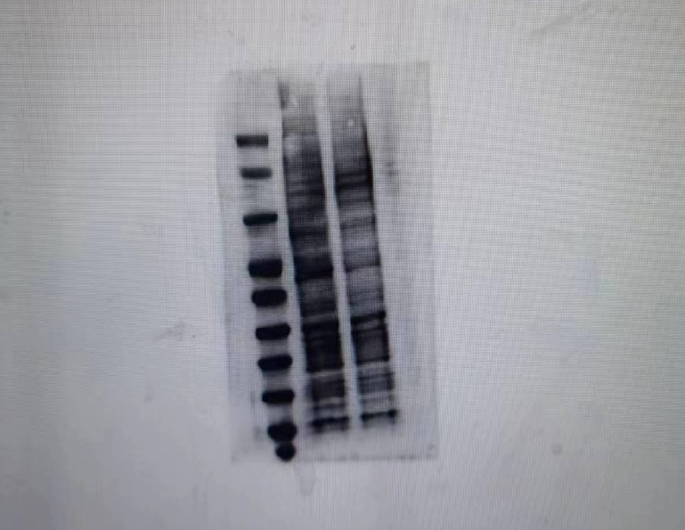

The original, uncropped Western Blot image of the Figure 8G-Actin.
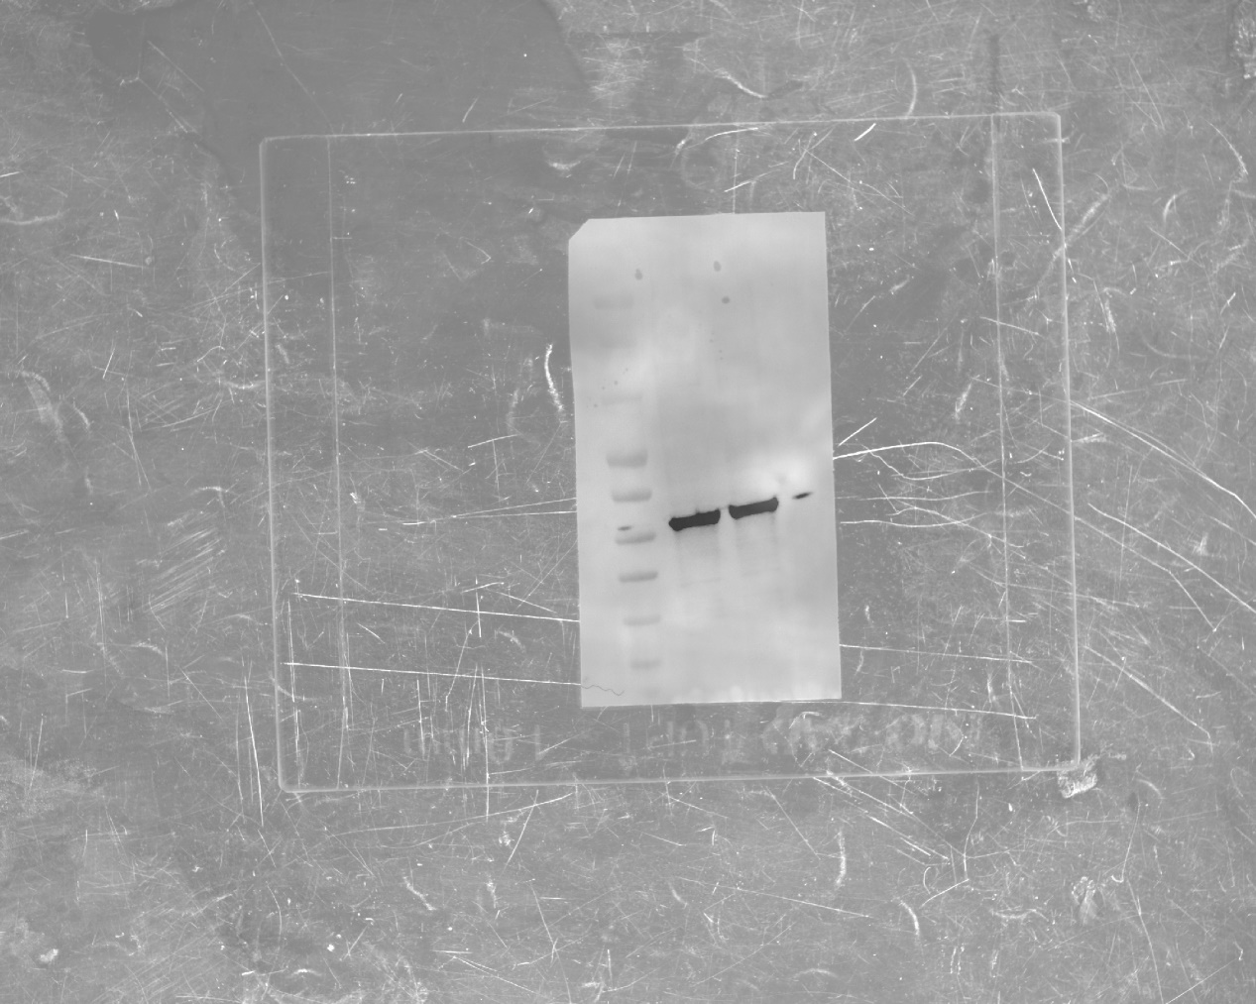

The photo of the membrane for Figure 8G.
