Fig. S1. Relationship between mRNA expression levels of RNASET2 and clinicopathological features. mRNA expression of RNASET2 did not correlate significantly with (A) patient age and (C) lymph node metastasis, whereas high expression was observed in patients with (B) T3-T4 stage, (D) distant metastases, (E) high pathological stage, and (F) high histological grade. **, p < 0.01, ***, p < 0.001. RNASET2, Ribonuclease T2. ccRCC, clear cell renal cell carcinoma.

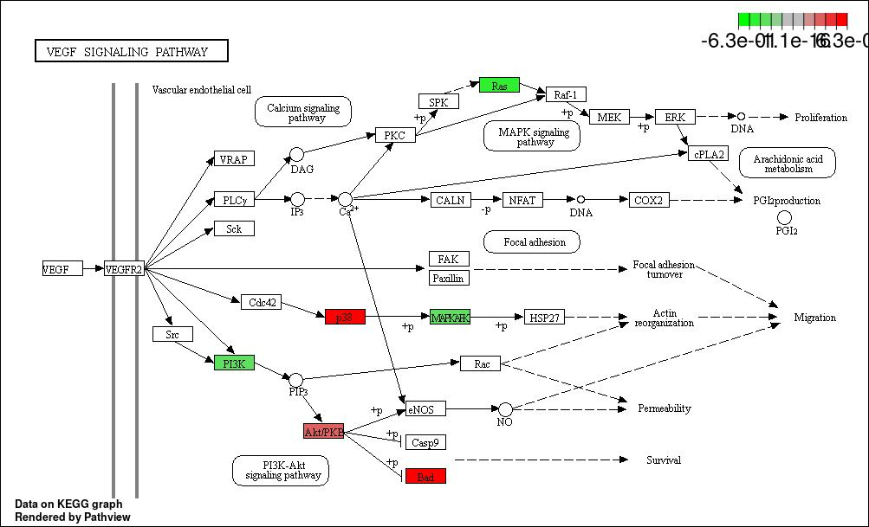
Fig. S2. The VEGF signaling pathway (www.kegg.jp/kegg/kegg1.html).

