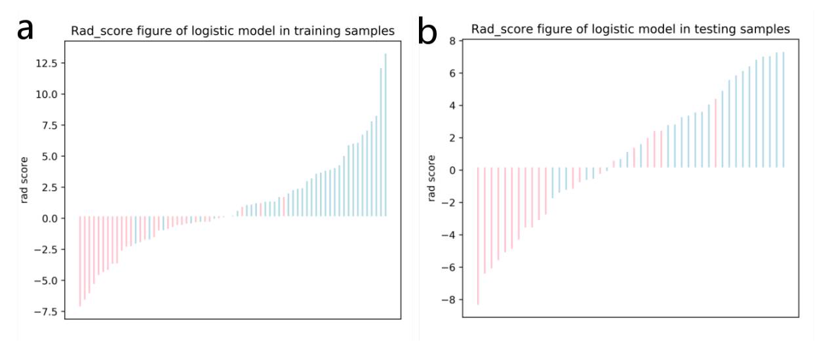

Figure S1. The Rad-score for each patient in the training (a) and testing (b) sets.

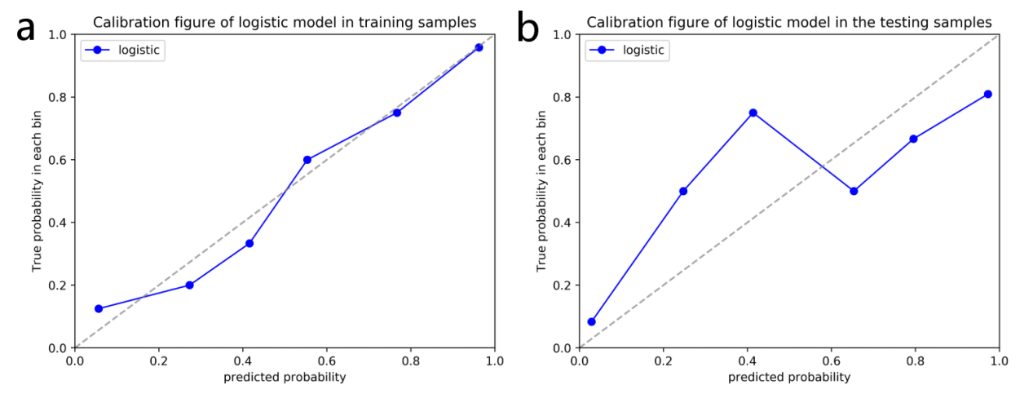

Figure S2. Radiomics nomogram calibration curves for the training (a) and testing (b) sets. The calibration curves show a good fit for the nomogram. The 45° straight lines indicated a perfect match between the true (Y-axis) and predicted (X-axis) probabilities. The closer the distance between the two curves, the better accuracy.

Figure S3. Heatmap and cluster analysis of immunohistochemistry with Rad-score.

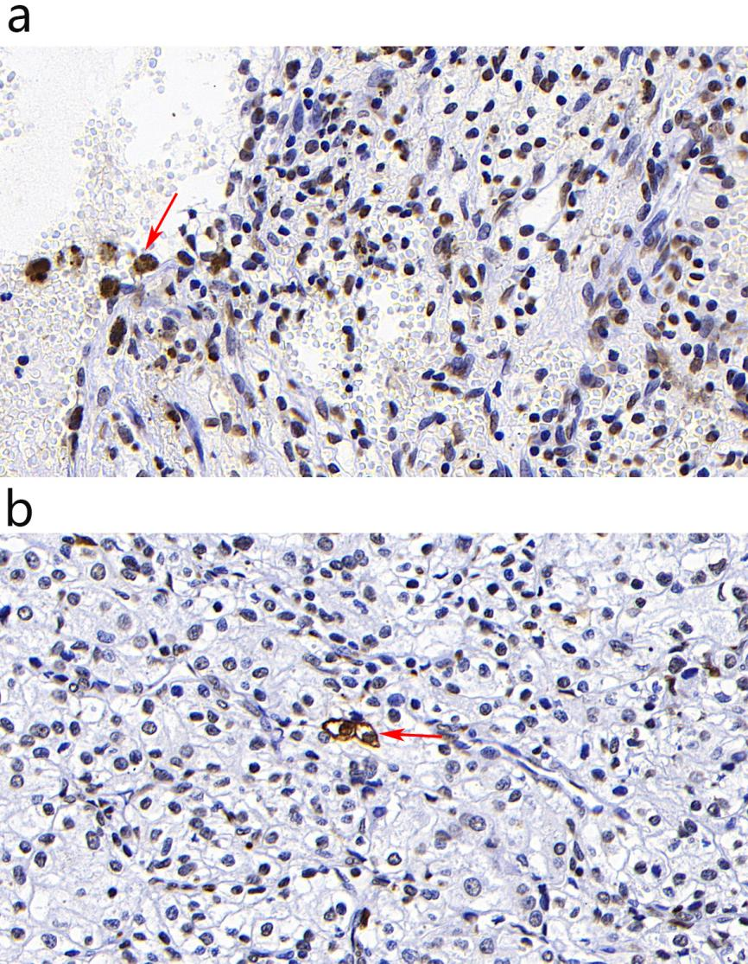
Figure S4. TUNEL assays were conducted on both low-grade and high-grade ccRCC samples: a) one patient with ccRCC graded as grade I by WHO/ISUP. b) one patient with ccRCC graded as grade IV by WHO/ISUP. The red arrows highlight apoptotic cells.

