Supplementary Table S1. Sequences of siRNAs
Name | Sense (5'-3') | Antisense (5'-3')
siRNA1 (MAPK1-Homo-355) | GUGCUCUGCUUAUGAUAAUTT | AUUAUCAUAAGCAGAGCACTT
siRNA2 (MAPK1-Homo-513) | CACCAACCAUCGAGCAAAUTT | AUUUGCUCGAUGGUUGGUGTT
siRNA3 (MAPK1-Homo-714) | CCACCUGUGAUCUCAAGAUTT | AUCUUGAGAUCACAGGUGGTT
Non-targeting control siRNA | UUCUCCGAACGUGUCACGU | ACGUGACACGUUCGGAGAA

Supplementary Table S2. Primer sequences for RT-PCR
Gene | Primer | Sequence
MAPK1 | Forward (5'-3') | ATTACGACCCGAGTGACGAG
MAPK1 | Reverse (3'-5') | CCTGGCTGGAATCTAGCAGT
GAPDH | Forward (5'-3') | GGTCGGAGTCAACGGATTTG
GAPDH | Reverse (3'-5') | GGAAGATGGTGATGGGATTTC

Supplementary Table S3. Quality control for RNA-Seq
SampleID | raw_total | clean_total | ratio_total | raw_base | clean_base | ratio_base | uniqtag | Q20 | Q30 | GC | DUP
NC_1 | 55228412 | 52367713 | 94.82% | 8.284G | 7.149G | 86.29% | 11527377(43.21%) | 98.64 | 95.89 | 50% | 25.87%
NC_2 | 97905030 | 92768241 | 94.75% | 14.686G | 12.631G | 86.01% | 19236797(40.52%) | 98.65 | 95.88 | 50% | 23.31%
NC_3 | 86326418 | 82279012 | 95.31% | 12.949G | 11.121G | 85.88% | 16515867(39.44%) | 98.68 | 95.95 | 51% | 21.97%
siMAPK1_1 | 86590388 | 81335742 | 93.93% | 12.989G | 11.027G | 84.90% | 17187360(40.98%) | 98.66 | 95.88 | 50% | 23.22%
siMAPK1_2 | 81914208 | 77772093 | 94.94% | 12.287G | 10.915G | 88.83% | 14815882(37.37%) | 98.69 | 95.95 | 51% | 22.76%
siMAPK1_3 | 121937672 | 115769384 | 94.94% | 18.291G | 15.531G | 84.91% | 24030579(40.66%) | 98.68 | 95.95 | 50% | 21.33%

Supplementary Table S4. Differentially expressed genes between MAPK1-knockdown cells and non-targeting control cells
Gene Symbol | Chr | baseMean | log₂FC | log₂FCSE | stat | pvalue | padj | NC_1 | NC_2 | NC_3 |  | siMAPK1_1 | siMAPK1_2 | siMAPK1_3
SRPK3 | chrX | 4.88 | 3.70 | 1.33 | 2.79 | 5.31E-03 | 1.00E+00 | 0.00 | 0.01 | 0.00 | 0.06 |  | 0.07 | 0.04
AMELX | chrX | 4.45 | 3.56 | 1.38 | 2.59 | 9.65E-03 | 1.00E+00 | 0.00 | 0.06 | 0.00 | 0.18 |  | 0.53 | 0.20
SNORD17 | chr20 | 21.44 | 1.64 | 0.55 | 2.95 | 3.13E-03 | 1.00E+00 | 1.21 | 1.48 | 1.27 | 1.56 |  | 7.26 | 3.87
CTB-52I2.4 | chr19 | 12.84 | 1.62 | 0.61 | 2.64 | 8.34E-03 | 1.00E+00 | 0.06 | 0.12 | 0.14 | 0.35 |  | 0.39 | 0.30
TMEM202-AS1 | chr15 | 26.00 | 1.58 | 0.44 | 3.57 | 3.57E-04 | 1.00E+00 | 0.11 | 0.20 | 0.12 | 0.49 |  | 0.49 | 0.35
MYH16 | chr7 | 19.05 | 1.33 | 0.51 | 2.58 | 9.98E-03 | 1.00E+00 | 0.06 | 0.07 | 0.02 | 0.16 |  | 0.12 | 0.13
ETV7 | chr6 | 32.29 | 1.13 | 0.38 | 3.01 | 2.59E-03 | 1.00E+00 | 0.28 | 0.20 | 0.29 | 0.60 |  | 0.55 | 0.57
ACTG2 | chr2 | 221.46 | 1.03 | 0.16 | 6.26 | 3.80E-10 | 6.36E-08 | 1.04 | 1.04 | 1.39 | 2.56 |  | 2.14 | 2.50
PPP1R36 | chr14 | 44.70 | 0.89 | 0.33 | 2.71 | 6.66E-03 | 1.00E+00 | 0.44 | 0.25 | 0.26 | 0.57 |  | 0.55 | 0.60
GANAB | chr11 | 12370.19 | 0.83 | 0.05 | 16.24 | 2.84E-59 | 7.86E-56 | 51.27 | 54.91 | 54.88 | 96.29 |  | 96.63 | 97.56
HABP4 | chr9 | 1668.07 | 0.80 | 0.07 | 11.02 | 3.06E-28 | 4.24E-25 | 9.40 | 8.89 | 8.89 | 15.72 |  | 15.08 | 16.95
TPM4 | chr19 | 27481.92 | 0.79 | 0.05 | 16.36 | 3.62E-60 | 1.33E-56 | 49.46 | 49.43 | 49.11 | 89.22 |  | 83.67 | 86.81
CTD-3148I10.9 | chr19 | 49.40 | 0.78 | 0.30 | 2.60 | 9.23E-03 | 1.00E+00 | 1.63 | 1.80 | 1.48 | 2.64 |  | 2.65 | 3.25
ZNF345 | chr19 | 60.31 | 0.77 | 0.28 | 2.77 | 5.53E-03 | 1.00E+00 | 0.34 | 0.28 | 0.24 | 0.52 |  | 0.42 | 0.53
ODAM | chr4 | 452.54 | 0.75 | 0.12 | 6.13 | 8.96E-10 | 1.32E-07 | 6.97 | 5.39 | 6.56 | 10.67 |  | 9.83 | 11.51
OGFR | chr20 | 4589.47 | 0.72 | 0.07 | 9.72 | 2.38E-22 | 2.40E-19 | 20.62 | 22.71 | 23.69 | 33.47 |  | 39.94 | 38.76
MEX3D | chr19 | 843.20 | 0.71 | 0.09 | 7.97 | 1.60E-15 | 7.07E-13 | 5.79 | 6.84 | 6.02 | 10.63 |  | 10.24 | 10.19
CHST14 | chr15 | 739.86 | 0.68 | 0.09 | 7.44 | 1.01E-13 | 3.40E-11 | 8.12 | 7.79 | 7.92 | 12.58 |  | 13.73 | 12.30
FGD3 | chr9 | 368.00 | 0.66 | 0.12 | 5.33 | 9.76E-08 | 8.64E-06 | 1.37 | 1.45 | 1.62 | 2.25 |  | 2.61 | 2.31
UPK3B | chr7 | 254.07 | 0.65 | 0.17 | 3.92 | 8.70E-05 | 2.53E-03 | 2.00 | 2.14 | 2.82 | 3.52 |  | 4.44 | 3.26
PAGE4 | chrX | 151.86 | 0.64 | 0.21 | 3.10 | 1.94E-03 | 2.90E-02 | 2.08 | 1.31 | 1.48 | 2.11 |  | 2.35 | 3.11
KLF2 | chr19 | 537.95 | 0.64 | 0.11 | 5.66 | 1.52E-08 | 1.60E-06 | 5.31 | 4.03 | 4.31 | 6.78 |  | 7.48 | 7.11
LINC01996 | chr17 | 195.84 | 0.64 | 0.16 | 3.86 | 1.13E-04 | 3.09E-03 | 3.66 | 3.14 | 4.18 | 5.58 |  | 5.46 | 6.21
XXbac-BPG181B23.9 | chr6 | 132.16 | 0.63 | 0.19 | 3.26 | 1.11E-03 | 1.87E-02 | 4.33 | 6.59 | 5.94 | 8.88 |  | 8.75 | 9.30
THAP7-AS1 | chr22 | 100.68 | 0.63 | 0.23 | 2.76 | 5.79E-03 | 1.00E+00 | 0.67 | 0.79 | 0.87 | 1.41 |  | 0.94 | 1.34
LMTK3 | chr19 | 797.65 | 0.63 | 0.10 | 6.16 | 7.23E-10 | 1.08E-07 | 2.91 | 3.27 | 3.09 | 4.36 |  | 5.62 | 4.67
FGG | chr4 | 151.25 | 0.63 | 0.17 | 3.60 | 3.24E-04 | 7.06E-03 | 0.96 | 1.12 | 0.92 | 1.54 |  | 1.56 | 1.62
TUBA5P | chr1 | 119.69 | 0.62 | 0.21 | 2.99 | 2.79E-03 | 1.00E+00 | 0.75 | 1.13 | 1.00 | 1.34 |  | 1.67 | 1.54
ZNF488 | chr10 | 167.89 | 0.61 | 0.17 | 3.65 | 2.58E-04 | 5.88E-03 | 1.13 | 1.23 | 1.07 | 1.91 |  | 1.79 | 1.64
PALM3 | chr19 | 197.90 | 0.59 | 0.16 | 3.62 | 3.00E-04 | 6.63E-03 | 1.70 | 1.50 | 1.95 | 2.39 |  | 2.79 | 2.67
CEL | chr9 | 268.89 | 0.59 | 0.14 | 4.09 | 4.32E-05 | 1.40E-03 | 2.50 | 2.91 | 2.78 | 3.60 |  | 4.71 | 4.23
LINC02747 | chr11 | 429.41 | -0.59 | 0.12 | -5.06 | 4.19E-07 | 3.09E-05 | 7.06 | 5.83 | 6.56 | 4.52 |  | 4.39 | 4.20
PADI1 | chr1 | 2864.19 | -0.59 | 0.07 | -7.94 | 2.05E-15 | 8.75E-13 | 18.89 | 22.66 | 22.21 | 14.18 |  | 14.94 | 13.99
KRT7 | chr12 | 335.32 | -0.59 | 0.14 | -4.35 | 1.39E-05 | 5.73E-04 | 2.87 | 2.81 | 3.47 | 2.02 |  | 2.29 | 1.88
CCND1 | chr11 | 30300.37 | -0.59 | 0.04 | -13.19 | 9.97E-40 | 2.21E-36 | 231.38 | 238.24 | 226.35 | 153.32 |  | 159.66 | 155.77
SNRK | chr3 | 226.69 | -0.59 | 0.17 | -3.45 | 5.52E-04 | 1.09E-02 | 1.21 | 1.45 | 0.90 | 0.87 |  | 0.74 | 0.78
STARD4 | chr5 | 126.18 | -0.60 | 0.22 | -2.73 | 6.33E-03 | 6.88E-02 | 1.06 | 0.77 | 0.62 | 0.64 |  | 0.49 | 0.48
ASAP2 | chr2 | 1071.68 | -0.60 | 0.10 | -6.08 | 1.19E-09 | 1.69E-07 | 5.67 | 6.05 | 4.49 | 3.79 |  | 3.57 | 3.48
SWSAP1 | chr19 | 114.29 | -0.60 | 0.22 | -2.72 | 6.57E-03 | 1.00E+00 | 2.03 | 2.30 | 2.98 | 1.53 |  | 2.00 | 1.42
FAXDC2 | chr5 | 97.43 | -0.60 | 0.23 | -2.60 | 9.43E-03 | 1.00E+00 | 0.52 | 0.53 | 0.49 | 0.44 |  | 0.34 | 0.26
VDR | chr12 | 94.53 | -0.61 | 0.21 | -2.84 | 4.57E-03 | 1.00E+00 | 0.57 | 0.63 | 0.62 | 0.43 |  | 0.39 | 0.40
NFATC2 | chr20 | 263.53 | -0.61 | 0.14 | -4.47 | 7.98E-06 | 3.59E-04 | 1.07 | 1.30 | 1.12 | 0.78 |  | 0.76 | 0.79
UGCG | chr9 | 609.77 | -0.61 | 0.12 | -4.92 | 8.68E-07 | 5.58E-05 | 5.38 | 5.51 | 3.83 | 3.56 |  | 3.07 | 3.10
MIGA1 | chr1 | 206.51 | -0.61 | 0.16 | -3.84 | 1.22E-04 | 3.25E-03 | 0.83 | 0.74 | 0.68 | 0.41 |  | 0.54 | 0.53
AC006262.6 | chr19 | 248.93 | -0.63 | 0.14 | -4.38 | 1.18E-05 | 5.02E-04 | 1.24 | 1.21 | 1.39 | 0.83 |  | 0.93 | 0.78
MAL2 | chr8 | 13516.56 | -0.63 | 0.07 | -8.79 | 1.49E-18 | 1.10E-15 | 150.05 | 157.75 | 126.94 | 101.58 |  | 93.08 | 90.30
LGALS7B | chr19 | 110.15 | -0.63 | 0.24 | -2.65 | 8.00E-03 | 1.00E+00 | 4.51 | 5.45 | 8.42 | 3.63 |  | 4.06 | 4.43
TNFAIP3 | chr6 | 313.68 | -0.63 | 0.12 | -5.07 | 3.93E-07 | 2.92E-05 | 2.43 | 2.23 | 2.24 | 1.58 |  | 1.48 | 1.45
UHMK1 | chr1 | 1203.86 | -0.64 | 0.19 | -3.36 | 7.85E-04 | 1.42E-02 | 5.47 | 5.41 | 3.56 | 3.18 |  | 3.05 | 3.17
TRNP1 | chr1 | 1141.94 | -0.64 | 0.08 | -8.50 | 1.97E-17 | 1.15E-14 | 21.67 | 21.68 | 20.60 | 13.96 |  | 13.36 | 14.32
SLC41A1 | chr1 | 1857.33 | -0.64 | 0.06 | -9.96 | 2.22E-23 | 2.46E-20 | 10.61 | 10.80 | 10.85 | 7.05 |  | 6.92 | 7.04
ZNF10 | chr12 | 110.26 | -0.65 | 0.22 | -2.93 | 3.39E-03 | 1.00E+00 | 0.82 | 0.72 | 0.68 | 0.52 |  | 0.34 | 0.56
GASAL1 | chr8 | 79.58 | -0.65 | 0.25 | -2.63 | 8.53E-03 | 1.00E+00 | 0.78 | 1.11 | 0.91 | 0.72 |  | 0.54 | 0.57
CDA | chr1 | 92.40 | -0.65 | 0.23 | -2.87 | 4.08E-03 | 1.00E+00 | 3.86 | 4.22 | 4.46 | 2.10 |  | 2.88 | 3.10
MSMO1 | chr4 | 2618.05 | -0.65 | 0.18 | -3.72 | 2.00E-04 | 4.77E-03 | 39.01 | 36.06 | 27.22 | 24.59 |  | 21.88 | 19.31
TMEM267 | chr5 | 128.74 | -0.66 | 0.24 | -2.72 | 6.48E-03 | 7.01E-02 | 1.37 | 2.06 | 1.10 | 1.17 |  | 1.05 | 0.72
EXPH5 | chr11 | 224.65 | -0.67 | 0.17 | -3.89 | 9.93E-05 | 2.82E-03 | 0.96 | 0.65 | 0.68 | 0.49 |  | 0.54 | 0.42
KRT6A | chr12 | 7677.48 | -0.67 | 0.08 | -8.26 | 1.50E-16 | 8.02E-14 | 90.69 | 103.86 | 98.32 | 68.98 |  | 64.21 | 53.91
KDM1B | chr6 | 177.63 | -0.67 | 0.17 | -3.91 | 9.34E-05 | 2.69E-03 | 1.43 | 1.12 | 1.01 | 0.73 |  | 0.74 | 0.77
SYTL4 | chrX | 508.28 | -0.67 | 0.10 | -6.49 | 8.71E-11 | 1.72E-08 | 2.72 | 2.63 | 2.31 | 1.59 |  | 1.65 | 1.62
GPRC5B | chr16 | 378.35 | -0.68 | 0.11 | -6.03 | 1.68E-09 | 2.27E-07 | 2.09 | 2.13 | 2.15 | 1.37 |  | 1.31 | 1.35
MITF | chr3 | 96.93 | -0.69 | 0.22 | -3.10 | 1.93E-03 | 1.00E+00 | 0.58 | 0.55 | 0.40 | 0.30 |  | 0.35 | 0.31
ABAT | chr16 | 466.92 | -0.71 | 0.11 | -6.25 | 4.20E-10 | 6.84E-08 | 2.04 | 1.64 | 1.76 | 1.16 |  | 1.08 | 1.11
CFL2 | chr14 | 679.70 | -0.72 | 0.10 | -6.88 | 6.12E-12 | 1.50E-09 | 5.72 | 5.47 | 4.39 | 3.30 |  | 3.13 | 3.16
BIRC3 | chr11 | 646.68 | -0.72 | 0.10 | -7.09 | 1.30E-12 | 3.60E-10 | 3.65 | 3.19 | 2.92 | 1.98 |  | 2.09 | 1.92
NDUFC2 | chr11 | 306.80 | -0.73 | 0.15 | -4.94 | 7.67E-07 | 5.03E-05 | 5.79 | 5.50 | 3.90 | 3.26 |  | 2.92 | 3.04
RP11-680H20.2 | chr11 | 57.04 | -0.73 | 0.28 | -2.60 | 9.31E-03 | 1.00E+00 | 0.46 | 0.39 | 0.36 | 0.30 |  | 0.22 | 0.22
ITGA2 | chr5 | 1749.48 | -0.74 | 0.08 | -9.34 | 9.54E-21 | 8.80E-18 | 8.53 | 9.27 | 7.45 | 5.01 |  | 5.34 | 4.96
IL6ST | chr5 | 384.60 | -0.75 | 0.15 | -5.09 | 3.67E-07 | 2.74E-05 | 1.54 | 1.72 | 1.08 | 0.94 |  | 0.83 | 0.85
PKIB | chr6 | 84.94 | -0.75 | 0.27 | -2.74 | 6.18E-03 | 1.00E+00 | 0.98 | 1.08 | 0.76 | 0.76 |  | 0.59 | 0.36
KRT13 | chr17 | 5823.38 | -0.76 | 0.06 | -12.31 | 7.67E-35 | 1.41E-31 | 75.56 | 72.65 | 80.35 | 44.58 |  | 47.73 | 44.68
NCEH1 | chr3 | 683.96 | -0.76 | 0.09 | -8.10 | 5.51E-16 | 2.77E-13 | 5.49 | 5.80 | 5.00 | 3.34 |  | 3.30 | 3.10
EMP3 | chr19 | 1335.01 | -0.78 | 0.09 | -9.01 | 2.09E-19 | 1.66E-16 | 32.26 | 29.06 | 32.04 | 16.61 |  | 20.47 | 17.99
C15orf62 | chr15 | 54.38 | -0.80 | 0.30 | -2.66 | 7.78E-03 | 1.00E+00 | 0.97 | 0.68 | 0.89 | 0.41 |  | 0.63 | 0.44
CYB5R4 | chr6 | 242.62 | -0.81 | 0.16 | -4.94 | 7.90E-07 | 5.11E-05 | 1.03 | 1.05 | 0.84 | 0.70 |  | 0.49 | 0.50
SSC4D | chr7 | 159.21 | -0.81 | 0.17 | -4.82 | 1.46E-06 | 8.31E-05 | 2.35 | 2.16 | 2.06 | 1.19 |  | 1.25 | 1.32
RP11-401P9.7 | chr16 | 70.84 | -0.83 | 0.26 | -3.12 | 1.80E-03 | 1.00E+00 | 0.97 | 0.83 | 0.66 | 0.42 |  | 0.58 | 0.40
CCK | chr3 | 64.92 | -0.84 | 0.29 | -2.93 | 3.38E-03 | 1.00E+00 | 1.26 | 1.26 | 1.16 | 0.46 |  | 0.99 | 0.64
PDE5A | chr4 | 86.66 | -0.86 | 0.23 | -3.70 | 2.14E-04 | 1.00E+00 | 0.40 | 0.37 | 0.30 | 0.22 |  | 0.17 | 0.20
NPIPB3 | chr16 | 262.63 | -0.87 | 0.16 | -5.33 | 9.94E-08 | 8.73E-06 | 2.17 | 2.21 | 2.17 | 0.91 |  | 1.55 | 1.18
STEAP1 | chr7 | 42.58 | -0.88 | 0.32 | -2.73 | 6.31E-03 | 1.00E+00 | 0.99 | 1.09 | 1.15 | 0.56 |  | 0.72 | 0.53
XKR9 | chr8 | 95.98 | -0.89 | 0.24 | -3.71 | 2.06E-04 | 1.00E+00 | 1.10 | 1.04 | 0.75 | 0.61 |  | 0.57 | 0.41
GNE | chr9 | 63.56 | -0.91 | 0.28 | -3.28 | 1.03E-03 | 1.00E+00 | 0.52 | 0.36 | 0.42 | 0.18 |  | 0.26 | 0.26
SELENOT | chr3 | 2097.68 | -0.92 | 0.08 | -12.09 | 1.26E-33 | 2.00E-30 | 20.97 | 21.07 | 18.36 | 11.65 |  | 10.06 | 10.69
KRT81 | chr12 | 737.38 | -0.92 | 0.12 | -7.79 | 6.60E-15 | 2.44E-12 | 12.41 | 16.24 | 16.72 | 8.76 |  | 8.53 | 7.19
HIPK3 | chr11 | 265.18 | -0.93 | 0.17 | -5.57 | 2.59E-08 | 2.63E-06 | 1.66 | 1.23 | 1.00 | 0.71 |  | 0.64 | 0.71
DMRT1 | chr9 | 38.45 | -0.93 | 0.33 | -2.78 | 5.38E-03 | 1.00E+00 | 0.50 | 0.45 | 0.46 | 0.26 |  | 0.22 | 0.28
TMEM156 | chr4 | 159.21 | -0.96 | 0.17 | -5.55 | 2.90E-08 | 2.84E-06 | 2.34 | 2.51 | 2.59 | 1.42 |  | 1.33 | 1.16
S100A3 | chr1 | 41.70 | -0.97 | 0.32 | -3.01 | 2.64E-03 | 1.00E+00 | 2.00 | 2.06 | 1.94 | 0.95 |  | 0.91 | 1.22
BCAS1 | chr20 | 34.23 | -0.98 | 0.37 | -2.63 | 8.55E-03 | 1.00E+00 | 0.12 | 0.17 | 0.21 | 0.07 |  | 0.11 | 0.09
KLK14 | chr19 | 370.10 | -0.98 | 0.12 | -8.03 | 9.84E-16 | 4.74E-13 | 12.14 | 12.24 | 13.10 | 5.99 |  | 7.21 | 6.17
SERPINB2 | chr18 | 565.67 | -1.00 | 0.10 | -10.20 | 1.91E-24 | 2.34E-21 | 8.10 | 8.49 | 8.40 | 4.37 |  | 4.26 | 4.10
KLK5 | chr19 | 148.67 | -1.01 | 0.19 | -5.18 | 2.17E-07 | 1.78E-05 | 2.84 | 4.01 | 4.02 | 1.80 |  | 2.12 | 1.64
IGFL1 | chr19 | 83.92 | -1.05 | 0.23 | -4.47 | 7.90E-06 | 1.00E+00 | 4.19 | 4.10 | 4.89 | 2.25 |  | 2.33 | 1.93
UBD | chr6 | 125.91 | -1.06 | 0.21 | -4.99 | 5.93E-07 | 4.12E-05 | 5.90 | 4.69 | 6.76 | 2.99 |  | 2.25 | 3.13
CXCL8 | chr4 | 164.97 | -1.10 | 0.20 | -5.46 | 4.85E-08 | 4.55E-06 | 3.41 | 3.61 | 2.14 | 1.63 |  | 1.40 | 1.30
CTD-2020K17.3 | chr17 | 32.28 | -1.24 | 0.40 | -3.12 | 1.82E-03 | 1.00E+00 | 0.82 | 0.58 | 0.42 | 0.17 |  | 0.28 | 0.31
CCL22 | chr16 | 82.58 | -1.29 | 0.24 | -5.32 | 1.06E-07 | 1.00E+00 | 1.40 | 1.19 | 1.09 | 0.41 |  | 0.51 | 0.58
MYH15 | chr3 | 34.78 | -1.30 | 0.36 | -3.59 | 3.33E-04 | 1.00E+00 | 0.18 | 0.19 | 0.22 | 0.07 |  | 0.07 | 0.10
ITGAX | chr16 | 43.13 | -1.31 | 0.34 | -3.84 | 1.24E-04 | 1.00E+00 | 0.27 | 0.34 | 0.18 | 0.10 |  | 0.12 | 0.10
TNFRSF9 | chr1 | 46.45 | -1.37 | 0.33 | -4.13 | 3.69E-05 | 1.00E+00 | 0.31 | 0.29 | 0.36 | 0.16 |  | 0.08 | 0.13
ADAMTS14 | chr10 | 1681.99 | -1.38 | 0.07 | -18.94 | 4.88E-80 | 2.70E-76 | 12.87 | 13.49 | 13.32 | 5.02 |  | 5.57 | 4.92
CAVIN4 | chr9 | 17.64 | -1.47 | 0.55 | -2.69 | 7.15E-03 | 1.00E+00 | 0.31 | 0.31 | 0.15 | 0.07 |  | 0.06 | 0.14
RN7SL368P | chr19 | 15.00 | -1.54 | 0.58 | -2.66 | 7.91E-03 | 1.00E+00 | 3.64 | 1.95 | 1.74 | 1.00 |  | 1.04 | 0.53
MAPK1 | chr22 | 1836.48 | -1.69 | 0.07 | -24.67 | 2.39E-134 | 2.64E-130 | 14.18 | 14.16 | 12.96 | 4.36 |  | 4.39 | 4.23
RP11-75C10.6 | chr17 | 11.02 | -1.84 | 0.68 | -2.72 | 6.60E-03 | 1.00E+00 | 0.18 | 0.29 | 0.17 | 0.10 |  | 0.05 | 0.03
DENND2C | chr1 | 12.59 | -2.59 | 0.70 | -3.69 | 2.20E-04 | 1.00E+00 | 0.11 | 0.05 | 0.11 | 0.01 |  | 0.00 | 0.03
RP11-226M10.3 | chr17 | 8.53 | -2.66 | 0.84 | -3.16 | 1.57E-03 | 1.00E+00 | 0.19 | 0.29 | 0.17 | 0.07 |  | 0.00 | 0.03
LINC02404 | chr12 | 5.71 | -3.04 | 1.07 | -2.84 | 4.49E-03 | 1.00E+00 | 0.16 | 0.26 | 0.18 | 0.06 |  | 0.02 | 0.00
ORM2 | chr9 | 9.11 | -3.64 | 0.94 | -3.86 | 1.12E-04 | 1.00E+00 | 0.32 | 0.68 | 1.03 | 0.00 |  | 0.04 | 0.11
CDKN2B-AS1 | chr9 | 3.39 | -4.30 | 1.57 | -2.74 | 6.09E-03 | 1.00E+00 | 0.02 | 0.01 | 0.00 | 0.00 |  | 0.00 | 0.00

Supplementary Table S5. Quality control for ChIP-Seq
SampleID | raw_total | clean_total | ratio_total | raw_base | clean_base | ratio_base | uniqtag | Q20 | Q30 | GC | DUP
Input_1 | 45029406 | 44074281 | 97.88% | 6.754G | 6.418G | 95.02% | 17677661(79.91%) | 98.5 | 95.52 | 47% | 79.51%
Input_2 | 78943264 | 77463967 | 98.13% | 11.841G | 11.255G | 95.05% | 29999627(77.20%) | 98.55 | 95.53 | 41% | 77.86%
MAPK_IP_1 | 56886356 | 55083651 | 96.83% | 8.533G | 8.047G | 94.30% | 21844997(78.87%) | 98.56 | 95.51 | 43% | 79.76%
MAPK_IP_2 | 41595396 | 40785543 | 98.05% | 6.239G | 5.954G | 95.43% | 16181229(78.96%) | 98.57 | 95.55 | 43% | 80.03%

Supplementary Table S6. Homer de novo Motif Results
Rank | Motif | P-value | log P-value | % of Targets | % of Background | STD  (BgSTD) | Best Match/Details
1 | 5'-AGGCAATTAA-3' | 1e-1045 | -2.41E+03 | 55.65% | 43.00% | 102.9bp (160.4bp) | Hmx1/MA0896.1/Jaspar(0.821)
2 | 5'-TTA[C/G]C-3' | 1e-1038 | -2.39E+03 | 71.72% | 59.65% | 102.2bp (169.4bp) | REB1/MA0363.1/Jaspar(0.848)
3 | 5'-TGG[C/T]TTC[C/T]-3' | 1e-905 | -2.09E+03 | 49.60% | 37.94% | 104.3bp (168.7bp) | GCR1/MA0304.1/Jaspar(0.770)
4 | 5'-[T/C]TT[T/C]C[T/C]C-3' | 1e-903 | -2.08E+03 | 58.10% | 46.33% | 104.1bp (170.4bp) | PRDM1/MA0508.3/Jaspar(0.853)
5 | 5'-CTA[T/C]CACT-3' | 1e-888 | -2.05E+03 | 67.57% | 56.18% | 102.6bp (163.7bp) | At5g04390(C2H2)/col200-At5g04390-DAP-Seq(GSE60143)/Homer(0.777)
6 | 5'-ATGCATGA-3' | 1e-888 | -2.05E+03 | 58.63% | 46.97% | 103.2bp (167.3bp) | ASD-1(RRM)/Caenorhabditis_elegans-RNCMPT00180-PBM/HughesRNA(0.890)
7 | 5'-[T/A]TGCT[G/C]-3' | 1e-874 | -2.01E+03 | 79.15% | 68.88% | 100.5bp (184.1bp) | POL010.1_DCE_S_III/Jaspar(0.843)
8 | 5'-[G/T]GGCAACA[C/T/G]AG-3' | 1e-806 | -1.86E+03 | 60.02% | 48.93% | 101.1bp (176.6bp) | kni/dmmpmm(Papatsenko)/fly(0.692)
9 | 5'-[G/A/T][G/A/C]A[T/A/C]TTT[G/T/A][G/A/C]-3' | 1e-742 | -1.71E+03 | 68.62% | 58.29% | 102.1bp (164.7bp) | ATHB21(HB)/colamp-ATHB21-DAP-Seq(GSE60143)/Homer(0.639)
10 | 5'-[C/T/A]T[A/T/C][A/C]CT[C/G/T]CTG[G/C]-3' | 1e-717 | -1.65E+03 | 63.21% | 52.83% | 101.3bp (168.2bp) | SRSF2(RRM)/Homo_sapiens-RNCMPT00072-PBM/HughesRNA(0.672)
11 | 5'-CTC[T/A][A/T][G/C/A][C/A]-3' | 1e-651 | -1.50E+03 | 68.72% | 59.07% | 102.6bp (174.8bp) | z/dmmpmm(SeSiMCMC)/fly(0.743)
12 | 5'-T[G/C][C/G]CA[A/T/G]-3' | 1e-639 | -1.47E+03 | 58.49% | 48.60% | 102.1bp (176.9bp) | NFIA/MA0670.1/Jaspar(0.968)
13 | 5'-[T/G]T[T/G][C/T]G[T/G/C][T/C]T[T/C/G][T/C][T/C]-3' | 1e-613 | -1.41E+03 | 40.02% | 30.80% | 102.3bp (158.2bp) | VRN1(ABI3VP1)/col-VRN1-DAP-Seq(GSE60143)/Homer(0.788)
14 | 5'-[T/C]C[A/T/C]CA[C/G/T/A]TTC[T/A/C][A/T/G/C]-3' | 1e-595 | -1.37E+03 | 44.35% | 35.04% | 104.6bp (167.2bp) | PU.1-IRF(ETS:IRF)/Bcell-PU.1-ChIP-Seq(GSE21512)/Homer(0.716)
15 | 5'-[A/T]AATG[A/C]-3' | 1e-586 | -1.351E+03 | 54.53% | 44.87% | 105.1bp  (153.8bp) | AT2G31460(REMB3)/col-AT2G31460-  DAP-Seq(GSE60143)/Homer(0.869)
16 | 5'-[T/G]GG[A/T/C/G][A/G]GA[A/T]G[G/T/A]-3' | 1e-563 | -1.30E+03 | 27.35% | 19.58% | 102.8bp (181.0bp) | REF2(RRM)/Drosophila_melanogaster-RNCMPT00059-PBM/HughesRNA(0.701)
17 | 5'-[T/C]AGT[A/T/G/C]CT-3' | 1e-509 | -1.17E+03 | 54.04% | 45.20% | 103.7bp (159.7bp) | SPL11(SBP)/col100-SPL11-DAP-Seq(GSE60143)/Homer(0.788)
18 | 5'-GATCTTG-3' | 1e-508 | -1.17E+03 | 39.17% | 30.80% | 102.0bp (174.1bp) | MATR3(RRM)/Homo_sapiens-RNCMPT00037-PBM/HughesRNA(0.849)
19 | 5'-[C/T/G][C/A]AAACCATAT[T/C/G/A]-3' | 1e-415 | -9.57E+02 | 29.12% | 22.22% | 103.5bp (155.3bp) | HuR(RRM)/Homo_sapiens-RNCMPT00136-PBM/HughesRNA(0.791)
20 | 5'-CATGATCCAATC-3' | 1e-381 | -8.79E+02 | 51.30% | 43.67% | 102.5bp (166.5bp) | AARE(HLH)/mES-cMyc-ChIP-Seq/Homer(0.757)
21 | 5'-GC[G/C][A/C][G/C]A-3' | 1e-368 | -8.49E+02 | 65.31% | 57.98% | 103.0bp (172.9bp) | ZBTB33/MA0527.1/Jaspar(0.781)
22 | 5'-[G/A/T]CA[T/G][C/T]C[T/A]-3' | 1e-338 | -7.80E+02 | 23.59% | 17.82% | 102.7bp (181.9bp) | G3BP2(RRM)/Homo_sapiens-RNCMPT00021-PBM/HughesRNA(0.798)
23 | 5'-[G/C/A]A[G/A][A/T]T[C/T/G]TG[G/A][G/A/T]TG-3' | 1.00E-275 | -6.34E+02 | 4.75% | 2.44% | 99.8bp (177.9bp) | GATA11/MA1014.1/Jaspar(0.670)
24 | 5'-[T/G/A][A/G/T][G/A]TGA[G/A]TGA[G/A]T-3' | 1.00E-260 | -6.01E+02 | 12.13% | 8.37% | 103.1bp (157.5bp) | WUS1(Homeobox)/colamp-WUS1-DAP-Seq(GSE60143)/Homer(0.815)
25 | 5'-CACCATGTGAA-3' | 1.00E-231 | -5.33E+02 | 4.80% | 2.63% | 102.9bp (186.8bp) | INO4/INO4_YPD/4-INO4,37-INO2(Harbison)/Yeast(0.829)
26 | 5'-[C/T]ACA[C/T][A/T/G][C/T][A/T/G]C3' | 1.00E-228 | -5.25E+02 | 11.29% | 7.88% | 102.1bp (166.0bp) | Rbm24(RRM)/Tetraodon_nigroviridis-RNCMPT00285-PBM/HughesRNA(0.846)
27 | 5'-CC[A/T/C][A/T]GTGGA[G/A][C/T]T-3' | 1.00E-133 | -3.07E+02 | 1.19% | 0.44% | 100.2bp (199.4bp) | ZNF354C/MA0130.1/Jaspar(0.693)
28 | 5'-GGGAGGCCTCAG-3' | 1.00E-131 | -3.04E+02 | 2.26% | 1.15% | 100.6bp (185.7bp) | HNRNPH2(RRM)/Homo_sapiens-RNCMPT00160-PBM/HughesRNA(0.649)
29 | 5'-A[T/G/A]TGT[A/T/G]A[G/T]TTTC-3' | 1.00E-109 | -2.52E+02 | 3.84% | 2.46% | 103.9bp (156.1bp) | tll/dmmpmm(Papatsenko)/fly(0.698)

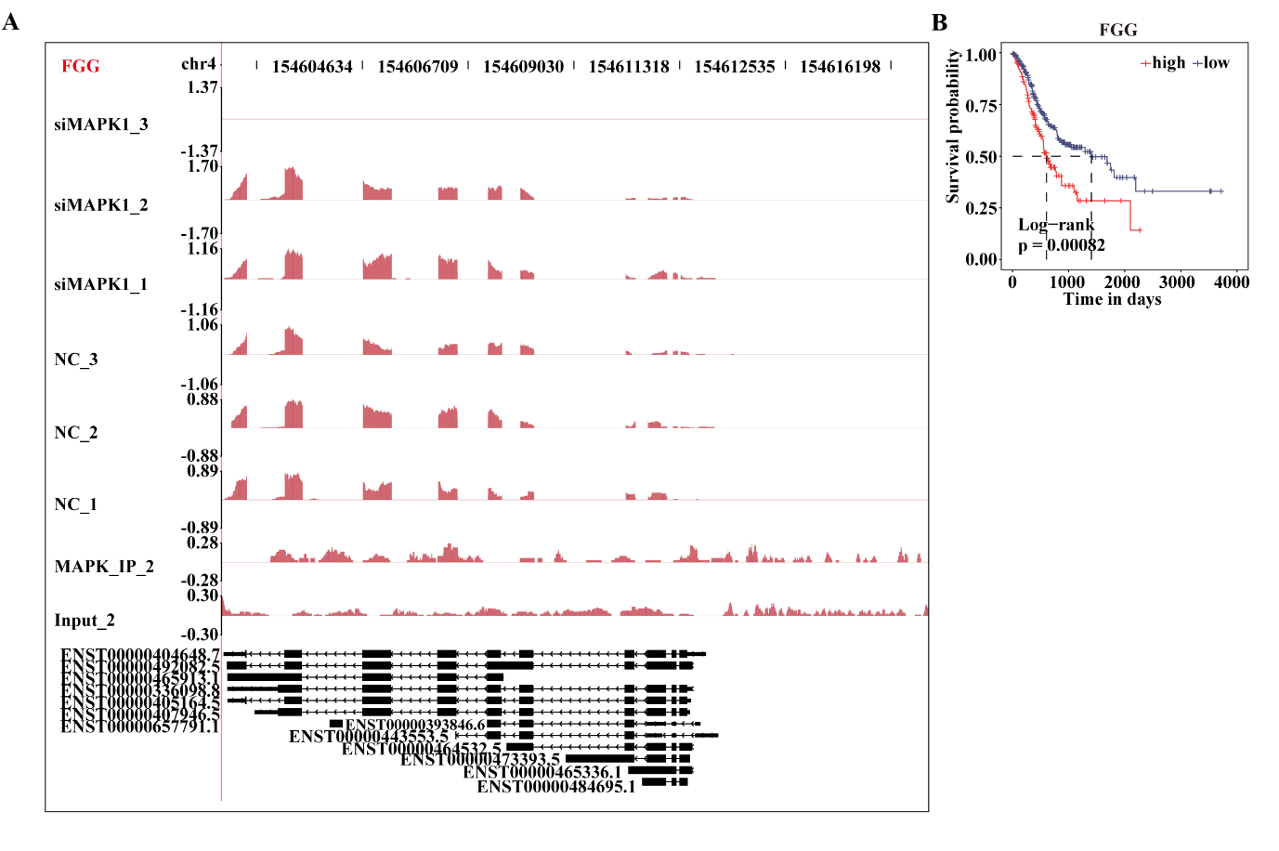
Fig S1. Validation of FGG associated with MAPK1. (A) The peak reads and binding locations throughout the mRNA are shown in the IGV Sashimi Plot. The red sections indicate the peak positions. The transcripts for each gene are shown below, and the read distribution of the bound gene is plotted in the top panel. (B) Prognostic line plots of a few significant genes from the TCGA data on gastric cancer. siMAPK1: short interfering MAPK1; NC: non-targeting control; Input: background noise without undergoing immunoprecipitation.

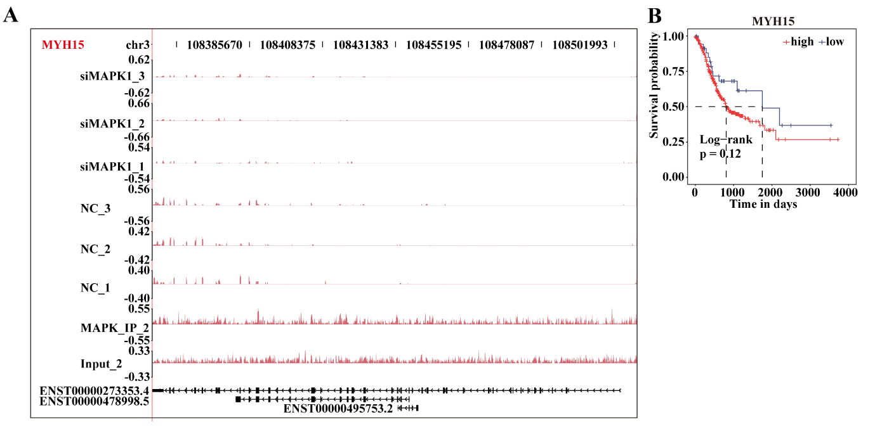
Fig S2. Validation of MYH15 associated with MAPK1. (A) The peak reads and binding locations throughout the mRNA are shown in the IGV Sashimi Plot. The red sections indicate the peak positions. The transcripts for each gene are shown below, and the read distribution of the bound gene is plotted in the top panel. (B) Prognostic line plots of a few significant genes from the TCGA data on gastric cancer. siMAPK1: short interfering MAPK1; NC: non-targeting control; Input: background noise without undergoing immunoprecipitation.

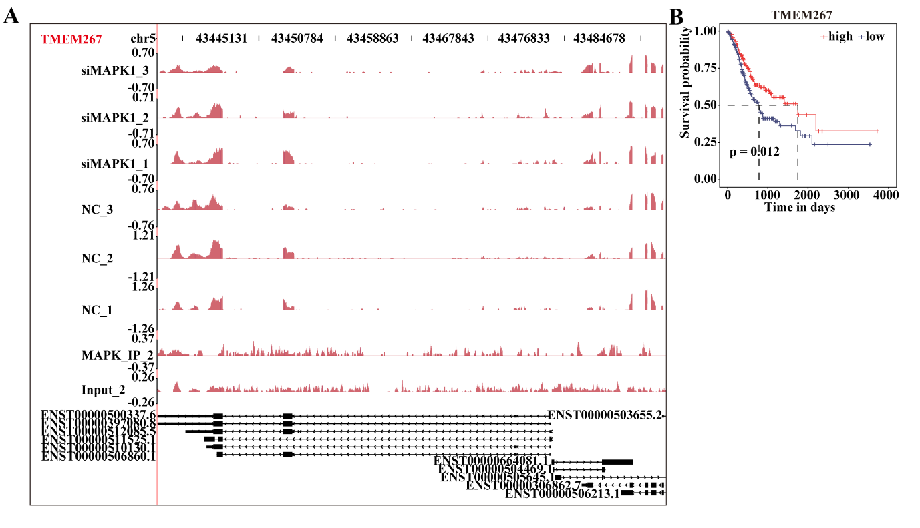
Fig S3. Validation of TMEM267 associated with MAPK1. (A) The peak reads and binding locations throughout the mRNA are shown in the IGV Sashimi Plot. The red sections indicate the peak positions. The transcripts for each gene are shown below, and the read distribution of the bound gene is plotted in the top panel. (B) Prognostic line plots of a few significant genes from the TCGA data on gastric cancer. siMAPK1: short interfering MAPK1; NC: non-targeting control; Input: background noise without undergoing immunoprecipitation.

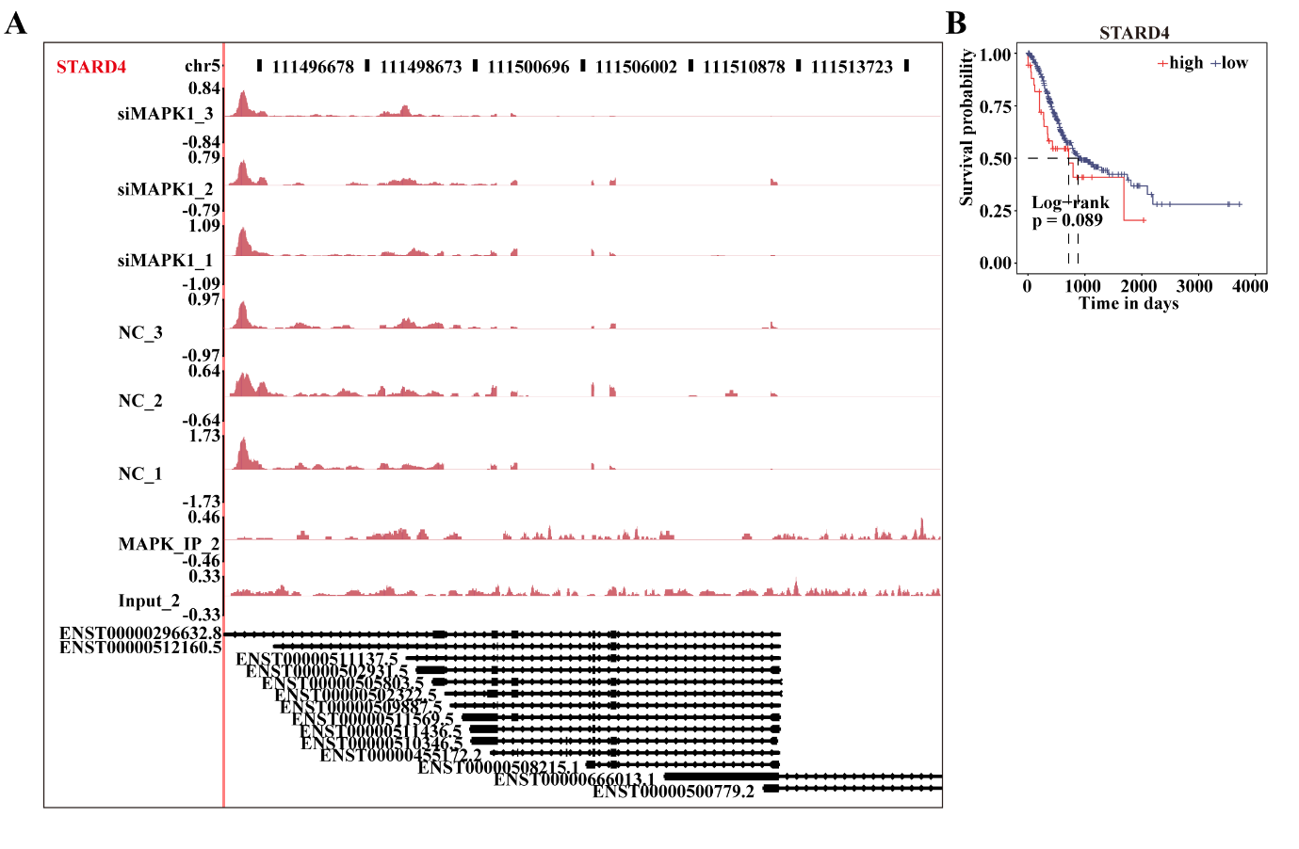
Fig S4. Validation of STARD4 associated with MAPK1. (A) The peak reads and binding locations throughout the mRNA are shown in the IGV Sashimi Plot. The red sections indicate the peak positions. The transcripts for each gene are shown below, and the read distribution of the bound gene is plotted in the top panel. (B) Prognostic line plots of a few significant genes from the TCGA data on gastric cancer. siMAPK1: short interfering MAPK1; NC: non-targeting control; Input: background noise without undergoing immunoprecipitation.

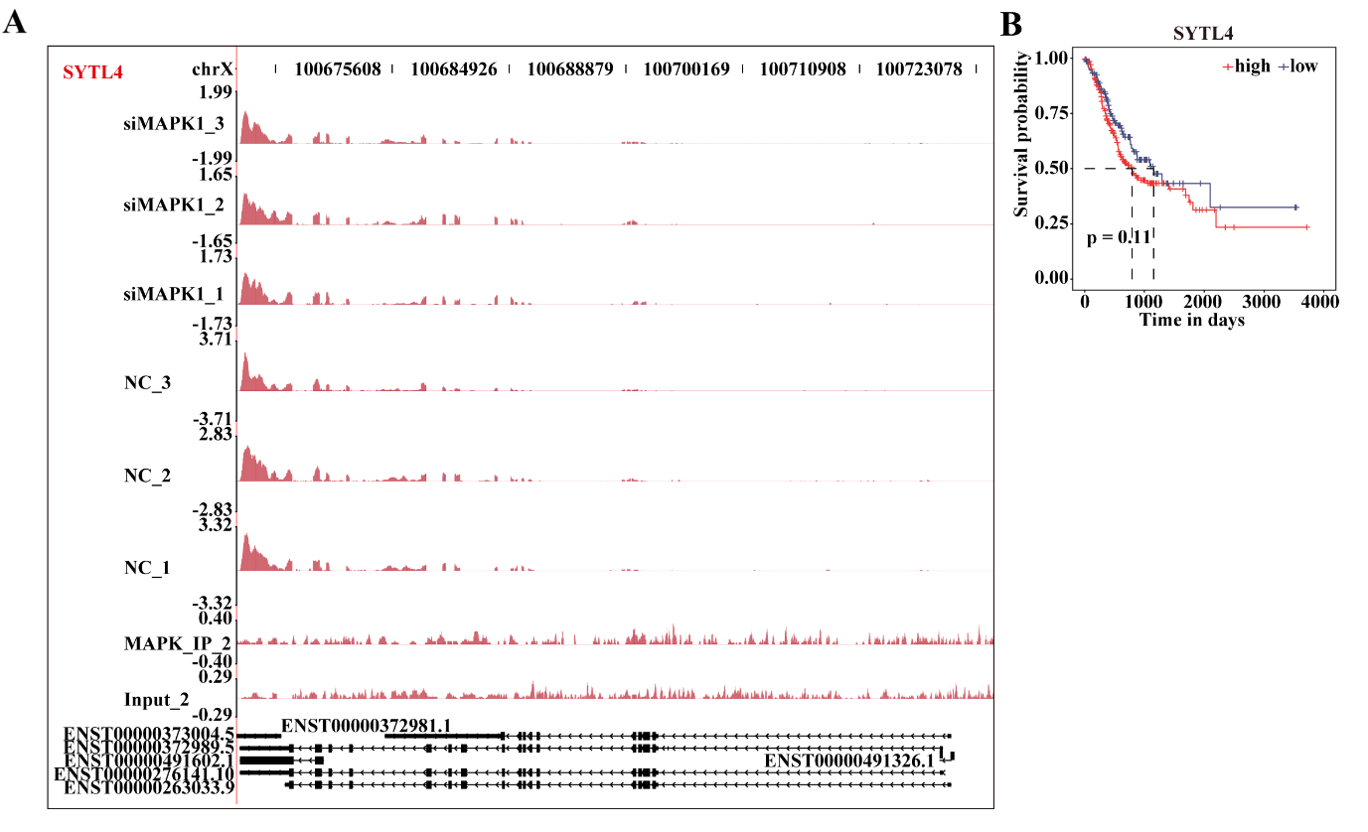
Fig S5. Validation of SYTL4 associated with MAPK1. (A) The peak reads and binding locations throughout the mRNA are shown in the IGV Sashimi Plot. The red sections indicate the peak positions. The transcripts for each gene are shown below, and the read distribution of the bound gene is plotted in the top panel. (B) Prognostic line plots of a few significant genes from the TCGA data on gastric cancer. siMAPK1: short interfering MAPK1; NC: non-targeting control; Input: background noise without undergoing immunoprecipitation.

