Supplementary materials
Figure S1 The mRNA expression of S100P between tumor and adjacent tissues was assessed from TCGA and GTEx databases.
Figure S2 S100P expression in different clinicopathological stages of pancreatic cancer samples from the TCGA-PAAD.
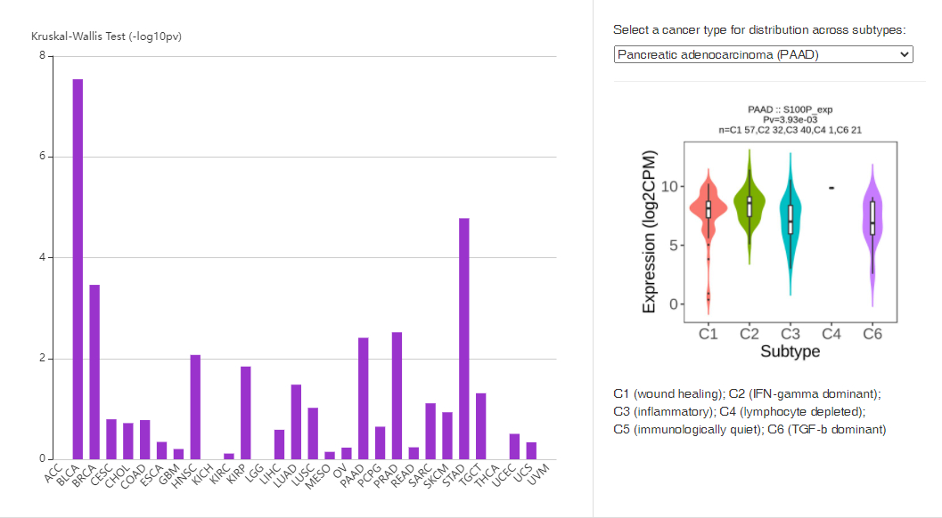
Figure S3 Analysis of immune subtypes was assessed using the E-MTAB-6134 dataset.
Figure S4 The protein expression of S100P in 137 primary pancreatic cancers and 74 adjacent tissues using the UALCAN dataset.

