Supplement
eTable.1 Univariate Cox regression analyses for the complete and post-screening data in SCLC patients
eTable.2 Multivariate Cox regression analyses for the SCLC patients in the training set
eTable.3 TNM staging stratification of patients in the region of the training set
eTable.4 Characteristics of chemotherapy and radiotherapy treatment lines for all SCLC patients
e Figure. 1 Survival curves of chemotherapy and radiotherapy treatment lines for SCLC patients
eTable.5 Characteristics of patients stratified by sex in the training set
eTable.6 Chemotherapy regimens reference

eTable.1 Univariate Cox regression analyses for the complete and post-screening data in SCLC patients
Variables | Complete data |  |  | Adjusted data
Variables | HR (95% CI) | P Value |  | HR (95% CI) | P Value
Sex
Male | Reference |  |  | Reference
Female | 0.806 (0.743-0.875) | < 0.001 |  | 0.827 (0.748-0.914) | < 0.001
Age
≤45 | Reference |  |  | Reference
46-60 | 1.206 (1.028-1.416) | 0.021 |  | 1.365 (1.118-1.665) | 0.002
61-75 | 1.467 (1.253-1.718) | < 0.001 |  | 1.633 (1.341-1.989) | < 0.001
＞75 | 2.096 (1.724-2.548) | < 0.001 |  | 2.428 (1.906-3.094) | < 0.001
Smoke
No | Reference |  |  | Reference
Yes | 1.178 (1.094-1.269) | < 0.001 |  | 1.151 (1.051-1.259) | 0.002
Alcohol use
No | Reference |  |  | Reference
Yes | 1.039 (0.961-1.124) | 0.339 |  | 1.022 (0.931-1.121) | 0.648
Region
Eastern | Reference |  |  | Reference
Southern | 1.16 (1.005-1.339) | 0.043 |  | 1.313 (1.11-1.553) | 0.001
Western | 0.864 (0.782-0.954) | 0.004 |  | 0.803 (0.707-0.913) | 0.001
Northern | 0.999 (0.905-1.103) | 0.981 |  | 0.956 (0.845-1.08) | 0.468
Hospital
Specialized | Reference |  |  | Reference
General | 1.032 (0.924-1.154) | 0.576 |  | 1.03 (0.91-1.165) | 0.642
Health insurance
Urban employees' basic medical insurance | Reference |  |  | Reference
Urban residents' basic medical insurance | 1.112 (0.979-1.263) | 0.103 |  | 1.058 (0.908-1.231) | 0.472
New rural cooperative medical scheme | 1.09 (0.993-1.196) | 0.069 |  | 1.044 (0.936-1.164) | 0.443
Self-pay | 1.108 (0.895-1.37) | 0.347 |  | 1.141 (0.879-1.48) | 0.322
Other | 0.982 (0.751-1.283) | 0.894 |  | 0.838 (0.621-1.133) | 0.251
TNM Stage
Ⅰ | Reference |  |  | Reference
Ⅱ | 1.251 (0.991-1.579) | 0.059 |  | 1.282 (0.989-1.662) | 0.061
Ⅲ | 1.511 (1.235-1.848) | < 0.001 |  | 1.536 (1.227-1.922) | < 0.001
Ⅳ | 2.161 (1.769-2.638) | < 0.001 |  | 2.336 (1.87-2.918) | < 0.001
Surgery
No | Reference |  |  | Reference
Yes | 0.553 (0.467-0.655) | < 0.001 |  | 0.522 (0.424-0.642) | < 0.001
Chemotherapy
No | Reference |  |  | Reference
Yes | 0.717 (0.659-0.78) | < 0.001 |  | 0.704 (0.634-0.781) | < 0.001
Radiotherapy
No | Reference |  |  | Reference
Yes | 0.723 (0.659-0.793) | < 0.001 |  | 0.723 (0.651-0.804) | < 0.001
Notes: HR, hazard ratio; Eastern, Southern, Western, and Northern represent respectively Eastern of Shandong, Southern of Shandong, Western of Shandong, and Northern of Shandong; Specialized, General represent respectively specialized tumor hospitals and general hospitals.

eTable.2 Multivariate Cox regression analyses for the SCLC patients in the training set
Variables |  | Unadjusted model |  |  | Adjusted model
 |  | HR (95% CI) | P Value |  | HR (95% CI) | P Value
Sex
Male |  | Reference |  |  | Reference
Female |  | 0.856 (0.731-1.002) | 0.053 |  | 0.856 (0.731-1.003) | 0.054
Age Group
≤45 |  | Reference
46-60 |  | 1.388 (1.093-1.763) | 0.007
61-75 |  | 1.496 (1.177-1.901) | 0.001
＞75 |  | 1.883 (1.391-2.55) | < 0.001
Age (continuous variable) (continuous variable |  |  |  |  | 1.012 (1.007-1.018) | < 0.001
Smoke
No |  | Reference |  |  | Reference
Yes |  | 0.995 (0.852-1.163) | 0.952 |  | 0.989 (0.846-1.156) | 0.891
Alcohol use
No |  | Reference |  |  | Reference
Yes |  | 1.08 (0.937-1.246) | 0.288 |  | 1.082 (0.939-1.247) | 0.278
Region
Eastern |  | Reference |  |  | Reference
Southern |  | 1.261 (1.004-1.583) | 0.046 |  | 1.237 (0.986-1.551) | 0.066
Western |  | 0.699 (0.589-0.83) | < 0.001 |  | 0.699 (0.589-0.829) | < 0.001
Northern |  | 0.903 (0.776-1.052) | 0.190 |  | 0.897 (0.771-1.045) | 0.163
Hospital
Specialized hospital |  | Reference |  |  | Reference
General |  | 0.948 (0.801-1.121) | 0.530 |  | 0.941 (0.795-1.113) | 0.475
Health insurance |  | Reference |  |  | Reference
Urban employees' basic medical insurance |  | 0.927 (0.756-1.137) | 0.467 |  | 0.922 (0.753-1.13) | 0.437
Urban residents' basic medical insurance |  | 1.029 (0.894-1.184) | 0.694 |  | 1.035 (0.9-1.19) | 0.631
New rural cooperative medical scheme |  | 0.957 (0.708-1.293) | 0.775 |  | 0.956 (0.708-1.292) | 0.770
Self-pay |  | 0.736 (0.436-1.241) | 0.250 |  | 0.737 (0.437-1.242) | 0.252
Other
TNM Stage
Ⅰ |  | Reference |  |  | Reference
Ⅱ |  | 1.105 (0.789-1.548) | 0.563 |  | 1.118 (0.798-1.567) | 0.517
Ⅲ |  | 1.458 (1.083-1.964) | 0.013 |  | 1.459 (1.084-1.965) | 0.013
Ⅳ |  | 1.971 (1.463-2.656) | < 0.001 |  | 1.967 (1.461-2.649) | < 0.001
Surgery
No |  | Reference |  |  | Reference
Yes |  | 0.676 (0.519-0.881) | 0.004 |  | 0.683 (0.524-0.889) | 0.005
Chemotherapy
No |  | Reference |  |  | Reference
Yes |  | 0.707 (0.615-0.813) | < 0.001 |  | 0.716 (0.623-0.822) | < 0.001
Radiotherapy
No |  | Reference |  |  | Reference
Yes |  | 0.797 (0.696-0.912) | 0.001 |  | 0.796 (0.695-0.911) | 0.001
Notes: Eastern, Southern, Western, and Northern represent respectively Eastern of Shandong, Southern of Shandong, Western of Shandong, and Northern of Shandong; Specialized, General represent respectively specialized tumor hospitals and general hospitals.

eTable.3 TNM staging stratification of patients in the region of the training set
 | Region |  |  |  | χ² | P value
 | Eastern  (N = 302) | Southern  (N = 122) | Western  (N = 402) | Northern  (N = 639) | χ² | P value
Ⅰ | 15(4.97) | 6(4.92) | 20(4.98) | 34(5.32)
Ⅱ | 33(10.93) | 12(9.84) | 38(9.45) | 58(9.08)
Ⅲ | 95(31.46) | 54(44.26) | 193(48.01) | 250(39.12) | 22.928 | 0.006
Ⅳ | 159(52.65) | 50(40.98) | 151(37.56) | 297(46.48)

eTable.4 Characteristics of chemotherapy and radiotherapy treatment lines for all SCLC patients
Characteristics | Censored  (N=326) | Death  (N=1983) | χ² | P value
Chemotherapy treatment line
no chemotherapy | 57(17.48) | 464(23.40)
pre-surgery | 39(11.96) | 339(17.10)
post-surgery | 26(7.98) | 51(2.57)
pre-radiotherapy | 73(22.39) | 316(15.94) | 45.474 | < 0.001
post-radiotherapy | 0(0.00) | 21(1.06)
simultaneous radiotherapy and chemotherapy | 19(5.83) | 84(4.24)
unknown | 112(34.36) | 708(35.70)
Radiotherapy treatment line
no radiotherapy | 226(69.33) | 1539(77.61)
pre-surgery | 3(0.92) | 8(0.40)
post-surgery | 2(0.61) | 4(0.20)
pre-chemotherapy | 2(0.61) | 23(1.16) | 23.828 | 0.001
post-chemotherapy | 64(19.63) | 260(13.11)
simultaneous radiotherapy and chemotherapy | 27(8.28) | 103(5.19)
unknown | 2(0.61) | 46(2.32)

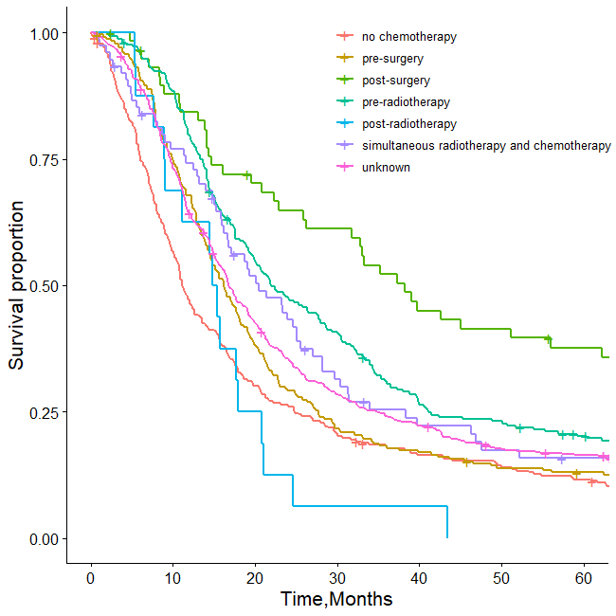 | 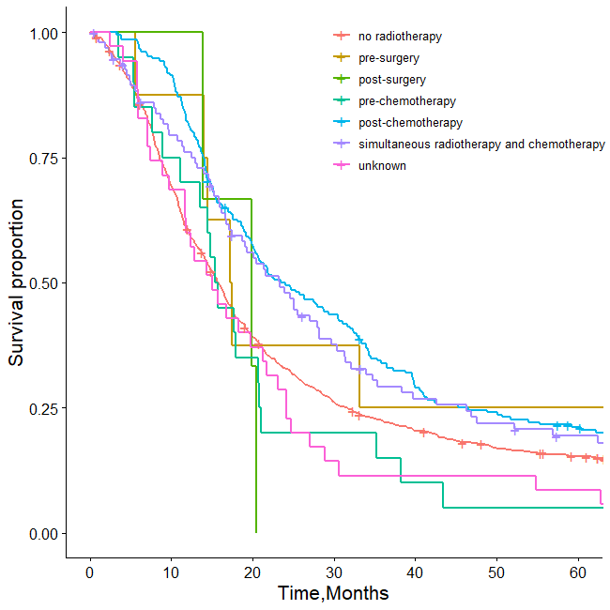
e Figure. 1 Survival curves of chemotherapy and radiotherapy treatment lines for SCLC patients

eTable.5 Characteristics of patients stratified by sex in the training set
 | Male  (N = 1071) | Female  (N = 394) | χ² | P value
Smoke
No | 238(22.22) | 344(87.31)
Yes | 833(77.78) | 50(12.69) | 509.605 | < 0.001
TNM Stage
Ⅰ | 53(4.95) | 22(5.58)
Ⅱ | 98(9.15) | 43(10.91)
Ⅲ | 431(40.24) | 161(40.86) | 1.770 | 0.621
Ⅳ | 489(45.66) | 168(42.64)

eTable.6 Chemotherapy regimens reference
 | Chemotherapy Regimens
limited-stage small-cell lung cancer | Etoposide + Cisplatin
 | Etoposide + Carboplatin
extensive-stage small-cell lung cancer | Etoposide + Carboplatin + Atelizumab
 | Etoposide + Platinum + Duvalizumab
 | Etoposide + Platinum + Adelbilimab
 | Etoposide + Platinum + Sluritumab
 | Etoposide + Platinum
 | Etoposide + Cisplatin
 | Etoposide + Carboplatin
 | Irinotecan + Cisplatin
 | Irinotecan + Carboplatin
 | Etoposide + Loplatin

