Supplementary Information for

SARIFA as a new histopathological biomarker is associated with adverse clinicopathological characteristics, tumor-promoting fatty-acid metabolism, and might predict a metastatic pattern in pT3a prostate cancer

Johanna S. Enke,¹ Matthias Groß,² Bianca Grosser,² Eva Sipos,² Julie Steinestel,³ Phillip Löhr,⁴ Johanna Waidhauser,⁴ Constantin Lapa,¹ Bruno Märkl,² *Nic G. Reitsam²

1 Nuclear Medicine, Faculty of Medicine, University of Augsburg, Augsburg, Germany
2 Pathology, Faculty of Medicine, University of Augsburg, Augsburg, Germany
3 Urology, Faculty of Medicine, University of Augsburg, Augsburg, Germany
4 Hematology and Oncology, Faculty of Medicine, University of Augsburg, Augsburg, Germany

*Corresponding Author:
Dr. med. Nic Gabriel Reitsam
nic.reitsam@uka-science.de, nic.reitsam@uk-augsburg.de

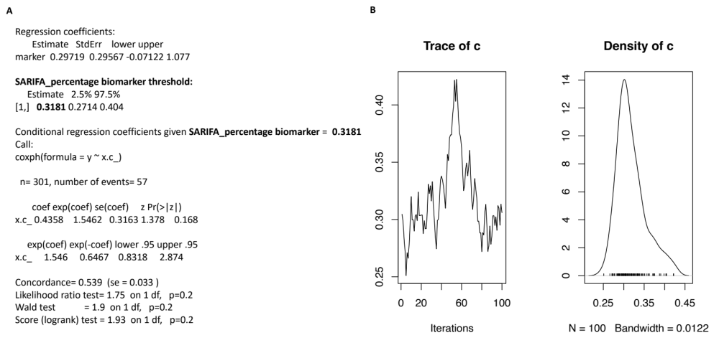
Supplementary Figures
Figure S1. Biomarker threshold regression model for identifying optimal cut-off of SARIFA-positive slides (percentage) for our quantitative approach. A. Summary of biomarker threshold model with 0.3181 (31.81%) as the estimated optimal cut-off for our quantitative SARIFA approach, which we simplified to at least (≥) one third of all slides showing SARIFAs. Here, HR for quantitative SARIFA positivity according to the optimized cut-off is 1.546 (95% CI: 0.832-2.874, p = 0.168), basically identical to those of our simplified cut-off with more than one third (≥33%) of all slides. B. Plot visualizing biomarker threshold model. CI: confidence interval, HR: hazard ratio, SARIFA: Stroma-AReactive-Invasion-Front-Areas.
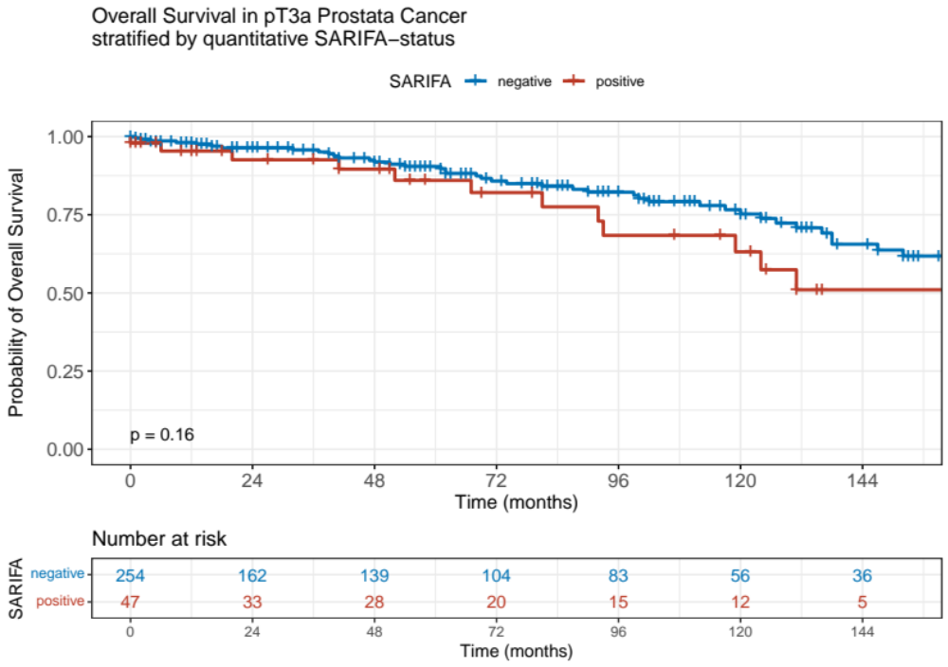
Figure S2. Kaplan-Meier curves regarding overall survival of pT3a prostate cancer patients stratified by quantitative and optimized SARIFA-status. A. SARIFA positivity (defined as ≥1/3 of all slides with SARIFAs) is not statistically associated with decreased overall survival in pT3a prostate cancer patients but showing a clear trend towards poorer outcome (p=0.16). SARIFA: Stroma-AReactive-Invasion-Front-Areas, pT: depth of invasion.

Supplementary Tables

Table S1. Clinicopathological characteristics of pT3a prostate carcinomas with regards to quantitative (≥1/3 of all slides) SARIFA-status
 |  |  |  | SARIFA-status
Variable |  | All cases |  | SARIFA-positive (quant.) |  | SARIFA-negative (quant.)
 |  | n=301 | 100% | n=47 | 16% | n=254 | 84% | p-value
Age in years, at surgery, median (range) |  | 68 (46-87) |  | 66 (52-79) |  | 68 (46-87) |  | 0.256
iPSA* (mean ±standard deviation), in ng/ml |  | 14.85 ±15.19 |  | 22.42 ±26.28 |  | 13.40 ±11.52 |  | 0.091
pN category | pN0 | 212 | 70% | 24 | 51% | 188 | 74% | 0.004
 | pN1 | 87 | 29% | 23 | 49% | 64 | 25% | 0.004
 | NA | 2 | 1% | 0 | 0% | 2 | 1% | 0.004
Gleason Score | 6 | 11 | 4% | 2 | 4% | 9 | 4% | 0.101
 | 7 | 183 | 61% | 26 | 55% | 157 | 62% | 0.101
 | 8 | 48 | 16% | 5 | 11% | 43 | 17% | 0.101
 | 9 | 53 | 18% | 11 | 23% | 42 | 17% | 0.101
 | 10 | 6 | 2% | 3 | 6% | 3 | 1% | 0.101
Lymphatic invasion | L0 | 216 | 72% | 29 | 62% | 187 | 74% | 0.237
 | L1 | 26 | 9% | 6 | 13% | 20 | 8% | 0.237
 | NA | 59 | 20% | 12 | 26% | 47 | 19% | 0.237
Vascular invasion | V0 | 230 | 76% | 32 | 68% | 198 | 78% | 0.151
 | V1 | 12 | 4% | 4 | 9% | 8 | 3% | 0.151
 | NA | 59 | 20% | 11 | 23% | 48 | 19% | 0.151
Perineural invasion | Pn0 | 8 | 3% | 1 | 2% | 7 | 3% | 0.777
 | Pn1 | 252 | 84% | 41 | 87% | 211 | 83% | 0.777
 | NA | 41 | 14% | 5 | 11% | 36 | 14% | 0.777
R status | R0 | 172 | 57% | 19 | 40% | 153 | 60% | 0.012
 | R1 | 129 | 43% | 28 | 60% | 101 | 40% | 0.012
Extraprostatic extension | focal | 158 | 52% | 17 | 36% | 141 | 56% | 0.005
 | non-focal | 97 | 32% | 14 | 30% | 32 | 13% | 0.005
 | NA | 46 | 15% | 16 | 34% | 81 | 32% | 0.005
p-values that are statistically significant are highlighted in bold.
*iPSA: initial prostate specific antigen values were only available for 211 patients (34 SARIFA-positive, 177 SARIFA-negative)
SARIFA: Stroma AReactive Invasion Front Areas, pT: depth of invasion, pN: lymph node status, R status: residual tumor status, quant.: quantitative approach with ≥1/3 of all slides need to show SARIFA in order to make the whole case SARIFA-positive . Extraprostatic extension according to Ball et al. ¹⁵.

 |  |  |  | SARIFA-status
Variable |  | All cases |  | SARIFA-positive |  | SARIFA-negative
 |  | n=301 | in % | n=178 | 59% | n=123 | in % | p-value
Grade Group | 1 | 11 | 3.7 | 3 | 1.7 | 8 | 6.5 | 0.015
ISUP 2014/WHO 2016 | 2 | 88 | 29.2 | 50 | 28.1 | 38 | 30.9 | 0.015
 | 3 | 95 | 31.6 | 57 | 32.0 | 38 | 30.9 | 0.015
 | 4 | 48 | 15.9 | 24 | 13.5 | 24 | 19.5 | 0.015
 | 5 | 59 | 19.6 | 44 | 24.7 | 15 | 12.2 | 0.015
Quantitative SARIFA assessment |  |  |  | SARIFA-positive (quant.) |  | SARIFA-negative (quant.)
 |  | n=301 | in % | n=47 | in % | n=254 | in % | p-value
Grade Group | 1 | 11 | 3.7 | 2 | 4.3 | 9 | 3.5 | 0.178
ISUP 2014/WHO 2016 | 2 | 88 | 29.2 | 9 | 19.1 | 79 | 31.1 | 0.178
 | 3 | 95 | 31.6 | 17 | 36.2 | 78 | 30.7 | 0.178
 | 4 | 48 | 15.9 | 5 | 10.6 | 43 | 16.9 | 0.178
 | 5 | 59 | 19.6 | 14 | 29.8 | 45 | 17.7 | 0.178
p-values that are statistically significant are highlighted in bold.
SARIFA: Stroma AReactive Invasion Front Areas
quantitative (quant.) SARIFA-status: ≥1/3 of all slides with SARIFA define SARIFA-positivity
Table S2. Association between grade groups and SARIFA-status in pT3a grostate carcinomas

Overall Survival | *p-value
iPSA (initial PSA value) | 0.007
Age>65 | 0.379
Extraprostatic extension (focal vs non-focal) | 0.105
pN (pN0 vs pN1) | 0.347
R status (R0 vs R1) | 0.639
Lymphatic invasion (no vs yes) | 0.867
Vascular invasion (no vs yes) | 0.057
Perineural invasion | 0.990
*Risk group | 0.466
SARIFA (negative vs positive) | 0.506
p-values that are statstically significant are higlighted in bold.
SARIFA: Stroma AReactive Invasion Front Areas, pT: depth of invasion, pN: lymph node status, R status: residual tumor status; *Simplified risk groups are defined as: Grade Group 1 = 1; Grade Group 2 and 3 = 2; Grade Group 4 and 5 = 3.
*As only the association of iPSA and survival was statistially significant in univariate Cox regression analysis, results of this multivariate model should be interpreted with caution (overfitting as potential bias!).
Table S3. Multivariate Cox regression analysis regarding overall survival in pT3a prostate cancer

