Supplemental figure 1 flow graph of the study

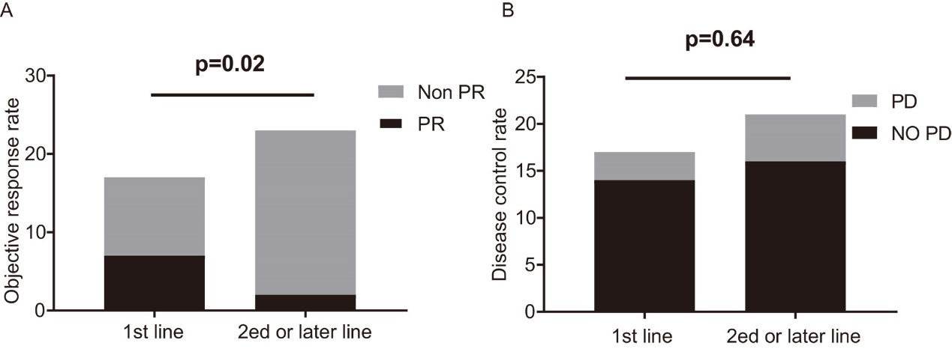
Supplemental figure 2 Response of ICI-treated RET-positive patients stratified by treatment lines. A and B: ORR and DCR for patients in different treatment lines. ORR, objective response rate, including partial response and complete response; DCR, disease control rate, including stable disease, partial response, and complete response.
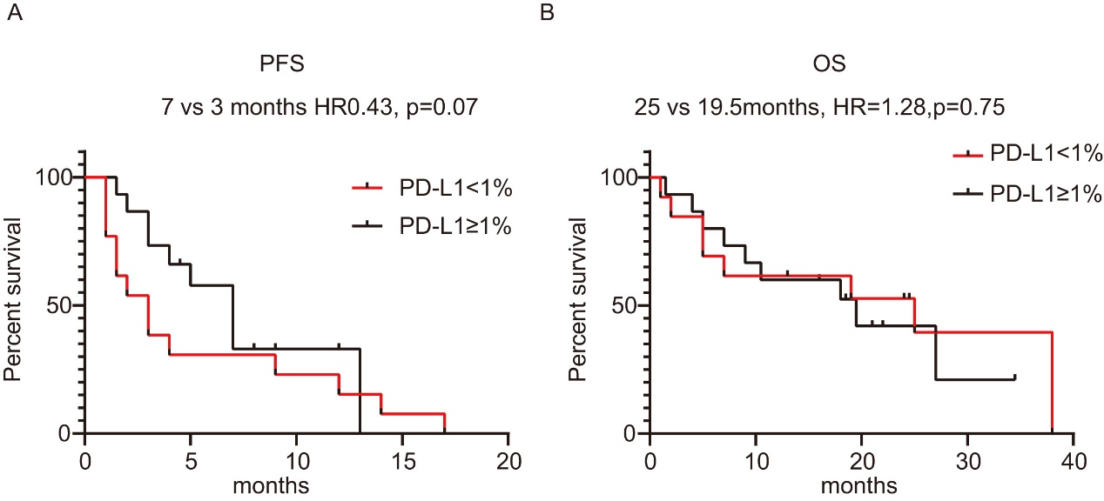
Supplemental figure 3 PFS and OS for patients stratified by PD-L1 expression. A and B: PFS and OS of ICI-treated patients based on PD-L1 expression. PFS, progression-free survival; OS, overall survival.
Supplemental table 1 Co-occurring mutations with RET fusions
Co-occurring mutations | Total population
TP53 | 27/232 (11.6%)
KRAS G12D | 2/232 (0.8%)
NRAS | 2/232 (0.8%)
MTOR | 6/232 (2.6%)
HRAS | 2/232 (0.8%)
ERBB2 | 4/232 (1.7%)
PTEN | 7/232 (3.0%)
CDKN2A | 7/232 (3.0%)
EGFR  Exon 19 deletion  Exon 21 L858R | 3/232 (1.2%)  2/232 (0.8%)
ARID1A | 4/232 (1.7%)
RET mutations | 4/232 (1.7%)

Supplemental Table 2: Treatment regimens for patients treated with ICIs.

ID | Regimen | Line | PFS (mo) | Reason for discontinuation | Best response
1 | Tislelizumab + chemo | 1 | 3 | PD | SD
2 | Camrelizumab + chemo | 1 | 3 | PD | PR
3 | Chemo + Camrelizumab | 1 | 12 | Ongoing | PR
4 | sintilimab+ chemo | 1 | 8 | ongoing | SD
5 | Camrelizumab + chemo | 1 | 14 | PD | PR
6 | Tislelizumab + chemo | 2 | 9 | ongoing | SD
7 | toripalimab + chemo | 1 | 2 | PD | PD
8 | Camrelizumab+chemo | 2 | 4.5 | ongoing | SD
9 | Camrelizumab +chemo | 1 | 1.5 | PD | PD
10 | pembrolizumab + chemo | 1 | 4 | PD | PR
11 | Camrelizumab + chemo | 2 | 1 | PD | PD
12 | Camrelizumab +chemo | 1 | 2 | PD | PD
13 | Camrelizumab +chemo | 2 | 3 | ongoing | SD
14 | Camrelizumab + chemo | 1 | 4 | PD | SD
15 | Camrelizumab + chemo | 2 | 5 | PD | SD
16 | Camrelizumab + chemo | 1 | 1 | PD | PD
17 | Tislelizumab +chemo | 1 | 6 | ongoing | SD
18 | Camrelizumab + chemo | 2 | 2 | PD | PD
19 | Camrelizumab + chemo | 1 | 5 | PD | PR
20 | sintilimab + chemo | 3 | 7 | PD | SD
21 | Camrelizumab + chemo | 1 | 12 | PD | SD
22 | Camrelizumab + chemo | 2 | 9 | PD | SD
23 | Camrelizumab + chemo | 2 | 12 | PD | SD
24 | Sintilimab + chemo | 1 | 7 | PD | PR
25 | Camrelizumab + chemo | 1 | 7 | PD | SD
26 | Camrelizumab + chemo | 3 | 17 | PD | SD
27 | Camrelizumab + chemo | 3 | 3 | PD | SD
28 | Camrelizumab + chemo | 2 | 3 | PD | SD
29 | Camrelizumab + chemo | 2 | 1 | PD | PD
30 | Camrelizumab + chemo | 2 | 12 | PD | PR
31 | Camrelizumab+chemo | 4 | 1 | PD | PD
32 | Camrelizumab + chemo | 3 | 1 | SD | SD
33 | Camrelizumab + chemo | 3 | 1.5 | PD | PD
34 | Camrelizumab+chemo | 2 | 3 | PD | SD
35 | Camrelizumab + chemo | 1 | 7 | PD | PR
36 | Camrelizumab+chemo | 2 | 8 | PD | PD
37 | sintilimab + chemo | 3 | 1.5 | PD | PD
38 | sintilimab + chemo | 3 | 13 | PD | PR
chemo, chemotherapy; PFS, progression free survival; mo, months; PD, progressive disease; PR, partial response; SD, stable disease; NA, not available.
Supplemental Table 3 the efficacy of ICI based therapies in patients with RET fusions
Best response | All patients n% | ICI in 1st line | ICI in 2ed or later line
CR | 0 | 0 | 0
PR | 9 (23.7%) | 7 (41.2%) | 2 (9.5%)
SD | 21 (55.3%) | 7 (41.2%) | 14 (66.7%)
PD | 8 (21.1%) | 3 (17.6%) | 5 (23.8%)
ORR | 9 (23.7%; 95%CI, 9.5%-37.8%) | 7 (41.2%; 95% CI: -15.1%-67.3%) | 2 (9.5%;95% CI: 4.2%-23.2%)
DCR | 30 (78.9%, 95%CI: 64.5%-92.5%) | 14 (82.4%;95% CI -62.1%-102.6%) | 16 (76.2%; 95% CI 56.3%-96.1%)

Supplemental table 4 safety profile
event | treated population (28 patients have occured side effects)
event | Any grade | Grade 3, 4, 5
total | 75.7% | 10.8%
Skin effects | 6/28 (21.4%) | 0
RCCEP | 1/28 (3.6%) | 0
anemia | 16/28 (57.1%) | 1/28 (3.6%)
neutropenia | 3/28 (10.7%) | 0
thrombocytopenia | 5/28 (17.9%) | 1/28 (3.6%)
leukopenia | 6/28 (21.4%) | 1/28 (3.6%)
liver injury | 10/28 (35.7%) | 2/28 (7.1%)
hypothyroidism | 5/28 (17.9%) | 0
Kidney injury | 2/28 (7.1%) | 0
adrenal insufficiency | 1/28 (3.6%) | 0
hypokalemia | 2/28 (7.1%) | 0
hyperglycemia | 1/28 (3.6%) | 0
RCCEP: Reactive cutaneous capillary endothelial proliferation

