SUPPLEMENTARY DATA
Supplementary table 1. Survival of mice as determined by the Log-Rank test.
Cell Line | CY v PBS | CY v TRETINOIN+CY
CT26 | 0.0024 | 0.7753
WEHI164 | 0.0026 | 0.1283
4T1 | 0.0026 | 0.4527
AE17 | 0.0016 | 0.9104
LLC | 0.0175 | 0.9720

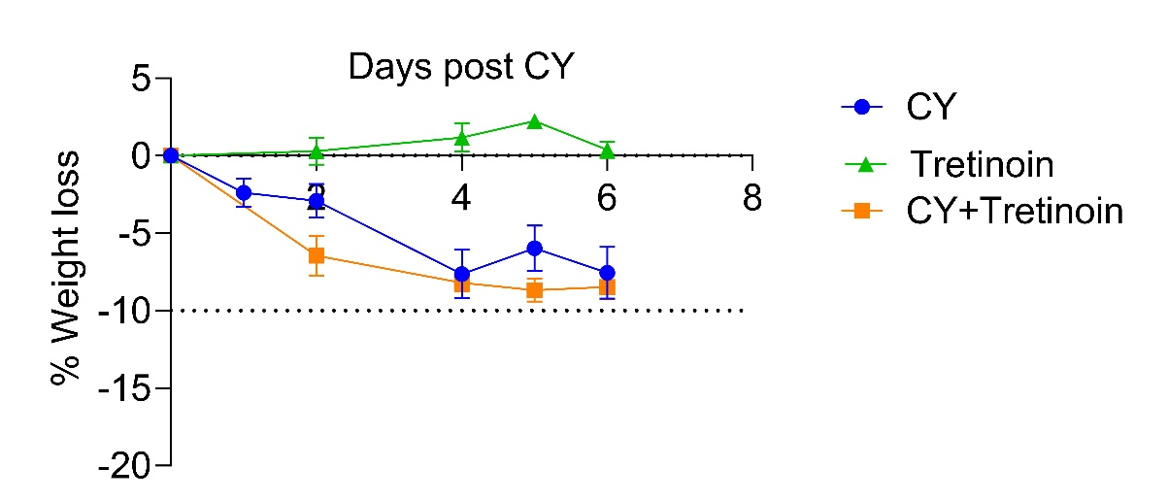
Supplementary figure 1. There is no additional toxicity with the addition of tretinoin to CY. Weight loss (%) of mice treated with CY, Tretinoin or the combination.

