Supplementary
ALC | NLR
- 1m vs baseline  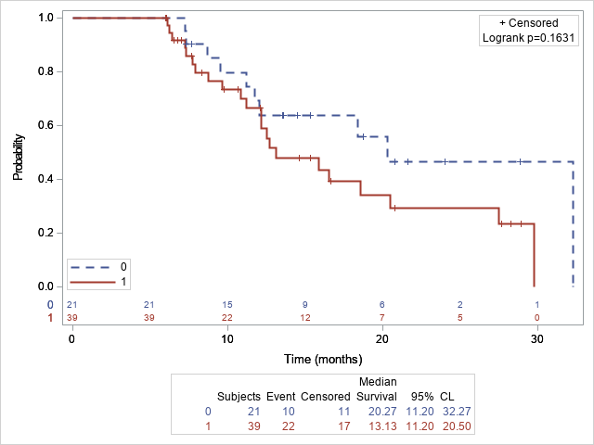 | D. 1m vs baseline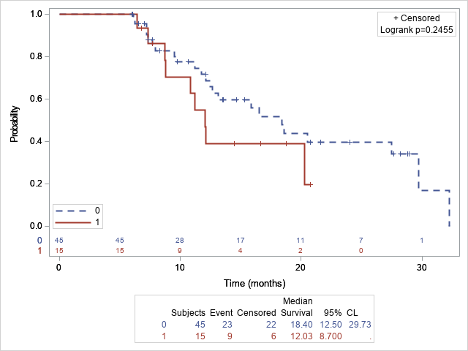
- 3m vs baseline  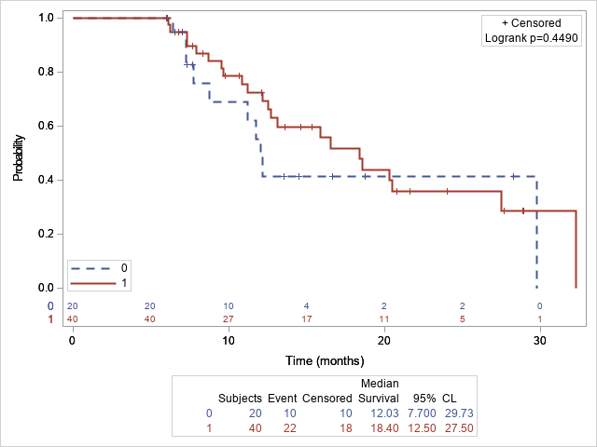 | E. 3m vs baseline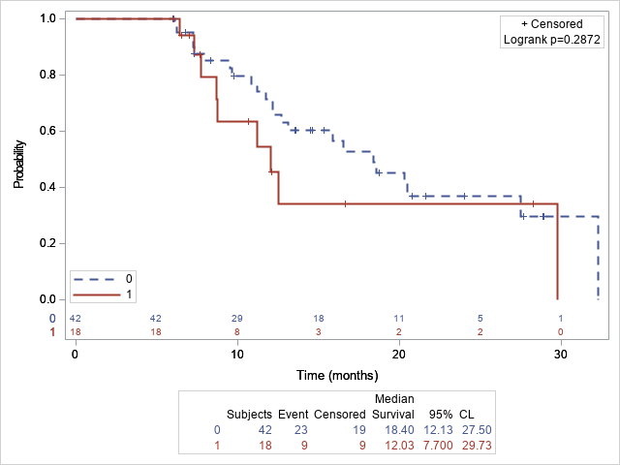
- 6m vs baseline  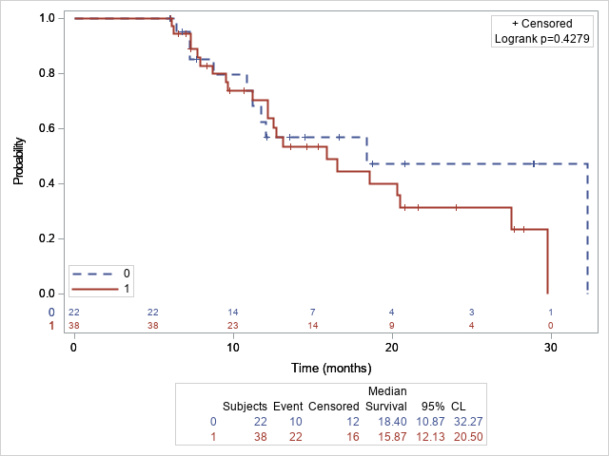 | F. 6m vs baseline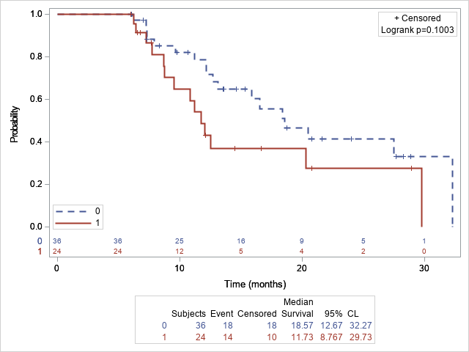
ALC= absolute lymphocyte count; NLR=neutrophil to lymphocyte ratio
Supplementary Figure. 1. Overall survival (OS) among patients with increased or decreased trends of ALC, NLR (0: decreasing, 1: non-decreasing)

PFS | OS
- 1m vs baseline  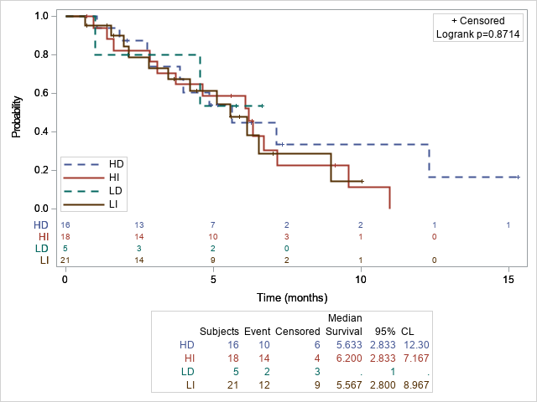 | - 1m vs baseline  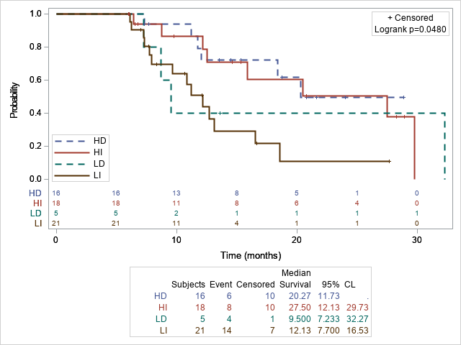
- 3m vs baseline  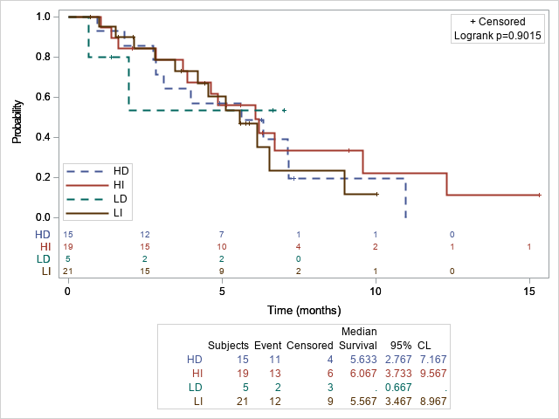 | - 3m vs baseline  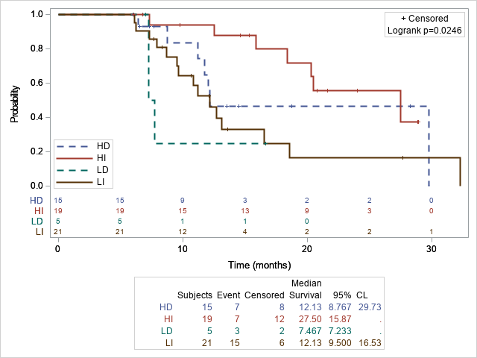
- 6m vs baseline  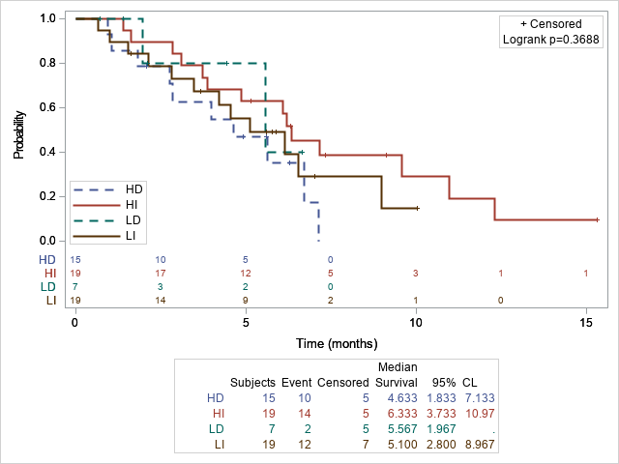 | - 6m vs baseline  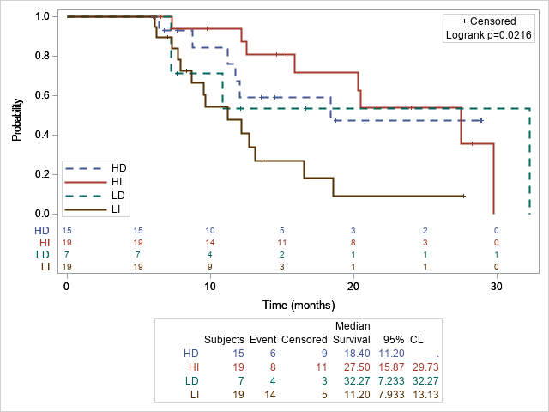
HD= Initially high then decreasing; HI= Initially high then increasing; LD= Initially low then decreasing; LI= Initially low then increasing; PFS=Progression-free-survival; OS= Overall survival; ALC=absolute lymphocyte count
Supplementary Figure 2. Comparing PFS and OS among different groups of patients stratified by ALC trends according to the baseline level.

PFS | OS
- 1m vs baseline | - 1m vs baseline
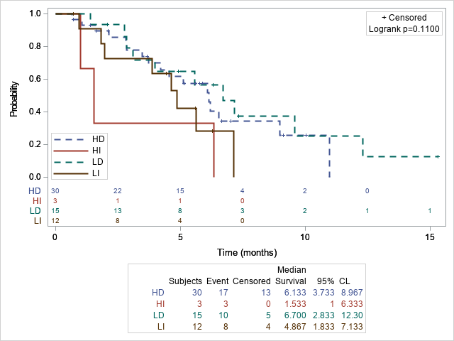 | 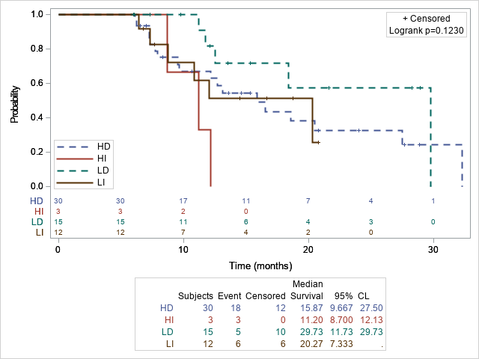
- 3m vs baseline | - 3m vs baseline
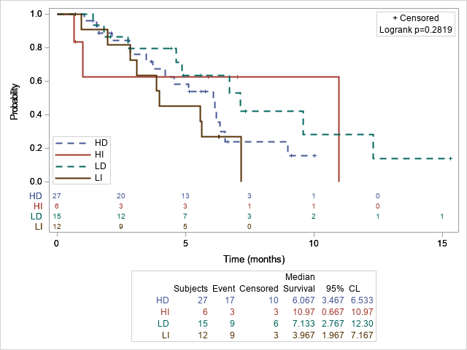 | 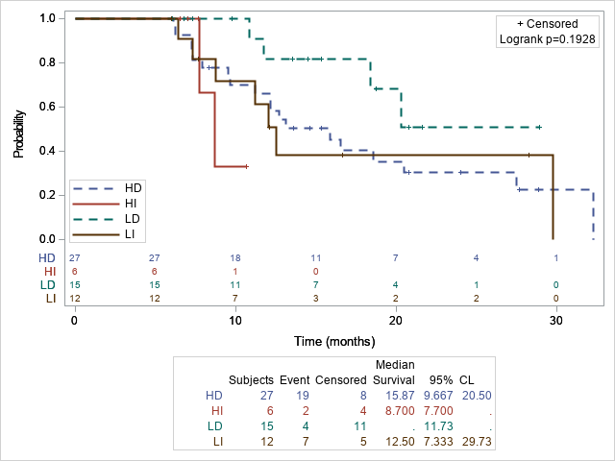
- 6m vs baseline | - 6m vs baseline
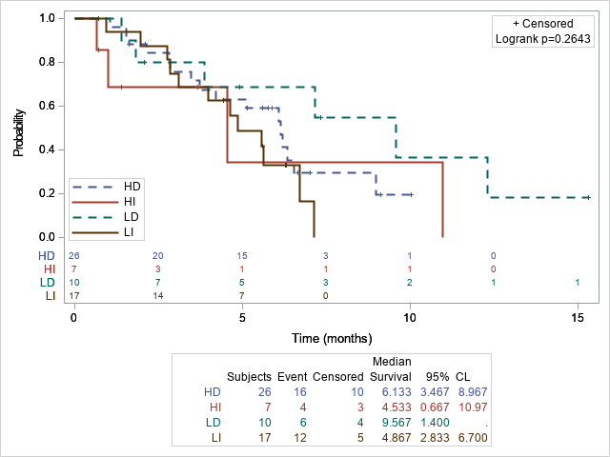 | 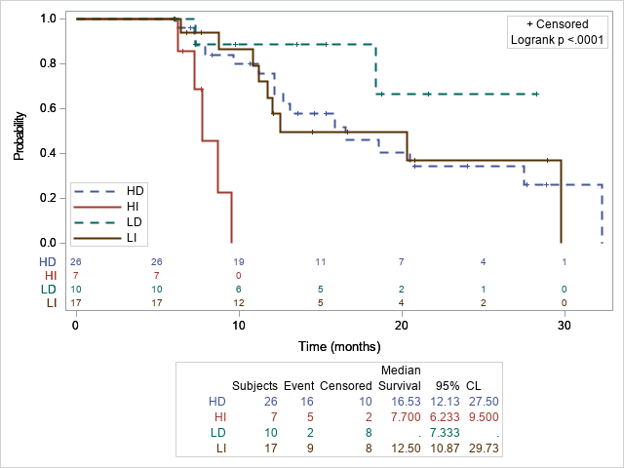
HD= Initially high then decreasing; HI= Initially high then increasing; LD= Initially low then decreasing; LI= Initially low then increasing; PFS=Progression-free-survival; OS= Overall survival; NLR=neutrophil to lymphocyte ratio
Supplementary Figure 3. Comparing PFS and OS among different groups of patients stratified by NLR baseline and trends.

ALC | NLR
At 3 month-test 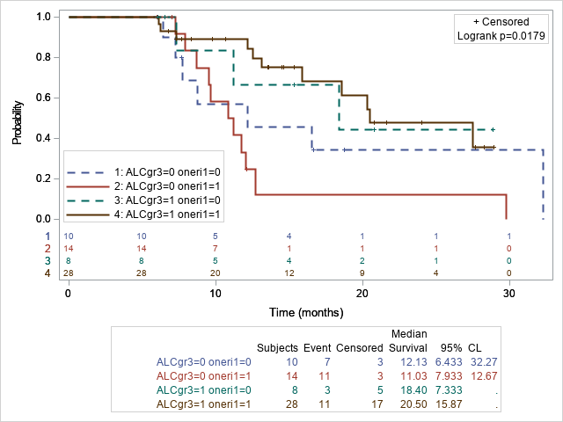 | At 3 month-test 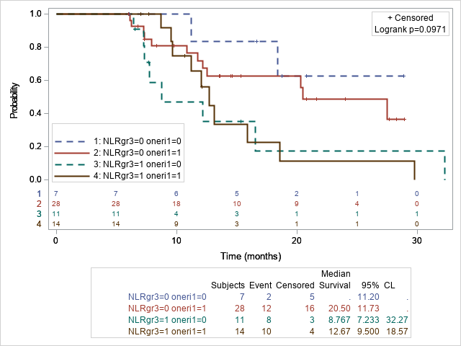
At 6-month-test 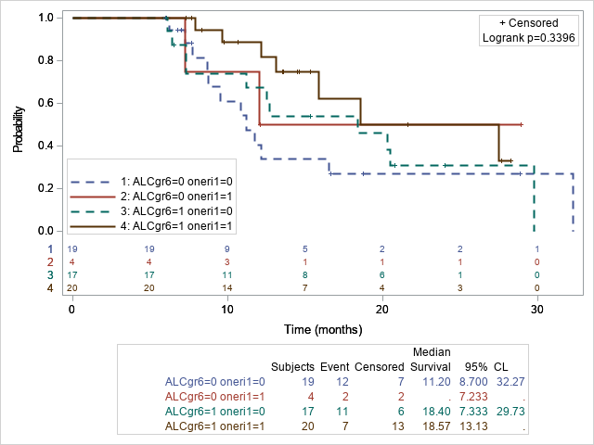 | At 6-momnth test 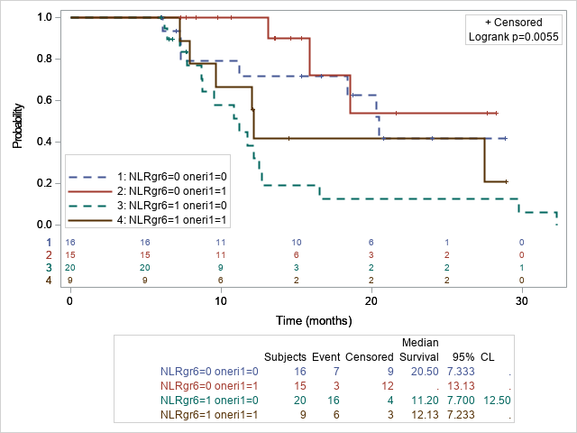
ALC= absolute lymphocyte count; NLR=neutrophil to lymphocyte ratio; OS= Overall survival;
ALCgr3=0 Oneri1=0 refers patients with low ALC and off eribulin treatment at 3 month; ALCgr3=0 Oneri1=1 refers patients with low ALC and on eribulin treatment at 3 month; ALCgr3=1 Oneri1=0 refers patients with high ALC and off eribulin treatment at 3 month; ALCgr3=1 Oneri1=1 refers patients with high ALC and on eribulin treatment at 3 month
ALCgr6=0 Oneri1=0 refers patients with low ALC and off eribulin treatment at 6 month; ALCgr6=0 Oneri1=1 refers patients with low ALC and on eribulin treatment at 6 month; ALCgr6=1 Oneri1=0 refers patients with high ALC and off eribulin treatment at 6 month; ALCgr6=1 Oneri1=1 refers patients with high ALC and on eribulin treatment at 6 month
Supplementary Figure 4: Analysis on the association of high(1)/low(0) NLR/ALC with OS stratified by on(1)/off(0) treatment with eribulin

