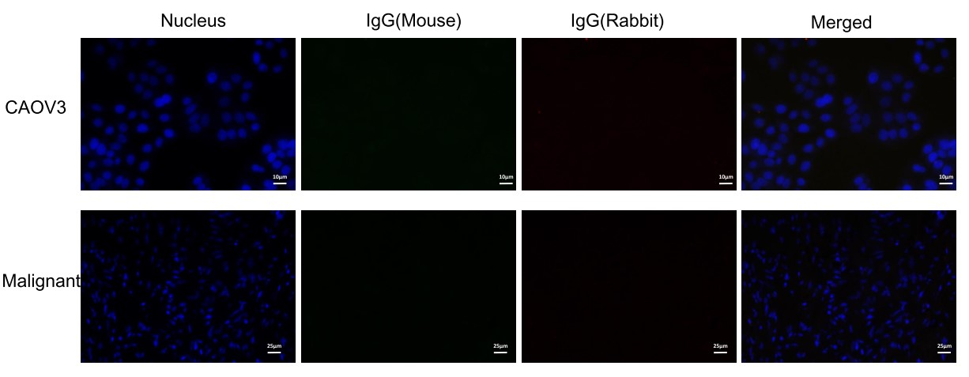Figure S1. The negative control of dual-labeled immunofluorescence technology.
The primary antibody (TMEFF1 and ST14) was replaced with rabbit or mouse IgG as a negative control. Blue represents the nucleus, red represents rabbit, green represents mouse (original magnification, ×600, ×400).

