Whole Gel
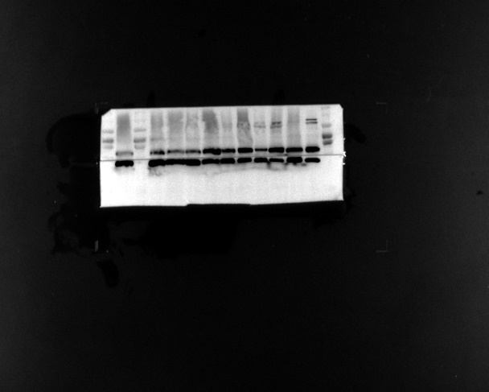
ECL Whole Blots (EIF4A3 47KDa， GAPDH 37KDa）The same gel.
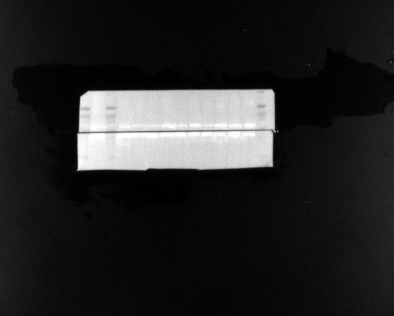
White light (Marker:170 130 100 70 55 40 35 25 15 10KDa)

