WB original image

Figure 1C
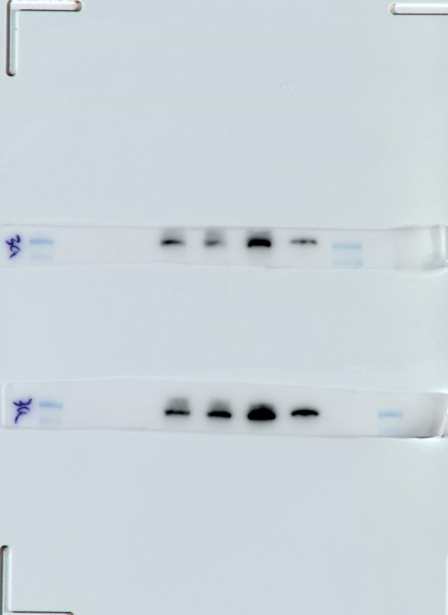
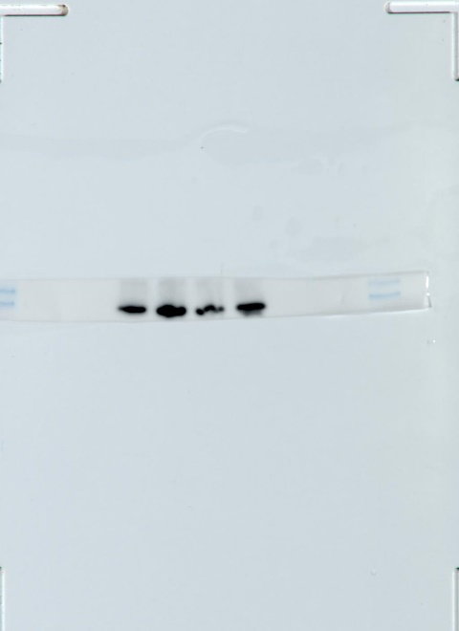
eIF3a
eIF3a
170KDa
170KDa
eIF3a
170KDa

N1 N2 LY1 LY3 LY8 U2932
N1 N2 LY1 LY3 LY8 U2932

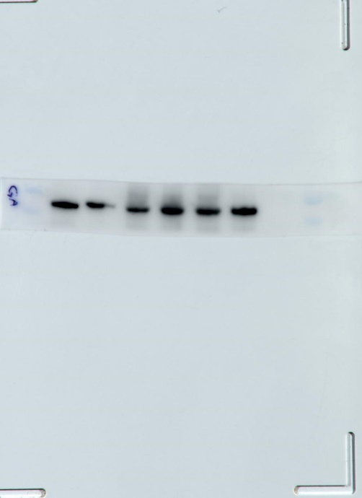
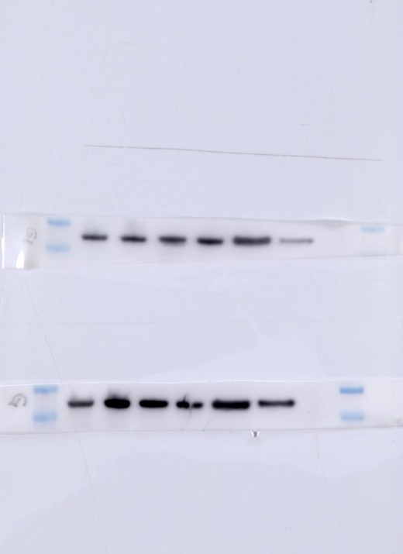

GAPDH
36KDa
36KDa
GAPDH

36KDa
GAPDH

N1 N2 LY1 LY3 LY8 U2932
N1 N2 LY1 LY3 LY8 U2932

Figure 2B

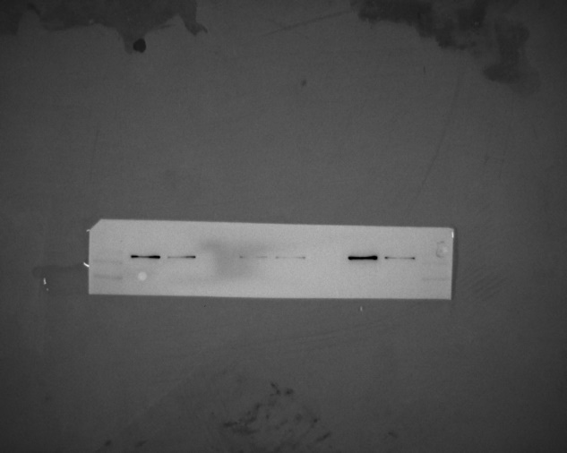

eIF3a
170kDa

NC-LV SI-LV NC-LV SI-LV NC-LV SI-LV
LY1 LY3 LY8
NC-LV SI-LV NC-LV SI-LV NC-LV SI-LV
LY1 LY3 LY8

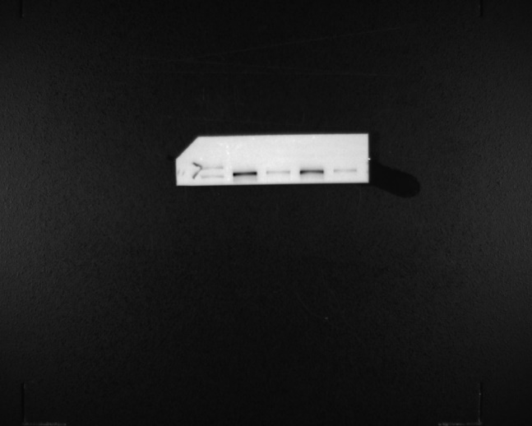
170kDa
eIF3a

NC-LV SI-LV NC-LV SI-LV
LY1 LY8
NC-LV SI-LV NC-LV SI-LV
LY1 LY8

170kDa
eIF3a

NC-LV SI-LV NC-LV SI-LV
LY1 LY8
NC-LV SI-LV NC-LV SI-LV
LY1 LY8

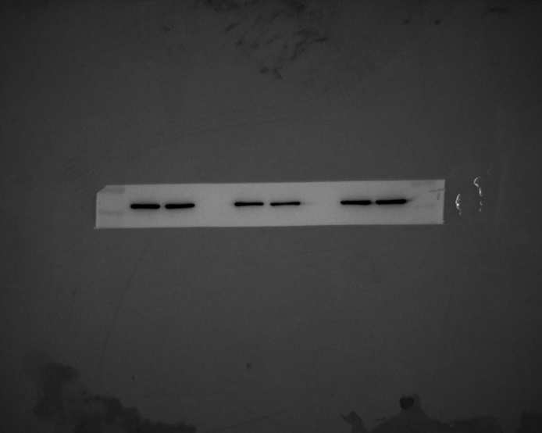
36kDa

36kDa
GAPDH

NC-LV SI-LV NC-LV SI-LV NC-LV SI-LV
LY1 LY3 LY8
NC-LV SI-LV NC-LV SI-LV NC-LV SI-LV
LY1 LY3 LY8

36kDa
GAPDH

NC-LV SI-LV NC-LV SI-LV
LY1 LY8
NC-LV SI-LV NC-LV SI-LV
LY1 LY8

36kDa
GAPDH

NC-LV SI-LV NC-LV SI-LV
LY1 LY8
NC-LV SI-LV NC-LV SI-LV
LY1 LY8

Figure 2E

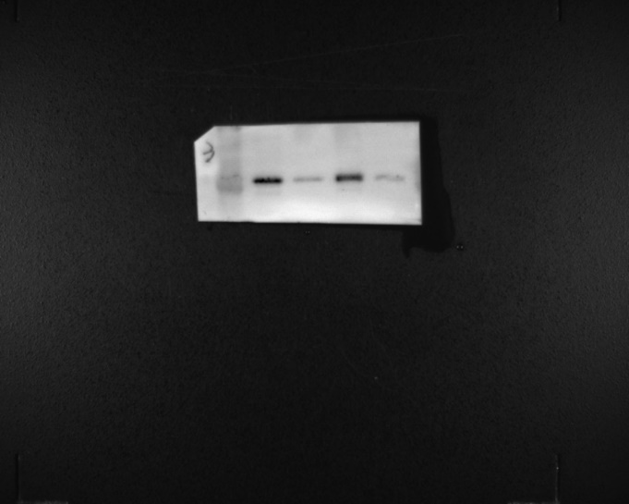
36kDa
Cyclin D1

NC-LV SI-LV NC-LV SI-LV
LY1 LY8
NC-LV SI-LV NC-LV SI-LV
LY1 LY8

36kDa
Cyclin D1

NC-LV SI-LV NC-LV SI-LV
LY1 LY8
NC-LV SI-LV NC-LV SI-LV
LY1 LY8

36kDa
Cyclin D1

NC-LV SI-LV NC-LV SI-LV
LY1 LY8
NC-LV SI-LV NC-LV SI-LV
LY1 LY8

34kDa
CDK4

NC-LV SI-LV NC-LV SI-LV
LY1 LY8
NC-LV SI-LV NC-LV SI-LV
LY1 LY8

CDK4
34kDa

NC-LV SI-LV NC-LV SI-LV
LY1 LY8
NC-LV SI-LV NC-LV SI-LV
LY1 LY8
NC-LV SI-LV NC-LV SI-LV
LY1 LY8

34kDa
CDK4

NC-LV SI-LV NC-LV SI-LV
LY1 LY8
NC-LV SI-LV NC-LV SI-LV
LY1 LY8

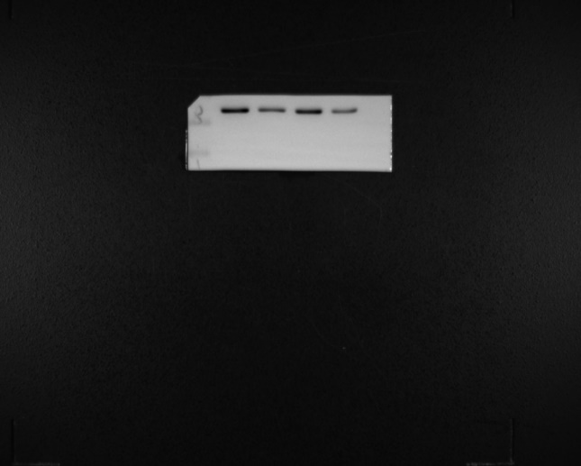
37kDa
CDK6

NC-LV SI-LV NC-LV SI-LV
LY1 LY8
NC-LV SI-LV NC-LV SI-LV
LY1 LY8

37kDa
CDK6

NC-LV SI-LV NC-LV SI-LV
LY1 LY8
NC-LV SI-LV NC-LV SI-LV
LY1 LY8

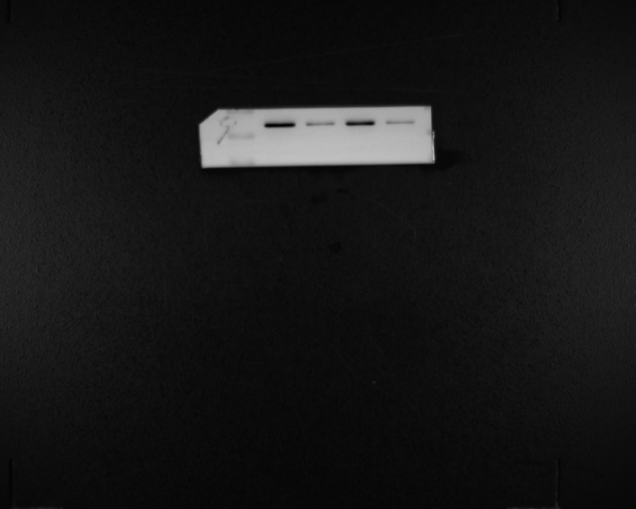
37kDa
CDK6

37kDa

NC-LV SI-LV NC-LV SI-LV
LY1 LY8
NC-LV SI-LV NC-LV SI-LV
LY1 LY8

36kDa
GAPDH

NC-LV SI-LV NC-LV SI-LV
LY1 LY8
NC-LV SI-LV NC-LV SI-LV
LY1 LY8

GAPDH
36kDa

NC-LV SI-LV NC-LV SI-LV
LY1 LY8
NC-LV SI-LV NC-LV SI-LV
LY1 LY8

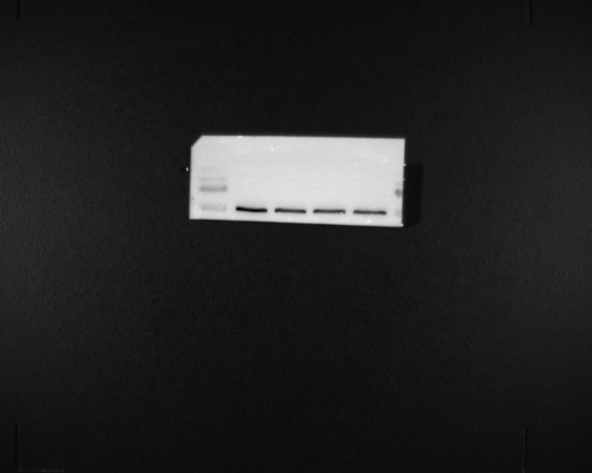
36kDa
GAPDH

NC-LV SI-LV NC-LV SI-LV
LY1 LY8
NC-LV SI-LV NC-LV SI-LV
LY1 LY8

Figure S1
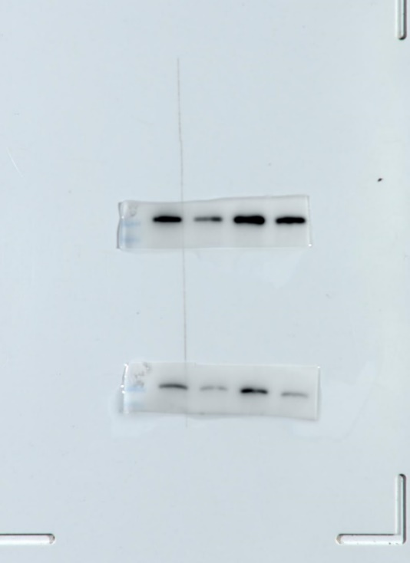

170kDa
eIF3a
170kDa
eIF3a

170kDa
eIF3a

NC-LV SI-LV NC-LV SI-LV
LY1 LY8
SI-LV NC-LV LY1

170kDa
eIF3a

36kDa
GAPDH

SI-LV NC-LV LY1
LY8 NC-LV SI-LV

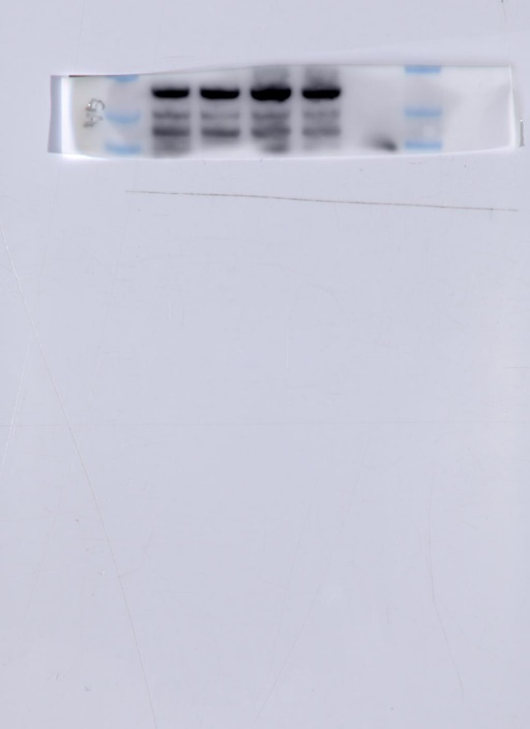
36kDa
GAPDH

36kDa
GAPDH

NC-LV SI-LV NC-LV SI-LV
LY1 LY8
LY8 NC-LV SI-LV

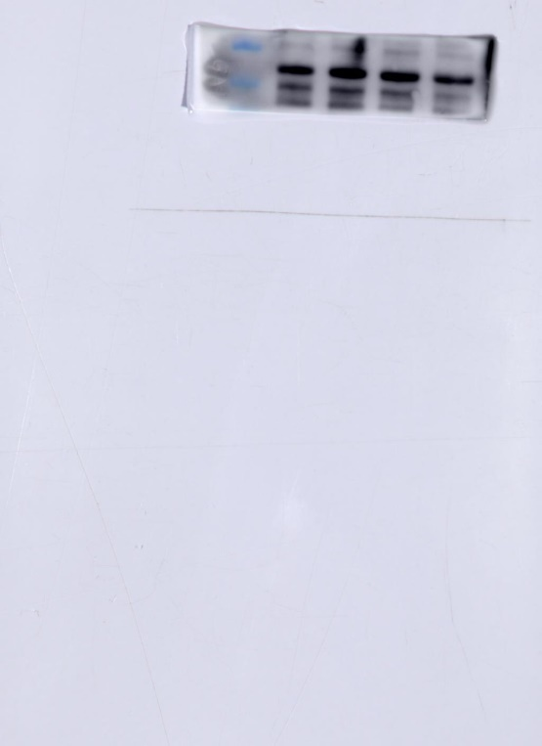
36kDa
GAPDH

NC-LV SI-LV NC-LV SI-LV
LY1 LY8

