Supplementary files:

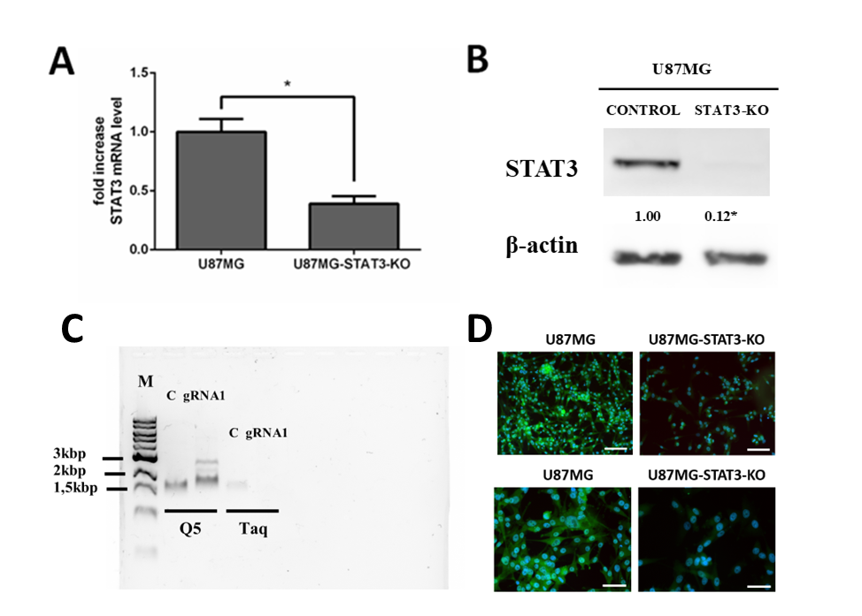

Supplementary figure 1. – STAT3 knockout in cultivated GBM stabilized cell line U87MG. Cells were transfected using STAT3 Human Gene Knockout kit (with gRNA1) and knockout of STAT3 was verified in vitro on mRNA level (A) and protein level (B, D) as described in the Materials and Methods section. Furthermore, DNA evaluation of CRISPR-Cas9 transfection using PCR was carried out (C) as described in the Materials and Methods section *p ˂ 0.05 STAT3 expression in transfected vs non-transfected cells
M-marker; P1-P10 – subcultivation of U87MG cells after CRISPR-Cas9 transfection; P43 – control non-transfected U87MG cells; gRNA1 – U87MG transfected cells using gRNA1; gRNA2 – U87MG transfected cells using gRNA2
Fluorescence microscopy, magnification 200x (upper row), 400x (lower row). Scale 20µm.

Originals for supplementary figure 1B. – CRISPR-Cas9 mediated knockout of STAT3 expression in U87MG cell line. Beta actin expression was used as control. Original unprocessed immunoblots.
Lane 1: U87MG cell line - control
Lane 2: U87MG cell line treated with STAT3 Human Gene KO (CRISPR) gRNA1
Lane 3: U87MG cell line treated with STAT3 Human Gene KO (CRISPR) gRNA2

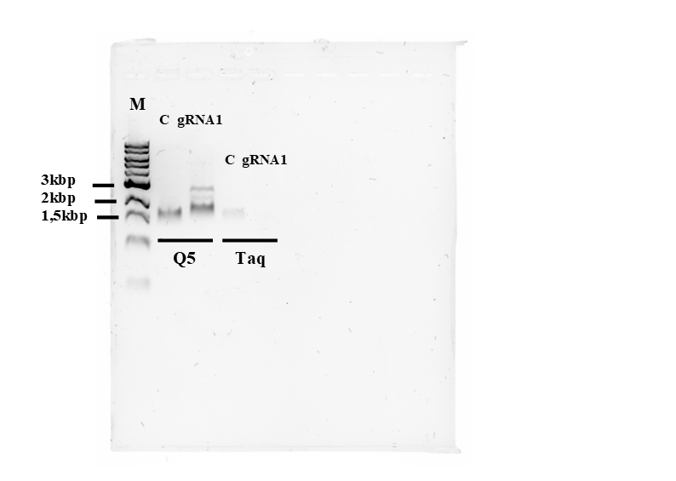
Originals for supplementary figure 1C. – evaluation of CRISPR-Cas9 transfection efficiency at DNA level using PCR. Original unprocessed gel scan.
C – control
gRNA1 – STAT3 gRNA vector 1 in pCas-Guide CRISP vector.
Target Sequence: GCAGCTTGACACACGGTACC

Supplementary figure 2: Immunohistochemical analysis of the glioma sample collected from Foxn1-nu mice with implanted U87MG and U87MG STAT3 KO glioma cells collected from tumor-bearing mice U87MG IDH1wt and U87MG STAT3 KO in untreated mice. GBM samples were processed and IDH1, STAT3, pSTAT3, were detected by immunohistochemistry and histochemistry, as described in the Materials and Methods section.

Supplementary table 1 – Antibodies and details of immunohistochemical reactions used in the study
Antibody | Clone | Dilution | Manufacturer | Positive control
GFAP | EP672Y | RTU | Ventana, Basel, Switzerland | Brain
MEOX2 | 6A5 | 1:1000 | Sigma Aldrich s.r.o., Prague, CR | Appendix – HEV*
EGFR | 31G7 | 1:100 | Novus Biologicals, Ontario, Canada | Placenta
SOX11 | MRQ-58 | 1:50 | Cell Marque, Rocklin, CA, USA | Foetal brain
SOX10 | EP268 | 1:50 | Cell Marque, Rocklin, CA, USA | Appendix
PDGFRa | C-9 | 1:100 | SCBT Inc., Dallas, TX, USA | Appendix
MerTK | Y323 | 1:400 | Abcam, Cambridge, MA, USA | Appendix
CD44 | MRQ-13 | 1:400 | Cell Marque, Rocklin, CA, USA | Brain
CD56 | MRQ-42 | 1:2000 | Cell Marque, Rocklin, CA, USA | Appendix
CD57 | TBO1 | 1:50 | Dako, Glostrup, Denmark | Appendix
Olig2 | EP112 | 1:200 | Cell Marque, Rocklin, CA, USA | Brain
IDH1 R132H | H09 | 1:100 | Dianova GmBH, Hamburg, Germany | Glioma
p53 | DO7 | RTU | Ventana, Basel, Switzerland | Breast carcinoma
Carbon anhydrase 9 (CAIX) | EP161 | 1:100 | Cell Marque, Rocklin, CA, USA | Renal carcinoma
ZEB1 | CL0151 | 1:100 | Novus Biologicals, Ontario, Canada | Appendix
ZEB2 | polyclonal | 1:50 | Thermo Fisher, Brno, Czech Republic | Appendix
TWIST | 10E4E6 | 1:500 | LS Bio, Lynnwood, WA, USA | Placenta
SNAI1 | polyclonal | 1:200 | Merck KGaA, Darmstadt, Germany | Kidney
STAT3 | 124H6 | 1:400 | Cell Signalling, Danvers, MA, USA | Parathyroid gland
STAT3 p705 | D3A7 | 1:100 | Cell Signalling, Danvers, MA, USA | Parathyroid gland
HIF1a | EP118 | 1:50 | BioSB, Santa Barbara, CA, USA | Placenta
HIF1b | D28F3 | 1.50 | Cell Signalling, Danvers, MA, USA | Placenta
CD34 | QBEnd10 | 1:50 | Cell Marque, Rocklin, CA, USA | Appendix

* HEV – high endothelial venules

Supplementary table 2 – Primers used in the study
GCACACAGTTCCTTCCAAATG | h_IDH1_f
ACGCCCATCATATTTCTTCAGA | h_IDH1_r
CGTGTGGAAGAGTTCAAGCT | h_IDH2_f
GGGACTAGGCGTGGGATG | h_IDH2_r
TGTACCCTAACTAGCCGAGG | h_HIF1a_f
ATACGTGAATGTGGCCTGTG | h_HIF1a_r
TGTGGACCCAGTTTCTGTGA | h_HIF1b_f
GCCAAGTCCATTCCTGCATC | h_HIF1b_r
GCCCAATAGCCCTGAAGACT | h_HIF2a_f
GTCCAGCTCATTGAAATCCGT | h_HIF2a_r
GCCACCCATATGTACCATCG | h_EGFR_f
TGCGTCTATCATCCAGCACT | h_EGFR_r
CAGTGGCGGAACTTGCAAT | h_PTEN_f
TCACCTTTAGCTGGCAGACC | h_PTEN_r
GAGAATCTCCAGGATGACTTTGA | h_STAT3_f
TTGCATGTCTCCTTGACTCTTG | h_STAT3_r
CTGGAGGAGCAGTTACGGTC | h_VEGFC_f
TCCTTTCCTTAGCTGACACTTGT | h_VEGFC_r
GCGGATCAAACCTCACCAAG | h_VEGFA_f
GCTCTATCTTTCTTTGGTCTGCA | h_VEGFA_r
TGCTGTCTCCATGTTTGATGTATC | h_B2M_f
TCTCTGCTCCCCACCTCTAAG | h_B2M_f

Supplementary table 3 – Mutational analysis of the most common markers related with hypoxia in repeatedly resected gliomas. All changes of interest in mutational status of analyzed targets are highlighted in bold

mutational analysis of hypoxia-related markers
 | resection | IDH1 | IDH2 | PIK3CA | EGFR | PTEN | TP53 | prom TERT | BRAF | RB1
Le | 1st | wt | wt | mut (8%) | wt | mut | mut | wt | wt | mut
Le | 2nd | wt | wt | mut (24%) | wt | wt | mut | wt | wt | mut
Le | 3rd | wt | wt | wt | wt | wt | mut | wt | wt | mut
Le | 4th | wt | wt | wt | wt | wt | mut | wt | wt | mut
Pu | 1st | wt | wt | wt | wt | wt | wt | wt | wt | wt
Pu | 2nd | wt | mut | wt | wt | mut | mut | wt | wt | wt
Pu | 3rd | wt | mut | wt | wt | mut | mut | wt | wt | wt
Ku | 1st | mut | wt | wt | wt | wt | wt | wt | mut | wt
Ku | 2nd | mut | wt | wt | wt | wt | wt | wt | mut | wt
Do | 1st | wt | wt | wt | wt | wt | wt | mut | wt | wt
Do | 2nd | wt | wt | wt | mut | wt | wt | mut | wt | wt
Jo | 1st | wt | wt | wt | mut | wt | wt | mut | wt | wt
Jo | 2nd | wt | wt | wt | mut | wt | wt | mut | wt | wt
Bi | 1st | wt | wt | wt | wt | wt | mut | mut | wt | wt
Bi | 2nd | wt | wt | wt | wt | wt | mut | mut | wt | wt
Ná | 1st | wt | wt | wt | wt | wt | wt | wt | wt | wt
Ná | 2nd | wt | wt | wt | wt | wt | wt | wt | wt | wt

