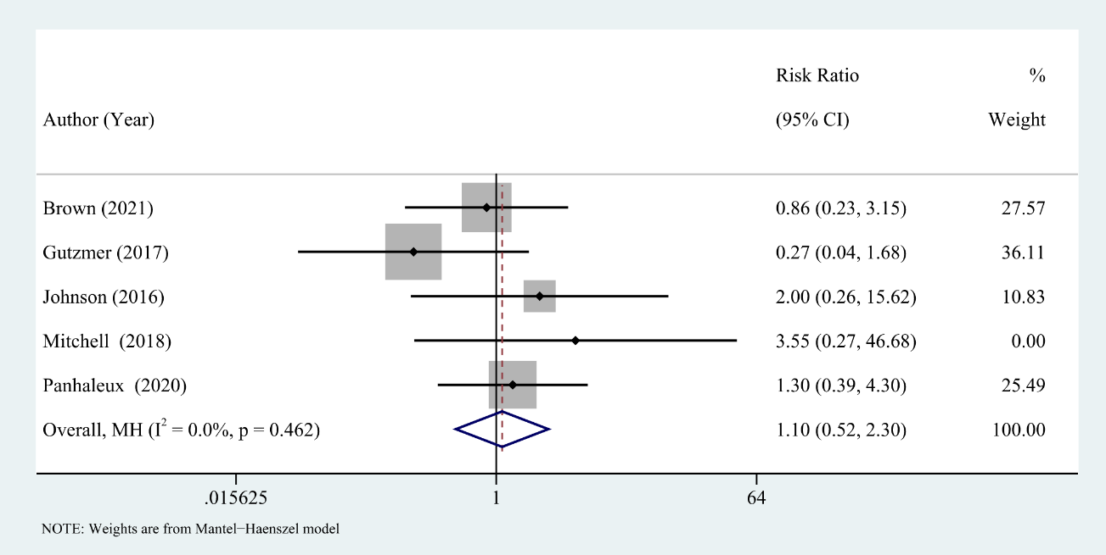
Supplementary Fig. 5. The assciation between flares and ORR

