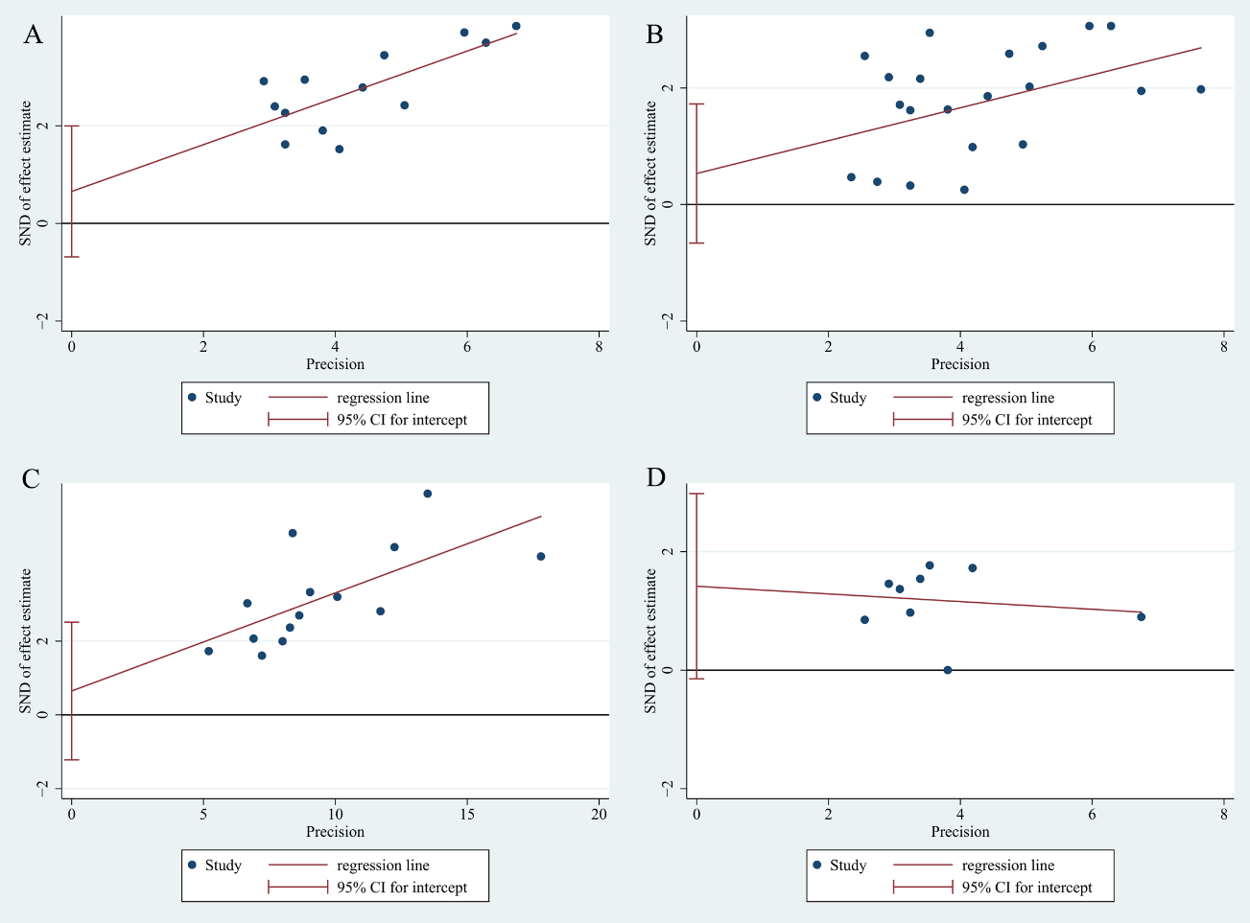 Supplementary Fig. 6. Egger’s test for included studies. (A) TirAEs. (B) flares. (C) new onset irAEs. (D) ORR

