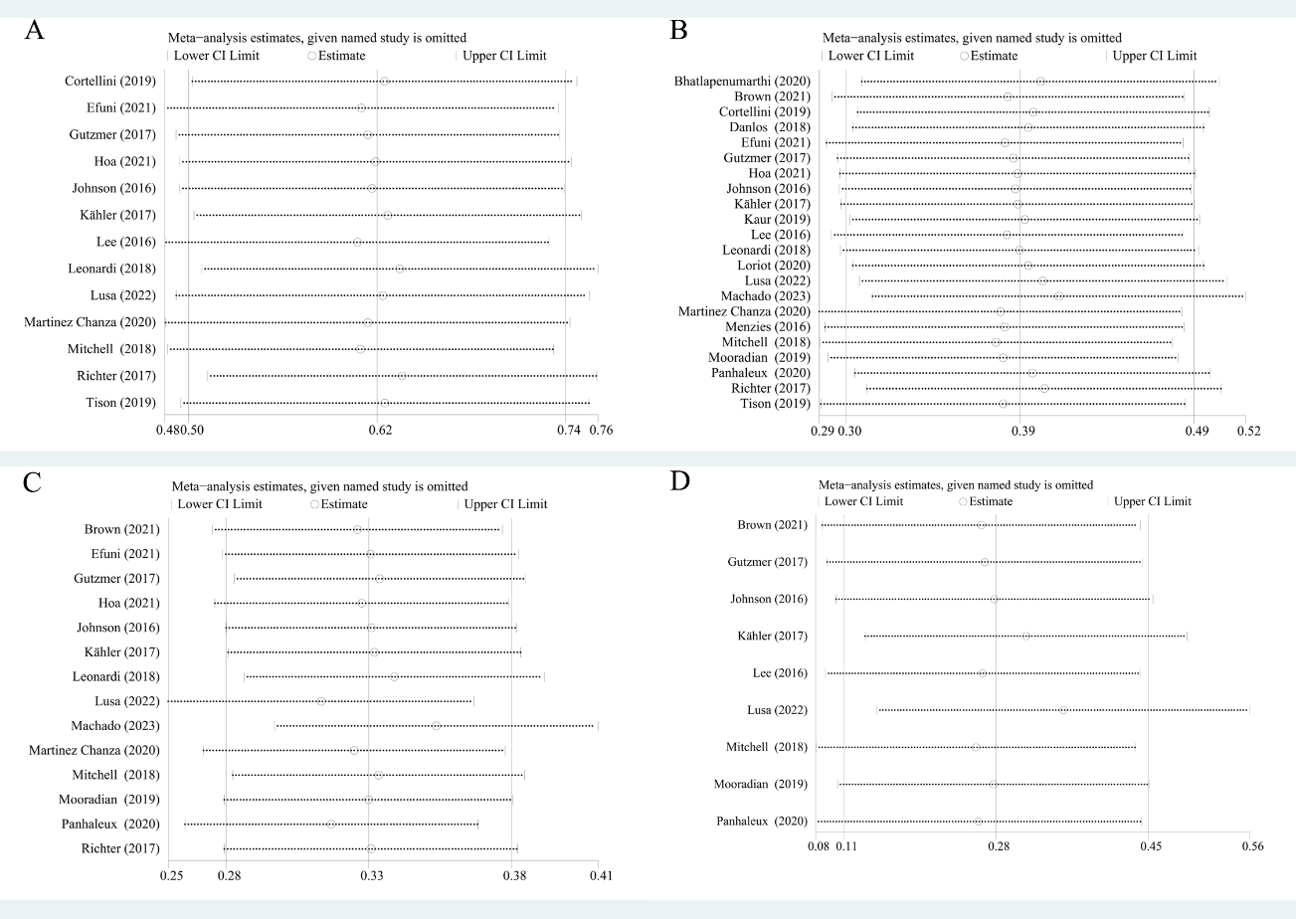
Supplementary Fig. 7. The results of sensitivity analyses. (A) TirAEs. (B) flares. (C) new onset irAEs. (D) ORR

