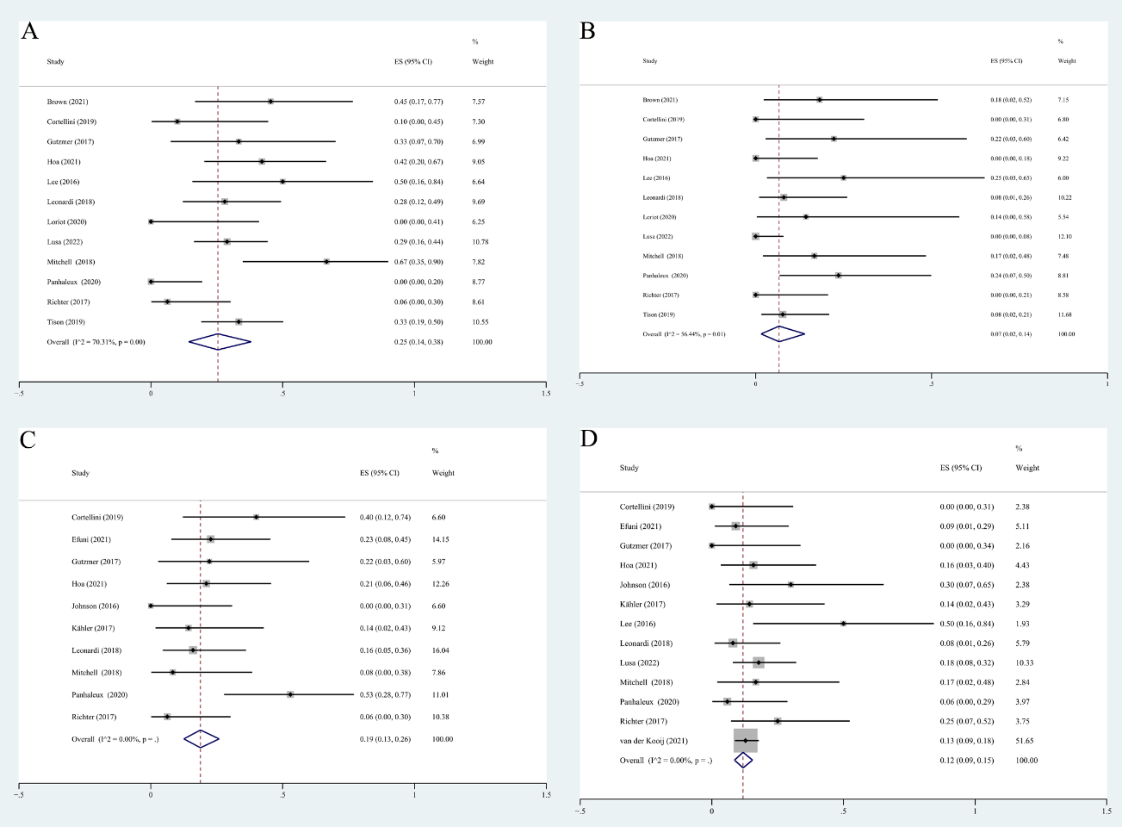
Supplementary Fig. 2. (A) The pooled incidence rates of flares grade 1-2. (B) The pooled incidence rates of flares grade 3-4. (C) The pooled incidence rates of new onset irAEs grade 1-2. (D) The pooled incidence rates of new onset irAEs grade 3-4

