Supplementary Materials
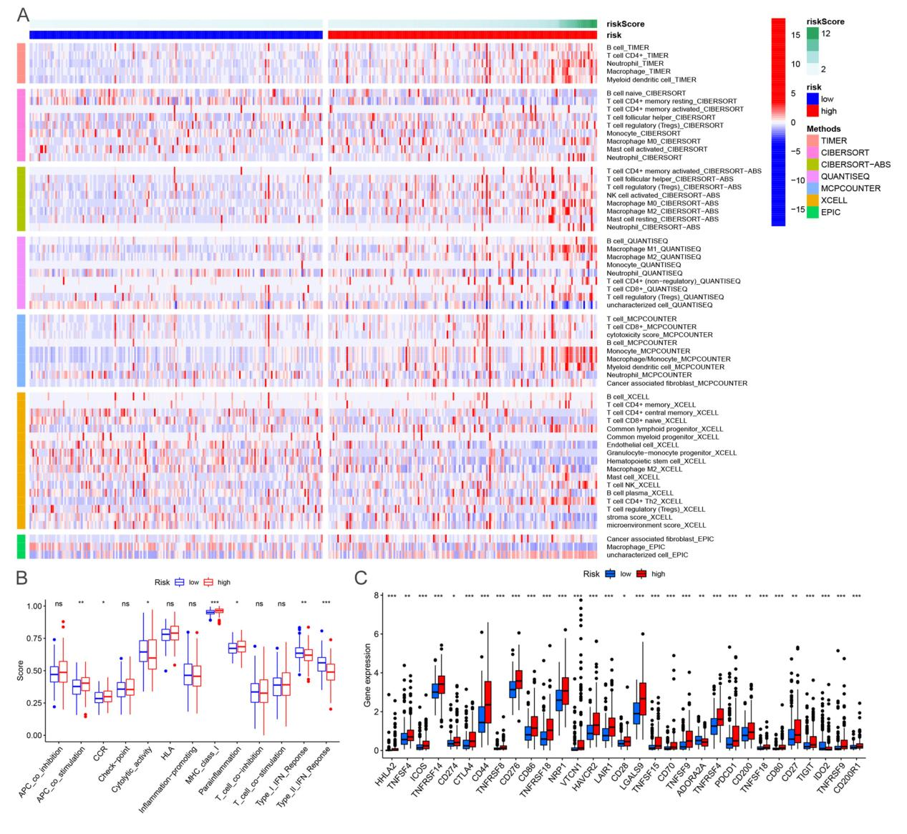
Figure S1. A. Heatmap for immune responses based on CIBERSORT, ESTIMATE, quanTIseq, xCell, MCP-counter, EPIC, and TIMER algorithms among the high and low-risk groups. B. The correlation between immune cell subpopulations and related functions was evaluated using ssGSEA. C. Expression of common immune checkpoints between the high and low-risk HCC patients.

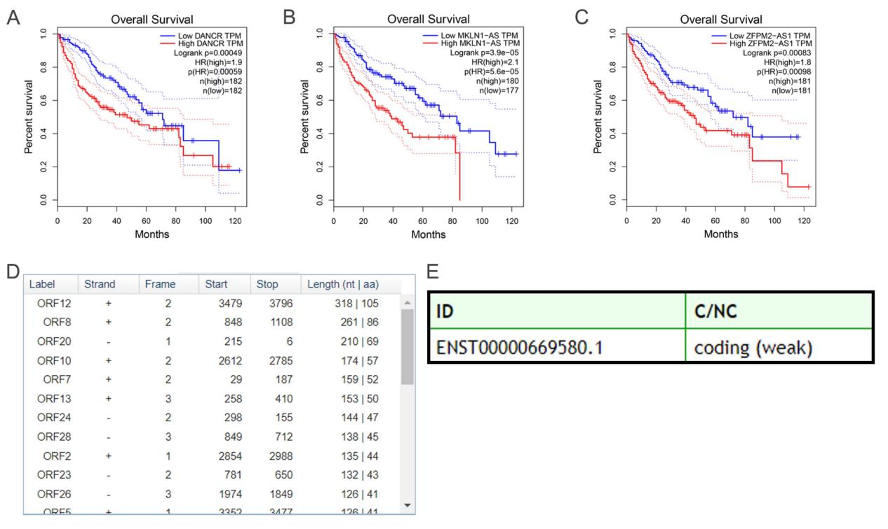
Figure S2. A-C. Overall survival of HCC patients (N=362) from the Gepia project with high or low expression levels. D. The protein-coding potential analysis of NRAV was performed using the ORF finder from NCBI. E. Using CPC 2.0 to predict the coding capability of NRAV. Table S1. The list of 174 ferroptosis-related DEGs. Table S2. The list of primer sequences. (Supplementary Materials)

