Supplemental materials
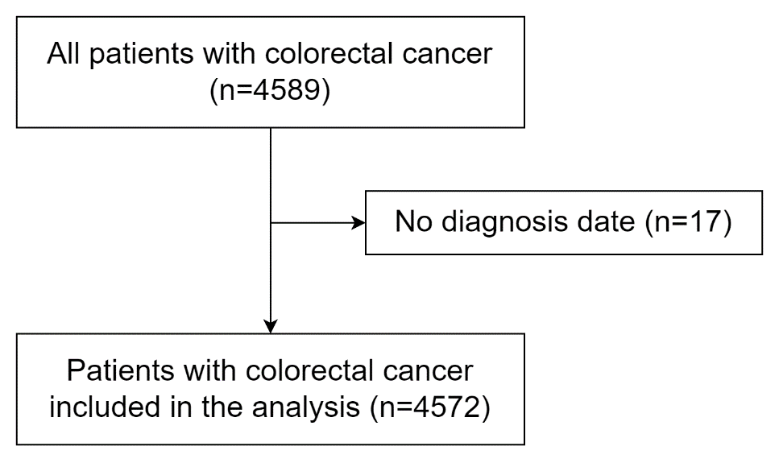

Figure S1 Flow chart of patient selection process.
Figure S2 Distribution of age at diagnosis of the included 4572 cases of colorectal cancer

Table S1 Distribution of sample size across geographical regions.
Geographical regions | Hospitals | Sample Size
Eastern | ⑪ Zhejiang Cancer Hospital | 435
Eastern | ⑩ School of Nursing, Jining Medical University | 877
Northern | ③ Beijing Office for Cancer Prevention and Control, Peking University Cancer Hospital & Institute | 288
Northern | ④ Department of Public Health and Preventive Medicine, Baotou Medical College | 275
Southern | ⑫ Sun Yat-sen University Cancer Center | 168
Southern | ⑬ The First Affiliated Hospital, Jinan University | 165
Southern | ⑭ The First Affiliated Hospital of Guangxi Medical University | 163
Southern | ⑮ Wuzhou Red Cross Hospital | 169
Central | ⑧ Henan Cancer Hospital | 331
Central | ⑨ Xinxiang Central Hospital | 358
Northeast | ① Cancer Hospital of China Medical University, Liaoning Cancer Hospital and Institute | 173
Northeast | ② Dalian Medical University | 191
Southwest | ⑱ Sichuan Cancer Hospital & Institute | 222
Southwest | ⑲ Chengdu Medical College | 102
Southwest | ⑯ Chongqing Cancer Hospital | 164
Southwest | ⑰ Chongqing Medical University | 164
Northwest | ⑦ Affiliated Tumor Hospital, Xinjiang Medical University | 166
Northwest | ⑤ Gansu Provincial Cancer Hospital | 88
Northwest | ⑥ The First People's Hospital of Lanzhou City | 73

Table S2 Semi-structured questionnaire on CRC knowledge

Questions | Answers
1. Before you were diagnosed with CRC, did you think which of the following was/were the high- risk factors of CRC? | A. Aged 50~74.
 | B. A history of colorectal adenoma.
 | C. A history of chronic diarrhoea, chronic constipation or bloody stool.
 | D. A history of chronic appendicitis or appendectomy.
 | E. A history of chronic cholecystitis or cholecystectomy.
 | F. Lack of physical exercise.
 | G. Unhealthy habits such as heavy smoking or drinking.
 | H. Unhealthy diet such as excessive intake of red meat, or less intake of vegetables and cellulose.
 | I. A first- degree family history of CRC.
 | J. Others, please specify: _____.
 | K. I did not know.
2. Before you were diagnosed with CRC, did you think which of the following was/were the procedure of CRC screening? | A. For the general population aged 50~74, questionnaire survey is needed for the first screening, then decide whether colonoscopy is necessary.
 | B. For the general population aged 50~74, faecal occult blood test should be done at least once a year. If it is positive, colonoscopy is required.
 | C. For the general population aged 50~74, colonoscopy screening should be done at least once every 5 years.
 | D. For a high- risk population, colonoscopy screening should be done at least once every year.
 | E. Others, please specify: ________.
 | F. I did not know.
3. Before you were diagnosed with CRC, did you think which of the following was/were the treatment methods of CRC? | A. Endoscopic treatment (endoscopic mucosal resection).
 | B. Surgical treatment (colectomy + regional lymphadenectomy).
 | C. Radiotherapy.
 | D. Chemotherapy.
 | E. Targeted therapy.
 | F. Traditional Chinese medicine treatment.
 | G. I did not know.

Table S3 Selected nine items from EORTC QLQ-C30
Scales or items | Questions
Physical scale | Do you need help with eating, dressing, washing yourself or using the toilet?
Cognitive scale | Have you had difficulty remembering things?
Emotional function | Did you feel irritable?
 | Did you feel depressed?
Social function | Has your physical condition or medical treatment interfered with your family life?
 | Has your physical condition or medical treatment interfered with your social activities?
Fatigue | Were you tired?
Sleep disturbance | Have you had trouble sleeping?
Financial impacts | Has your physical condition or medical treatment interfered with your financial difficulties?

Table S4 The estimated effects of multivariate regressions on early-onset CRC and HRQOL.

Variables | Beta | Se | P value
Early-onset CRC | -0.753 | 0.737 | 0.307
HRQOL before treatment | 0.614 | 0.012 | < 0.001
Sex
Male | 2.996 | 0.614 | < 0.001
Female | Reference
Clinical stage at first diagnosis
Ⅰ | Reference
Ⅱ | -1.066 | 2.008 | 0.596
Ⅲ | -1.406 | 1.933 | 0.467
Ⅳ | -4.800 | 1.948 | 0.014
Location of cancer
Colon | Reference
Rectum | -3.841 | 0.602 | < 0.001
Education level
Primary school or below | Reference
Middle school | 0.016 | 0.770 | 0.983
High school/specialized secondary schools | 0.122 | 0.840 | 0.884
University/specialty or above | 1.490 | 0.956 | 0.119
CRC, colorectal cancer; HRQOL, health-related quality of life; LOCRC, late-onset colorectal cancer; EOCRC, early-onset colorectal cancer.

