Supplementary Tables and Figures：
Years | Normal patients | Abnormal patients
Years | n=1177 | n=95
2017 | 134(11%) | 32(34%)
2018 | 324(28%) | 16(17%)
2019 | 381(32%) | 27(28%)
2020 | 274(23%) | 17(18%)
2021 | 64(5.4%) | 3(3.1%)
Supplementary Table 1. The number and proportion of patients included each year. Data were shown as numbers (percentages).

Follow-up time(month) | Total | Normal patients | Abnormal patients
Follow-up time(month) | n=1272 | n=1177 | n=95
Median | 32.6 | 32.4 | 35.7
95%CI | 30.96-34.24 | 30.72-34.08 | 27.40-43.93
Supplementary Table 2. The median follow-up time for the study population using the Reverse Kaplan-Meier method. CI, confidence interval.

Biomarkers |  |  | CEA | CA50 | CA19-9 | CA242 | CA72-4
CK-MB/CK | Total | Rho | 0.215 | 0.156 | 0.154 | 0.168 | 0.158
CK-MB/CK | Total | P | <0.001 | <0.001 | <0.001 | <0.001 | <0.001
CK-MB/CK | Stage I | Rho | 0.220 | 0.252 | 0.156 | 0.188 | 0.138
CK-MB/CK | Stage I | P | 0.002 | 0.007 | 0.09 | 0.009 | 0.2
CK-MB/CK | Stage II | Rho | 0.198 | 0.043 | 0.116 | 0.083 | 0.046
CK-MB/CK | Stage II | P | <0.001 | 0.5 | 0.05 | 0.08 | 0.4
CK-MB/CK | Stage III | Rho | 0.215 | 0.188 | 0.167 | 0.203 | 0.219
CK-MB/CK | Stage III | P | <0.001 | <0.001 | <0.001 | <0.001 | <0.001
CK-MB/CK | Male | Rho | 0.205 | 0.138 | 0.152 | 0.188 | 0.101
CK-MB/CK | Male | P | <0.001 | 0.003 | 0.001 | <0.001 | 0.03
CK-MB/CK | Female | Rho | 0.229 | 0.178 | 0.154 | 0.127 | 0.232
CK-MB/CK | Female | P | <0.001 | 0.001 | 0.002 | 0.003 | <0.001
CK-MB/CK | Age(≤60) | Rho | 0.262 | 0.172 | 0.179 | 0.206 | 0.160
CK-MB/CK | Age(≤60) | P | <0.001 | <0.001 | <0.001 | <0.001 | 0.001
CK-MB/CK | Age(＞60) | Rho | 0.166 | 0.142 | 0.131 | 0.133 | 0.157
CK-MB/CK | Age(＞60) | P | <0.001 | 0.003 | 0.006 | <0.001 | 0.001
Supplementary Table 3. The correlation analysis of CK-MB/CK and other biomarkers. Rho and P values from Spearman's correlation test. CK-MB, creatine kinase type M and B; CK, creatine kinase.

Variable | χ² | P value
CK-MB/CK | 0.037 | 0.8
CA19-9 | 0.342 | 0.6
CA242 | 0.561 | 0.5
Supplementary Table 4. Evaluating the proportional hazards assumption of the Cox model by the Schoenfeld residual test. χ² and P values from Schoenfeld residual test.

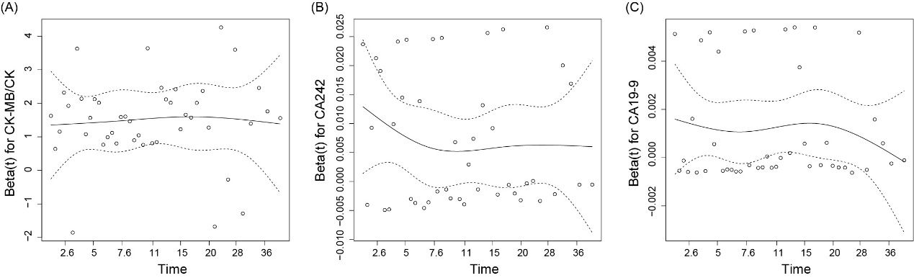
Supplementary Figure 1. The residual plot for CK-MB/CK, CA242, and CA19-9. CA, carbohydrate antigen; CK-MB, creatine kinase type M and B; CK, creatine kinase.

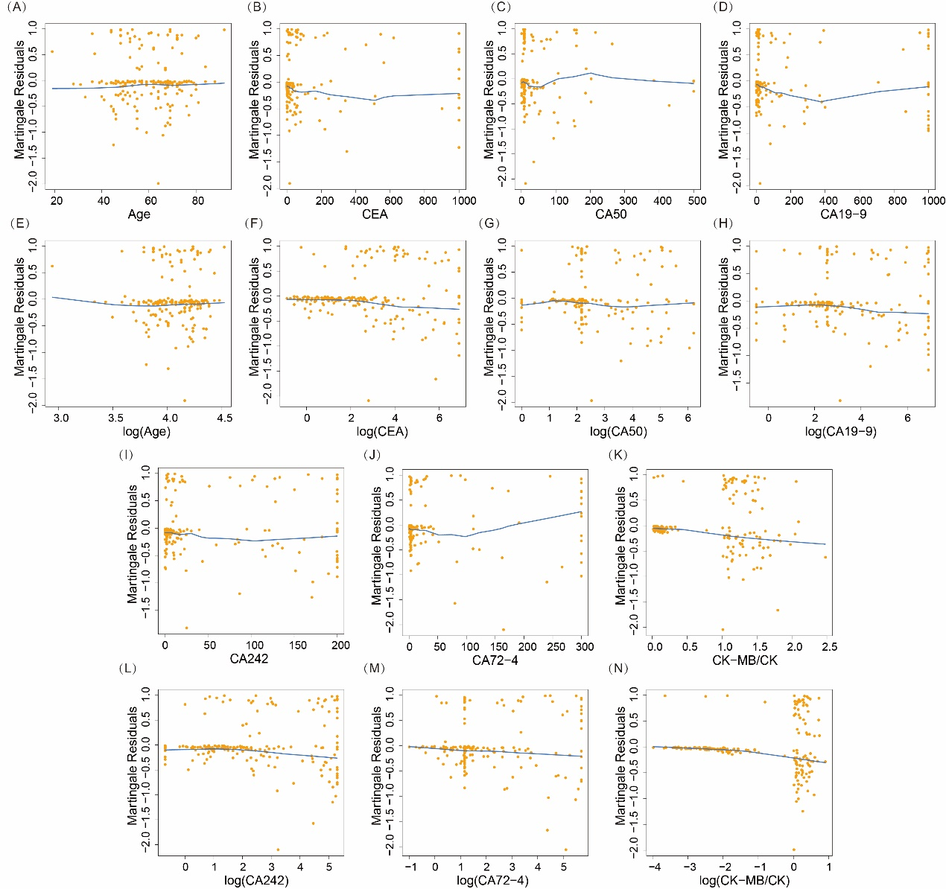
Supplementary Figure 2. Martingale residual scatter plot of Cox regression analyses on overall survival. Abbreviations: CEA, carcinoembryonic antigen; CA, carbohydrate antigen; CK-MB, creatine kinase type M and B; CK, creatine kinase.

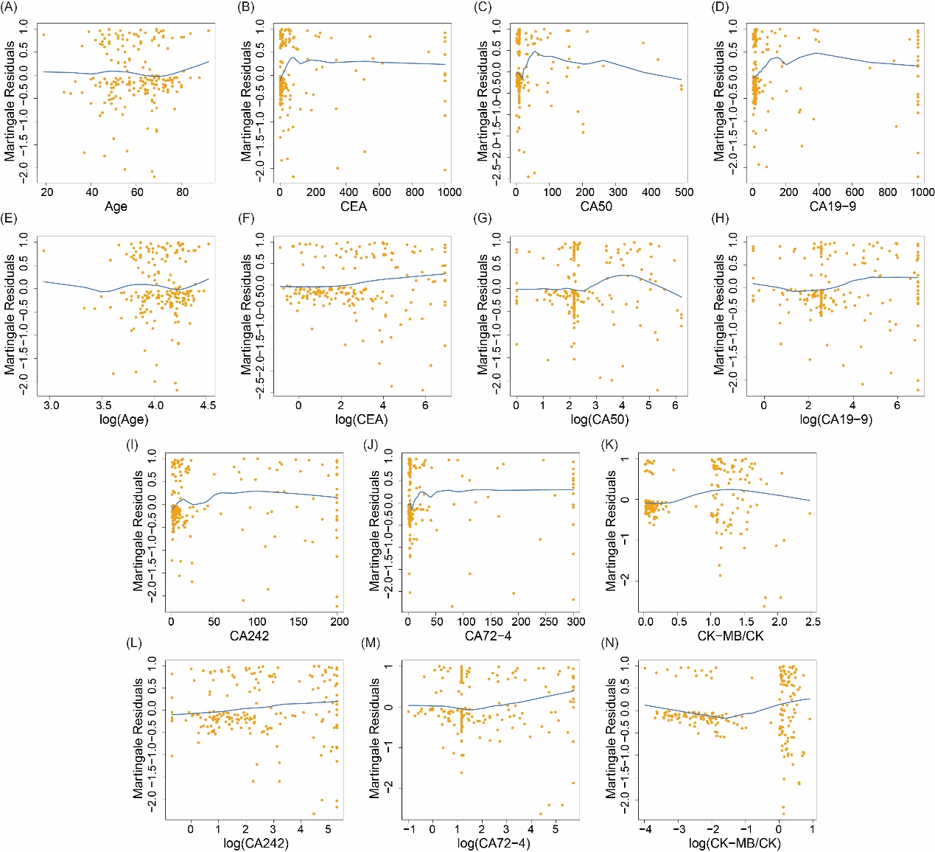
Supplementary Figure 3. Martingale residual scatter plot of Cox regression analyses on disease-free survival. Abbreviations: CEA, carcinoembryonic antigen; CA, carbohydrate antigen; CK-MB, creatine kinase type M and B; CK, creatine kinase.

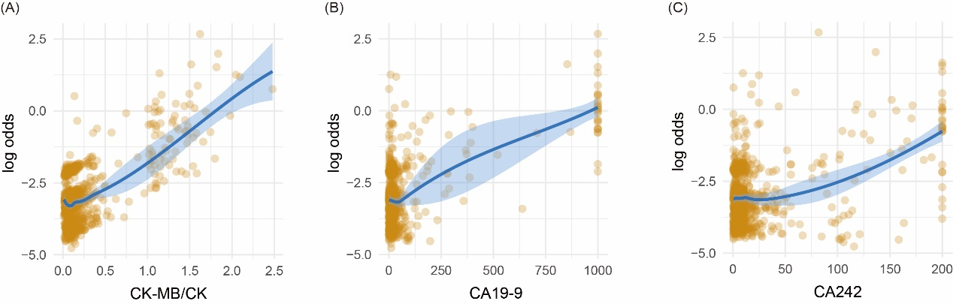
Supplementary Figure 4. Scatter plot to verify linear conditions in logistic regression analysis. Abbreviations: CA, carbohydrate antigen; CK-MB, creatine kinase type M and B; CK, creatine kinase.

