Supplementary figure legends

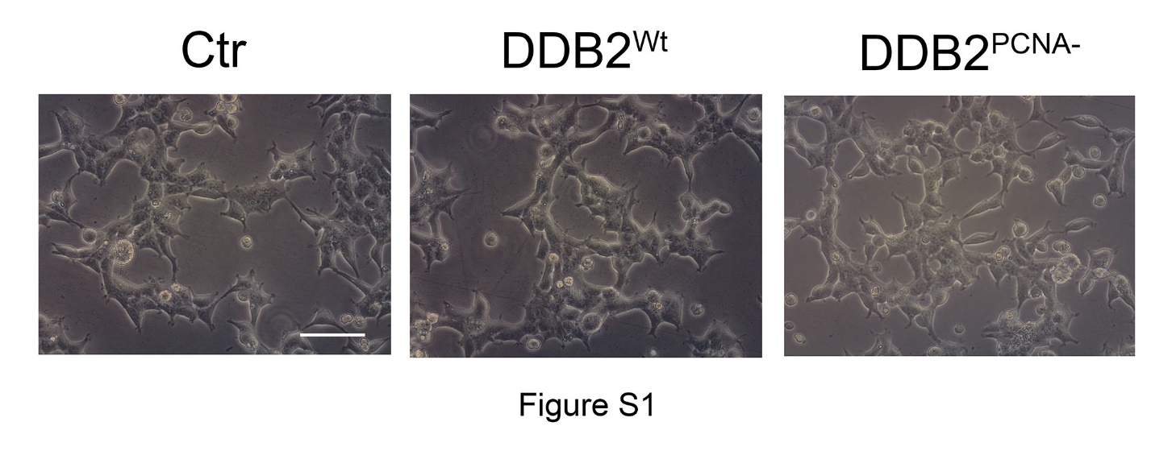

Figure S1 - Representative images of morphological phenotypes of unirradiated control (Ctr), DDB2^{Wt} or DDB2^{PCNA-} clones (scale bar = 50 μm).
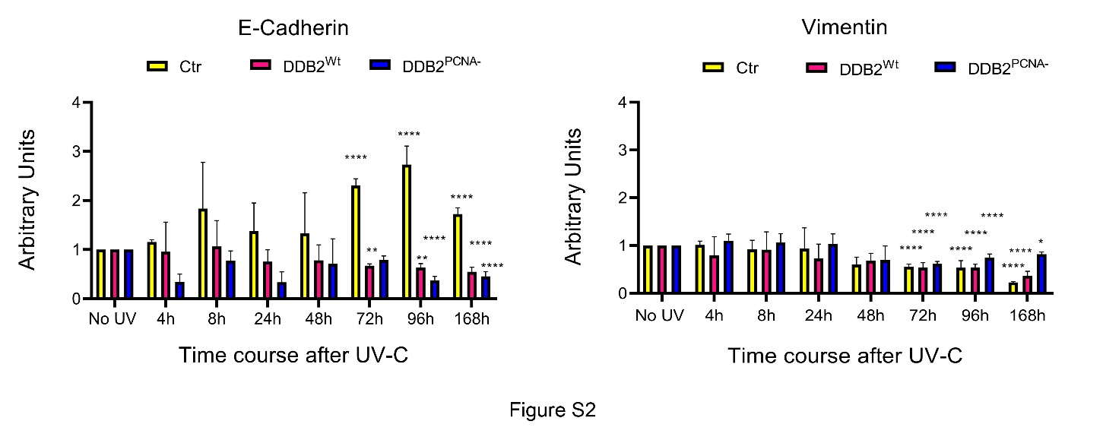
Figure S2 - Complete time-course of E-Cadherin and Vimentin expression after UV damage. Data are the mean ± S.D. from at least three independent experiments. Statistical significance was calculated using the one-way ANOVA with Tukey’s multiple comparison; *p<0.05; **p<0.01; ***p<0.001 and ****p<0.0001. The statistical significance, calculated at different times after UV, is towards the unirradiated samples.
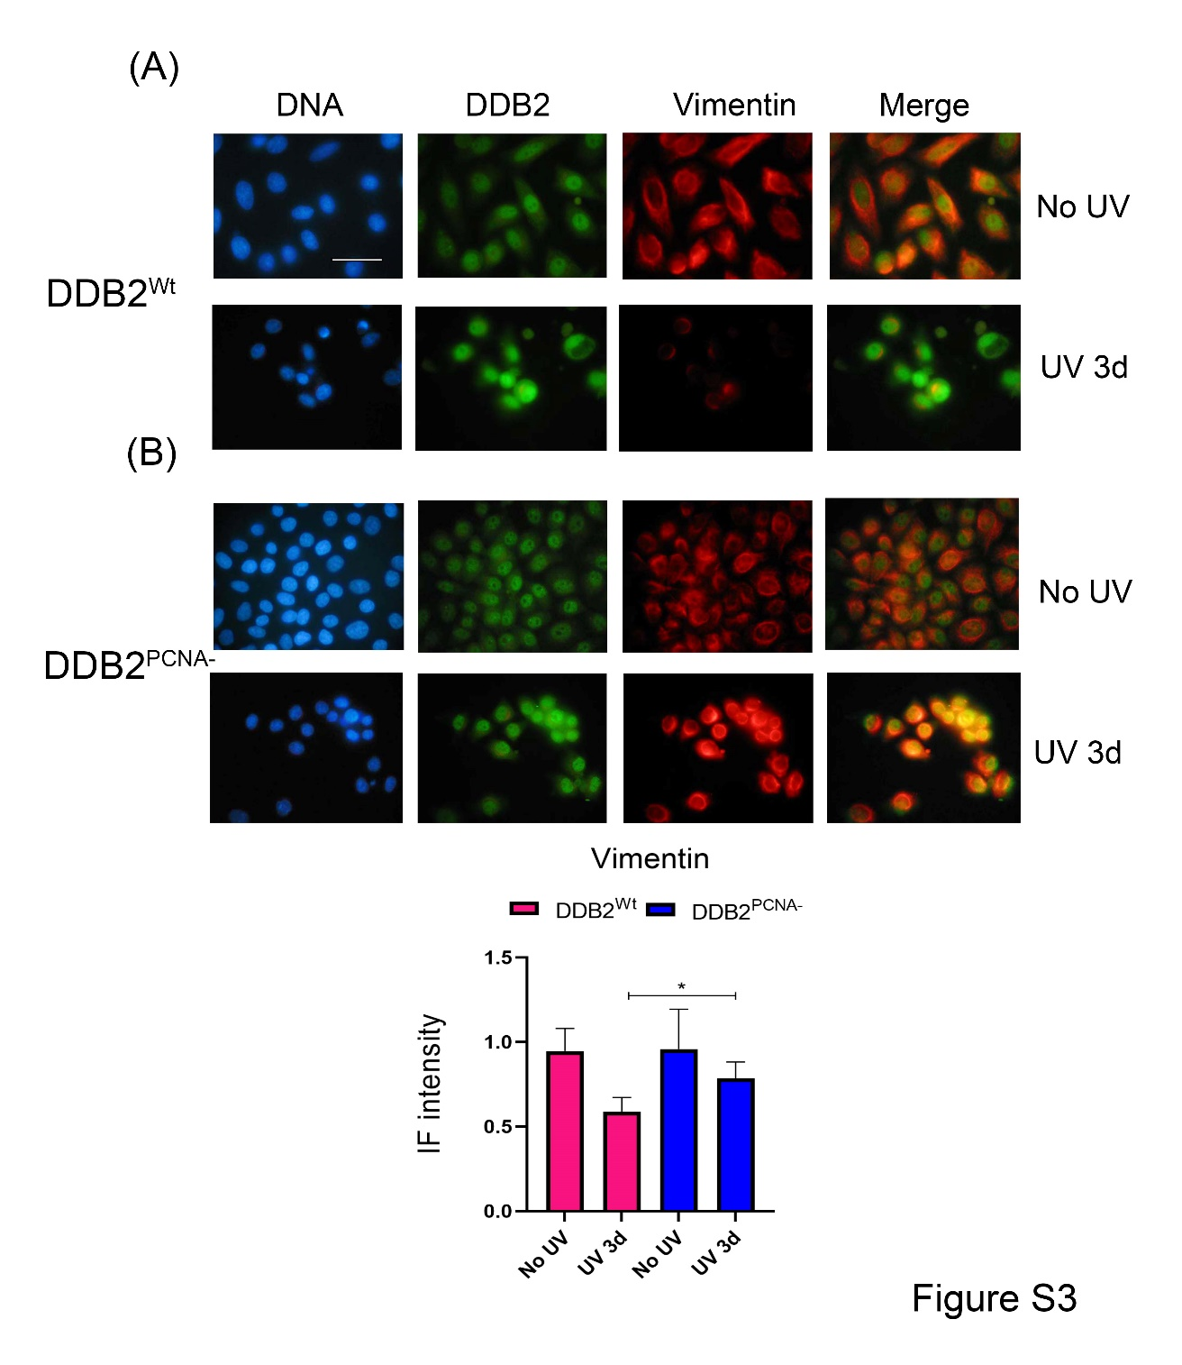
Figure S3 - Immunofluorescence analysis of Vimentin expression. HeLa cells transiently transfected with DDB2^{Wt} or DDB2^{PCNA-} constructs were irradiated and stained in blue (DNA), green (DDB2) and red (Vimentin); (scale bar = 50 μm).
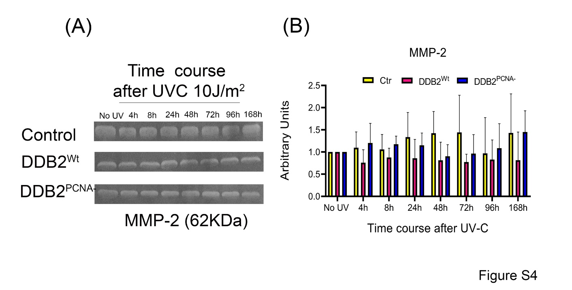
Figure S4 - Time course of MMP2 activity. Gel electrophoresis of MMP2 (A) and densitometric analysis of the obtained results (B).
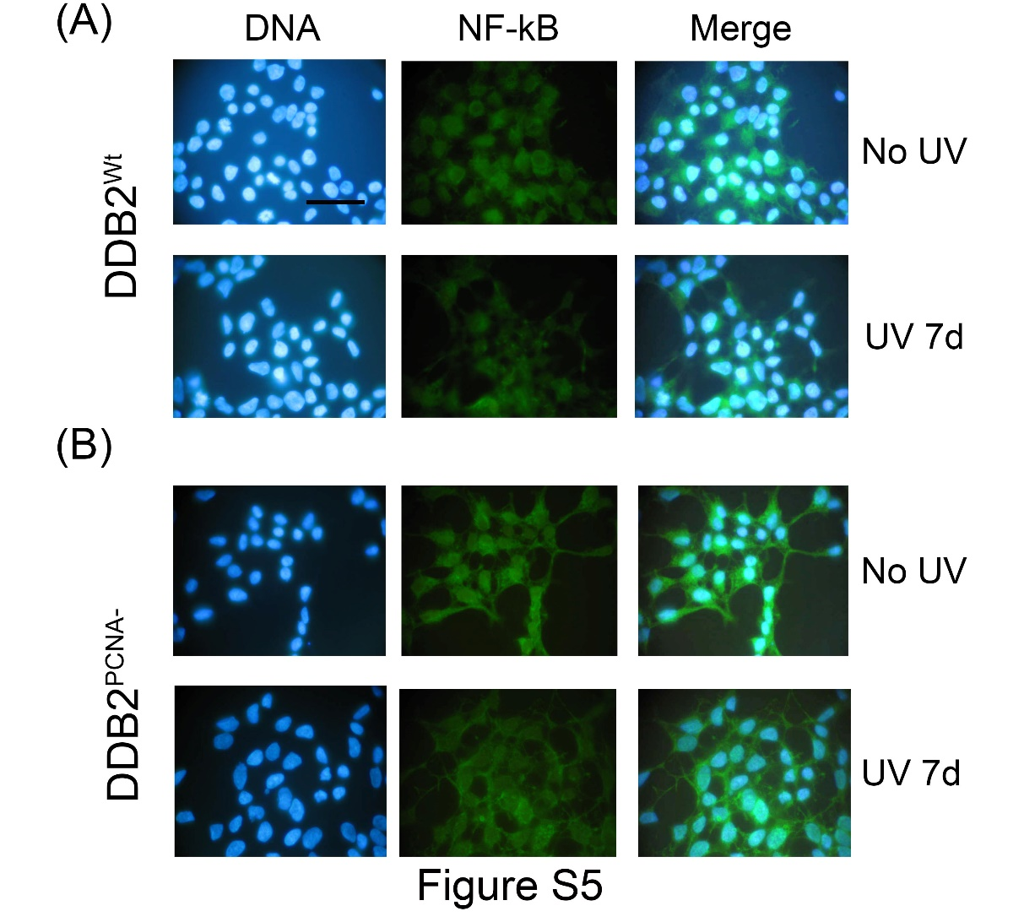
Figure S5 - Immunofluorescence analysis of NF-kB cellular distribution in untreated and UV-treated DDB2^{Wt} and DDB2^{PCNA-} clones. First panel DNA (blue, Hoechst staining), second panel NF-kB (green), third panel (merge) (scale bar = 50 μm).

WB – Original uncropped WB images of Figure 1 (1C and 1E), Figure 4 (4C and D), Figure 5 (5A), Figure 6 (6A and 6B), and figure 7 (7A).

