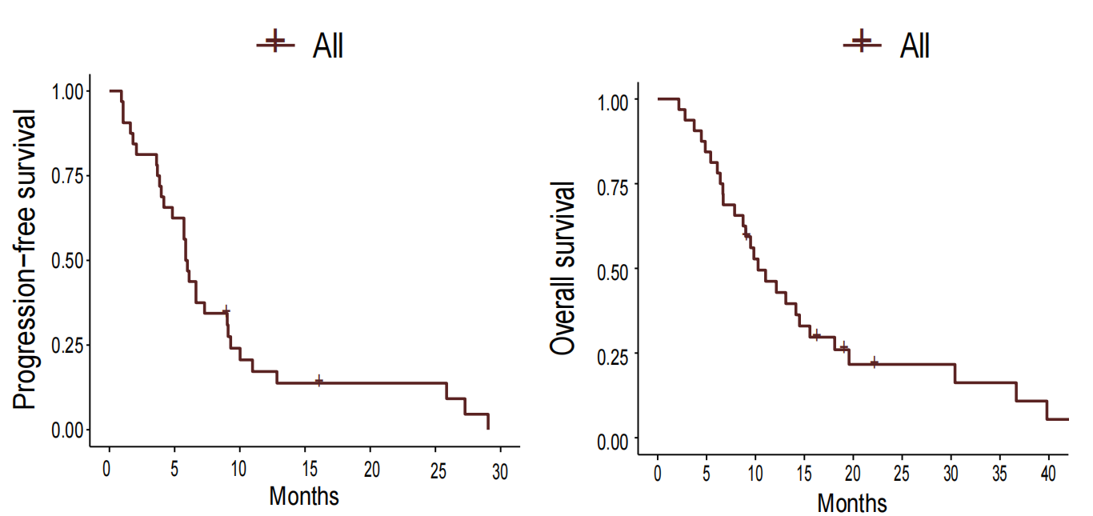
Figure S1. Progression-free survival and overall survival curves for all patients

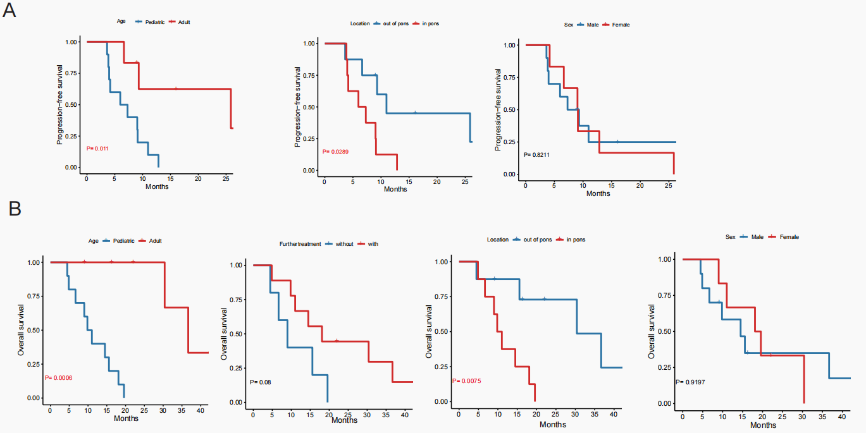

Figure S2. Prognostic analysis of newly diagnosed patients
A Progression-free survival was compared between groups based on age, tumor location, sex.
B Overall survival was compared between groups based on age, tumor location, further treatment, sex.

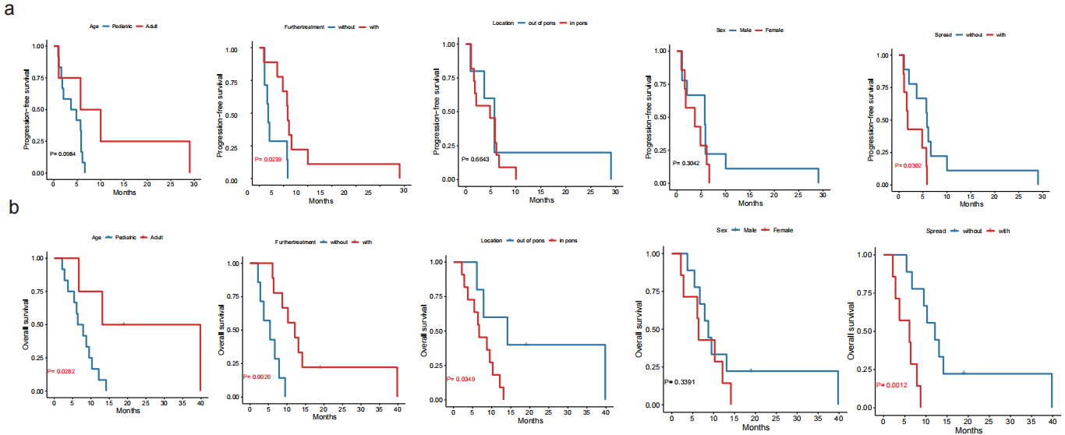
Figure S3. Prognostic analysis of recurrent patients
A Progression-free survivals were compared between groups based on age, tumor location, further treatment, sex, and spread.
B Overall survivals were compared between groups based on age, tumor location, further treatment, sex, and spread.

TableS1. Treatment in newly diagnosed patients
Patient ID | Gender | Age | Location | Treament history | Progressed | PFS(months) | Salvage treatment | Status | OS(months)
3 | M | 9 | Pon | Partial+XRT | Yes | 6.0 | Supportive care | Dead | 6.7
5 | M | 31 | Thalamus | Subtotal+XRT/TMZ | Yes | 9.3 | Bev mono-/combined therapy | Alive | 42.6+
6 | M | 10 | Pon | Partial+XRT/TMZ | Yes | 4.0 | Clinical trials | Dead | 4.9
8 | F | 23 | Thalamus | Total+XRT/TMZ | Yes | 25.9 | Reoperation/Clinical trials | Dead | 30.4
9 | F | 8 | Pon | Partial+XRT/TMZ | Yes | 4.2 | Supportive care | Dead | 9.0
11 | M | 5 | Pon | Partial+XRT | Yes | 7.3 | Bev mono-/combined therapy | Dead | 9.8
12 | M | 9 | Thalamus | Total+XRT/TMZ | Yes | 3.6 | Supportive care | Dead | 4.5
13 | M | 5 | Pon | Partial+XRT/TMZ | Yes | 3.8 | Reoperation/Clinical trials | Dead | 14.5
14 | F | 15 | Pon | Subtotal+XRT/TMZ | Yes | 9.1 | Clinical trials | Dead | 18.1
16 | M | 53 | Thalamus | Partial+XRT/TMZ | Yes | 27.3 | Reoperation/Bev mono-/combined therapy | Dead | 36.7
18 | M | 15 | Ventricles | Partial+XRT/TMZ | Yes | 11.0 | Supportive care | Dead | 15.6
22 | F | 12 | Pon | Biopsy+XRT/TMZ | Yes | 12.8 | Supportive care | Dead | 19.6
25 | M | 47 | Thalamus | Subtotal+XRT/TMZ | Not available | 9.1+ | Not available | Not available | 9.1+
26 | M | 35 | Spine | Partial+XRT/TMZ | Not available | 16.3+ | Not available | Not available | 16.3+
28 | F | 55 | Ventricle | Partial+XRT/TMZ | Yes | 6.6 | Bev mono-/combined therapy | Alive | 22.2+
32 | F | 7 | Pon | Partial+XRT/TMZ | Yes | 9.0 | Bev mono-/combined therapy | Dead | 11.0
XRT radiation therapy; XRT/TMZ, Temozolomide concurrent chemoradiotherapy; Bev Bevacizumab

Table S2. Univariate prognostic analysis of newly diagnosed patients
Factors | OS |  |  | PFS
Factors | median | 95%CI | P Value | median | 95%CI | P Value
Gender  male  female | 14.5  18.1 | 6.52-22.48  7.86-28.35 | 0.920 | 7.3  9.0 | 2.72-11.86  6.08-11.99 | 0.821
Age
≥18 | 36.7 | 26.64-46.70 | 0.001 | 25.9 | 0.370-51.341 | 0.011
＜18 | 9.8 | 6.68-12.98 | 0.001 | 6.0 | 1.143-10.816 | 0.011
Location
Pons | 9.8 | 7.02-12.65 | 0.008 | 6.0 | 1.654-10.305 | 0.029
Out of pons | 30.4 | 11.10-49.70 | 0.008 | 11.0 | 6.852-15.095 | 0.029
Diameter |  |  | 0.636 |  |  | 0.914
≤3 | 9.8 | - | 0.636 | 7.3 | - | 0.914
>3 | 15.6 | 9.47-21.66 | 0.636 | 9.0 | 4.52-13.55 | 0.914
WHO Grade |  |  | 0.806 |  |  | 0.855
2 | 9.0 | - | 0.806 | 4.2 | - | 0.855
3 | 4.9 | - | 0.806 | 4.0 | - | 0.855
4 | 15.6 | 9.84-21.30 | 0.806 | 9.0 | 6.34-11.73 | 0.855
Ki67（%） |  |  | 0.667 |  |  | 0.264
≤ 5 | 19.6 | - | 0.667 | 12.8 | - | 0.264
>5 | 15.6 | 8.89-22.25 | 0.667 | 9.0 | 4.40-13.66 | 0.264
MGMT |  |  | 0.600 |  |  | 0.233
methylated | 30.4 | - | 0.600 | 25.9 | - | 0.233
unmethylated | 15.57 | 8.23-22.91 | 0.600 | 9.0 | 3.96-14.11 | 0.233
Surgical intervention |  |  | 0.617 |  |  | 0.880
biopsy only | 19.6 | - | 0.617 | 12.8 | - | 0.880
partial resection | 11.0 | 3.80-18.26 | 0.617 | 6.6 | 4.60-8.67 | 0.880
Gross/sub total | 30.4 | 8.89-51.92 | 0.617 | 9.3 | 4.58-14.01 | 0.880
Responses |  |  | 0.771 |  |  | 0.043
PR | 9.8 | - | 0.771 | 7.3 | - | 0.043
SD | 18.1 | 6.35-29.85 | 0.771 | 9.1 | 5.98-12.22 | 0.043
PD | 14.5 | - | 0.771 | 3.8 | - | 0.043
Salvage treatment |  |  |  | N/A
Anti-tumor | 18.1 | 7.58-28.61 | 0.080
Supportive | 9.0 | 3.99-14.01 | 0.080

Table S3. Treatment in recurrent patients
Patient ID | Gender | Age(years) | Location | Spread | Times of recurrence | Initial treatment | First PFS(months) | Second-line treatment | Second PFS(months) | Current Treatment | PFS(months) | Status | OS(months)
1 | M | 13 | Pon | No | 1 | Biopsy+XRT/TMZ+adjTMZ | 10.8 | - | - | Partial+TMZ/Apa | 2.1 | Dead | 5.4
2 | F | 8 | Pon | Yes | 1 | Partial+XRT/TMZ+ Cytotoxic drugs | 5.7 | - | - | TMZ/Apa | 1.8 | Dead | 2.8
4 | M | 13 | Pon | No | 1 | Partial+XRT/TMZ+ Cytotoxic drugs | 15.2 | - | - | TMZ/Apa | 5.8 | Dead | 9.4
7 | M | 31 | Thalamus | No | 1 | Partial+XRT/TMZ+adjTMZ | 5.5 | - | - | TMZ/Apa | 29.0 | Dead | 39.2
10 | M | 28 | Pon | No | 1 | Partial+XRT/TMZ+adjTMZ | 5.4 | - | - | TMZ/Apa | 10.0 | Dead | 12.9
15 | M | 17 | Thalamus | Yes | 1 | Partial+XRT/TMZ+adjTMZ | 6.1 | - | - | TMZ/Apa | 1.1 | Dead | 3.7
17 | F | 7 | Pon | No | 1 | Partial+XRT/TMZ/Bev+adjTMZ | 9.8 | - | - | TMZ/Apa | 6.1 | Dead | 10.2
19 | M | 26 | Pon | No | 1 | Partial+XRT | 23.7 | - | - | TMZ/Apa | 1.1 | Dead | 6.6
20 | F | 9 | Pon | Yes | 1 | Partial+XRT/TMZ+adjTMZ | 20.6 | - | - | TMZ/Apa | 0.9 | Dead | 6.0
21 | M | 33 | brachium pontis | No | 2 | Total+XRT/TMZ+adjTMZ | 33.9 | reXRT/Nimot+adjTMZ | 15.6 | TMZ/Apa | 5.7 | Alive | 18.8+
23 | F | 8 | Pon | Yes | 1 | Partial+XRT/TMZ | 3.2 | - | - | TMZ/Apa | 1.6 | Dead | 2.1
24 | F | 8 | Pon | Yes | 2 | Partial | 2.4 | XRT/TMZ | 2.9 | TMZ/Apa | 4.8 | Dead | 6.3
27 | F | 10 | Thalamus | No | 1 | Subotal+XRT/TMZ+adjTMZ | 6.0 | - | - | TMZ/Apa | 3.7 | Dead | 13.9
29 | F | 10 | Pon | No | 1 | Partial+XRT/TMZ+adjTMZ | 3.4 | - | - | TMZ/Apa | 6.6 | Dead | 12.0
30 | M | 13 | Thalamus | Yes | 1 | Partial+XRT/TMZ+adjTMZ | 6.9 | - | - | TMZ/Apa | 5.8 | Dead | 8.6
31 | M | 10 | Ventricle | Yes | 1 | Partial+XRT/TMZ | 4.5 | - | - | TMZ/Apa | 5.7 | Dead | 7.8

Table S4. Prognostic analysis of recurrent patients
Factors | OS |  |  | PFS
Factors | median | 95%CI | P Value | median | 95%CI | P Value
Gender  male  female | 8.6  6.3 | 6.10-11.12  5.54-7.08 | 0.339 | 5.7  3.7 | 0.39-11.04  0-8.49 | 0.304
Age
≥18 | 12.9 | 0-34.228 | 0.028 | 5.7 | 0-8.364 | 0.098
＜18 | 6.3 | 3.357-9.263 | 0.028 | 3.7 | 0-14.506 | 0.098
Location
Pons | 6.6 | 3.158-10.042 | 0.035 | 4.8 | 3.931-7.502 | 0.664
Out of pons | 13.9 | 0.661-27.199 | 0.035 | 5.7 | 1.559-8.100 | 0.664
Spread or not
Spread | 6.0 | 6.788-17.132 | 0.001 | 1.8 | 1.301-2.313 | 0.030
no | 12.0 | 0.031-11.989 | 0.001 | 5.8 | 5.464-6.232 | 0.030
MGMT |  |  | 0.114 |  |  | 0.109
methylated | 6.0 | - | 0.114 | 0.9 | - | 0.109
unmethylated | 8.6 | 5.88-11.34 | 0.114 | 5.7 | 2.31-9.13 | 0.109
Responses |  |  | 0.007 |  |  | <0.001
PR | 12.9 | - | 0.007 | 10.0 | - | <0.001
MR | 12.0 | 6.60-17.32 | 0.007 | 5.8 | 2.38-9.32 | <0.001
SD | 7.8 | 4.09-11.41 | 0.007 | 5.7 | 4.71-6.72 | <0.001
PD | 5.4 | 1.68-9.16 | 0.007 | 1.1 | 0.91-1.19 | <0.001
Salvage treatment |  |  |  | N/A
Anti-tumor | 12.0 | 6.788-17.132 | 0.003
Supportive | 5.4 | 0.955-9.885 | 0.003

Table S5. Comparison of efficiency in newly diagnosed patients with history
Year | Author | Regimen | Number of patients | The proportion of non-pontine patients | The proportion of adult patients | mPFS(months) | mOS(months)
Current | Yu-an Li | XRT or XRT/TMZ+adjTMZ/APA | 16 | 50.0% | 37.5% | 9.0 | 15.6
2011 | Cohen KJ | XRT/TMZ+adjTMZ | 58 | 0 | 0 | 6.1 | 9.6
2013 | Bailey S | XRT/TMZ+adjTMZ | 43 | 0 | 14.0% | 5.6 | 9.5
2014 | Aihara K | XRT/TMZ or ACNU | 10 | 100% | 90.0% | 6.0 | 10.4
2020 | Schulte JD | XRT or XRT/TMZ±adjTMZ | 60 | 91.7% | 100% | 9.6 | 29.6
2022 | Jang SW | XRT or XRT/TMZ±adjTMZ | 24 | 66.4% | 54.2% | 3.9 | 10.4

Table S6. Comparison of efficiency in recurrent patients with history
Year | Author | Regimen | Number of patients | Proportion of disseminated patients | Proportion of non-pontine patients | Proportion of adult patients | mPFS  (months) | 1-year PFS rate
Current | Yu-an Li | TMZ/APA | 16 | 43.8% | 37.5% | 25.0% | 4.8 | 6.3%
2017 | Lassaletta A | reXRT | 16 | 12.5% | 0 | 0 | 4.0 | 6.3%
2018 | Broniscer A | Dasatinib/Crizotinib | 25 | 12.0% | 56.0% | 8.0% | 1.4 | -
2014 | Bartels U | Nimotuzumab | 44 | - | 0 | 0 | 1.7 | 2.3%
2021 | EI-Khouly | CPT11+Bev+ Erlotinib | 9 | - | 0 | 0 | 3.2 | 11.1%

