Supplementary materials for

Associations between chronic obstructive pulmonary disease and ten common cancers: novel insights from Mendelian randomization analyses

Liao et al.

Figure S1. Scatter plot showing the SNP effects on both chronic obstructive pulmonary disease (exposure) and other types of cancer (outcome).
(The gray error bars denote the 95% confidence intervals of the effects; A-H represents cancer of esophagus, liver, colon and rectum, thyroid, stomach, prostate, cervix, and female breast, respectively.)
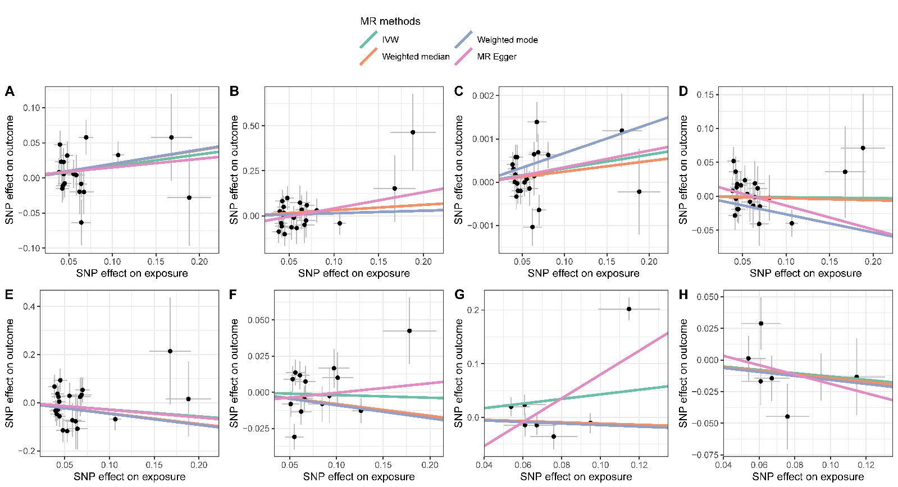

Figure S2. Leave-one-out analysis for chronic obstructive pulmonary disease and other types of cancer.
(The blue line denotes the integrated effect size; A-H represents cancer of esophagus, liver, colon and rectum, thyroid, stomach, prostate, cervix, and female breast, respectively.
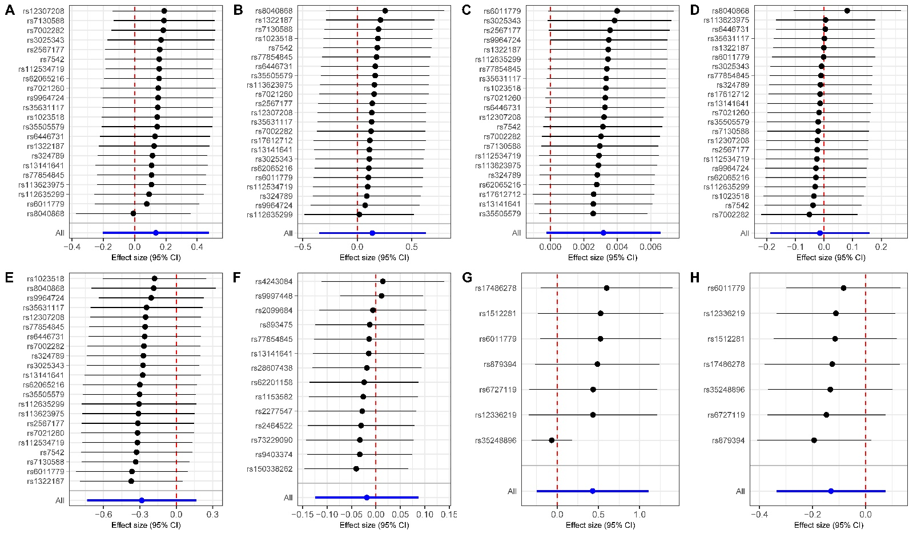

Table S1. Sample size for COPD GWAS in the Global Biobank Meta-analysis Initiative.
Endpoint | Sex | Ancestry | Biobank | Case | Control | Stage
COPD | Both sex | non-Finnish European | BioMe | 611 | 8193 | discovery
COPD | Both sex | non-Finnish European | BioVU | 4962 | 55358 | discovery
COPD | Both sex | non-Finnish European | CCPM | 1533 | 18365 | discovery
COPD | Both sex | non-Finnish European | ESTBB | 10596 | 115610 | discovery
COPD | Both sex | Finnish | FinnGen | 6915 | 186723 | discovery
COPD | Both sex | non-Finnish European | GS | 239 | 19793 | discovery
COPD | Both sex | non-Finnish European | HUNT | 5529 | 61332 | discovery
COPD | Both sex | non-Finnish European | Lifelines | 3103 | 22372 | discovery
COPD | Both sex | non-Finnish European | MGB | 3922 | 18033 | discovery
COPD | Both sex | non-Finnish European | MGI | 4834 | 37287 | discovery
COPD | Both sex | non-Finnish European | UCLA | 2005 | 14636 | discovery
COPD | Both sex | non-Finnish European | UKBB | 14310 | 379656 | discovery
COPD | Male | non-Finnish European | BioMe | 313 | 3906 | discovery
COPD | Male | non-Finnish European | BioVU | 2631 | 24203 | discovery
COPD | Male | non-Finnish European | CCPM | 769 | 7181 | discovery
COPD | Male | Finnish | FinnGen | 4521 | 81410 | discovery
COPD | Male | non-Finnish European | GS | 95 | 8132 | discovery
COPD | Male | non-Finnish European | HUNT | 2868 | 28653 | discovery
COPD | Male | non-Finnish European | Lifelines | 1582 | 8902 | discovery
COPD | Male | non-Finnish European | MGI | 2471 | 18580 | discovery
COPD | Male | non-Finnish European | UKBB | 7663 | 176589 | discovery
COPD | Female | non-Finnish European | BioMe | 298 | 4287 | discovery
COPD | Female | non-Finnish European | BioVU | 2359 | 31155 | discovery
COPD | Female | non-Finnish European | CCPM | 764 | 11184 | discovery
COPD | Female | Finnish | FinnGen | 2394 | 105313 | discovery
COPD | Female | non-Finnish European | GS | 144 | 11661 | discovery
COPD | Female | non-Finnish European | HUNT | 2661 | 32679 | discovery
COPD | Female | non-Finnish European | Lifelines | 1521 | 13470 | discovery
COPD | Female | non-Finnish European | MGI | 2363 | 18707 | discovery
COPD | Female | non-Finnish European | UKBB | 6758 | 206058 | discovery
COPD | Both sex | Europeans | CanPath | 137 | 7123 | replication
COPD | Both sex | Europeans | bbofa | 273 | 12440 | replication
COPD | Female | Europeans | bbofa | 214 | 8873 | replication
COPD | Male | Europeans | bbofa | 59 | 3567 | replication
COPD | Both sex | Europeans | PMBB | 2658 | 23439 | replication
COPD | Female | Europeans | PMBB | 947 | 10371 | replication
COPD | Male | Europeans | PMBB | 1711 | 13068 | replication

Table S2. Phenotype definitions recommended by GBMI.
COPD Cases | Controls
491,491.0,491.1,491.2,491.20,491.21,491.22,491.8,491.9,492,492.0,492.8,494,494.0,494.1,496, J41,J41.0,J41.1,J41.8,J42,J43,J43.0,J43.1,J43.2,J43.8,J43.9,J44,J44.0,J44.1,J44.8,J44.9,J47,J44.1,J44,J44.0,J47.1,J47.9,J47.0,J47,J43.2,J43.0,J43.1,J43.8,J43.9,J43,J41.8,J42,J41.1,J41.0,J41,J44.9 | Subjects with the following ICD codes were excluding from controls: 490,493,493.0,493.00,493.01,493.02,493.1,493.10,493.11,493.12,493.2,493.20,493.21,493.22,493.8,493.81,493.82,493.9,493.90,493.91,493.92,519.11,J40,J45,J45.0,J45.1,J45.8,J45.9,J46,J45.31,J45.901,J45.42,J45.41,J45.51,J45.990,J45.902,J45.21,J45.52,J45.32,J45.22,J40,J45.909,J45.998,J45.40,J45.20,J45,J45.991,J45.90,J45.30,J45.50,J98.01

Table S3. Instrumental variables for COPD.
Exposure | CHR | Position | Other allele. | Effect allele. | SNP | EAF | Beta | SE | P value
COPD | 4 | 3283024 | G | A | rs6446731 | 0.2942 | 0.041153 | 0.007281 | 1.58E-08
COPD | 4 | 66938586 | G | T | rs35631117 | 0.5407 | -0.04412 | 0.006699 | 4.54E-11
COPD | 4 | 111450477 | T | C | rs77854845 | 0.1316 | -0.05849 | 0.010049 | 5.88E-09
COPD | 4 | 144585304 | T | C | rs13141641 | 0.4527 | -0.06407 | 0.006769 | 2.92E-21
COPD | 5 | 132458080 | G | T | rs1023518 | 0.284 | 0.052684 | 0.007462 | 1.66E-12
COPD | 6 | 32648168 | A | T | rs17612712 | 0.4094 | 0.080828 | 0.012309 | 5.15E-11
COPD | 6 | 164951975 | G | T | rs1322187 | 0.3253 | 0.045065 | 0.007881 | 1.08E-08
COPD | 7 | 117456239 | T | C | rs112534719 | 0.02358 | 0.16781 | 0.023421 | 7.78E-13
COPD | 8 | 10809483 | A | G | rs7002282 | 0.5831 | -0.03969 | 0.006987 | 1.34E-08
COPD | 8 | 27479528 | A | T | rs35505579 | 0.09941 | 0.067262 | 0.011123 | 1.47E-09
COPD | 8 | 27555088 | A | G | rs113623975 | 0.1188 | -0.06895 | 0.010938 | 2.91E-10
COPD | 9 | 125908872 | C | T | rs7021260 | 0.7144 | 0.055274 | 0.008413 | 5.02E-11
COPD | 9 | 133613233 | G | A | rs3025343 | 0.09592 | 0.062135 | 0.011071 | 2.00E-08
COPD | 11 | 76559639 | A | G | rs7130588 | 0.3342 | 0.038492 | 0.007048 | 4.73E-08
COPD | 12 | 67723961 | T | C | rs12307208 | 0.09872 | -0.06417 | 0.011339 | 1.52E-08
COPD | 12 | 83553708 | G | T | rs324789 | 0.3877 | -0.04238 | 0.007747 | 4.49E-08
COPD | 14 | 94371805 | G | T | rs112635299 | 0.02004 | 0.18822 | 0.025347 | 1.12E-13
COPD | 15 | 78618839 | T | C | rs8040868 | 0.3877 | 0.10658 | 0.006838 | 9.00E-55
COPD | 16 | 30114519 | G | C | rs7542 | 0.4444 | -0.0419 | 0.007379 | 1.36E-08
COPD | 17 | 40062520 | G | A | rs62065216 | 0.4436 | 0.04386 | 0.007131 | 7.71E-10
COPD | 18 | 37579161 | C | T | rs9964724 | 0.7011 | -0.04799 | 0.007295 | 4.77E-11
COPD | 18 | 40870233 | A | C | rs2567177 | 0.3617 | 0.043086 | 0.007483 | 8.53E-09
COPD | 20 | 63352965 | C | T | rs6011779 | 0.7938 | -0.06982 | 0.008321 | 4.83E-17
COPD in males | 1 | 161530340 | A | G | rs2099684 | 0.2941 | 0.062192 | 0.010968 | 1.42E-08
COPD in males | 2 | 228688181 | A | G | rs62201158 | 0.07839 | -0.10131 | 0.016468 | 7.66E-10
COPD in males | 3 | 25501784 | C | T | rs1153582 | 0.2142 | -0.06671 | 0.010777 | 6.00E-10
COPD in males | 4 | 7851332 | C | A | rs28607438 | 0.1603 | 0.092395 | 0.013895 | 2.94E-11
COPD in males | 4 | 88939692 | G | A | rs2464522 | 0.7188 | 0.060897 | 0.00987 | 6.83E-10
COPD in males | 4 | 111450477 | T | C | rs77854845 | 0.1333 | -0.08461 | 0.015006 | 1.71E-08
COPD in males | 4 | 139949361 | C | T | rs9997448 | 0.337 | -0.05496 | 0.009774 | 1.88E-08
COPD in males | 4 | 144585304 | T | C | rs13141641 | 0.4092 | -0.06542 | 0.009005 | 3.74E-13
COPD in males | 5 | 132464267 | C | T | rs11748326 | 0.2069 | 0.066458 | 0.011003 | 1.54E-09
COPD in males | 5 | 148476959 | G | A | rs7733410 | 0.4935 | -0.05647 | 0.009425 | 2.08E-09
COPD in males | 6 | 32005780 | T | C | rs150338262 | 0.1234 | -0.1781 | 0.028475 | 3.99E-10
COPD in males | 6 | 142241727 | C | T | rs9403374 | 0.4296 | -0.056 | 0.010262 | 4.85E-08
COPD in males | 8 | 27584610 | C | A | rs73229090 | 0.1069 | -0.0973 | 0.016385 | 2.88E-09
COPD in males | 12 | 111823834 | G | A | rs11525583 | 0.1701 | 0.093615 | 0.016906 | 3.07E-08
COPD in males | 14 | 94371805 | G | T | rs112635299 | 0.02047 | 0.22876 | 0.038672 | 3.31E-09
COPD in males | 15 | 67177870 | A | G | rs893475 | 0.3784 | -0.05099 | 0.009333 | 4.67E-08
COPD in males | 15 | 78619330 | G | C | rs4243084 | 0.3232 | 0.12609 | 0.009335 | 1.42E-41
COPD in males | 15 | 78790089 | A | G | rs2277547 | 0.2879 | -0.05317 | 0.009663 | 3.75E-08
COPD in males | 20 | 63352965 | C | T | rs6011779 | 0.7987 | -0.07255 | 0.012876 | 1.76E-08
COPD in females | 2 | 59295660 | A | G | rs6727119 | 0.4364 | -0.05392 | 0.009703 | 2.74E-08
COPD in females | 3 | 168992055 | G | T | rs879394 | 0.2593 | 0.061017 | 0.011019 | 3.07E-08
COPD in females | 4 | 144513749 | A | G | rs1512281 | 0.4114 | -0.06705 | 0.009955 | 1.63E-11
COPD in females | 6 | 32639593 | C | T | rs35248896 | 0.2392 | 0.11467 | 0.015987 | 7.35E-13
COPD in females | 9 | 125969996 | C | T | rs12336219 | 0.6798 | 0.060822 | 0.010867 | 2.18E-08
COPD in females | 15 | 78575140 | A | C | rs17486278 | 0.3212 | 0.094802 | 0.010246 | 2.19E-20
COPD in females | 20 | 63352965 | C | T | rs6011779 | 0.7964 | -0.07583 | 0.01213 | 4.06E-10

