Supplementary Figure S1. RNH1 knockdown and RNH1 overexpression models was successfully constructed in LUAD cells. (A) Western blot was performed to detect the expression of RNH1 in LUAD cell lines (NCI-H1975, NCI-H1395, A549, NCI-H1437, HCC827) and human normal lung epithelial cells (BEAS-2B). qRT-PCR and Western blot were used to detect the expression of RNH1 in NCI-H1395 cells (B) and NCI-H1437 cells (C). shNC, negative control; vector-1, empty vector 1. P<0.05 was considered statistically significant.

Supplementary Figure S2. Venn plots showing the intersection of up-regulated genes (A) and down-regulated genes (B) in NCI-H1395 cells and NCI-H1437 cells. The number in the Venn diagram indicated the number of genes belonging to the corresponding intersection. GO enrichment analysis was performed on the genes with high expression (C) and low expression (D) selected after intersection. KEGG analysis was performed on the genes with high expression (E) and low expression (F) after intersection selection.
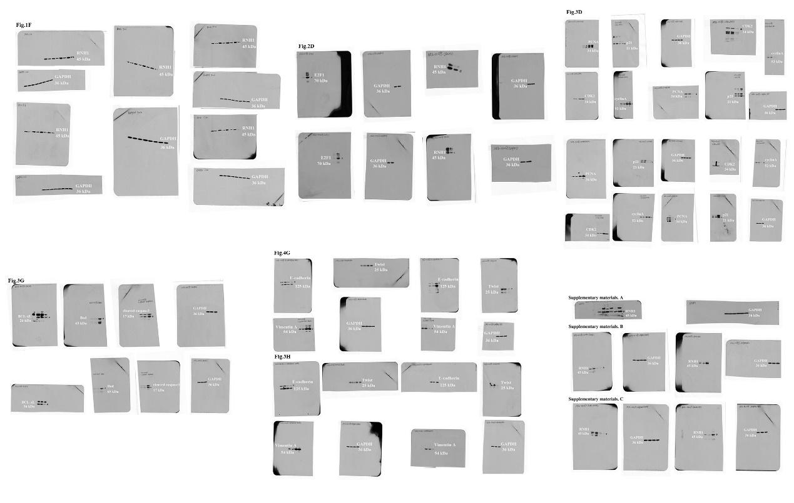
Supplementary Figure S3 Full-length of all blots.

Table.S1 Information about primary antibodies
Primary antibody | Dilution ratio |  | Manufacturer | Number
RNH1 |  | 1: 1000 | Affinity | DF1217
proliferating cell nuclear antigen (PCNA) |  | 1: 1000 | Abclonal, Wuhan, China | A12427
cyclin dependent kinase 2 (CDK2) |  | 1: 1000 | Abclonal | A0294
Cyclin |  | 1: 500 | Abclonal | AF0142
cyclin-dependent kinase inhibitor 1A (p21) |  | 1: 500 | Abclonal | A2691
Calcineurin E (E-cadherin) |  | 1: 500 | Abclonal | A3044
Vimentin |  | 1: 1000 | Affinity | AF7013
Twist |  | 1: 1000 | Abclonal | A3237
Bcl-2 associated death promoter (BCL-xL) |  | 1: 1000 | Abclonal | A19703
BCL2 associated agonist of cell death (Bad) |  | 1: 1000 | Abclonal | A19595
cleaved caspase 3 |  | 1: 1000 | Affinity | AF7022
E2F1 |  | 1: 1000 | Abclonal | A19579
p-Erk1/2 |  | 1：1000 | Abclonal | A22447
Erk1/2 |  | 1：500 | Abclonal | A4782
p-MEK1/2 |  | 1：500 | Abclonal | AP1349
MEK1/2 |  | 1：500 | Abclonal | A4868
p-PI3Kp85/p55 |  | 1：1000 | Affinity | AF3242
PI3K |  | 1：1000 | Affinity | AF6783
p-Akt |  | 1：1000 | Abclonal | AP1208
Akt |  | 1：1000 | Abclonal | A17909
MMP9 |  | 1:100 | Affinity | AF5228
GAPDH |  | 1: 10000 | Proteintech, Wuhan,China | 60004-1-Ig
Dilution ratio, manufacturer and catalogue number for primary antibodies used in western blot.

Table.S2. Correlation between RNH1 expression and clinicopathological features of LUAD
Clinicopathological Variables | High (36) | Low (84) | Chi-squared test P Value
Gender
Female | 11 | 28
Male | 25 | 56 | 0.766
Age, years
＜59 | 15 | 32
≥59 | 21 | 52 | 0.713
Tumor size, cm
≤1.9 | 15 | 43
＞1.9 | 21 | 41 | 0.339
Primary tumor
T1 | 25 | 76
T2/T3/T4 | 11 | 8 | 0.004
Lymph node metastasis
N0 | 30 | 81
N1 | 4 | 1
N2 | 2 | 2 | 0.028
Histological grading
1 | 10 | 18
2 | 18 | 51
3 | 8 | 15 | 0.552
Clinical stages
I | 30 | 81
II/III | 6 | 3 | 0.034
TNM stages
I | 28 | 79
II | 5 | 3
III | 3 | 2 | 0.031
Bold values meaning statistically significant.

