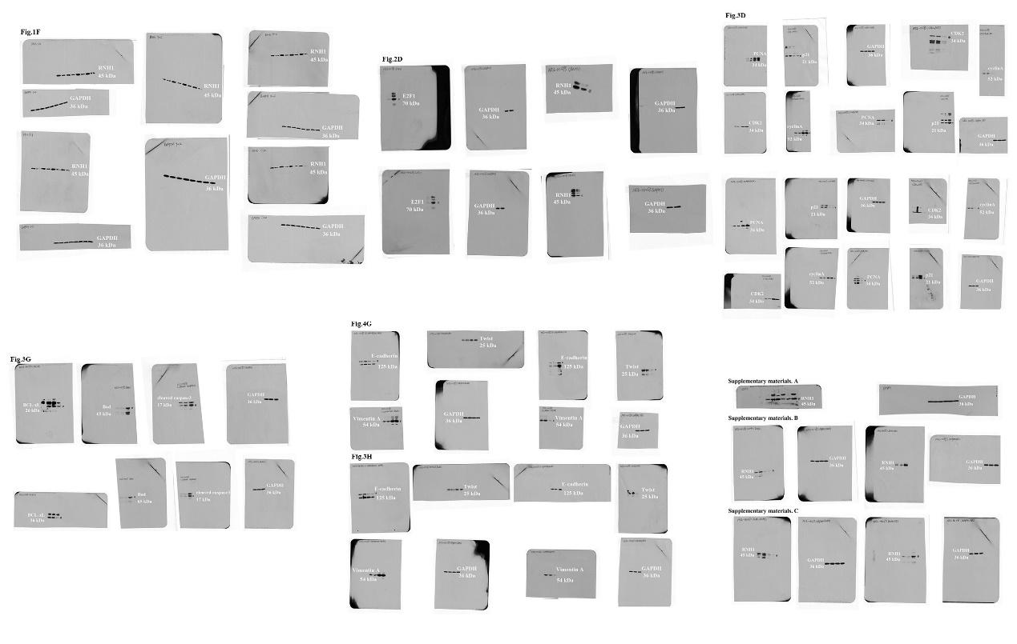
Supplementary Figure S3 Full-length of all blots.

