Supplementary Figures

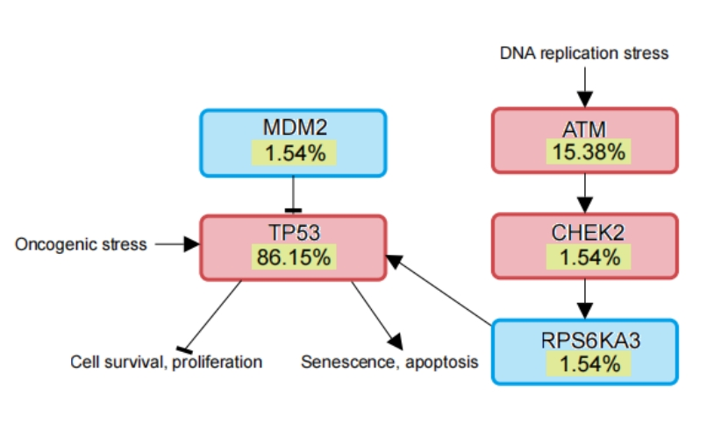
Figure S1. Mutated genes in the TP53 pathway. Tumor suppressor genes are in red, and oncogenes are in blue.

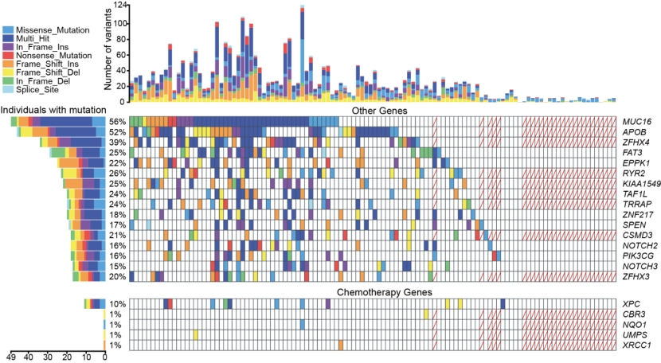
Figure S2. The landscape of frequently mutated genes and chemotherapy-related genes in 114 patients. Above, the histogram shows the number of variants of each patient in the corresponding panel. Right, the percentages of patients with mutations.
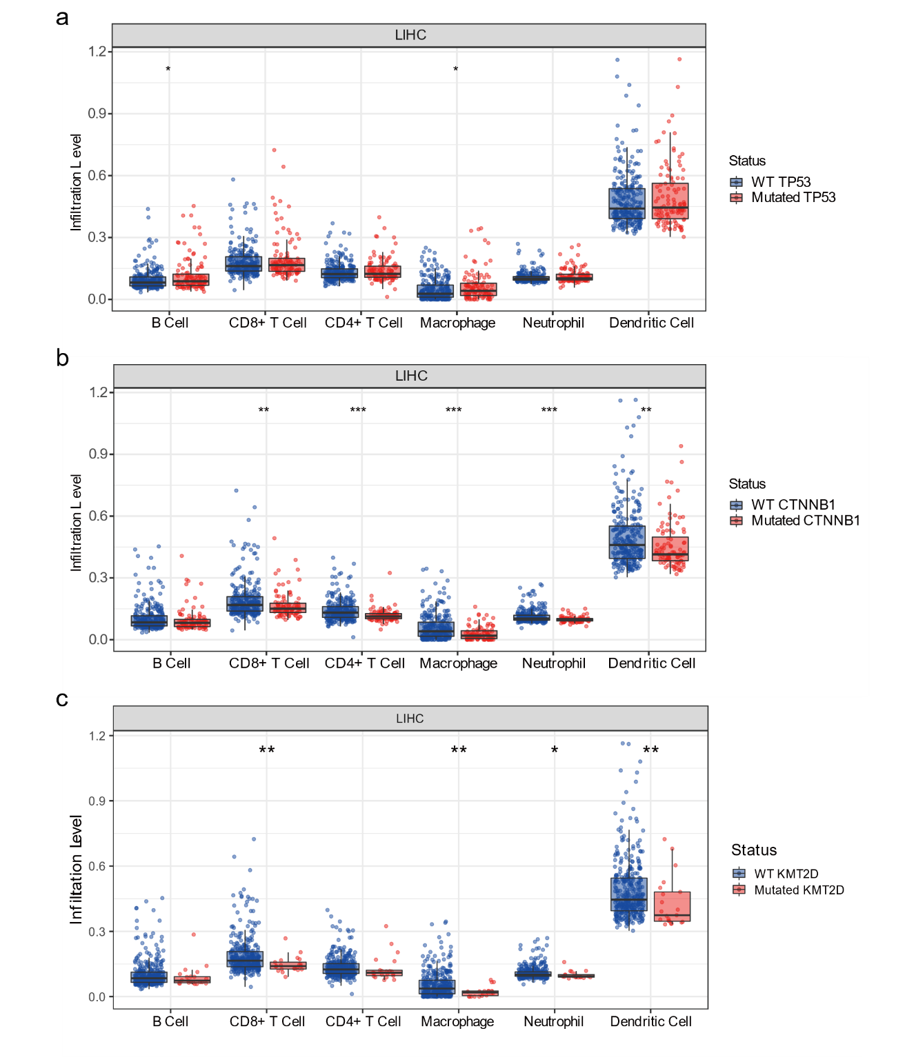
Figure S3. Association of immune infiltration with mutant genes. (a) Comparison of immune infiltration between TP53 mutated and wild-type samples. (b) Comparison of immune infiltration between CTNNB1 mutated and wild-type samples. (c) Comparison of immune infiltration between KMT2D mutated and wild-type samples. WT: wild type; *P < 0.05; **P < 0.01; ***P < 0.001.

