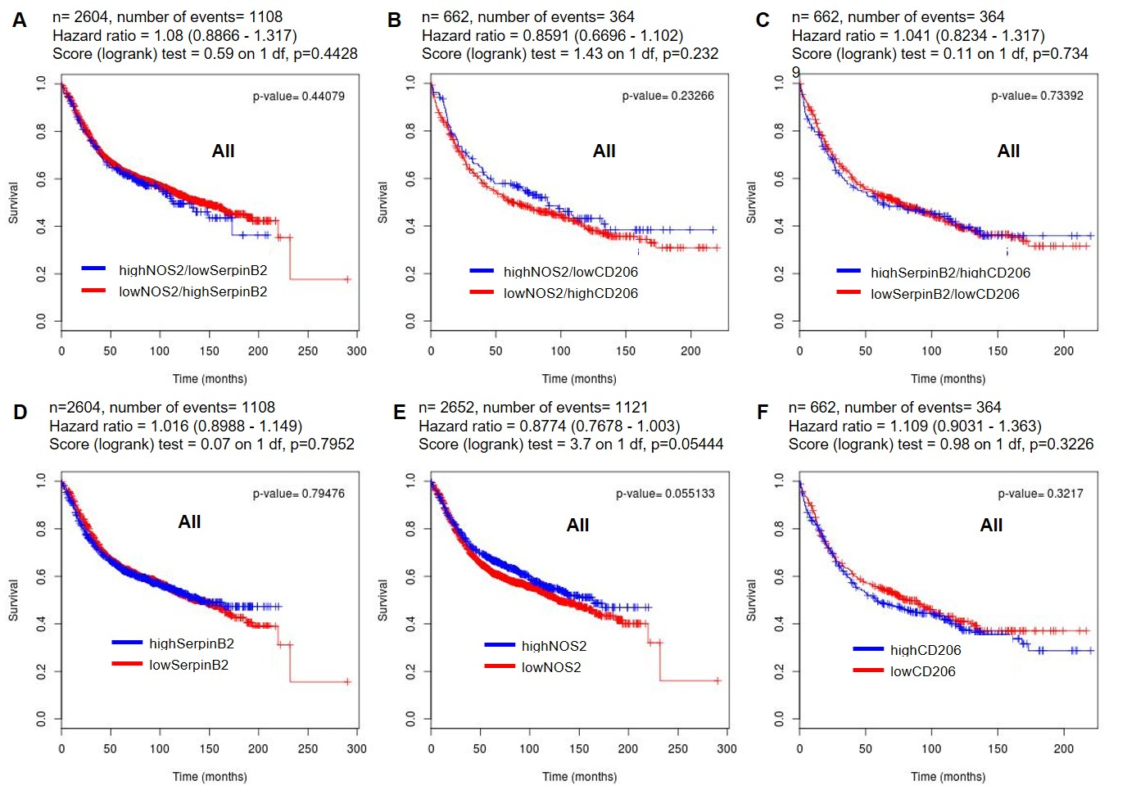
Supplementary Data 3: Kaplan-Meier plots of breast cancer patient survival based on the combination and individual of SerpinB2, NOS2, and CD206 expression in the BreastMark dataset. A-C Disease-free survival (DFS) analysis of all breast cancer patients using the combination of SerpinB2/NOS2, SerpinB2/CD206, and NOS2/CD206 groups. D-F Disease-free survival (DFS) analysis of all breast cancer patients using the individual expressions of SerpinB2, NOS2, or CD206 alone.

