Figure S1. Derivation of the cutoff value of the PAR score according to maximally selected log-rank statistics.
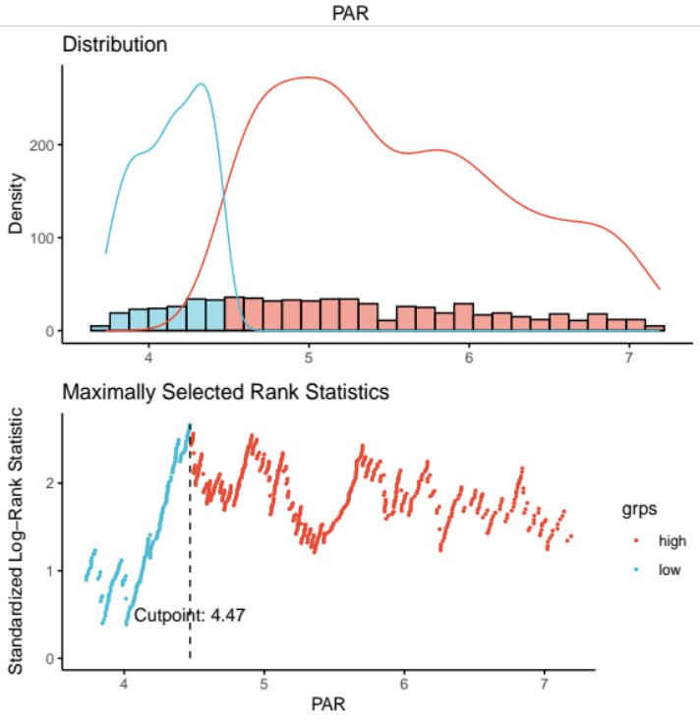

Figure S2. Proportional hazards diagnostic plots of multivariable Cox modeling.

