Raw data Fig.2 ——WB-RAW data of Fig.2D (Control-CIS-CIS+ galaxamide)
CIS+
galaxamide
Control CIS
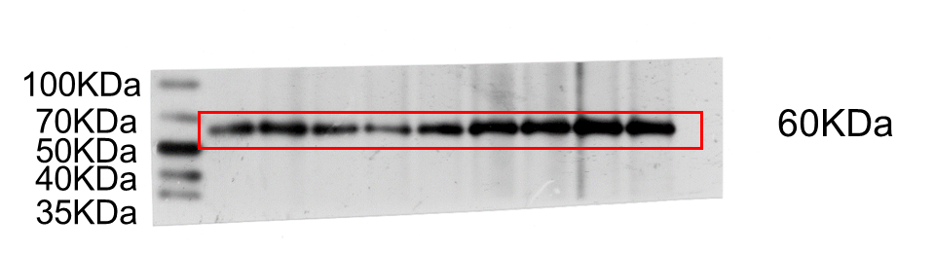
AMH
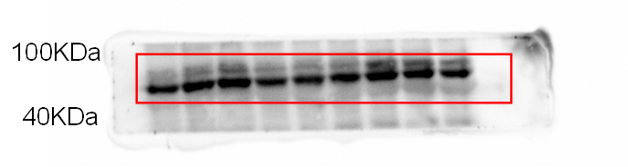
FSHR
71-78KDa
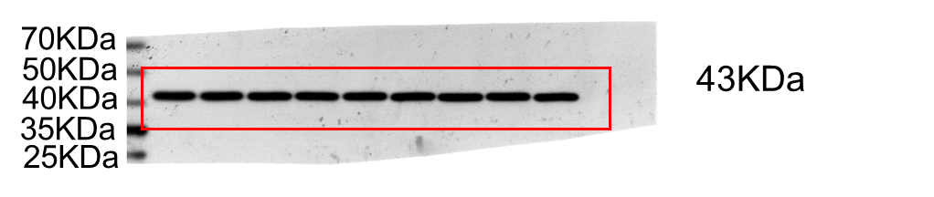
β-actin

Fig. 2D. Immunoblot analysis and quantification of AMH and FSHR expression in the ovaries of each group. AMH, anti-Mullerian hormone; FSHR, follicle stimulating hormone receptor.

Raw data Fig.3D ——WB-RAW data of Fig.3D (Control-CIS-CIS+ galaxamide)
CIS+
galaxamide
CIS
Control
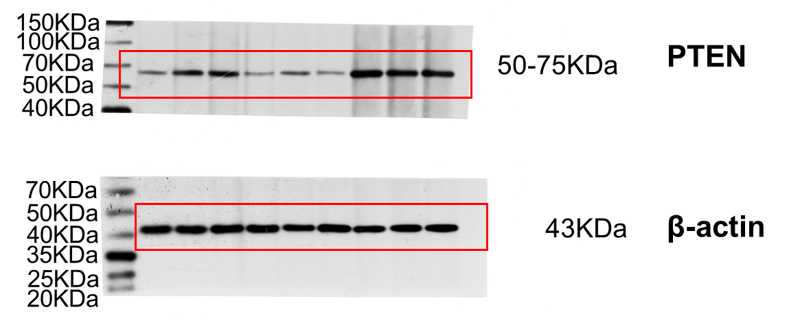
Fig. 3D. Western blot analyses of PTEN in the ovaries of the three groups.

Raw data Fig.3F ——WB-RAW data of Fig.3D (Control-CIS-CIS+ galaxamide)

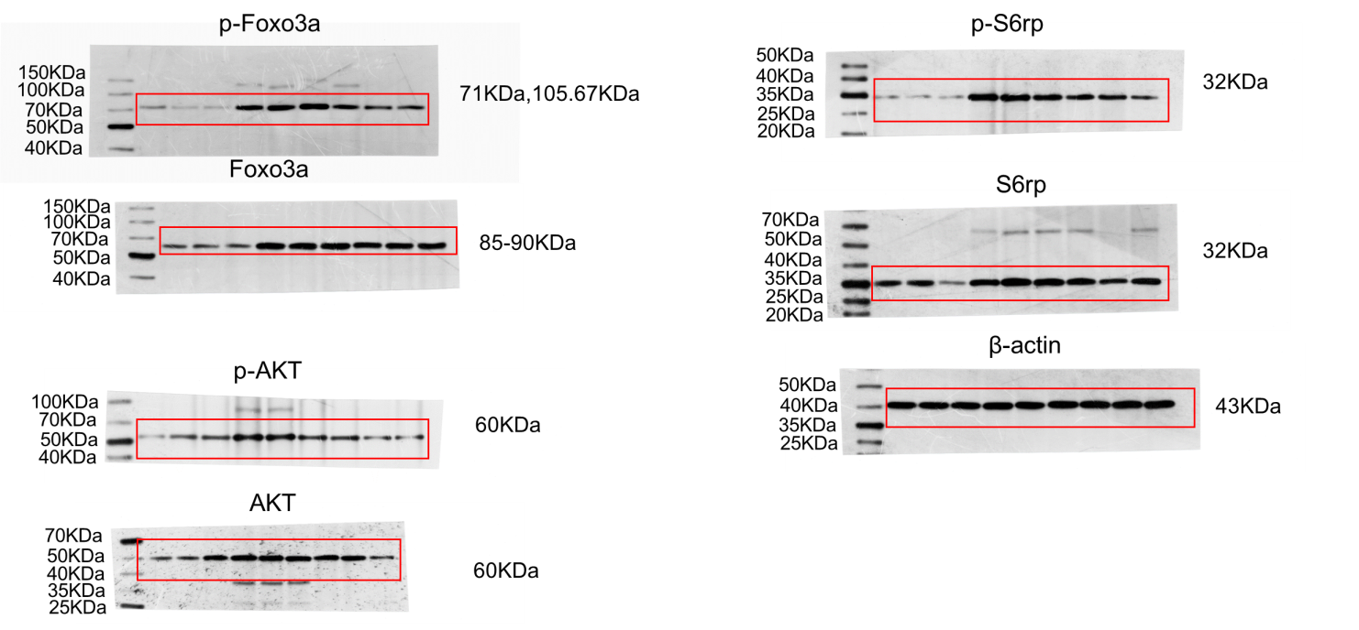
CIS+
galaxamide
CIS
Control

Fig. 3F. Immunoblot analysis and quantification of key proteins of PI3K-Akt and mTOR signaling in the ovaries of the three groups.

Raw data Fig.4D ——WB-RAW data of Fig.4D (Control-CIS-CIS+ galaxamide)
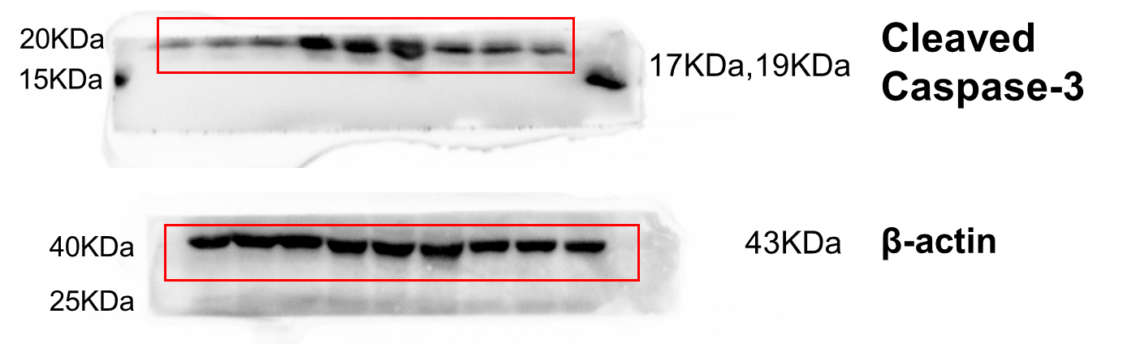
Fig. 4D. Western blotting showing the expression of cleaved caspase-3.

