Table S1 The characteristics of included 32 studies on EBNA1-IgA.
Study ID |  | TP | FP | FN | TN | Study area
Cheng 2003 |  | 78 | 22 | 7 | 234 | Guangdong
Gu 2003 |  | 52 | 7 | 5 | 51 | Guangdong
Huang 2003 |  | 70 | 3 | 14 | 57 | Guangdong
Hu 2006 |  | 69 | 25 | 16 | 107 | Guangdong
Wu 2006 |  | 40 | 2 | 3 | 38 | Guangdong
Liang 2008 |  | 166 | 28 | 29 | 160 | Guangdong
Gu 2008 |  | 108 | 26 | 27 | 104 | Guangdong
Cheng 2009 |  | 286 | 106 | 40 | 661 | Guangxi
Deng 2009 |  | 83 | 10 | 10 | 175 | Guangdong
Jiang 2009 |  | 40 | 8 | 9 | 81 | Guangdong
Ma 2011 |  | 156 | 12 | 12 | 162 | Guangxi
Zhang 2011 |  | 54 | 3 | 11 | 47 | Guangdong
Deng 2012 |  | 137 | 9 | 32 | 77 | Guangdong
Wang 2012 |  | 179 | 12 | 27 | 237 | Shanghai
Liu 2012 |  | 177 | 20 | 14 | 177 | Guangdong
Shi 2014 |  | 30 | 1 | 4 | 29 | Guangdong
Du 2015 |  | 367 | 25 | 49 | 663 | Guangdong
Gu 2016 |  | 53 | 2 | 7 | 58 | Guangdong
Yu 2016 |  | 120 | 21 | 32 | 654 | Guangdong
Chen 2017 |  | 176 | 15 | 40 | 93 | Guangxi
Gao 2017 |  | 175 | 15 | 25 | 185 | Guangdong
Zhang 2019 |  | 99 | 37 | 21 | 19 | Shaanxi
Fang 2020 |  | 39 | 3 | 9 | 90 | Guangdong
Liu 2020 |  | 97 | 2 | 9 | 148 | Guangdong
Rao 2020 |  | 281 | 48 | 39 | 272 | Guangdong
Yu 2020 |  | 180 | 55 | 21 | 996 | Guangdong
Gong 2021 |  | 601 | 95 | 61 | 636 | Shanghai
Lu 2021 |  | 44 | 6 | 10 | 94 | Guangdong
Wang 2021 |  | 49 | 8 | 31 | 62 | Guangdong
Wang2 2021 |  | 32 | 5 | 8 | 35 | Guangdong
Deng 2022 |  | 119 | 11 | 86 | 97 | Guangdong
Qu 2022 |  | 34 | 7 | 11 | 38 | Guangdong
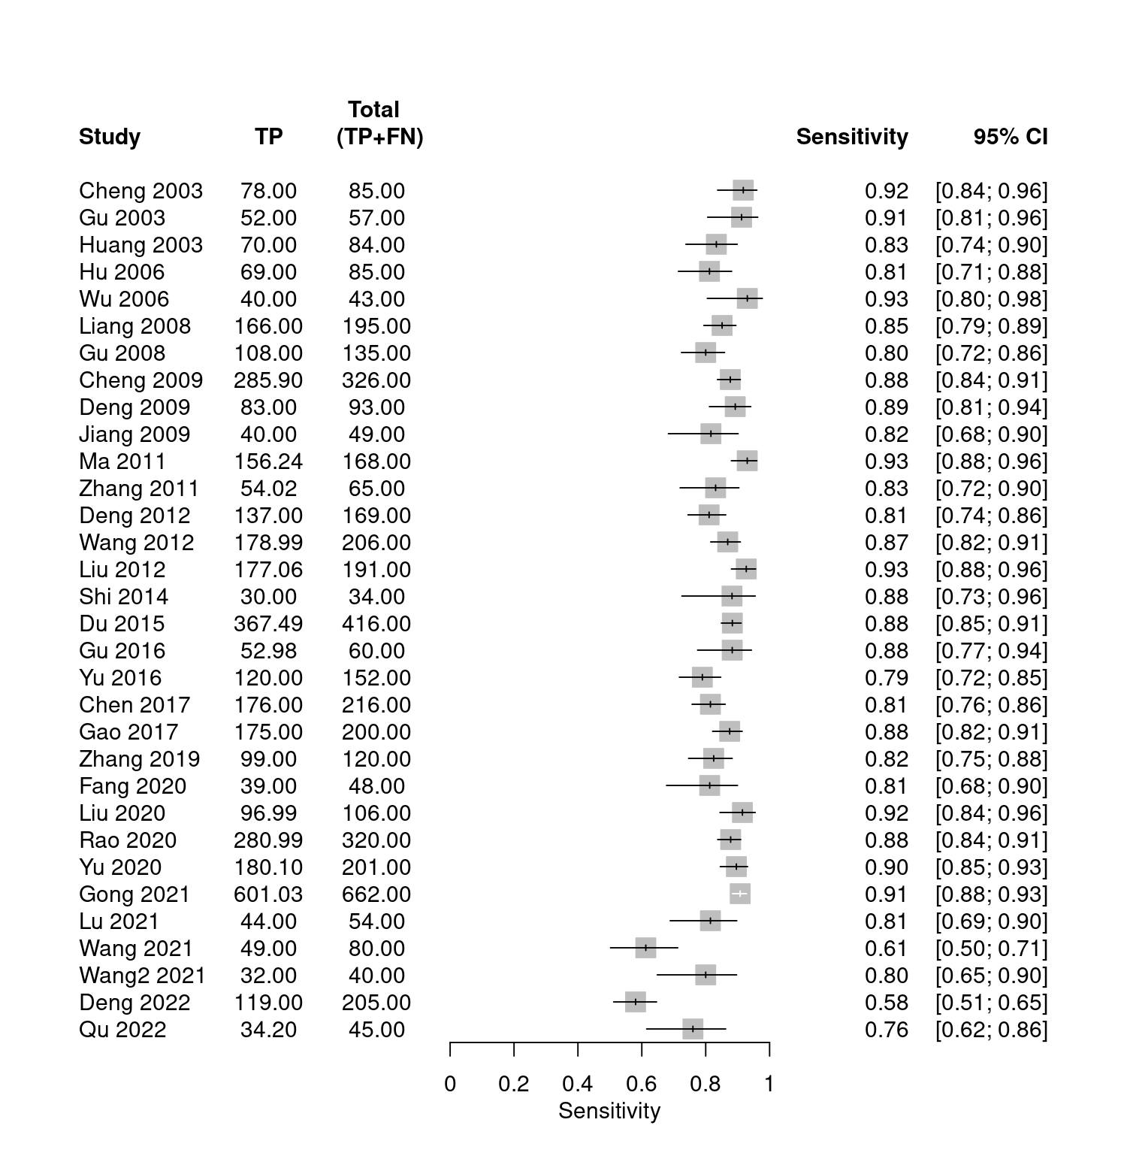
Figure S1.1 Forest plot of sensitivity of EBNA1-IgA.
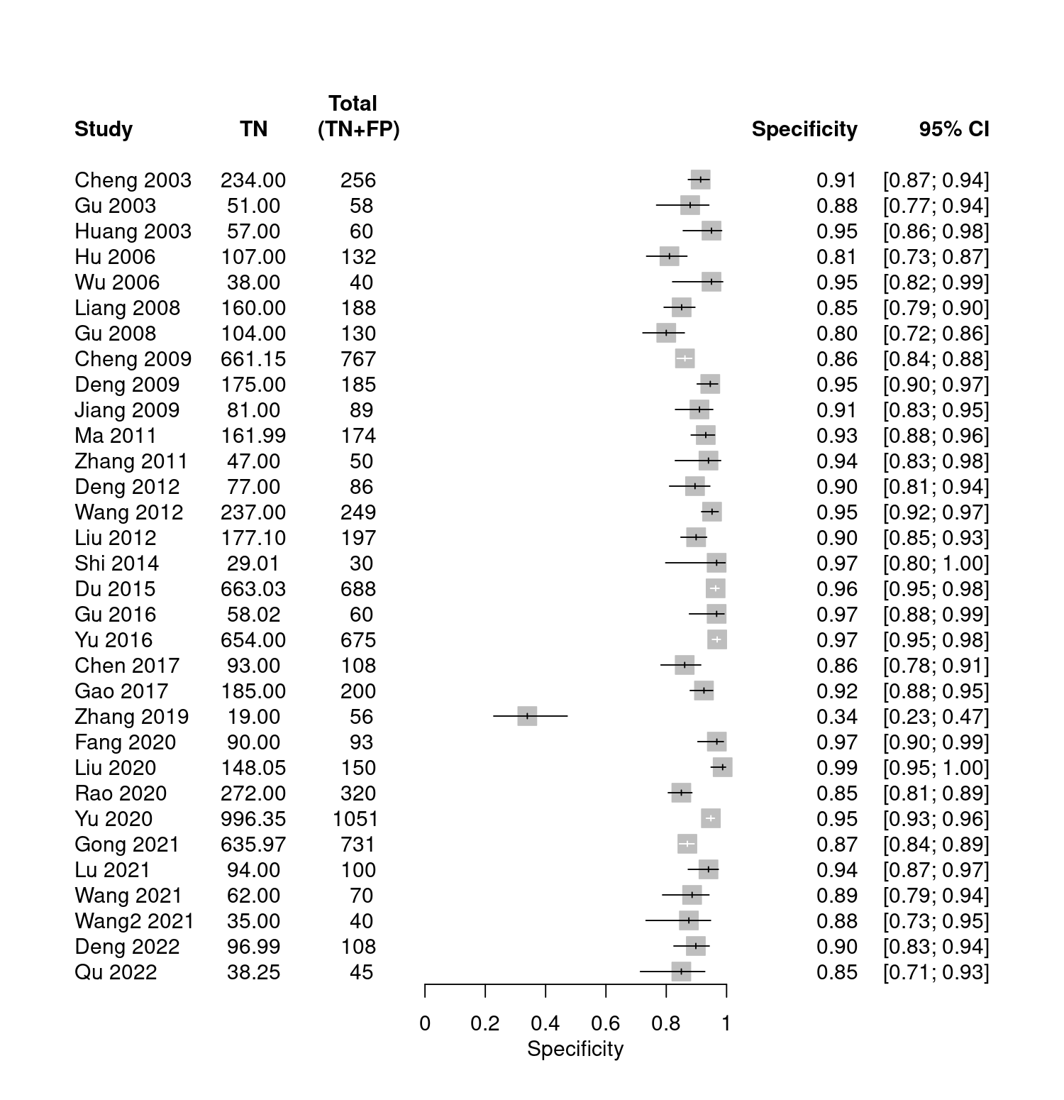
Figure S1.2 Forest plot of specificity of EBNA1-IgA.

Table S2 The characteristics of included 59 studies on VCA-IgA.
Study ID |  | TP | FP | FN | TN | Study area
Hu 2006 |  | 60 | 39 | 25 | 93 | Guangdong
Li 2006 |  | 51 | 1 | 8 | 59 | Fujian
Tang 2007 |  | 151 | 5 | 12 | 93 | Hong Kong
Gu 2008 |  | 124 | 21 | 11 | 109 | Guangdong
Deng 2009 |  | 81 | 12 | 12 | 173 | Guangdong
Pan 2009 |  | 25 | 5 | 12 | 54 | Guangdong
Yang 2009 |  | 117 | 3 | 60 | 88 | Guangxi
Chen 2010 |  | 42 | 3 | 11 | 37 | Guangdong
Hu 2010 |  | 281 | 13 | 19 | 487 | Guangdong
Tan 2010 |  | 44 | 0 | 79 | 40 | Guangdong
Ma 2011 |  | 140 | 20 | 28 | 154 | Guangxi
Wu 2011 |  | 37 | 9 | 5 | 33 | Guangdong
Zhang 2011 |  | 59 | 5 | 6 | 45 | Guangdong
Zhu 2011 |  | 31 | 1 | 6 | 32 | Guangxi
Deng 2012 |  | 109 | 12 | 60 | 74 | Guangdong
Lei 2012 |  | 54 | 13 | 48 | 137 | Hubei
Wang 2012 |  | 179 | 11 | 27 | 238 | Shanghai
Liu 2012 |  | 174 | 34 | 17 | 163 | Guangdong
Li 2013 |  | 397 | 143 | 52 | 1149 | Fujian
Yan 2013 |  | 39 | 3 | 12 | 47 | Beijing
Shi 2014 |  | 25 | 2 | 8 | 28 | Guangdong
Xu 2014 |  | 67 | 16 | 8 | 84 | Guangdong
Peng 2014 |  | 62 | 6 | 50 | 132 | Guangdong
Du 2015 |  | 364 | 27 | 52 | 661 | Guangdong
Peng 2015 |  | 115 | 10 | 127 | 208 | Guangdong
Wu 2015 |  | 23 | 53 | 7 | 1417 | Guangdong
Xu 2015 |  | 67 | 16 | 8 | 84 | Guangdong
Yi 2015 |  | 85 | 28 | 11 | 222 | Fujian
Zhang 2015 |  | 140 | 1691 | 15 | 7193 | Fujian
Gu 2016 |  | 20 | 11 | 40 | 49 | Guangdong
Pan 2016 |  | 92 | 172 | 8 | 828 | Guangdong
Wu 2016 |  | 134 | 349 | 35 | 3564 | Hainan
Yu 2016 |  | 68 | 56 | 84 | 619 | Guangdong
Zheng 2016 |  | 229 | 52 | 71 | 148 | Guangdong
Lin 2016 |  | 122 | 27 | 80 | 85 | Zhejiang
Chen 2017 |  | 162 | 19 | 54 | 89 | Guangxi
Yan 2017 |  | 52 | 3 | 16 | 47 | Beijing
Gao 2017 |  | 168 | 21 | 33 | 180 | Guangdong
Lin 2017 |  | 63 | 5 | 66 | 95 | Guangdong
Gao 2018 |  | 81 | 3 | 28 | 57 | Shaanxi
Li 2018 |  | 49 | 25 | 12 | 25 | Hubei
Zhang 2018 |  | 36 | 8 | 22 | 92 | Hunan
Li 2019 |  | 111 | 65 | 9 | 315 | Guangdong
Tang 2019 |  | 49 | 8 | 4 | 205 | Hunan
Zhang 2019 |  | 86 | 31 | 34 | 25 | Shaanxi
Cai 2020 |  | 49 | 2 | 7 | 18 | Guangdong
Fang 2020 |  | 41 | 5 | 7 | 88 | Guangdong
Guo 2020 |  | 1937 | 710 | 218 | 6247 | Fujian
Rao 2020 |  | 269 | 28 | 51 | 292 | Guangdong
Yu 2020 |  | 157 | 53 | 44 | 999 | Guangdong
Gong 2021 |  | 596 | 69 | 66 | 662 | Shanghai
Lu 2021 |  | 40 | 7 | 14 | 93 | Guangdong
Wang 2021 |  | 42 | 10 | 38 | 60 | Guangdong
Wang2 2021 |  | 30 | 7 | 10 | 33 | Guangdong
Zhang 2021 |  | 125 | 7 | 139 | 257 | Hunan
Deng 2022 |  | 145 | 14 | 60 | 94 | Guangdong
Qu 2022 |  | 41 | 9 | 4 | 36 | Guangdong
Qin 2023 |  | 128 | 29 | 35 | 111 | Shandong
Xu 2023 |  | 58 | 5 | 2 | 55 | Shandong

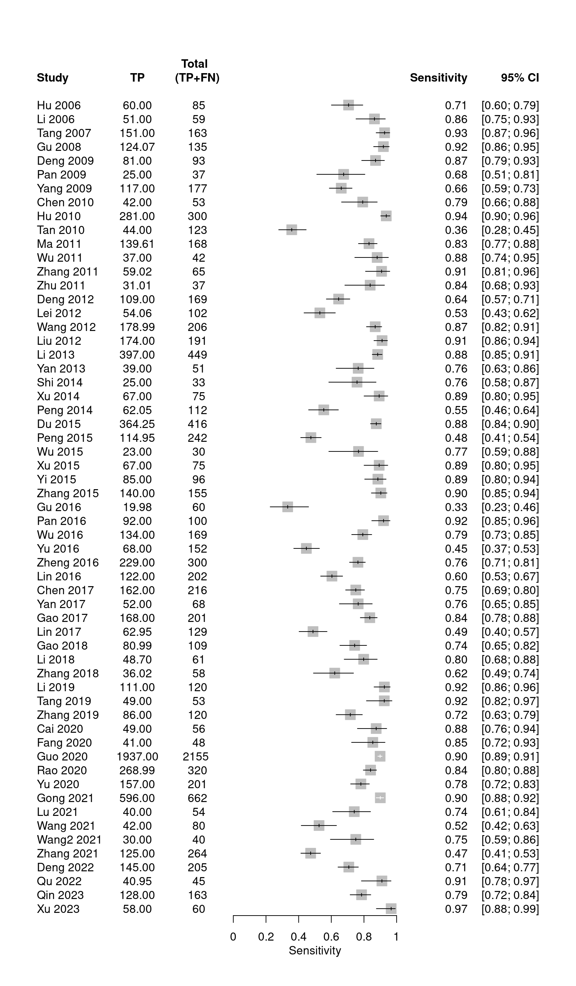
Figure S2.1 Forest plot of sensitivity of VCA-IgA.
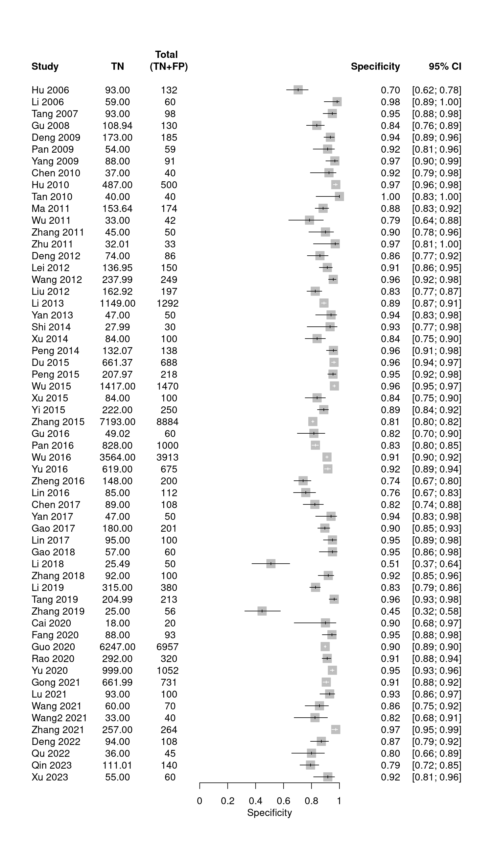
Figure S2.2 Forest plot of specificity of VCA-IgA.
Table S3 The characteristics of included 31 studies on EA-IgA.
Study ID |  | TP | FP | FN | TN | Study area
Zhang 2002 |  | 239 | 39 | 27 | 308 | Guangdong
Tang 2007 |  | 69 | 0 | 94 | 98 | Hong Kong
Gu 2008 |  | 125 | 12 | 10 | 118 | Guangdong
Chen 2010 |  | 27 | 0 | 26 | 40 | Guangdong
Tan 2010 |  | 88 | 1 | 35 | 39 | Guangdong
Ma 2011 |  | 85 | 8 | 83 | 166 | Guangxi
Wu 2011 |  | 38 | 5 | 4 | 37 | Guangdong
Zhang 2011 |  | 47 | 2 | 18 | 48 | Guangdong
Zhou 2011 |  | 135 | 21 | 17 | 179 | Guangdong
Liu 2012 |  | 89 | 9 | 102 | 188 | Guangdong
Li 2013 |  | 210 | 3 | 239 | 228 | Fujian
Yan 2013 |  | 16 | 2 | 35 | 48 | Beijing
Shi 2014 |  | 15 | 1 | 19 | 30 | Guangdong
Wu 2015 |  | 20 | 42 | 10 | 1428 | Guangdong
Yi 2015 |  | 47 | 10 | 49 | 240 | Fujian
Zhang 2015 |  | 75 | 366 | 80 | 8518 | Fujian
Pan 2016 |  | 49 | 39 | 51 | 961 | Guangdong
Yan 2017 |  | 21 | 2 | 47 | 48 | Beijing
Li 2018 |  | 31 | 14 | 30 | 36 | Hubei
Zhang 2018 |  | 42 | 5 | 16 | 95 | Hunan
Li 2019 |  | 63 | 13 | 57 | 367 | Guangdong
Tang 2019 |  | 40 | 3 | 13 | 210 | Hunan
Cai 2020 |  | 38 | 0 | 18 | 20 | Guangdong
Fang 2020 |  | 36 | 1 | 12 | 92 | Guangdong
Guo 2020 |  | 1004 | 213 | 1151 | 6744 | Fujian
Lu 2021 |  | 30 | 3 | 24 | 97 | Guangdong
Wang 2021 |  | 40 | 11 | 40 | 59 | Guangdong
Zhang 2021 |  | 151 | 5 | 113 | 259 | Hunan
Deng 2022 |  | 85 | 9 | 120 | 99 | Guangdong
Qin 2023 |  | 103 | 31 | 60 | 109 | Shandong
Xu 2023 |  | 35 | 2 | 25 | 58 | Shandong

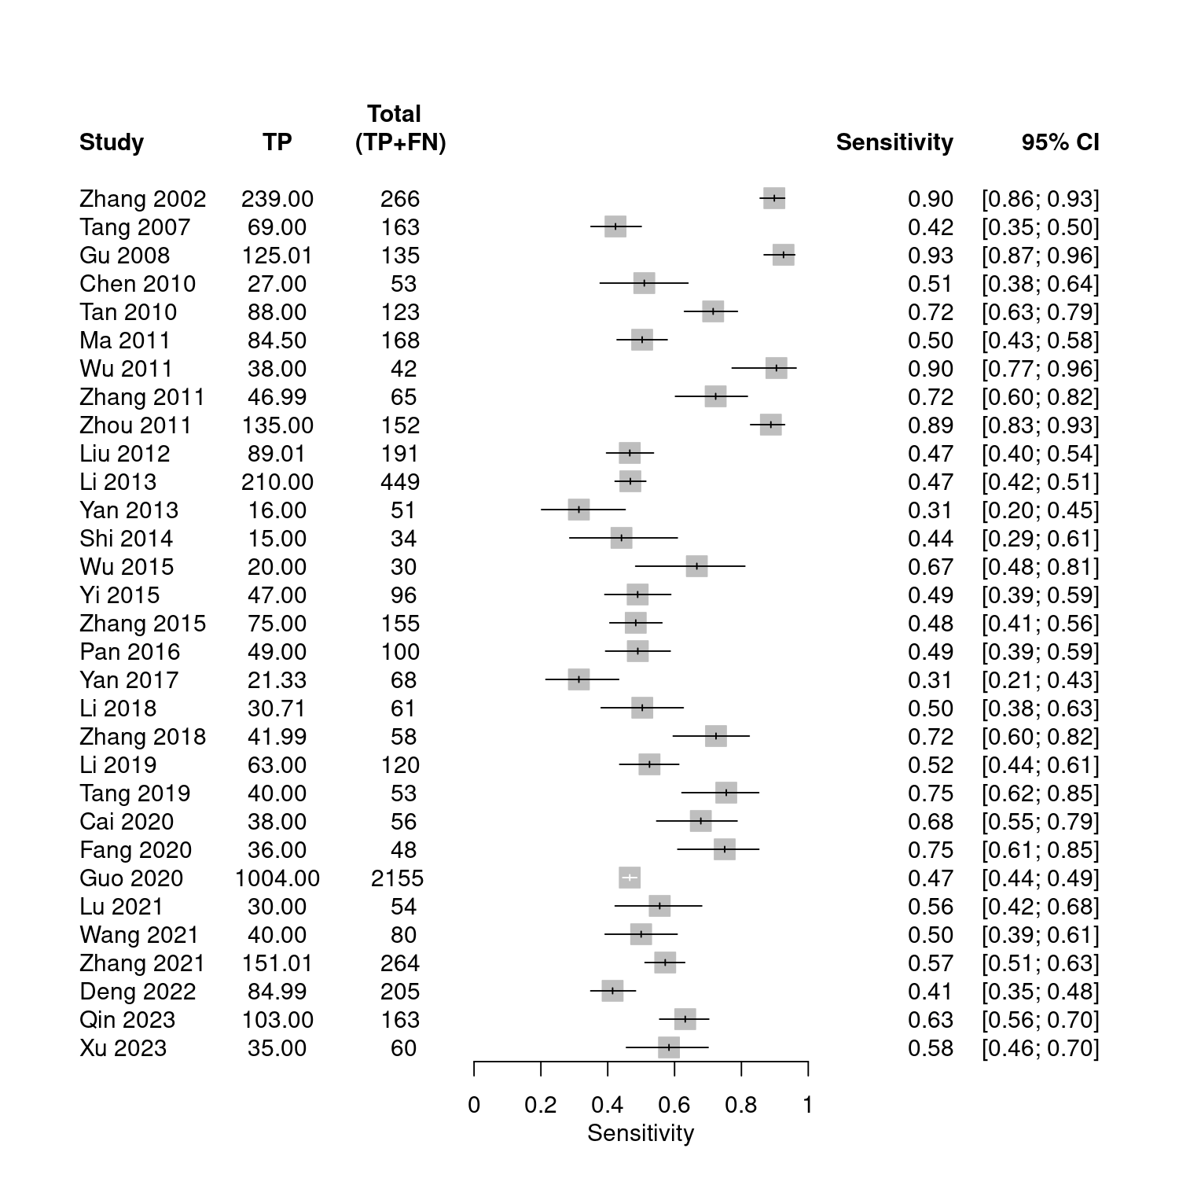
Figure S3.1 Forest plot of sensitivity of EA-IgA.
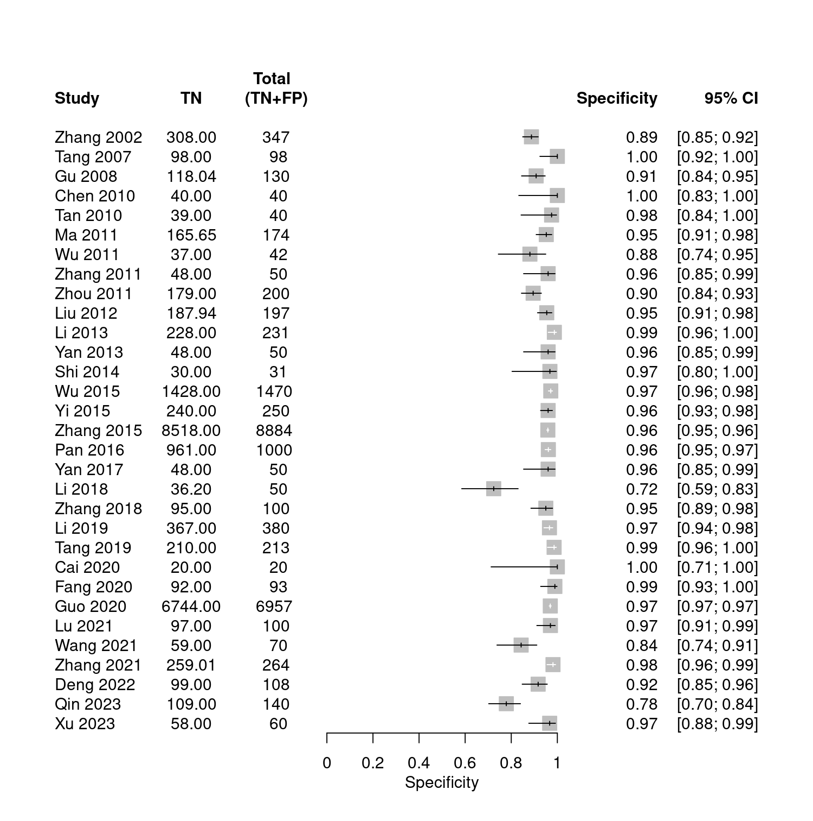
Figure S3.2 Forest plot of specificity of EA-IgA.

Table S4 The characteristics of included 12 studies on Zta-IgA.
Study ID |  | TP | FP | FN | TN | Study area
Gu 2003 |  | 50 | 6 | 7 | 52 | Guangdong
Hu 2006 |  | 64 | 32 | 21 | 100 | Guangdong
Liang 2008 |  | 158 | 36 | 37 | 152 | Guangdong
Ma 2011 |  | 148 | 17 | 20 | 157 | Guangxi
Liu 2012 |  | 169 | 22 | 22 | 175 | Guangdong
Shi 2014 |  | 30 | 1 | 3 | 29 | Guangdong
Gu 2016 |  | 44 | 7 | 16 | 53 | Guangdong
Yu 2016 |  | 91 | 35 | 61 | 640 | Guangdong
Chen 2017 |  | 179 | 6 | 37 | 102 | Guangxi
Liu 2020 |  | 81 | 19 | 25 | 131 | Guangdong
Gong 2021 |  | 574 | 66 | 88 | 665 | Shanghai
Wang2 2021 |  | 33 | 2 | 7 | 38 | Guangdong

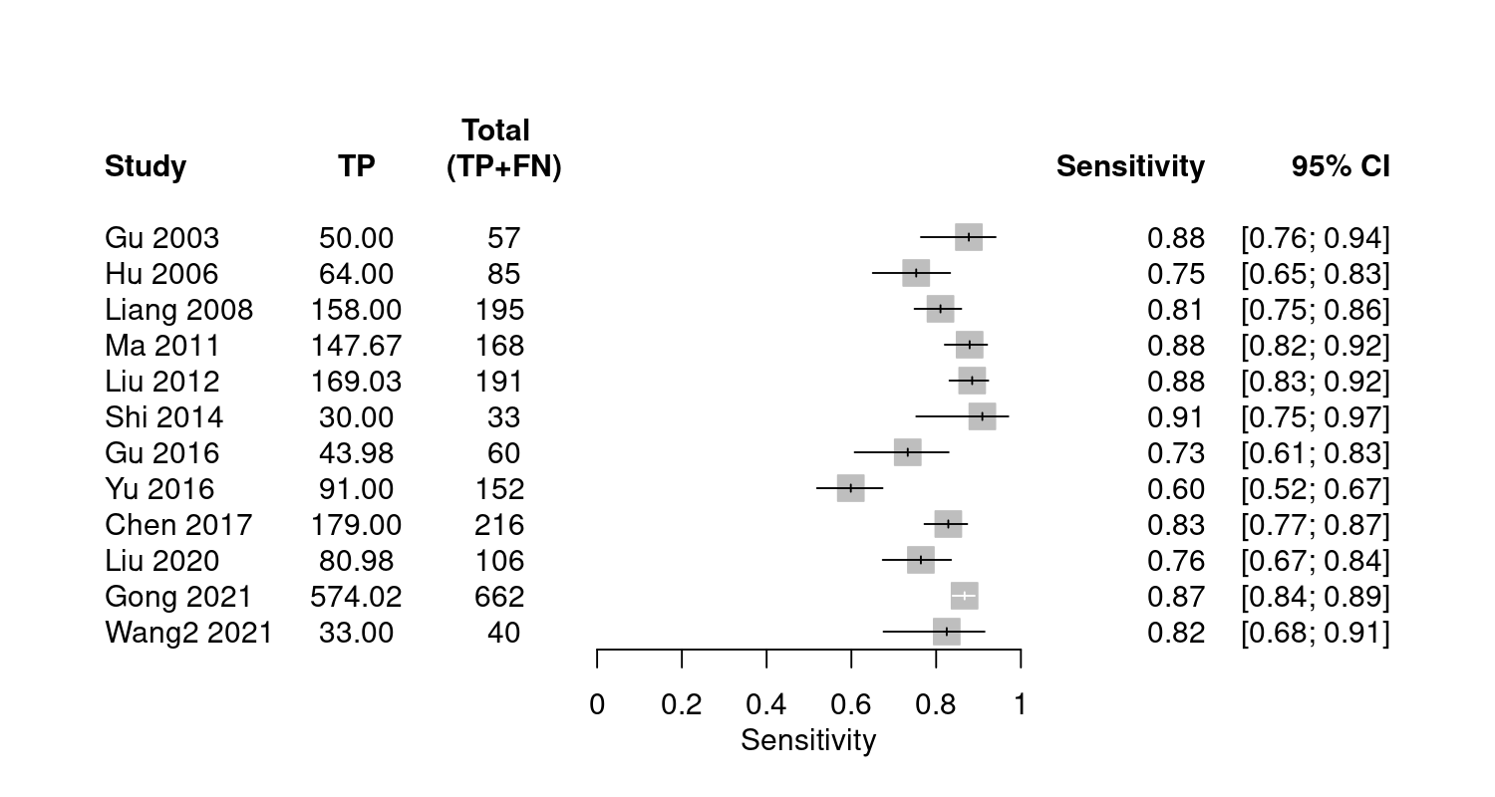
Figure S4.1 Forest plot of sensitivity of Zta-IgA.
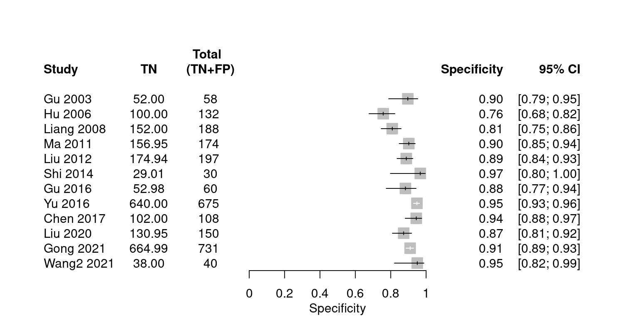
Figure S4.2 Forest plot of specificity of Zta-IgA.

Table 5 The characteristics of included 12 studies on EBNA1-IgA+VCA-IgA.
Study ID |  | TP | FP | FN | TN | Study area
Gu 2008 |  | 123 | 54 | 12 | 76 | Guangdong
Deng 2012 |  | 143 | 4 | 26 | 82 | Guangdong
Wang 2012 |  | 195 | 22 | 11 | 227 | Shanghai
Liu 2012 |  | 182 | 12 | 9 | 185 | Guangdong
He 2013 |  | 55 | 6 | 5 | 24 | Hunan
Du 2015 |  | 401 | 46 | 15 | 642 | Guangdong
Chen 2017 |  | 186 | 7 | 30 | 101 | Guangxi
Gao 2017 |  | 188 | 18 | 12 | 182 | Guangdong
Rao 2020 |  | 291 | 24 | 29 | 296 | Guangdong
Gong 2021 |  | 650 | 144 | 12 | 587 | Shanghai
Wang2 2021 |  | 35 | 2 | 5 | 38 | Guangdong
Deng 2022 |  | 180 | 24 | 25 | 84 | Guangdong

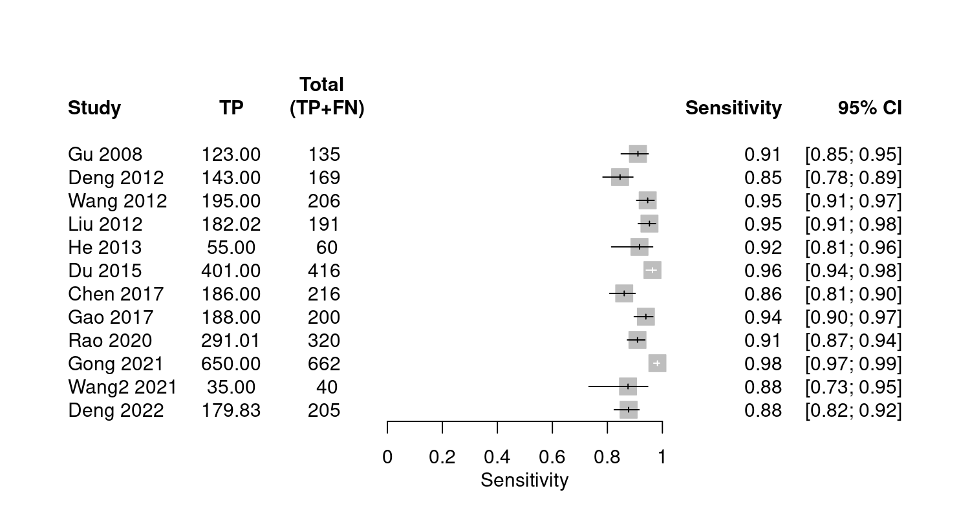
Figure S5.1 Forest plot of sensitivity of EBNA1-IgA+VCA-IgA.
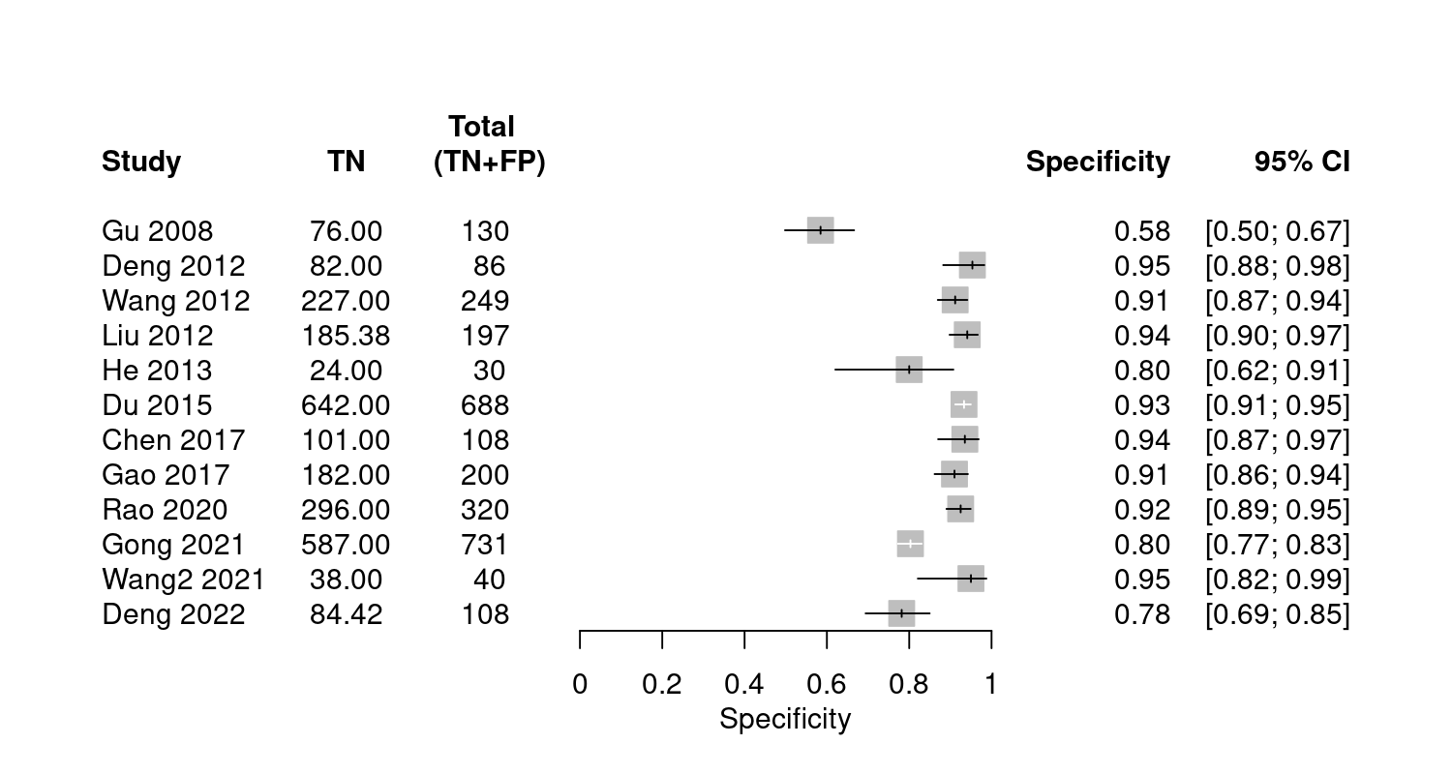
Figure S5.2 Forest plot of specificity of EBNA1-IgA+VCA-IgA.

Table S6 The characteristics of included 10 studies on VCA-IgA+EA-IgA.
Study ID |  | TP | FP | FN | TN | Study area
Gu 2008 |  | 124 | 48 | 11 | 82 | Guangdong
Liu 2012 |  | 163 | 15 | 28 | 182 | Guangdong
Yi 2015 |  | 87 | 38 | 9 | 212 | Fujian
Yan 2017 |  | 51 | 3 | 17 | 47 | Beijing
Li 2018 |  | 56 | 8 | 5 | 42 | Hubei
Zhang 2018 |  | 49 | 13 | 9 | 87 | Hunan
Tang 2019 |  | 51 | 2 | 2 | 211 | Hunan
Guo 2020 |  | 1946 | 748 | 209 | 6209 | Fujian
Zhang 2021 |  | 189 | 12 | 75 | 252 | Hunan
Deng 2022 |  | 170 | 22 | 35 | 86 | Guangdong
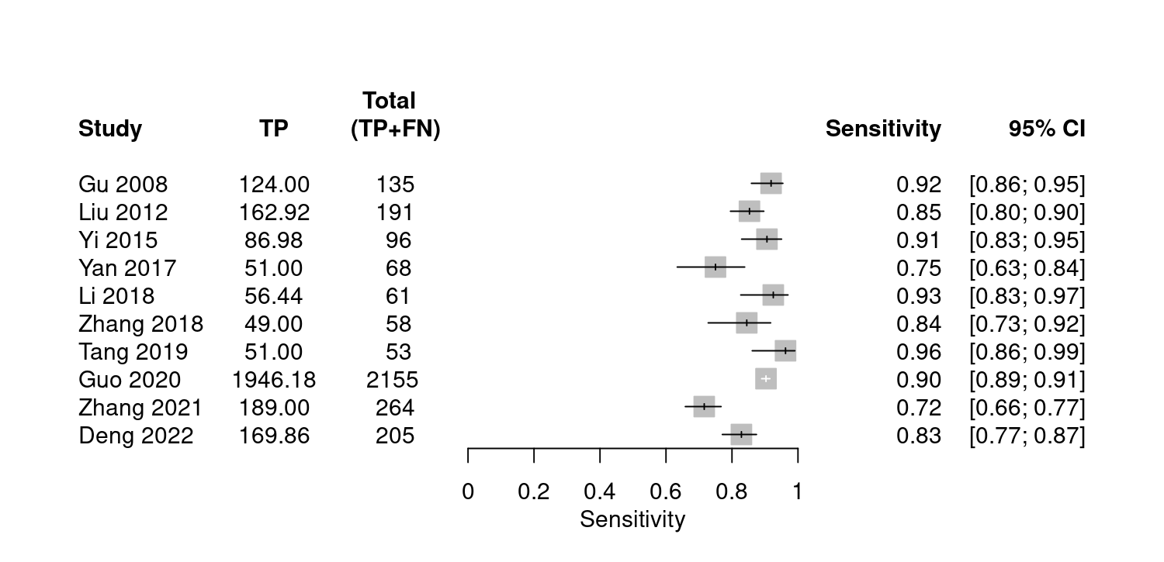
Figure S6.1 Forest plot of sensitivity of VCA-IgA+EA-IgA.
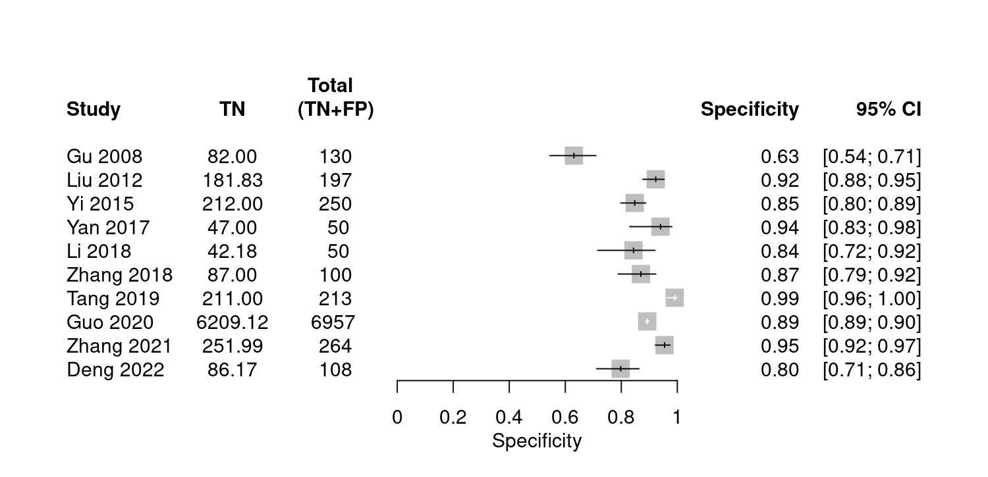
Figure S6.2 Forest plot of specificity of VCA-IgA+EA-IgA.

Table S7 The characteristics of included 12 studies on VCA-IgA+Rta-IgG.
Study ID |  | TP | FP | FN | TN | Study area
Wang 2012 |  | 185 | 32 | 21 | 217 | Shanghai
Liu 2012 |  | 163 | 13 | 28 | 184 | Guangdong
Xu 2014 |  | 71 | 20 | 4 | 80 | Guangdong
Du 2015 |  | 381 | 62 | 35 | 626 | Guangdong
Xu 2015 |  | 71 | 20 | 4 | 80 | Guangdong
Yi 2015 |  | 91 | 36 | 5 | 214 | Fujian
Wu 2016 |  | 169 | 431 | 0 | 3482 | Hainan
Zhang 2018 |  | 52 | 10 | 6 | 90 | Hunan
Tang 2019 |  | 50 | 1 | 3 | 212 | Hunan
Guo 2020 |  | 2009 | 984 | 146 | 5973 | Fujian
Zhang 2021 |  | 231 | 17 | 33 | 247 | Hunan
Deng 2022 |  | 172 | 21 | 33 | 87 | Guangdong

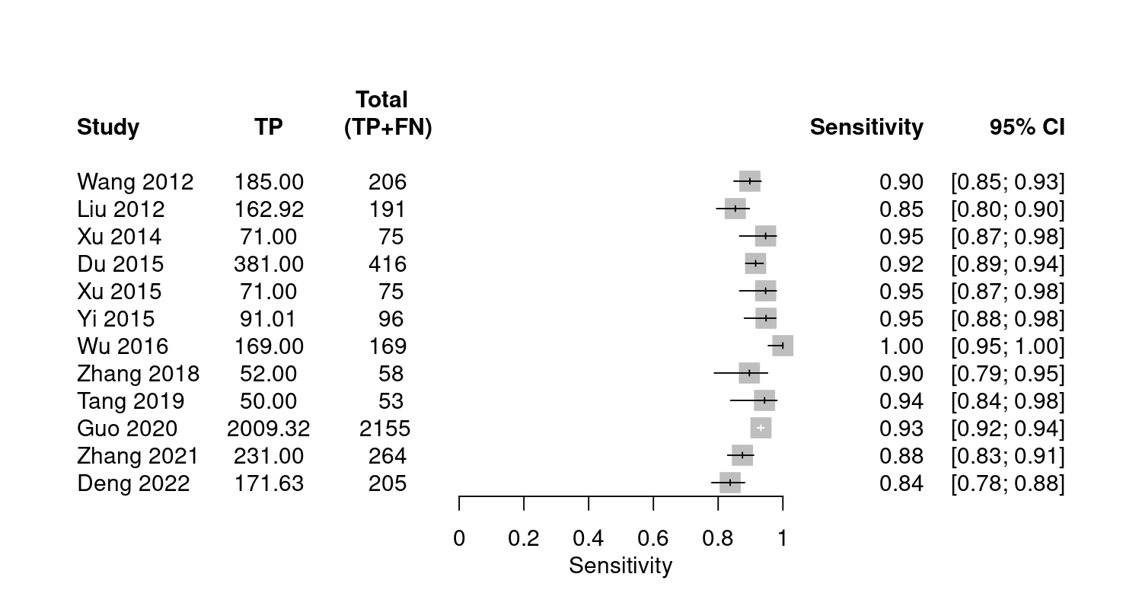
Figure S7.1 Forest plot of sensitivity of VCA-IgA+Rta-IgG.
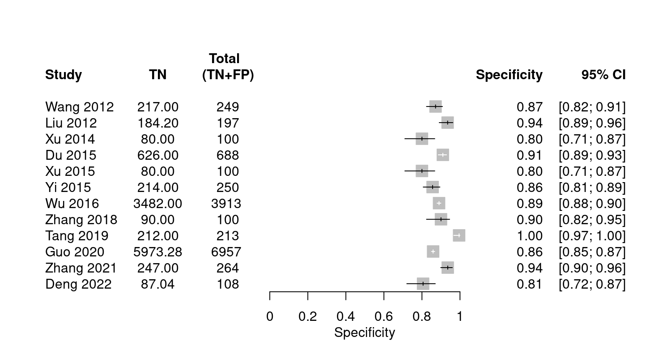
Figure S7.2 Forest plot of specificity of VCA-IgA+Rta-IgG.

Table S8 The characteristics of included 8 studies on EBNA1-IgA+VCA-IgA+Zta-IgA.
Study ID |  | TP | FP | FN | TN | Study area
Chen 2017 |  | 208 | 3 | 8 | 105 | Guangxi
Gao 2017 |  | 178 | 11 | 22 | 189 | Guangdong
Gong 2021 |  | 654 | 177 | 8 | 554 | Shanghai
Wang2 2021 |  | 39 | 1 | 1 | 39 | Guangdong
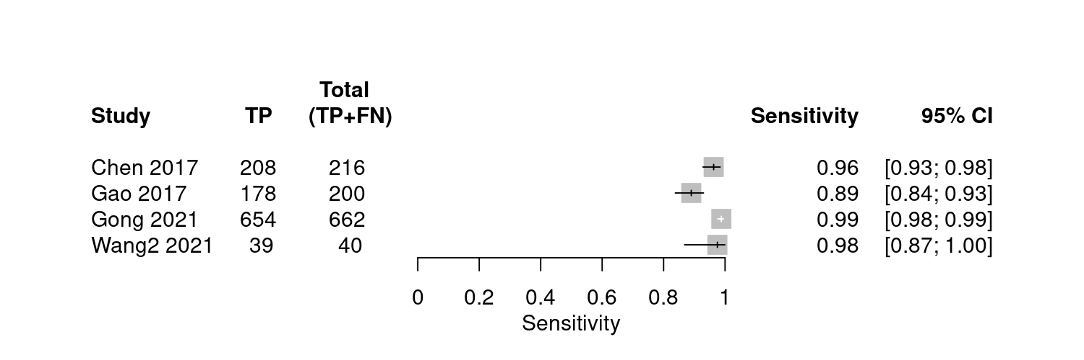
Figure S8.1 Forest plot of sensitivity of EBNA1-IgA+VCA-IgA+Zta-IgA.
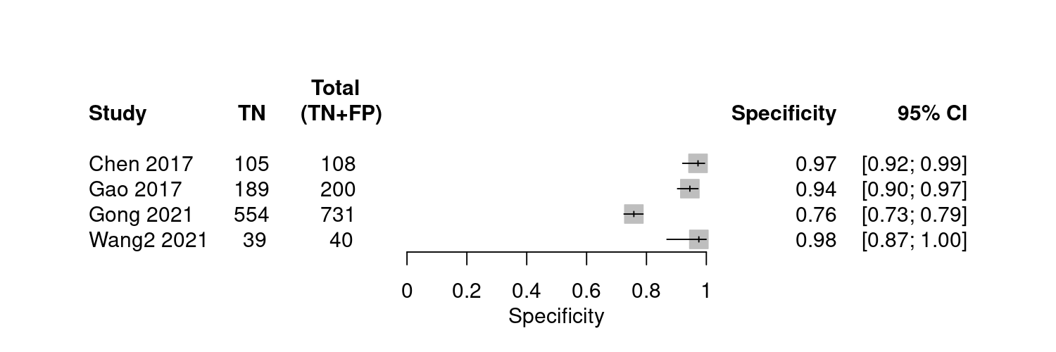
Figure S8.2 Forest plot of specificity of EBNA1-IgA+VCA-IgA+Zta-IgA.

Table S9 The characteristics of included 8 studies on VCA-IgA+EA-IgA+Rta-IgG.
Study ID |  | TP | FP | FN | TN | Study area
Yi 2015 |  | 92 | 46 | 4 | 204 | Fujian
Yan 2017 |  | 61 | 4 | 7 | 47 | Beijing
Zhang 2018 |  | 56 | 15 | 2 | 85 | Hunan
Li 2019 |  | 116 | 6 | 4 | 374 | Guangdong
Tang 2019 |  | 52 | 0 | 1 | 213 | Hunan
Zhang 2021 |  | 243 | 22 | 21 | 242 | Hunan
Deng 2022 |  | 185 | 28 | 20 | 80 | Guangdong
Qin 2023 |  | 157 | 61 | 6 | 79 | Shandong
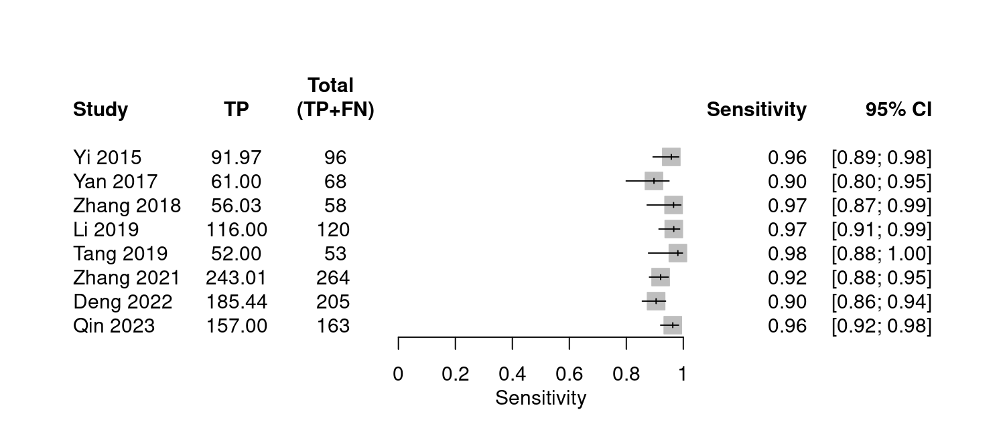
Figure S9.1 Forest plot of sensitivity of VCA-IgA+EA-IgA+Rta-IgG.
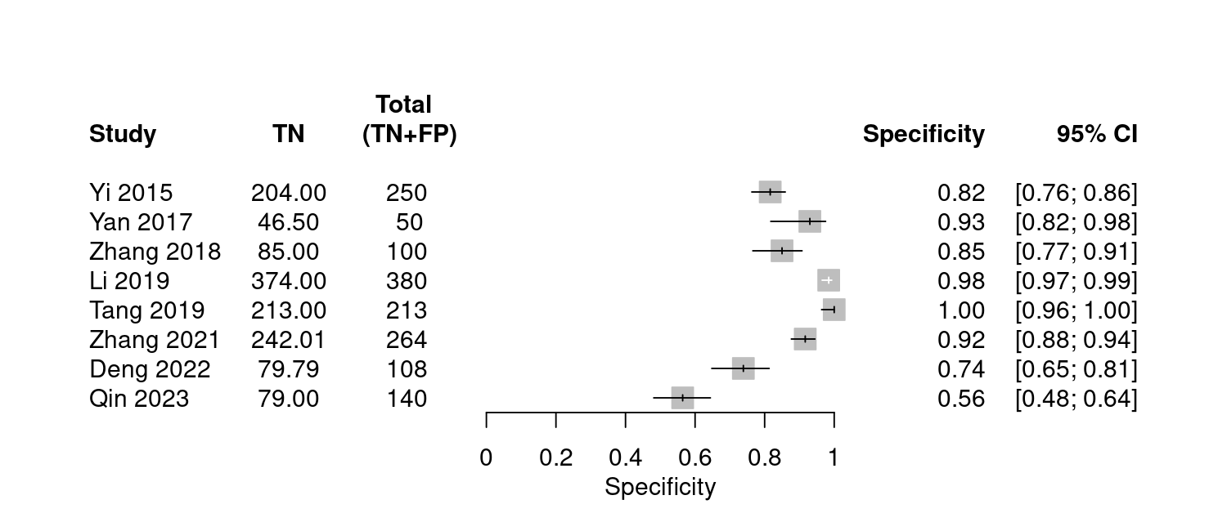
Figure S9.2 Forest plot of specificity of VCA-IgA+EA-IgA+Rta-IgG.
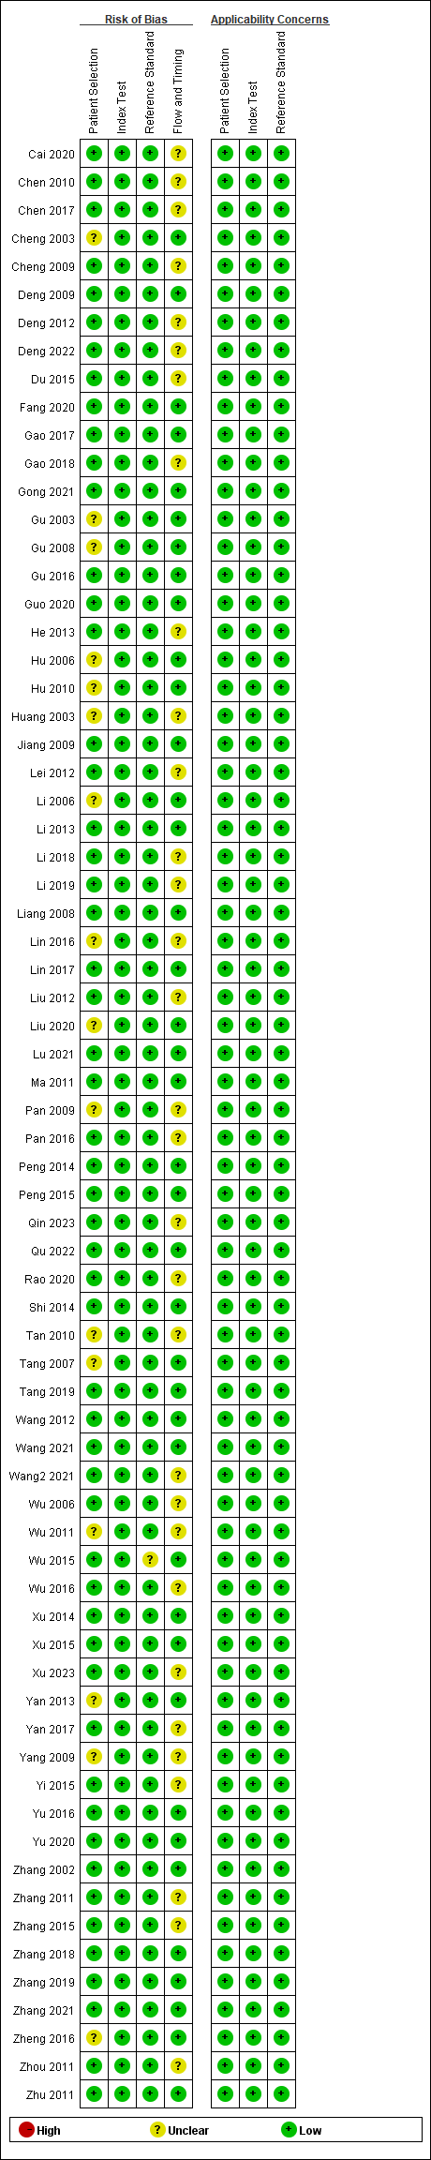
Figure S10.1 Risk of bias and applicability concerns summary.
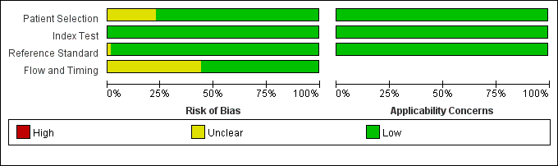
Figure S10.2 Risk of bias and applicability concerns graph.

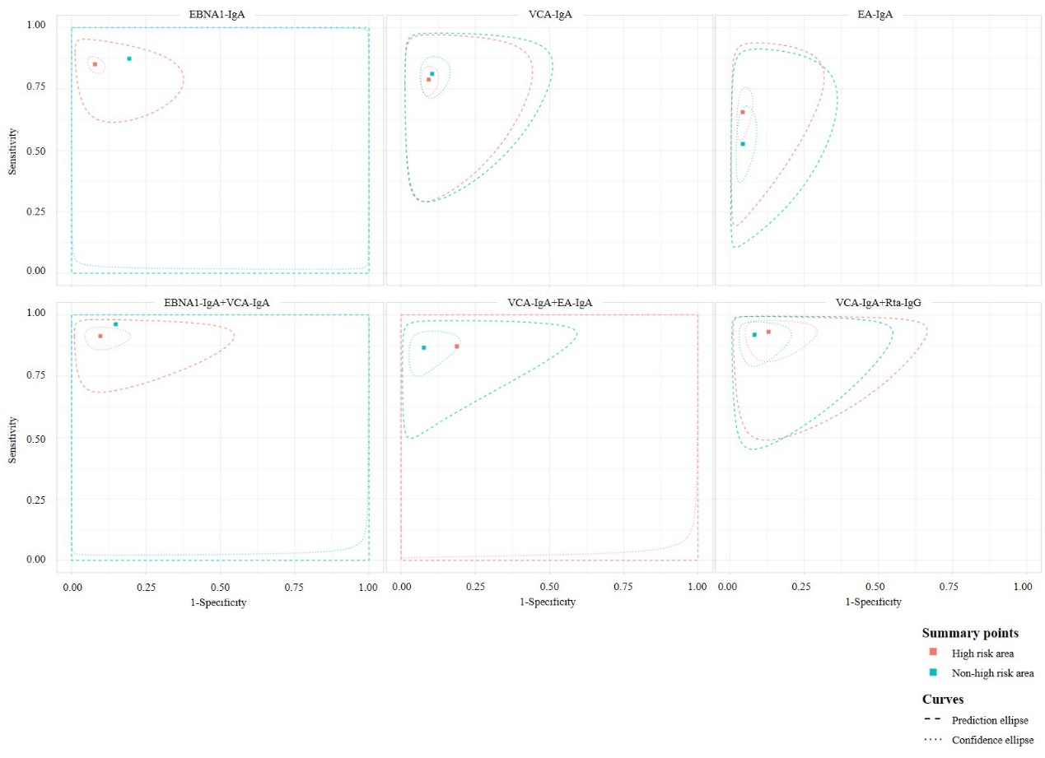
Figure S11.1 Subgroup analysis classified by study area.
P value of meta-regression: EBNA1-IgA=0.052; VCA-IgA=0.745; EA-IgA=0.167;
EBNA1-IgA+VCA-IgA=0.104; VCA-IgA+EA-IgA=0.232; VCA-IgA+Rta-IgG=0.422.

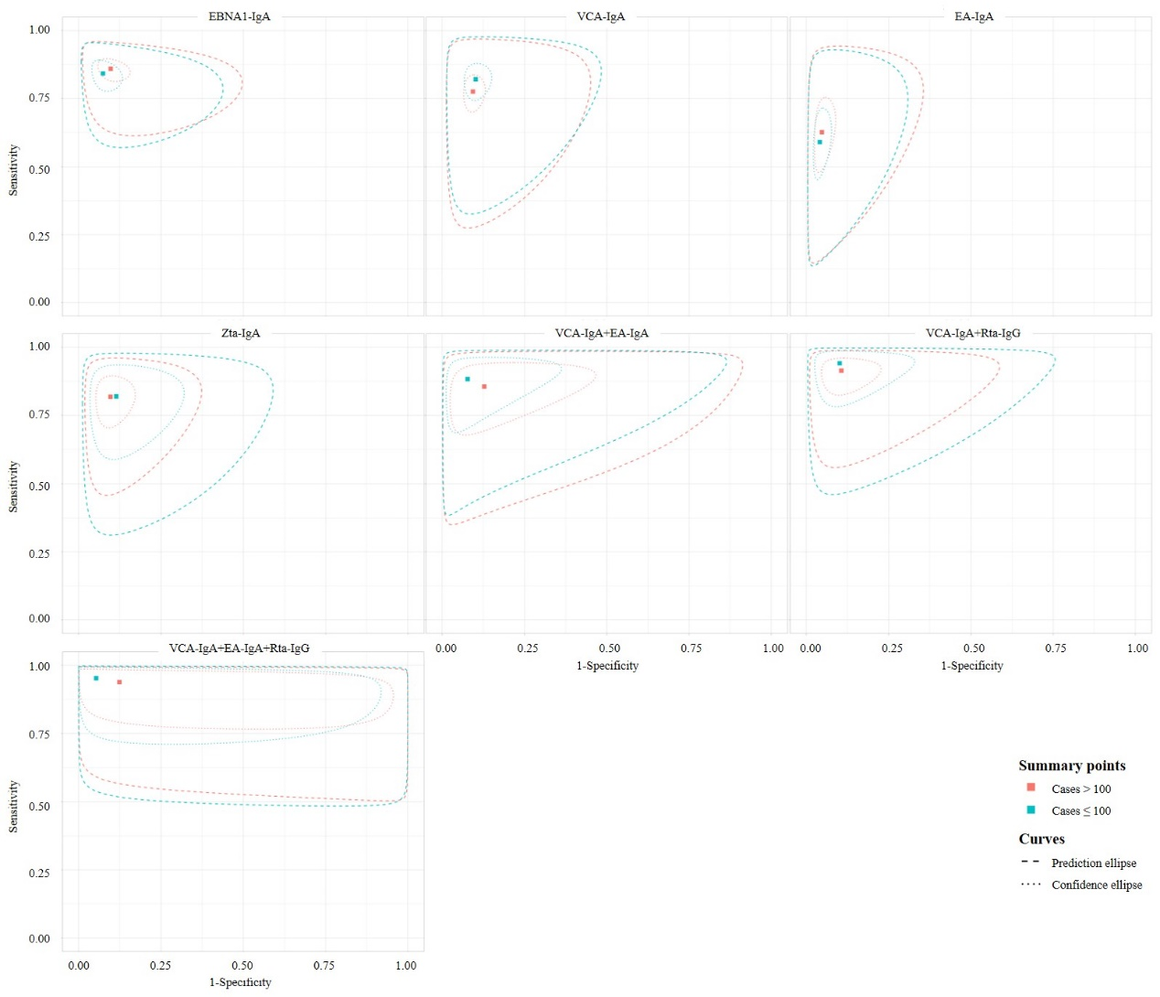
Figure S11.2 Subgroup analysis classified by number of cases.
P value of meta-regression: EBNA1-IgA=0.426; VCA-IgA=0.466; EA-IgA=0.835; Zta-IgA=0.876;
VCA-IgA+EA-IgA=0.421; VCA-IgA+Rta-IgG=0.629; VCA-IgA+EA-IgA+Rta-IgG=0.666.

Table S10 The DOR (95%) results of sensitivity analysis.
Antibody panel | Overall | Study area |  | Number of cases
Antibody panel | Overall | High risk | Non-high risk | Cases ≤100 | Cases ＞100
EBNA1-IgA | 61.802  (41.655,91.693) | 65.389  (45.442,94.091) | - | 61.609  (37.788,100.446) | 58.031  (32.172,104.677)
VCA-IgA | 36.559  (26.927,49.636) | 36.014  (25.587,50.690) | 37.841  (20.274,70.630) | 40.113  (24.890,64.648) | 34.116  (22.945,50.724)
EA-IgA | 33.893  (23.012,49.919) | 38.938  (25.654,59.102) | 24.838  (12.895,47.843) | 34.009  (18.195,63.570) | 33.475  (21.055,53.219)
Zta-IgA | 40.290  (25.985,62.469) | 38.156  (23.680,61.482) | - | 39.984  (14.181,112.737) | 42.204  (27.923,63.789)
EBNA1-IgA+VCA-IgA | 107.647  (61.173,189.43) | 99.423  (49.274,200.611) | - | - | 112.347  (59.814,211.019)
VCA-IgA+EA-IgA | 58.119  (30.676,110.114) | - | 81.089  (35.762,183.868) | 95.112  (25.864,349.763) | 42.175  (23.614,75.325)
VCA-IgA+Rta-IgG | 105.988  (60.118,186.857) | 107.146  (37.777,303.890) | 124.713  (59.501,261.395) | 152.263  (45.575,508.701) | 94.428  (45.967,193.980)
VCA-IgA+EA-IgA+Rta-IgG | 193.047  (47.641,782.251) | - | 179.343  (41.991,765.965) | 406.101  (36.717,4491.586) | 107.829  (21.230,547.678)

