SUPPLEMENTARY MATERIAL

Supplementary Table 1 PRISMA 2020 Checklist.
Supplementary Table 2 PRISMA 2020 for Abstract Checklist.
Supplementary Table 3 Excluded articles and reasons.
Full Search Strategy.
Supplementary Table 4. Baseline studies characteristics.
Supplementary Table 5. Comparison of DPYD variants in asian and european studies.
Supplementary Table 6. Included DPYD variants.
Supplementary Figure 1. Forest plot for treatment-related mortality.
Supplementary Figure 2. Sensibility analysis.
Supplementary Figure 3. Sensibility analysis.
Supplementary Figure 4. Sensibility analysis.

Table S1. PRISMA 2020 Checklist.
Section and Topic | Item # | Checklist item |  | Location where item is reported
TITLE
Title | 1 | Identify the report as a systematic review. |  | Page 1
ABSTRACT
Abstract | 2 | See the PRISMA 2020 for Abstracts checklist. |  | Page 1
INTRODUCTION
Rationale | 3 | Describe the rationale for the review in the context of existing knowledge. |  | Page 2
Objectives | 4 | Provide an explicit statement of the objective(s) or question(s) the review addresses. |  | Page 2
METHODS
Eligibility criteria | 5 | Specify the inclusion and exclusion criteria for the review and how studies were grouped for the syntheses. |  | Page 2
Information sources | 6 | Specify all databases, registers, websites, organizations, reference lists and other sources searched or consulted to identify studies. Specify the date when each source was last searched or consulted. |  | Page 3
Search strategy | 7 | Present the full search strategies for all databases, registers and websites, including any filters and limits used. |  | Page 3
Selection process | 8 | Specify the methods used to decide whether a study met the inclusion criteria of the review, including how many reviewers screened each record and each report retrieved, whether they worked independently, and if applicable, details of automation tools used in the process. |  | Page 2
Data collection process | 9 | Specify the methods used to collect data from reports, including how many reviewers collected data from each report, whether they worked independently, any processes for obtaining or confirming data from study investigators, and if applicable, details of automation tools used in the process. |  | Page 3
Data items | 10a | List and define all outcomes for which data were sought. Specify whether all results that were compatible with each outcome domain in each study were sought (e.g. for all measures, time points, analyses), and if not, the methods used to decide which results to collect. |  | Page 3
Data items | 10b | List and define all other variables for which data were sought (e.g. participant and intervention characteristics, funding sources). Describe any assumptions made about any missing or unclear information. |  | Page 4
Study risk of bias assessment | 11 | Specify the methods used to assess risk of bias in the included studies, including details of the tool(s) used, how many reviewers assessed each study and whether they worked independently, and if applicable, details of automation tools used in the process. |  | Page 9
Effect measures | 12 | Specify for each outcome the effect measure(s) (e.g. risk ratio, mean difference) used in the synthesis or presentation of results. |  | Page 9
Synthesis methods | 13a | Describe the processes used to decide which studies were eligible for each synthesis (e.g. tabulating the study intervention characteristics and comparing against the planned groups for each synthesis (item #5)). |  | Page 3
Synthesis methods | 13b | Describe any methods required to prepare the data for presentation or synthesis, such as handling of missing summary statistics, or data conversions. |  | Page 3
Synthesis methods | 13c | Describe any methods used to tabulate or visually display results of individual studies and syntheses. |  | Page 3
Synthesis methods | 13d | Describe any methods used to synthesize results and provide a rationale for the choice(s). If meta-analysis was performed, describe the model(s), method(s) to identify the presence and extent of statistical heterogeneity, and software package(s) used. |  | Page 3
Synthesis methods | 13e | Describe any methods used to explore possible causes of heterogeneity among study results (e.g. subgroup analysis, meta-regression). |  | Page 10
Synthesis methods | 13f | Describe any sensitivity analyses conducted to assess robustness of the synthesized results. |  | Page 10
Reporting bias assessment | 14 | Describe any methods used to assess risk of bias due to missing results in a synthesis (arising from reporting biases). |  | Page 9
Certainty assessment | 15 | Describe any methods used to assess certainty (or confidence) in the body of evidence for an outcome. |  | Page 9
RESULTS
Study selection | 16a | Describe the results of the search and selection process, from the number of records identified in the search to the number of studies included in the review, ideally using a flow diagram. |  | Page 4
Study selection | 16b | Cite studies that might appear to meet the inclusion criteria, but which were excluded, and explain why they were excluded. | Supplementary Table 3
Study characteristics | 17 | Cite each included study and present its characteristics. |  | Page 5
Risk of bias in studies | 18 | Present assessments of risk of bias for each included study. |  | Page 5
Results of individual studies | 19 | For all outcomes, present, for each study: (a) summary statistics for each group (where appropriate) and (b) an effect estimate and its precision (e.g. confidence/credible interval), ideally using structured tables or plots. |  | Page 5
Results of syntheses | 20a | For each synthesis, briefly summarise the characteristics and risk of bias among contributing studies. |  | Page 8
Results of syntheses | 20b | Present results of all statistical syntheses conducted. If meta-analysis was done, present for each the summary estimate and its precision (e.g. confidence/credible interval) and measures of statistical heterogeneity. If comparing groups, describe the direction of the effect. |  | Page 9
Results of syntheses | 20c | Present results of all investigations of possible causes of heterogeneity among study results. |  | Page 9
Results of syntheses | 20d | Present results of all sensitivity analyses conducted to assess the robustness of the synthesized results. |  | Page 10
Reporting biases | 21 | Present assessments of risk of bias due to missing results (arising from reporting biases) for each synthesis assessed. |  | Page 9
Certainty of evidence | 22 | Present assessments of certainty (or confidence) in the body of evidence for each outcome assessed. |  | Page 9
DISCUSSION
Discussion | 23a | Provide a general interpretation of the results in the context of other evidence. |  | Page 10
Discussion | 23b | Discuss any limitations of the evidence included in the review. |  | Page 10
Discussion | 23c | Discuss any limitations of the review processes used. |  | Page 10
Discussion | 23d | Discuss implications of the results for practice, policy, and future research. |  | Page 10
OTHER INFORMATION
Registration and protocol | 24a | Provide registration information for the review, including register name and registration number, or state that the review was not registered. |  | Page 2
Registration and protocol | 24b | Indicate where the review protocol can be accessed, or state that a protocol was not prepared. |  | Page 2
Registration and protocol | 24c | Describe and explain any amendments to information provided at registration or in the protocol. |  | Page 2
Support | 25 | Describe sources of financial or non-financial support for the review, and the role of the funders or sponsors in the review.
Competing interests | 26 | Declare any competing interests of review authors.
Availability of data, code and other materials | 27 | Report which of the following are publicly available and where they can be found: template data collection forms; data extracted from included studies; data used for all analyses; analytic code; any other materials used in the review.

Table S2. PRISMA 2020 for Abstract Checklist.
Section and Topic | Item # | Checklist item | Reported (Yes/No)
TITLE
Title | 1 | Identify the report as a systematic review. | Yes
BACKGROUND
Objectives | 2 | Provide an explicit statement of the main objective(s) or question(s) the review addresses. | Yes
METHODS
Eligibility criteria | 3 | Specify the inclusion and exclusion criteria for the review. | No
Information sources | 4 | Specify the information sources (e.g. databases, registers) used to identify studies and the date when each was last searched. | No
Risk of bias | 5 | Specify the methods used to assess risk of bias in the included studies. | No
Synthesis of results | 6 | Specify the methods used to present and synthesise results. | Yes
RESULTS
Included studies | 7 | Give the total number of included studies and participants and summarise relevant characteristics of studies. | Yes
Synthesis of results | 8 | Present results for main outcomes, preferably indicating the number of included studies and participants for each. If meta-analysis was done, report the summary estimate and confidence/credible interval. If comparing groups, indicate the direction of the effect (i.e. which group is favoured). | Yes
DISCUSSION
Limitations of evidence | 9 | Provide a brief summary of the limitations of the evidence included in the review (e.g. study risk of bias, inconsistency and imprecision). | No
Interpretation | 10 | Provide a general interpretation of the results and important implications. | Yes
OTHER
Funding | 11 | Specify the primary source of funding for the review. | No
Registration | 12 | Provide the register name and registration number. | No

Supplementary Table 3 Excluded articles and reasons.
N | Author | Title | Year | Exclusion criteria | DOI
1 | Abbas, R.F. | Genetic polymorphisms of Dpyd in patients with breast cancer on capecitabine therapy | 2023 | Without outcomes of interest | 10.22317/jcms.v9i3.1350
2 | Boige, V. | Dypd genotyping to predict toxicity in patients with stage iii colon cancer treated with 5-fluorouracil-based adjuvant chemotherapy in the petacc-8 phase iii trial. | 2015 | Wrong population | 10.1200/jco.2015.33.15_suppl.3584
3 | Challoob, M.A. | Assessing the hepatotoxic effects of fluoropyrimidine chemotherapy in male Iraqi colorectal cancer patients | 2024 | Wrong population | 10.7759/cureus.58126
4 | De With, M. | Capecitabine-induced hand-foot syndrome: A pharmacogenetic study beyond Dpyd | 2024 | Wrong population | 10.1016/j.biopha.2023.114232
5 | Del Re, M. | Prediction of fluoropyrimidine toxicities by screening Dpyd genetic variants. | 2021 | Wrong population | 10.1200/jco.2011.29.15_suppl.10524
6 | Etienne-Grimaldi, M.C. | Dpyd gene sequencing and in silico functionality prediction of polymorphisms in 3,471 colorectal cancer patients treated with fluoropyrimidine (fp) | 2021 | Without outcomes of interest | 10.1016/j.annonc.2022.07.481
7 | Guellec, C. B. | Toxicities associated with chemotherapy regimens containing a fluoropyrimidine: A real-life evaluation in France | 2020 | Wrong population | 10.1016/j.ejca.2019.09.028
8 | Jolivet, C. | Implementing Dpyd*2a genotyping in clinical practice: The Quebec (Canada) experience | 2020 | Wrong population | 10.1002/onco.13626
9 | Kanai, M. | Poor association between dihydropyrimidine dehydrogenase (Dpd) genotype and fluoropyrimidine-induced toxicity in an Asian population | 2022 | Wrong population | 10.1002/cam4.5541
10 | Kanai, M. | Impact of dihydropyrimidine dehydrogenase (Dpd) genotype on fluoropyrimidine-related toxicity in Asian population | 2020 | Wrong population | 10.1016/j.annonc.2020.10.294
11 | Kieran, R. | Dpd deficiency in an Irish oncology centre: Prevalence and clinical implications | 2023 | Wrong population | 10.1177/10781552231192107
12 | Kit, O.I. | Dpyd gene polymorphisms in patients with gastrointestinal tumors receiving chemotherapy with 5-fluorouracil. | 2020 | Without outcomes of interest | 10.1200/JCO.2020.38.4
13 | Knikman, J.E. | A nomogram to predict severe toxicity in Dpyd wild-type patients treated with capecitabine-based anticancer regimens | 2023 | Wrong population | 10.1002/cpt.3100
14 | Medwid, S. | Fluoropyrimidine-associated toxicity and Dpyd variants c.85t>c, c.496a>g, and c.1236g>a: Impact of haplotype | 2023 | Wrong population | 10.1007/s00280-022-04491-7
15 | Milano, G. | Highlight on Dpyd gene polymorphisms and treatment by capecitabine | 2016 | Wrong population | 10.1080/00365513.2016.1208438
16 | Palles, C. | An evaluation of the diagnostic accuracy of a panel of variants in Dpyd and a single variant in Enosf1 for predicting common capecitabine related toxicities | 2021 | Wrong population | 10.3390/cancers13071497
17 | Wigle, T.J. | Dpyd exon 4 deletion associated with fluoropyrimidine toxicity and importance of copy number variation | 2023 | Wrong population | 10.3390/curroncol30010051
18 | Audet, C. | Thymidilate synthase (ts), thymidine phosphorylase (tp), dihydropyrimidine dehydrogenase (dpd), and dihydrofolate reductase (dhfr) as predictive markers of capecitabine efficacy in breast cancer patients | 2009 | Wrong population | 10.1200/jco.2009.27.15_suppl.11033
19 | Chao, C. | Polymorphisms in egfr, gstp1, xpd, dpd, ercc1, and utg1a1 of colorectal cancer patients treated with 5-fluorouracil plus oxaliplatin or irinotecan chemotherapy | 2014 | Without outcomes of interest | 10.1016/j.bgm.2014.08.006
20 | Hayashi, K. | Intratumoral dpd gene expression has a clinical significance in pancreatic adenocarcinoma (pac) patients treated with s-1 | 2004 | Wrong population | 10.1200/jco.2004.22.90140.4113
21 | Ichikawa, W. | Thymidylate synthase and dihydropyrimidine dehydrogenase gene expression in relation to differentiation of gastric cancer | 2004 | Wrong population | 10.1002/ijc.20511
22 | Koopman, M. | Predictive and prognostic markers for the outcome of chemotherapy in advanced colorectal cancer, a retrospective analysis of the phase iii randomised cairo study | 2009 | Wrong population | 10.1016/j.ejca.2009.04.017
23 | Liersch, T. | Lymph node status and ts gene expression are prognostic markers in stage ii/iii rectal cancer after neoadjuvant fluorouracil-based chemoradiotherapy | 2006 | Wrong population | 10.1200/jco.2005.04.2739
24 | Marchetti, P. | Dihydropyrimidine dehydrogenase (dpd) evaluation in 5-fluorouracil (5fu)-based therapies for gastrointestinal (gic) and breast cancer (bc) patients (pts) | 2008 | Wrong population | 10.1200/jco.2008.26.15 suppl.13535
25 | Matsuyama, R. | Predicting 5-fluorouracil chemosensitivity of liver metastases from colorectal cancer using primary tumor specimens: Three-gene expression model predicts clinical response | 2006 | Wrong population | 10.1002/ijc.21843
26 | Melliti, R. | Dihydropyrimidine dehydrogenase deficiencies and fluoropyrimidine toxicities: A study in the tunisian center | 2021 | Wrong population | 10.1016/j.annonc.2021.05.276
27 | Nishina, T. | Clinical significance of dihydropyrimidine dehydrogenase (dpd), epidermal growth factor receptor (egfr), and excision repair cross-complementing gene 1 (ercc1) gene expression of tumor tissue in patients with advanced gastric cancer | 2007 | Wrong population | 10.1200/jco.2007.25.18_suppl.4629
28 | Ochiai, T. | Comparison of orotate phosphoribosyl transferase (oprt), thymidylate synthase (ts) and dihydropyrimidine dehydrogenase (dpd) activity as prognostic factors in resectable colorectal cancers (crc) | 2005 | Without outcomes of interest | 10.1200/jco.2005.23.16 suppl.3643
29 | Pavithran, K. | Dihydropyrimidine dehydrogenase deficiency in patients treated with 5fu or capecitabine based regimens: A single center experience from south india. | 2021 | Wrong population | 10.1200/jco.2021.39.15_suppl.e15517
30 | Sarac, S.B. | Data-driven assessment of the association of polymorphisms in 5-fluorouracil metabolism genes with outcome in adjuvant treatment of colorectal cancer | 2012 | Wrong population | 10.1111/j.1742-7843.2012.00885.x
31 | Shintani, Y. | Thymidylate synthase and dihydropyrimidine dehydrogenase mrna levels in tumor tissues and the efficacy of 5-fluorouracil in patients with non-small-cell lung cancer | 2004 | Wrong population | 10.1016/j.lungcan.2004.01.015
32 | Tanaka, K. | Ts and dpd mrna levels on formalin-fixed paraffin-embedded specimens as predictors for distant recurrence of rectal cancer treated with preoperative chemoradiotherapy | 2012 | Wrong population | 10.1002/jso.22123
33 | Wilson, E. | P-22 frequency of dihydropyrimidine dehydrogenase (dpd) deficiency detection and adverse events in patients receiving fluoropyrimidine-based therapy in a pancreatic and biliary tract cancer cohort | 2023 | Wrong population | 10.1016/j.annonc.2023.04.078
34 | Chawla, T. | Correlation of dihydropyrimidine dehydrogenase gene mutation with toxicity among gastrointestinal cancers (gi) taking 5-fluorouracil-based chemotherapy: Experience from a tertiary cancer center in eastern part of india | 2022 | Wrong population | 10.1016/j.annonc.2022.10.299
35 | Deng, X. | Predictive value of clinical toxicities of chemotherapy with fluoropyrimidines and oxaliplatin in colorectal cancer by dpyd and gstp1 gene polymorphisms | 2020 | Wrong population | 10.1186/s12957-020-02103-3
36 | Granados, J. | Risk of severe toxicity from topical fluoropyrimidine treatment in patients carrying dpyd variant alleles. | 2023 | Wrong population | 10.1200/jco.2023.41.16 suppl.12123
37 | Wigle, T.J. | Impact of pretreatment dihydropyrimidine dehydrogenase genotype-guided fluoropyrimidine dosing on chemotherapy associated adverse events | 2021 | Wrong population | 10.1111/cts.12981

Full Search Strategy
Pubmed
("Dihydropyrimidine Dehydrogenase Deficiency"[MeSH] OR "Dihydrouracil Dehydrogenase (NADP)"[MeSH] OR Dihydrouracil dehydrogenase OR Dihydropyrimidine dehydrogenase OR DPYD* OR DPD OR 1905+1G>A OR c.1905+1G>A OR IVS14+1G>A OR rs3918290 OR 2846A>T OR c.2846A>T OR D949V OR p.D949V OR Asp949Val OR p.Asp949Val OR rs67376798 OR 1679T>G OR c.1679T>G OR I560S OR p.I560S OR Ile560Ser OR p.Ile560Ser OR rs55886062 OR HapB3 OR 1129-5923C>G OR c.1129-5923C>G OR 1236G>A OR c.1236G>A OR E412E OR p.E412E OR Glu412Glu OR p.Glu412Glu OR rs56038477 OR rs75017182)
Cochrane
(("Dihydropyrimidine Dehydrogenase Deficiency"[MeSH]):ti,ab,kw OR ("Dihydrouracil Dehydrogenase (NADP)"[MeSH]):ti,ab,kw OR (Dihydrouracil dehydrogenase): ti,ab,kw OR (Dihydropyrimidine dehydrogenase): ti,ab,kw OR (DPYD*): ti,ab,kw OR (DPD): ti,ab,kw OR (1905+1G>A): ti,ab,kw OR (c.1905+1G>A): ti,ab,kw OR (IVS14+1G>A): ti,ab,kw OR (rs3918290): ti,ab,kw OR (2846A>T): ti,ab,kw OR (c.2846A>T): ti,ab,kw OR (D949V): ti,ab,kw OR (p.D949V): ti,ab,kw OR (Asp949Val): ti,ab,kw OR (p.Asp949Val): ti,ab,kw OR (rs67376798): ti,ab,kw OR (1679T>G): ti,ab,kw OR (c.1679T>G): ti,ab,kw OR (I560S): ti,ab,kw OR (p.I560S): ti,ab,kw OR (Ile560Ser): ti,ab,kw OR (p.Ile560Ser): ti,ab,kw OR (rs55886062): ti,ab,kw OR (HapB3): ti,ab,kw OR (1129-5923C>G): ti,ab,kw OR (c.1129-5923C>G): ti,ab,kw OR (1236G>A): ti,ab,kw OR (c.1236G>A): ti,ab,kw OR (E412E): ti,ab,kw OR (p.E412E): ti,ab,kw OR (Glu412Glu): ti,ab,kw OR (p.Glu412Glu): ti,ab,kw OR (rs56038477): ti,ab,kw OR (rs75017182): ti,ab,kw)
Embase
(TITLE-ABS-KEY("Dihydropyrimidine Dehydrogenase Deficiency"[MeSH]) OR TITLE-ABS-KEY("Dihydrouracil Dehydrogenase (NADP)"[MeSH]) OR TITLE-ABS-KEY(Dihydrouracil dehydrogenase) OR TITLE-ABS-KEY(Dihydropyrimidine dehydrogenase) OR TITLE-ABS-KEY(DPYD*) OR TITLE-ABS-KEY(DPD) OR TITLE-ABS-KEY(1905+1G>A) OR TITLE-ABS-KEY(c.1905+1G>A) OR TITLE-ABS-KEY(IVS14+1G>A) OR TITLE-ABS-KEY(rs3918290) OR TITLE-ABS-KEY(2846A>T) OR TITLE-ABS-KEY(c.2846A>T) OR TITLE-ABS-KEY(D949V) OR TITLE-ABS-KEY(p.D949V) OR TITLE-ABS-KEY(Asp949Val) OR TITLE-ABS-KEY(p.Asp949Val) OR TITLE-ABS-KEY(rs67376798) OR TITLE-ABS-KEY(1679T>G) OR TITLE-ABS-KEY(c.1679T>G) OR TITLE-ABS-KEY(I560S) OR TITLE-ABS-KEY(p.I560S) OR TITLE-ABS-KEY(Ile560Ser) OR TITLE-ABS-KEY(p.Ile560Ser) OR TITLE-ABS-KEY(rs55886062) OR TITLE-ABS-KEY(HapB3) OR TITLE-ABS-KEY(1129-5923C>G) OR TITLE-ABS-KEY(c.1129-5923C>G) OR TITLE-ABS-KEY(1236G>A) OR TITLE-ABS-KEY(c.1236G>A) OR TITLE-ABS-KEY(E412E) OR TITLE-ABS-KEY(p.E412E) OR TITLE-ABS-KEY(Glu412Glu) OR TITLE-ABS-KEY(p.Glu412Glu) OR TITLE-ABS-KEY(rs56038477) OR TITLE-ABS-KEY(rs75017182))
Web Of Science
(TS=("Dihydropyrimidine Dehydrogenase Deficiency"[MeSH]) OR TS=("Dihydrouracil Dehydrogenase (NADP)"[MeSH]) OR TS=(Dihydrouracil dehydrogenase) OR TS=(Dihydropyrimidine dehydrogenase) OR TS=(DPYD*) OR TS=(DPD) OR TS=(1905+1G>A) OR TS=(c.1905+1G>A) OR TS=(IVS14+1G>A) OR TS=(rs3918290) OR TS=(2846A>T) OR TS=(c.2846A>T) OR TS=(D949V) OR TS=(p.D949V) OR TS=(Asp949Val) OR TS=(p.Asp949Val) OR TS=(rs67376798) OR TS=(1679T>G) OR TS=(c.1679T>G) OR TS=(I560S) OR TS=(p.I560S) OR TS=(Ile560Ser) OR TS=(p.Ile560Ser) OR TS=(rs55886062) OR TS=(HapB3) OR TS=(1129-5923C>G) OR TS=(c.1129-5923C>G) OR TS=(1236G>A) OR TS=(c.1236G>A) OR TS=(E412E) OR TS=(p.E412E) OR TS=(Glu412Glu) OR TS=(p.Glu412Glu) OR TS=(rs56038477) OR TS=(rs75017182))

Supplementary Table 4. Baseline studies characteristics
Characteristics | Studies (n)/(%)  N=37 | Population (n)/(%)  N=16.226
Study design
Prospective study | 16 (43,24%)
Retrospective study | 12 (32,43%)
Clinical Trial | 9 (24,32%)
Sex
Male |  | 7559 (46,59%)
Female |  | 5769 (35,55%)
Not identified |  | 2898 (17,86%)
Study Origin
Europe | 29 (78,38%)
Asia | 7 (18,92%)
Americas | 1 (2,7%)
Oceania | 1 (2,7%)
Cancer site
Colorectal | 32 (86.49%) | 12754 (78.67%)
Other GI | 11 (29.73%) | 501 (3.09%)
Breast | 9 (24.32%) | 413 (2.55%)
Pancreas | 6 (16.22%) | 285 (1.76%)
Head and Neck | 5 (13.51%) | 57 (0.35%)
Others | 7 (18.92%) | 52 (0.32%)
Present variants
DPYD*2A | 36 (97,30%) | 174 (1,07%)
DPYD*13 | 7 (18,92%) | 11 (0,08%)
DPYD D949V | 20 (54,05%) | 105 (0,65%)
DPYD HapB3 | 9 (24,32%) | 127 (0,78%)

Supplementary Table 5. Comparison of DPYD variants in asian and european studies
 | Population | DPYD*2A | DPYD*13 | DPYD D949V | DPYD HapB3
Europeans | 12.747 | 118 (0,93%) | 11 (0,09%) | 95 (0,75%) | 104 (0,82%)
Asians | 593 | 29 (4,89%) | Not found | Not found | 1 (0,17%)

Supplementary Table 6. Included DPYD variants
Gene | Rsid | Nucleotide Change | AA change | Location
DPYD (*2A) | rs3918290 | c.1905+1G>A |  | Intronic
DPYD (*13) | rs55886062 | c.1679T>G | I560S | Exon 13
DPYD (D949V) | rs67376798 | c.2846A>T | D949V | Exon 22
DPYD (HapB3) | rs75017182 | c.1129-5923C>G |  | Intronic

Supplementary Figure 1. Forest plots for treatment-related mortality

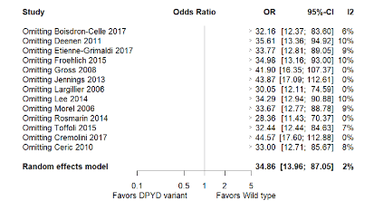
Supplementary Figure 2. Sensibility analysis
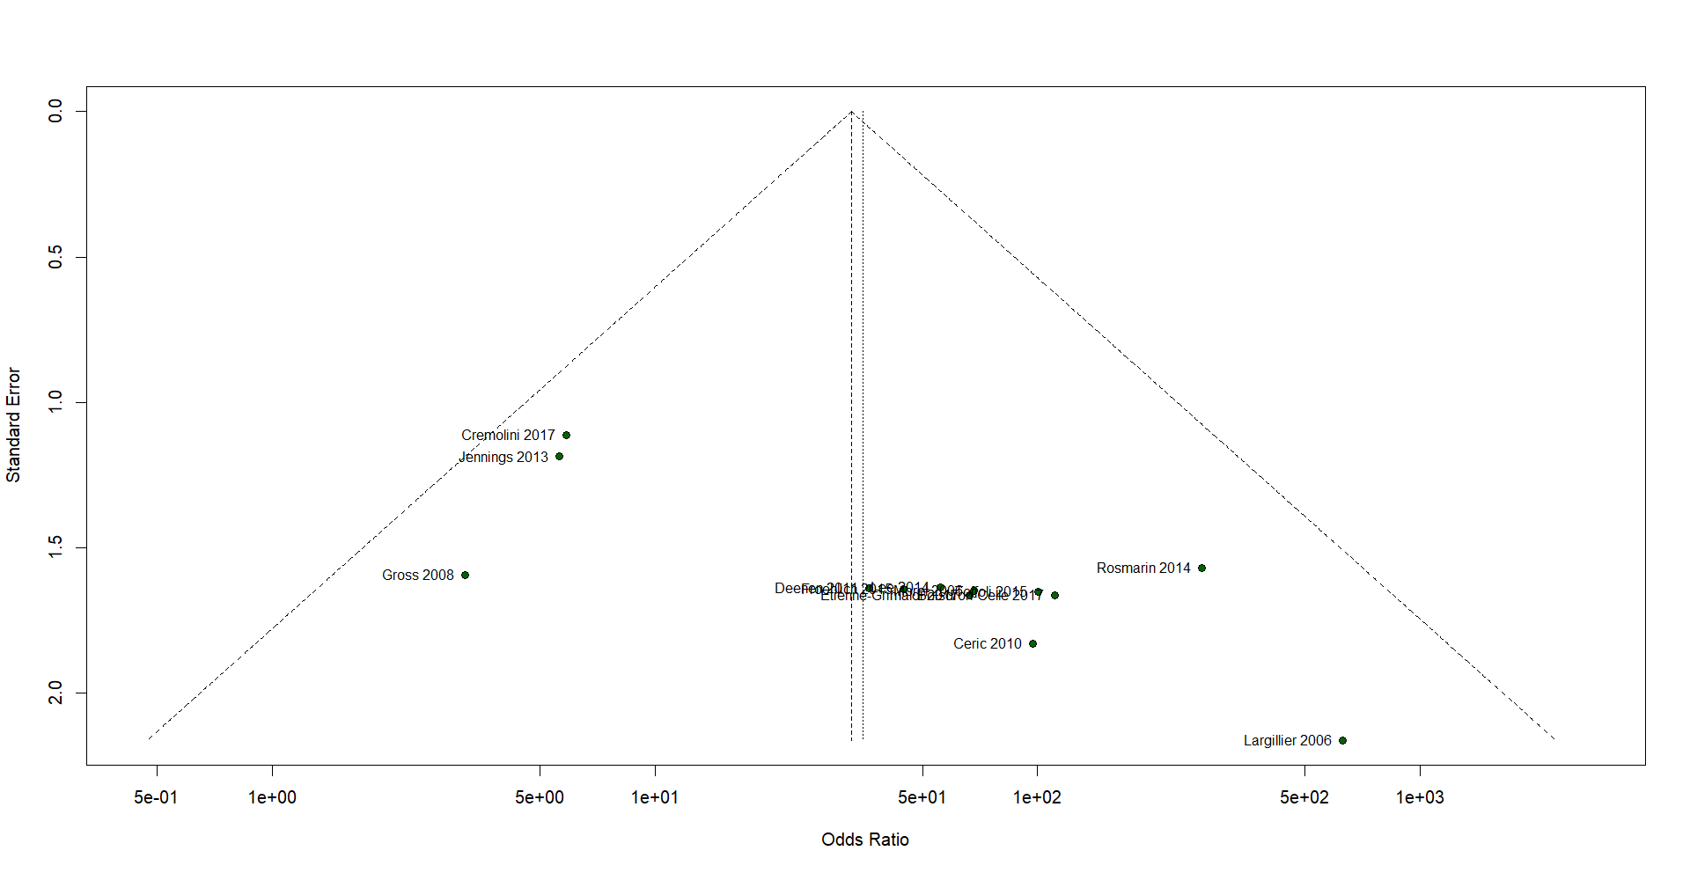
Supplementary Figure 3. Sensibility analysis
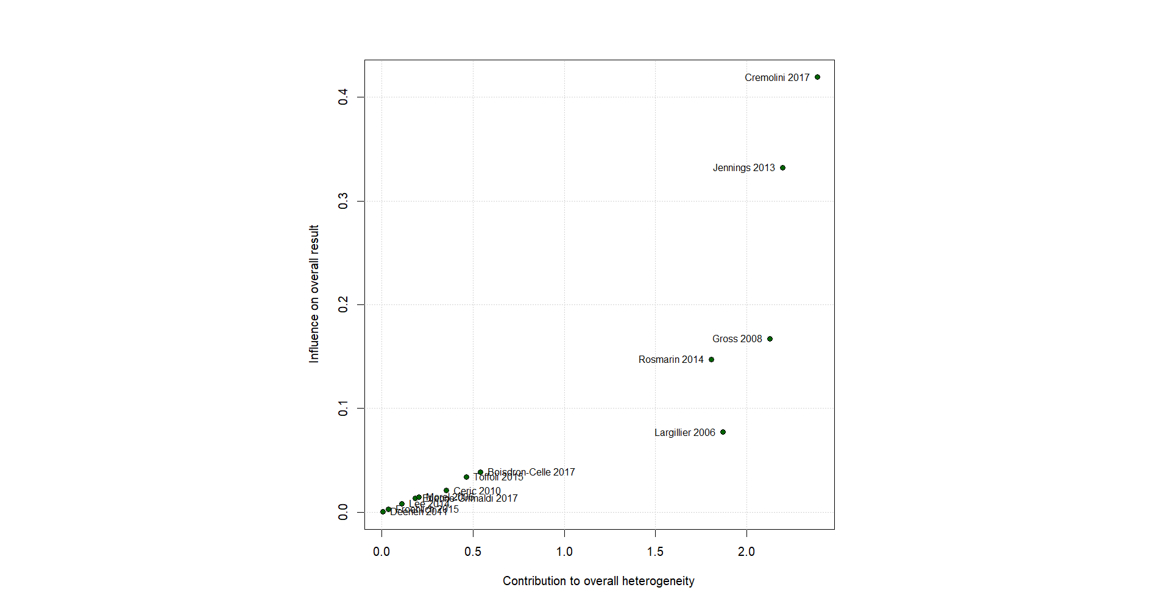
Supplementary Figure 4. Sensibility analysis
