Appendix 1: "Other" Histologies

Other Soft Tissue Sarcomas | n=13 | % out of total Other | % out of total cases included (N=153)
Carcinosarcoma | 1 | 7.6% | 0.6%
Spindle & epithelioid cell sarcoma | 1 | 7.6% | 0.6%
Ewing Sarcoma | 1 | 7.6% | 0.6%
Alveolar Rhabdomyosarcoma | 1 | 7.6% | 0.6%
Pleomorphic Rhabdomyosarcoma | 2 | 15.3% | 1.2%
Endometrial Stromal Sarcoma | 1 | 7.6% | 0.6%
Hemangioendothelioma | 1 | 7.6% | 0.6%
Osteosarcoma | 2 | 15.3% | 1.2%
Epithelioid Sarcoma | 1 | 7.6% | 0.6%
Fibromyxosarcoma | 1 | 7.6% | 0.6%
Adenosarcoma | 1 | 7.6% | 0.6%

Appendix 2: B7H3 positivity subgroup analysis
 | 1: Negative (Score=0) | 2: Positive (Score>0) | Total*** | p value
Age (Years) at Diagnosis |  |  |  | 0.968¹
N | 3 | 113 | 116
N-Miss | 1 | 36 | 37
Mean (SD) | 47.6 (8.0) | 47.9 (14.7) | 47.9 (14.6)
Range | 42.3 - 56.7 | 14.1 - 86.3 | 14.1 - 86.3
Prior Treatment* |  |  |  | 0.508²
Chemotherapy | 0 (0%) | 39 (26%) | 39 (26%)
Radiation | 0 (0%) | 7 (5%) | 7 (5%)
Both | 0 (0%) | 33 (22%) | 33 (22%)
Neither | 3 (100%) | 69 (47%) | 72 (48%)
Tumor Type* |  |  |  | 0.333²
Leiomyosarcoma (LMS) | 1 (25%) | 33 (22%) | 34 (22%)
Liposarcoma (LPS) | 0 (0%) | 49 (33%) | 49 (32%)
Undifferentiated Pleomorphic  Sarcoma (UPS) | 1 (25%) | 24 (16%) | 25 (16%)
Synovial Sarcoma (SS) | 2 (50%) | 30 (20%) | 32 (21%)
Other | 0 (0%) | 13 (9%) | 13 (8%)
Grade* |  |  |  | >0.99²
Grade 1 | 0 (0%) | 26 (19%) | 26 (18%)
Grade 2 | 1 (33%) | 54 (39%) | 55 (39%)
Grade 3 | 2 (67%) | 58 (42%) | 60 (43%)
Size of Primary Tumor (Largest Diameter, cm) |  |  |  | 0.438¹
N | 3 | 110 | 113
Mean (SD) | 12.8 (7.3) | 9.6 (7.0) | 9.7 (7.0)
Range | 5.0 - 19.5 | 1.2 - 40.0 | 1.2 - 40.0
- Linear Model ANOVA
- Fisher’s Exact Test for Count Data
*Percentiles represent the proportion of the variables in the positive / negative B7-H3 expression categories.
**Missing variables’ data was removed from the table and reported in tables 1and 2.
***The Total does not include missing data for corresponding variables.

Appendix 3: B7H3 Expression subgroup analysis.
 | 1: Low**** (Score<3) | 2: High (Score>=3) | Total*** | p value
Age (Years) at Diagnosis |  |  |  | 0.228¹
N | 34 | 82 | 116
Mean (SD) | 45.4 (15.3) | 49.0 (14.2) | 47.9 (14.6)
Range | 14.1 - 70.3 | 18.2 - 86.3 | 14.1 - 86.3
Prior Treatment* |  |  |  | 0.517²
Chemotherapy | 14 (30%) | 25 (24%) | 39 (26%)
Radiation | 1 (2%) | 6 (6%) | 7 (5%)
Both | 12 (26%) | 21 (20%) | 33 (22%)
Neither | 19 (41%) | 53 (50%) | 72 (48%)
Tumor Type* |  |  |  | 0.035²
Leiomyosarcoma (LMS) | 13 (28%) | 21 (20%) | 34 (22%)
Liposarcoma (LPS) | 10 (21%) | 39 (37%) | 49 (32%)
Undifferentiated Pleomorphic Sarcoma (UPS) | 5 (11%) | 20 (19%) | 25 (16%)
Synovial Sarcoma (SS) | 16 (34%) | 16 (15%) | 32 (21%)
Other | 3 (6%) | 10 (9%) | 13 (8%)
Grade* |  |  |  | 0.699²
Grade 1 | 9 (21%) | 17 (17%) | 26 (18%)
Grade 2 | 18 (42%) | 37 (38%) | 55 (39%)
Grade 3 | 16 (37%) | 44 (45%) | 60 (43%)
Size of Primary Tumor (Largest Diameter, cm) |  |  |  | 0.612¹
N | 33 | 80 | 113
Mean (SD) | 9.2 (5.3) | 9.9 (7.6) | 9.7 (7.0)
Range | 1.5 - 22.0 | 1.2 - 40.0 | 1.2 - 40.0
- Linear Model ANOVA
- Fisher’s Exact Test for Count Data
*Percentiles represent the proportion of the variables in the low / high B7-H3 expression categories.
**Missing variables’ data was removed from the table and reported in tables 1and 2.
***The Total does not include missing data for corresponding variables.
****Low category of B7-H3 expression includes negative expression of B7-H3.

Appendix 4: B7H3 positivity and median survival
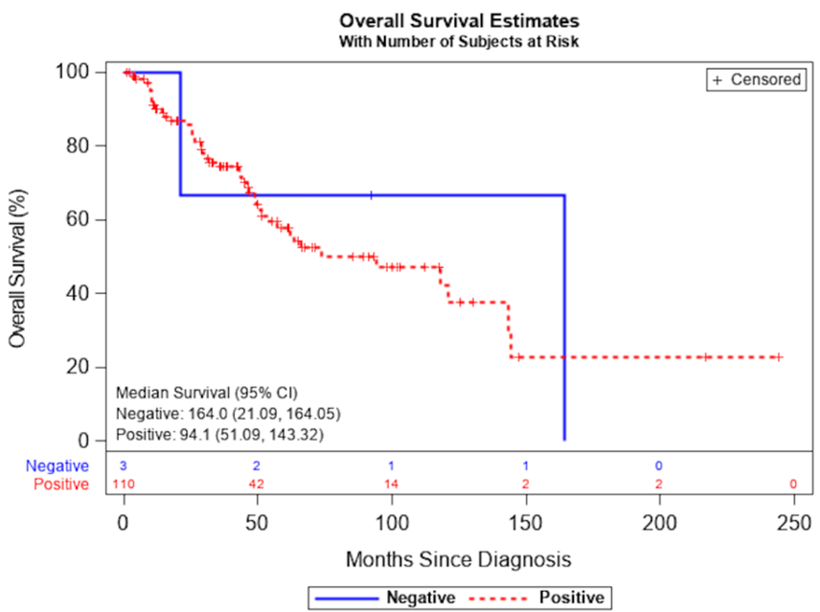

Appendix 5: B7H3 expression and median survival

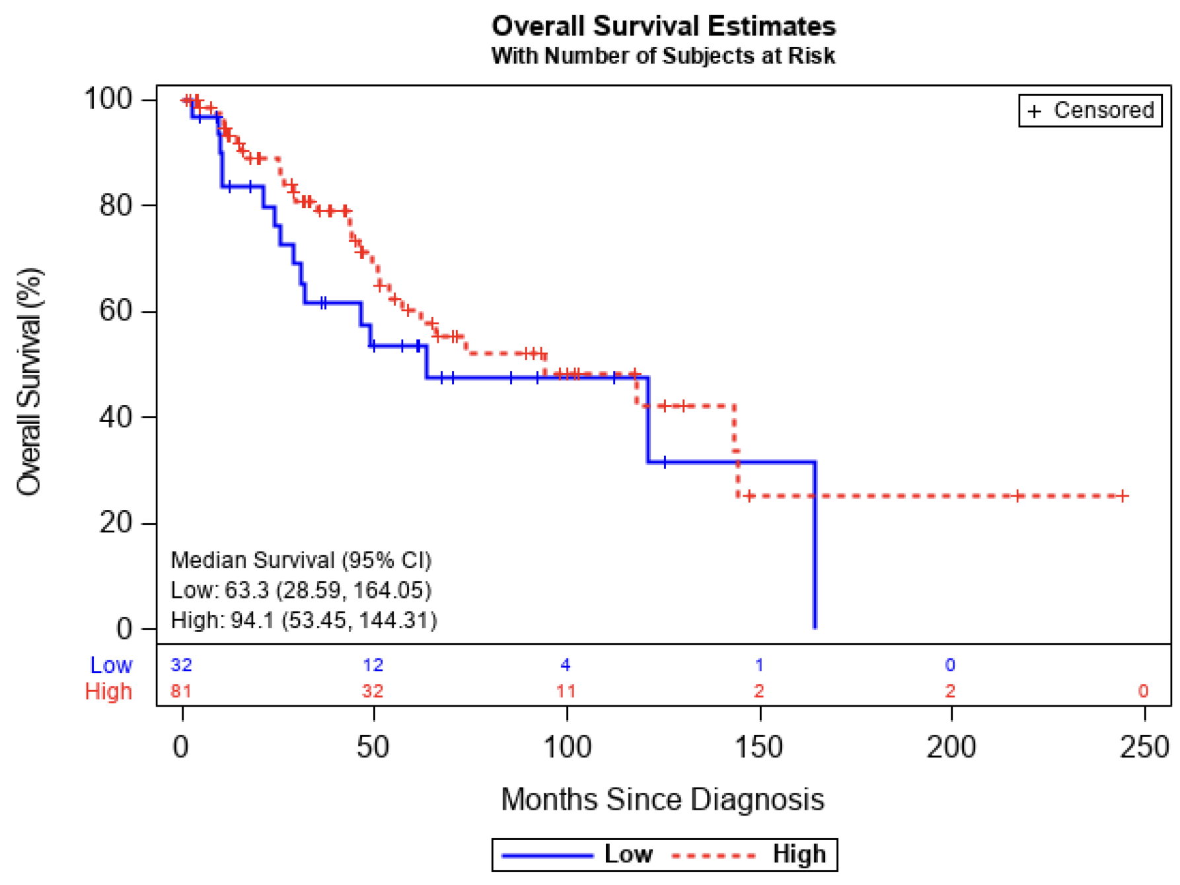

Appendix 6: PD-I positivity subgroup analysis
 | 1: Negative (Score=0) (N=7) | 2: Positive (Score>0) (N=72) | Total (N=79)** | p value
Age (Years) at Diagnosis |  |  |  | 0.622¹
N | 7 | 72 | 79
Mean (SD) | 47.8 (9.8) | 50.6 (15.0) | 50.4 (14.6)
Range | 33.2 - 63.2 | 18.2 - 86.3 | 18.2 - 86.3
Prior Treatment |  |  |  | 0.882²
Chemotherapy | 2 (29%) | 18 (25%) | 20 (25%)
Radiation | 1 (14%) | 6 (8%) | 7 (9%)
Both | 1 (14%) | 15 (21%) | 16 (20%)
Neither | 3 (43%) | 33 (46%) | 36 (46%)
Tumor Type |  |  |  | 0.484²
Leiomyosarcoma (LMS) | 3 (43%) | 16 (22%) | 19 (24%)
Liposarcoma (LPS) | 3 (43%) | 24 (33%) | 27 (34%)
Undifferentiated Pleomorphic  Sarcoma (UPS) | 1 (14%) | 18 (25%) | 19 (24%)
Synovial Sarcoma (SS) | 0 (0%) | 14 (19%) | 14 (18%)
Grade |  |  |  | 0.160²
Grade 1 | 3 (43%) | 12 (17%) | 15 (19%)
Grade 2 | 1 (14%) | 29 (41%) | 30 (38%)
Grade 3 | 3 (43%) | 30 (42%) | 33 (42%)
Size of Primary Tumor (Largest Diameter, cm) |  |  |  | 0.475¹
N | 7 | 72 | 79
Mean (SD) | 8.0 (4.2) | 10.2 (7.8) | 10.0 (7.6)
Range | 2.6 - 15.0 | 1.2 - 40.0 | 1.2 - 40.0
- Linear Model ANOVA
- Fisher’s Exact Test for Count Data
*Missing variables’ data was removed from the table and censored during analysis. **The Total per variable does not include missing data for corresponding variables.

Appendix 7: PD-I expression subgroup analysis
 | 1: Low** (Score<2) (N=38) | 2: High (Score>=2) (N=41) | Total***(N=79) | P value
Age (Years) at Diagnosis |  |  |  | 0.049¹
N | 38 | 41 | 79
Mean (SD) | 47.0 (12.2) | 53.5 (16.0) | 50.4 (14.6)
Range | 27.8 - 73.6 | 18.2 - 86.3 | 18.2 - 86.3
Prior Treatment |  |  |  | 0.504²
Chemotherapy | 7 (18%) | 13 (32%) | 20 (25%)
Radiation | 3 (8%) | 4 (10%) | 7 (9%)
Both | 8 (21%) | 8 (20%) | 16 (20%)
Neither | 20 (53%) | 16 (39%) | 36 (46%)
Tumor Type |  |  |  | 0.005²
Leiomyosarcoma (LMS) | 9 (24%) | 10 (24%) | 19 (24%)
Liposarcoma (LPS) | 16 (42%) | 11 (27%) | 27 (34%)
Undifferentiated Pleomorphic  Sarcoma (UPS) | 3 (8%) | 16 (39%) | 19 (24%)
Synovial Sarcoma (SS) | 10 (26%) | 4 (10%) | 14 (18%)
Grade |  |  |  | 0.225²
Grade 1 | 10 (27%) | 5 (12%) | 15 (19%)
Grade 2 | 14 (38%) | 16 (39%) | 30 (38%)
Grade 3 | 13 (35%) | 20 (49%) | 33 (42%)
Size of Primary Tumor (Largest Diameter, cm) |  |  |  | 0.542¹
N | 38 | 41 | 79
Mean (SD) | 10.5 (8.1) | 9.5 (7.2) | 10.0 (7.6)
Range | 1.2 - 39.2 | 2.0 - 40.0 | 1.2 - 40.0
- Linear Model ANOVA
- Fisher’s Exact Test for Count Data
*Missing variables’ data was removed from the table and censored during analysis.
**The Total does not include missing data for corresponding variables.
***Low category of PD-1 expression includes negative expression of PD-1.

Appendix 8: PD-LI positivity subgroup analysis
 | 1: Negative (Score=0) (N=32) | 2: Positive (Score>0) (N=47) | Total** (N=79) | p value
Age (Years) at Diagnosis |  |  |  | 0.007¹
N | 32 | 47 | 79
Mean (SD) | 45.1 (12.8) | 53.9 (14.7) | 50.4 (14.6)
Range | 18.2 - 73.6 | 24.8 - 86.3 | 18.2 - 86.3
Prior Treatment |  |  |  | 0.180²
Chemotherapy | 9 (28%) | 11 (23%) | 20 (25%)
Radiation | 1 (3%) | 6 (13%) | 7 (9%)
Both | 4 (12%) | 12 (26%) | 16 (20%)
Neither | 18 (56%) | 18 (38%) | 36 (46%)
Tumor Type |  |  |  | 0.067²
Leiomyosarcoma (LMS) | 8 (25%) | 11 (23%) | 19 (24%)
Liposarcoma (LPS) | 14 (44%) | 13 (28%) | 27 (34%)
Undifferentiated Pleomorphic  Sarcoma (UPS) | 3 (9%) | 16 (34%) | 19 (24%)
Synovial Sarcoma (SS) | 7 (22%) | 7 (15%) | 14 (18%)
Grade |  |  |  | 0.060²
Grade 1 | 10 (31%) | 5 (11%) | 15 (19%)
Grade 2 | 12 (38%) | 18 (39%) | 30 (38%)
Grade 3 | 10 (31%) | 23 (50%) | 33 (42%)
Size of Primary Tumor (Largest Diameter, cm) |  |  |  | 0.329¹
N | 32 | 47 | 79
Mean (SD) | 9.0 (6.0) | 10.7 (8.5) | 10.0 (7.6)
Range | 1.2 - 29.0 | 2.0 - 40.0 | 1.2 - 40.0

- Linear Model ANOVA
- Fisher’s Exact Test for Count Data
*Missing variables’ data was removed from the table and censored during analysis. **The Total per variable does not include missing data for corresponding variables.

Appendix 9: PD-LI expression subgroup analysis
 | 1: Low*** (Score<2) (N=52) | 2: High (Score>=2) (N=27) | Total** (N=79) | p value
Age (Years) at Diagnosis |  |  |  | 0.041¹
N | 52 | 27 | 79
Mean (SD) | 48.0 (13.7) | 55.0 (15.3) | 50.4 (14.6)
Range | 18.2 - 86.0 | 24.8 - 86.3 | 18.2 - 86.3
Prior Treatment |  |  |  | 0.466²
Chemotherapy | 15 (29%) | 5 (19%) | 20 (25%)
Radiation | 5 (10%) | 2 (7%) | 7 (9%)
Both | 8 (15%) | 8 (30%) | 16 (20%)
Neither | 24 (46%) | 12 (44%) | 36 (46%)
Tumor Type |  |  |  | < 0.001²
Leiomyosarcoma (LMS) | 13 (25%) | 6 (22%) | 19 (24%)
Liposarcoma (LPS) | 23 (44%) | 4 (15%) | 27 (34%)
Undifferentiated Pleomorphic  Sarcoma (UPS) | 5 (10%) | 14 (52%) | 19 (24%)
Synovial Sarcoma (SS) | 11 (21%) | 3 (11%) | 14 (18%)
Grade |  |  |  | 0.018²
Grade 1 | 13 (25%) | 2 (7%) | 15 (19%)
Grade 2 | 22 (43%) | 8 (30%) | 30 (38%)
Grade 3 | 16 (31%) | 17 (63%) | 33 (42%)
Size of Primary Tumor (Largest Diameter, cm) |  |  |  | 0.048¹
N | 52 | 27 | 79
Mean (SD) | 11.2 (8.5) | 7.6 (4.6) | 10.0 (7.6)
Range | 1.2 - 40.0 | 2.0 - 19.5 | 1.2 - 40.0
- Linear Model ANOVA
- Fisher’s Exact Test for Count Data
*Missing variables’ data was removed from the table and censored during analysis.
**The Total does not include missing data for corresponding variables.
***Low category of PD-1 expression includes negative expression of PD-1.

Appendix 10: Correlation between B7H3 and PD-1/PD-L1 positivity:

 | B7-H3 Negative (Score=0) (N=2) | B7-H3 Positive (Score>0) (N=77) | Total (N=79)* | p value
PD-1 Positivity |  |  |  | >0.99¹
Negative (Score=0) | 0 (0%) | 7 (9%) | 7 (9%)
Positive (Score>0) | 2 (100%) | 70 (91%) | 72 (91%)
PD-L1 Positivity |  |  |  | >0.99¹
Negative (Score=0) | 1 (50%) | 31 (40%) | 32 (41%)
Positive (Score>0) | 1 (50%) | 46 (60%) | 47 (59%)
- Fisher’s Exact Test for Count Data
*Missing variables’ data was removed from the table and censored during analysis.

Appendix 11: Correlation between B7H3 and PD-1/PD-L1 expression:

 | B7-H3 Low (Score<3) (N=16) | B7-H3 High (Score>=3) (N=63) | Total (N=79)* | p value
PD-1 Expression |  |  |  | >0.99¹
Low (Score<2) | 8 (50%) | 30 (48%) | 38 (48%)
High (Score>=2) | 8 (50%) | 33 (52%) | 41 (52%)
PD-L1 Expression |  |  |  | >0.99¹
Low (Score<2) | 11 (69%) | 41 (65%) | 52 (66%)
High (Score>=2) | 5 (31%) | 22 (35%) | 27 (34%)

- Fisher’s Exact Test for Count Data
*Missing variables’ data was removed from the table and censored during analysis.

Appendix 12: I B7H3 staining pattern

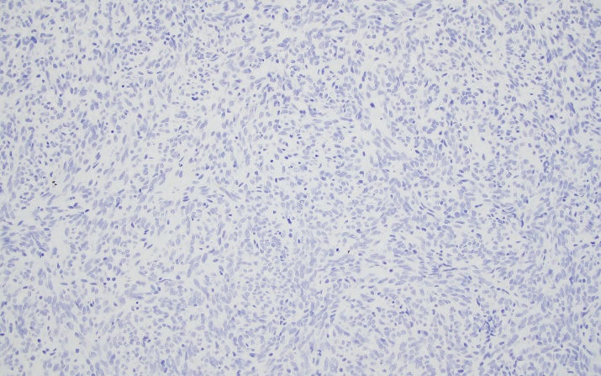 | 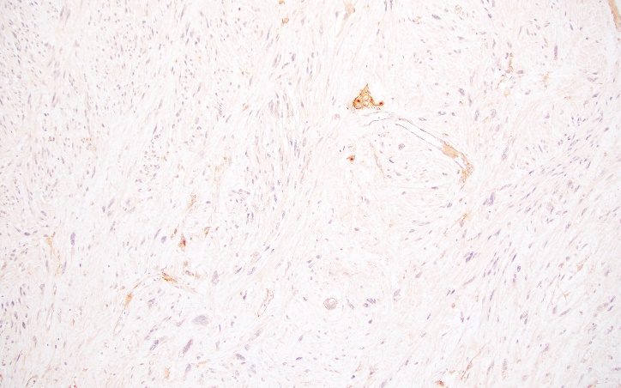
- Score 0 | - Score 1
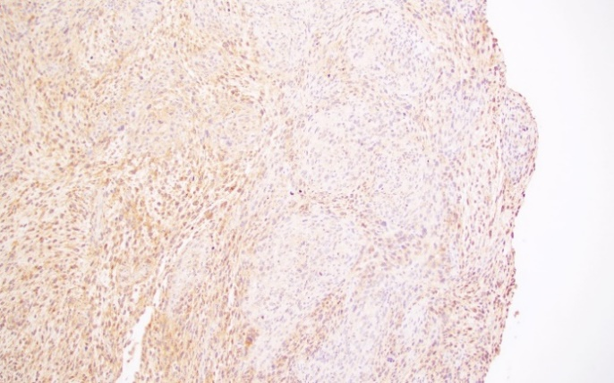 | 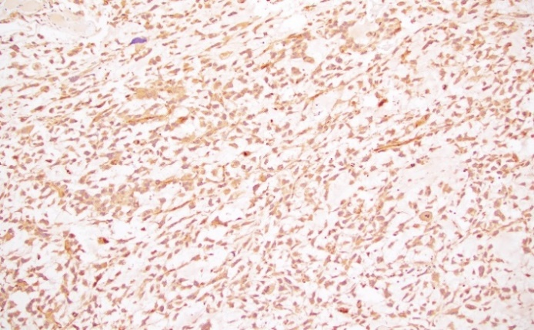
- Score 3 | - Score 4
Immunohistochemical staining for B7-H3 (A) Score 0 (0% positive cells): Negative staining for B7-H3 in the tumor cells. (B) Score 1: Positive membranous and cytoplasmic staining is seen in isolated tumor cells (between 0-25% of the tumor) as well as within normal endothelial cells. (C) Score 3: Patchy positive staining in approximately 50-7% of the tumor cells. (D) Score 4: Diffuse expression of B7-H3 with membranous and cytoplasmic positivity in the tumor cells as well as within the vascular endothelial cells. (between 75-100% of the tumor) (B7-H3 IHC, all images were captured at 10x magnification).

