FigureS1

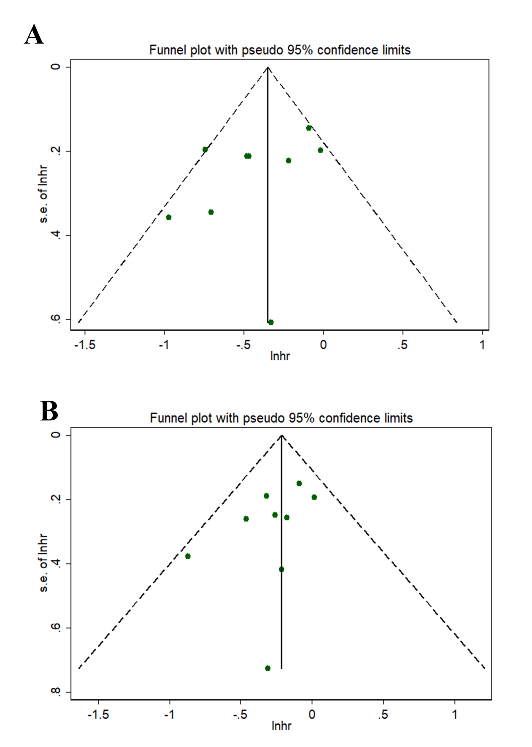
Supplementary Figure 1. Bias funnel plots for iPFS (A) and OS (B).

FigureS2
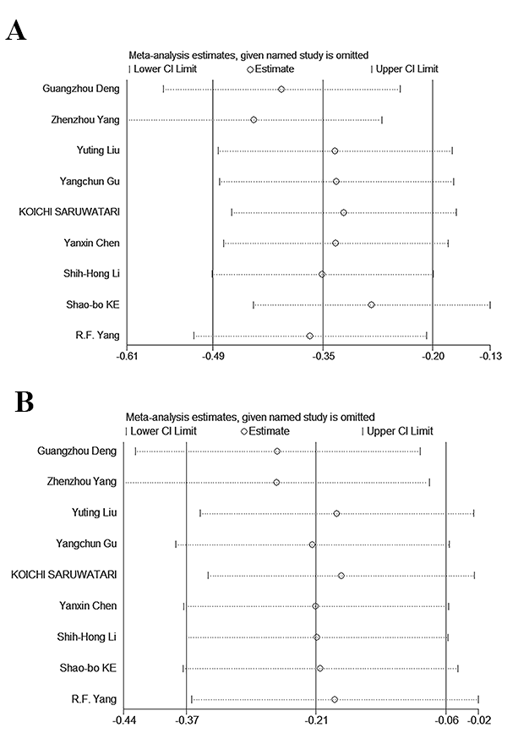
Supplementary Figure 2: Sensitivity analysis of patient iPFS (A) and OS (B) meta-analysis.

FigureS3
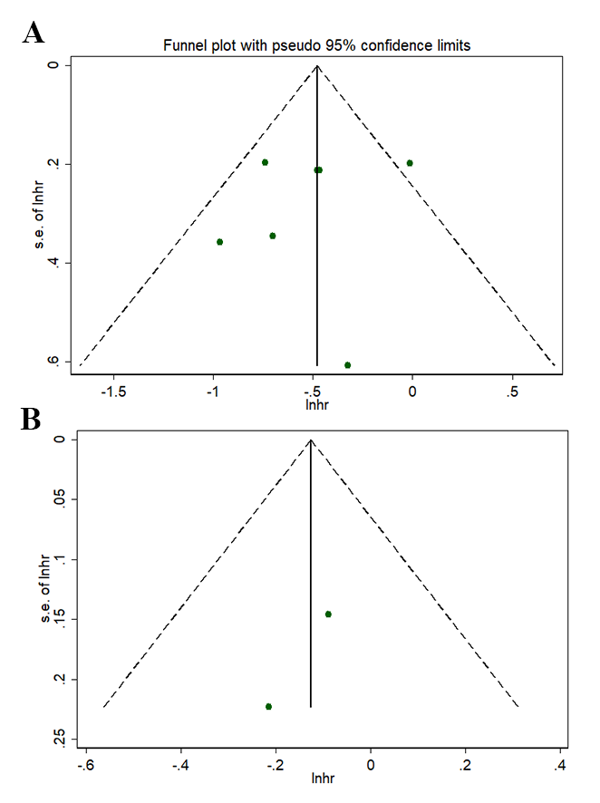
Supplementary Figure 3. Bias funnel plots for subgroups 1 (A) and 2 (B).

FigureS4

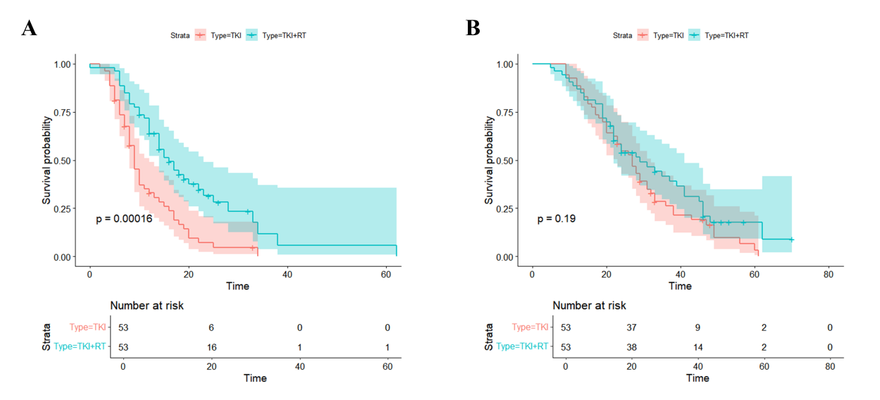

Supplementary Figure 4. Survival analysis curve after PSM. The survival analysis curves of iPFS (A) and OS (B) in patients treated with combination therapy and TKI alone.

FigureS5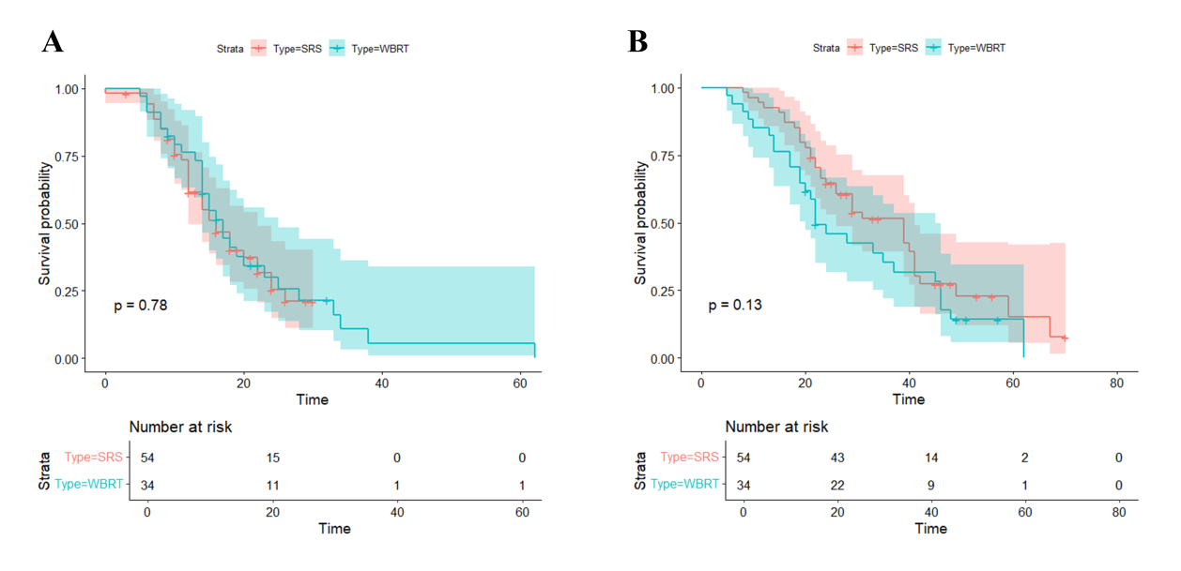

Supplementary Figure 5. Survival analysis curve of different radiotherapy technique. The survival analysis curves of iPFS (A) and OS (B) in patients treated with SRS and WBRT.
TableS1.Baseline characteristics of patients after PSM.
Characteristic | TKI+RT group | TKI group
Characteristic | （n=53) | (n=53) | P Value
Age |  |  | 1.000
<=60 | 28（58.2%） | 28（58.2%）
>60 | 25（47.2%） | 25（47.2%）
Sex |  |  | 0.698
Male | 28（58.2%） | 26（49.1%）
Woman | 25（47.2%） | 27（50.9%）
KPS Grade |  |  | 0.227
70 Points | 9（17.0%） | 10（18.9%）
80 Points | 34（64.2%） | 39（73.6%）
90 Points | 10（18.9%） | 4（7.5%）
Symptom
No | 18（34.0%） | 14（26.4%） | 0.397
Yes | 35（66.0%） | 39（73.6%）
Discovery time of intracranial lesions |  |  | 0.829
Isochronism | 39（73.6%） | 38（71.7%）
heterochrony | 14（26.4%） | 15（28.3%）
The gene mutation site |  |  | 0.963
Exon 19 | 22（41.5%） | 23（43.4%）
Exon 21 | 21（39.6%） | 21（39.6%）
Other | 10（18.9%） | 9（17.0%）
BM number |  |  | 0.291
<=2 | 15（28.3%） | 16（30.2%）
3-5 | 26（49.1%） | 31（58.5%）
>5 | 12（22.6%） | 6（11.3%）
History of the primary site of surgery |  |  | 0.447
No | 45（84.9%） | 42（79.2%）
Yes | 8（15.1%） | 11（20.8%）
Intracranial lesion |  |  | 0.814
Limit | 11（29.8%） | 12（22.6%）
extensive | 42（79.2%） | 41（77.4%）
Combined anti- vascular drugs |  |  | 0.556
No | 32（60.4%） | 29（54.7%）
Yes | 21（39.6%） | 24（45.3%）
Combined chemotherapy |  |  | 0.276
No | 36（67.9%） | 41（77.4%）
Yes | 17（32.1%） | 12（22.6%）
RT Method |  |  | 0.052
SRS | 21（39.6%） | 31（58.5%）
WB | 32（60.4%） | 22（41.5%）

Table S2 The side effects of TKI combined with brain radiotherapy in the treatment of lung cancer with brain metastasis
Comparison of treatment plans | Side effects of TKI+ brain radiotherapy | References
WBRT+ first generation TKI used in combination | All 43 patients with brain metastases could tolerate ectinib combined with WBRT. Some patients have grade 1 or 2 headache, which can be relieved by mannitol. Grade 4 or 5 treatment-related toxicity was not observed. |  | （1）
WBRT+ first generation TKI used in combination | The combination of WBRT with concurrent erlotinib was well tolerated with no unexpected neurotoxicity. |  | （2）
WBRT+ first generation TKI used in combination | Most patients had grade 1 or grade 2 adverse events. No grade 4 adverse reactions, treatment-related deaths, or discontinuation were observed. No deterioration in neurocognitive function was detected at 20 weeks. |  | （3）
WBRT+ third generation TKI used in combination | By using highly active targeted therapy, WBRT can be safely delayed in patients with asymptomatic EGFR-mutated NSCLC with BMS, reducing associated toxic effects that may negatively affect QOL. |  | （4）
WBRT alone VS WBRT+ first and third generation TKI combined | WBRT combined with ocitinib, ectinib, or erlotinib had a lower rate of adverse reactions than WBRT alone. In particular, the combination of WBRT and erlotinib reduced adverse events. |  | （5）
WBRT+ first generation TKI used in combination | The meta-analysis showed that WBRT plus gefitinib/erlotinib increased the incidence of rash but reduced the incidence of myelosuppression. Statistical differences were not found regarding other adverse events. |  | （6）
WBRT+ first generation TKI used in combination | Cognitive function was impaired in only a minority at baseline, and both MMSE and Trails B scores tended to improve over the course of treatment. This suggests that cognitive function was not negatively affected by the treatment at short-term. |  | （7）
WBRT+ first generation TKI used in combination | The addition of Gefitinib to RT was generally well tolerated. The most common toxicities were rash (86%) and diarrhea (43%). Grade III diarrhea developed in three patients (14%). Other grade II or higher toxicities occurring in about 50% of patients included nausea, vomiting, headache, and fatigue. Most side effects were grade II and were well controlled by supportive care. |  | （8）

- Li JR, Zhang Y, Zheng JL. Icotinib combined whole brain radiotherapy for patients with brain metastasis from lung adenocarcinoma harboring epidermal growth factor receptor mutation. J Thorac Dis. 2016 Jul;8(7):1504-12.
- Yang Z, Zhang Y, Li R, et al. Whole-brain radiotherapy with and without concurrent erlotinib in NSCLC with brain metastases: a multicenter, open-label, randomized, controlled phase III trial. Neuro Oncol. 2021 Jun 1;23(6):967-978.
- Zhou L, He J, Xiong W, et al. Impact of whole brain radiation therapy on CSF penetration ability of Icotinib in EGFR-mutated non-small cell lung cancer patients with brain metastases: Results of phase I dose-escalation study. Lung Cancer. 2016 Jun;96:93-100.
- Achrol AS, Rennert RC, Anders C, et al. Brain metastases. Nat Rev Dis Primers. 2019 Jan 17;5(1):5.
- Li S, Xu S, Li L, et al. Efficacy and safety of EGFR-TKI combined with WBRT vs. WBRT alone in the treatment of brain metastases from NSCLC: a systematic review and meta-analysis. Front Neurol. 2024 Apr 26;15:1362061.
- Zheng MH, Sun HT, Xu JG, et al. Combining Whole-Brain Radiotherapy with Gefitinib/Erlotinib for Brain Metastases from Non-Small-Cell Lung Cancer: A Meta-Analysis. Biomed Res Int. 2016;2016:5807346.
- Pesce GA, Klingbiel D, Ribi K, et al. Outcome, quality of life and cognitive function of patients with brain metastases from non-small cell lung cancer treated with whole brain radiotherapy combined with gefitinib or temozolomide. A randomised phase II trial of the Swiss Group for Clinical Cancer Research (SAKK 70/03). Eur J Cancer. 2012 Feb;48(3):377-84.
- Ma S, Xu Y, Deng Q, Yu X. Treatment of brain metastasis from non-small cell lung cancer with whole brain radiotherapy and Gefitinib in a Chinese population. Lung Cancer. 2009 Aug;65(2):198-203.

