Supplementary Appendix
This appendix has been provided by the authors to give readers additional information about their work.

Supplementary Table 1. NGS sequencing of patients at baseline and at disease progression.

Patient number | NGS at baseline | TP53 destructive mutation at baseline | NGS at disease progression | Exon 20 T790M mutation at disease progression
01 | L858R; Tp53p.P190L | Yes | L858R; Tp53p.P190L; EGFR copy number increasing | No
02 | 19 del; TP53p.R248Q; EGFR copy number increasing; ATMp.P7955; CCND3p.R37H; IRS2p.P1036delP | No | 19del; T790M; TP53p.R248Q | Yes
03 | 19 del; PTEN p.Q214*; SMAD4 p.G510E; CDKN2A copy number reducing; SF3B1 c.300+2T>A; CREBBP p.N58S; SMAD4 p.P130L | No | 19del; T790M; CREBBPp.N58S; KMTDp.E473D; KMTDp.S2858A | Yes
04 | 19 del | No | 19del; T790M; CDKN2A p.W110* | Yes
05 | 19 del; TP53 p.V272M | Yes | Not detected | unknown
06 | L858R | No | L858R; T790M | Yes
07 | L858R; Tp53 p.D228*fs*1; GRIN2Ap.Y1187C | No | L858R; CDK4 copy number reducing; RICTOR copy number reducing | No
08 | L858R; TP53 p.R282W | Yes | L858R; T790M | Yes
09 | 19 del; TP53p.Y205C; KDM6A p.Q154*; EGFR copy number increasing; CCND1 copy number increasing; NKX2-1 copy number increasing | Yes | NA | NA
10 | 19 del; TP53p.G105V; JAK2 c.3060-2A>T; MCL1 copy number increasing; RIT1 copy number increasing | No | NA | NA
11 | 19 del; TP53 p.C242S; AKT3 intron8/9 c.696+1G>A; TERTp.Arg381fsTer12 8; FANCG p.Leu589Pro | Yes | 19del; TP53 p.C242S | No
12 | 19 del; TP53 p.R280T; PTEN p.L112V; MCL1 copy number increasing | Yes | 19del; MLH1p.E511*Exon13; PTENp.L112V*Exon5; TP53p.R280G*Exon8 | No
13 | 19 del; TP53p.L194R | No |  | NA
14 | 19 del; TP53p.K132N; RB1 p.L647Hfs*10 | No | 19del; T790M; TP53p.K132N; RB1p.L647Hfs*10 | Yes
15 | L858R; TP53p.D259V; EGFR amplification; CREBBP rearrangement; PMS1 missense mutation; RAD54L missense mutation; PIK3CB amplification | Yes | L858R; T790M; TP53p.D259V | Yes
16 | 19 del; TP53 H214Lfs*24; STK11 F354L | No | NA | NA
17 | L858R; TP53 p.R273C; TP53 p.A161S | Yes | L858R; T790M; CDKN2A copy number reducing; TP53pA161S | Yes
18 | L858R; TP53p.G199V; ERBB2 p.S310F; AKT1 p.E49K; MYC amplification；TSC1 copy number reducing | Yes | NA | NA
19 | 19 del; CTNNB1p.S37F; EPHA3 point mutation; CDK4 amplification; MDM2 amplification | No | ARID1Ap.S1791L; ASXL!p.E41K; SDHAF2p.S10L | No
20 | L858R | No | NA | NA
Abbreviations: NGS, Next-Generation Sequencing; 19 del; EGFR gene exon 19 deletion mutation; L858R, EGFRp.L858R; NA, not Applicable.

Supplementary Table 2. Duration of Exposure in maintenance phase.
Patient number | Maintenace phase  ( Bevacizumab + Pemetrexed + Gefitinib ）
Patient number | Completed | Duration of Exposure (Months)
Patient number | Completed | Bevacizumab | Pemetrexed
01 | Yes | 24 | 24
02 | No | 15 | 15
03 | No | 14 | 14
04 | No | 9 | 9
05 | No | 13.6 | 13.6
06 | No | 4 | 15
07 | No | 20.5 | 17
08 | No | 13 | 13
09 | Yes | 24 | 24
10 | No | 4 | 4
11 | No | 7 | 13
12 | No | 16.3 | 16.3
13 | Yes | 24 | 24
14 | Yes | 24 | 24
15 | No | 17 | 17
16 | Yes | 24 | 24
17 | No | 4.5 | 4.5
18 | Yes | 24 | 24
19 | No | 13 | 13
20 | Yes | 24 | 24
The Median |  | 15.65 | 15.65
The Range |  | 4-24 | 4-24

Supplementary Table 3. Characteristics and efficacy of 14 patients after disease progression.

Patient number | Site of disease progression | EGFR exon 20 T790M | Treatment | Response | Secondary progression | Death | PFS  (Months) | OS  (Months)
01 | Brain | No | Chemoradiotherapy | PR | Yes | Yes | 8.5 | 15.7
02 | Lung | Yes | Osimertinib | PR | No | No | 14.2 | 16.1
03 | lymph node, bone | Yes | Osimertinib+radiotherapy | PR | Yes | No | 15.1 | 26.5
04 | Lung, lymph node | Yes | Osimertinib | PR | No | No | 2.1 | 2.1
05 | Brainstem | unknown | No treatment | PD | Yes | Yes | 0 | 0.2
06 | Lung | Yes | Osimertinib | PR | Yes | No | 10.5 | 13.5
07 | Meninx, Lung | No | Chemoradiotherapy | SD | Yes | Yes | 9.7 | 18.0
08 | Meninx, Lung | Yes | Osimertinib+radiotherapy | SD | Yes | Yes | 5.8 | 8.0
11 | Brain | No | Chemoradiotherapy | PR | No | No | 3.8 | 5.8
12 | Lung | No | Chemotherapy | SD | Yes | Yes | 4.0 | 11.0
14ª | Lung | Yes | Osimertinib+Chemotherapy | SD | No | No | 1.0 | 1.8
15 | Meninx, bone | Yes | Osimertinib+radiotherapy | SD | No | No | 12.4 | 14.4
17 | Lung | Yes | Osimertinib | PR | No | No | 15.2 | 18.0
19 | Brain | No | Chemoradiotherapy | PR | No | No | 1.8 | 3.3
Abbreviations: PR, partial response; SD, stable disease; PD, progressive disease; PFS, progression-free survival; PFS, time from first disease progression to secondary disease progression; OS, overall survival; OS, time from first disease progression to death or cutoff date; a, pathological type of this patient transformed from lung adenocarcinoma to small cell lung cancer.

Supplementary Fig. 1. (A) Progression-free survival, and (B) overall survival in patients after disease progression by RECIST version 1.1. PFS, progression-free survival; OS, overall survival.
Supplementary Figure 1.
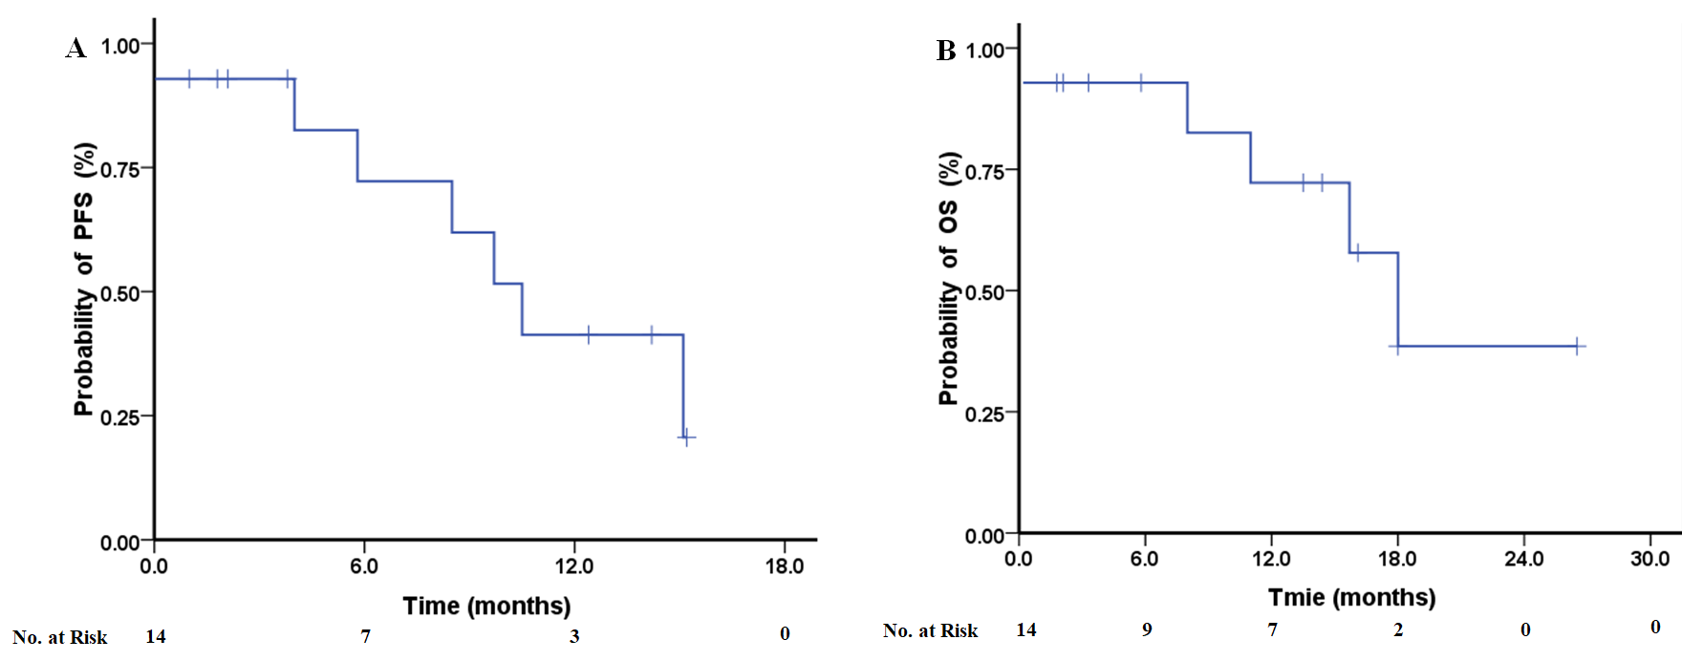
Supplementary Fig. 2. (A) Progression-free survival, and (B) overall survival in patients with T790M mutations and without T790M mutations after disease progression by RECIST version 1.1. PFS, progression-free survival; OS, overall survival.
Supplementary Figure 2.
