Osteosarcoma cells depend on MCL-1 for survival and osteosarcoma metastases respond to MCL-1 antagonism plus regorafenib in vivo

Yanhao Ji¹, Michael A. Harris^{1,2}, Lucas M. Newton^{1,3}, Tiffany J. Harris⁴, W. Douglas Fairlie^{1,4,5}, Erinna F. Lee^{1,4,5} & Christine J. Hawkins¹ (corresponding author)

- La Trobe Institute for Molecular Science, La Trobe University, Melbourne, VIC, 3086, Australia
- Peter MacCallum Cancer Centre, Melbourne, VIC, 3000, Australia
- Swinburne University, Hawthorn, VIC, 3122, Australia
- Olivia Newton-John Cancer Research Institute, Heidelberg, VIC, 3084, Australia
- School of Cancer Medicine, La Trobe University, Melbourne, VIC, 3086, Australia

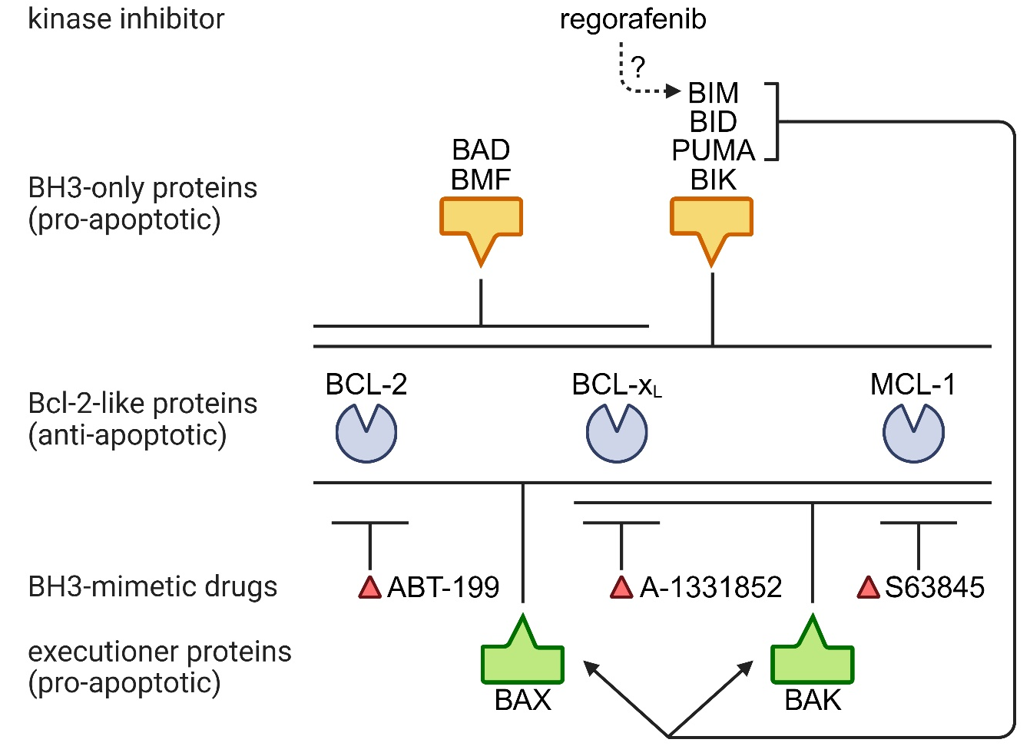

Supplementary Figure 1: Model illustrating interactions between proteins and drugs analyzed in this study (Fairlie WD and Lee EF, Biochem Soc Trans 49:2397-2410, 2021). Regorafenib has been shown to boost Bim expression (Sun B et al, Cell Death Discov 9:37, 2023) but may also interact with Bcl-2 family proteins via other mechanisms. Created in BioRender.com

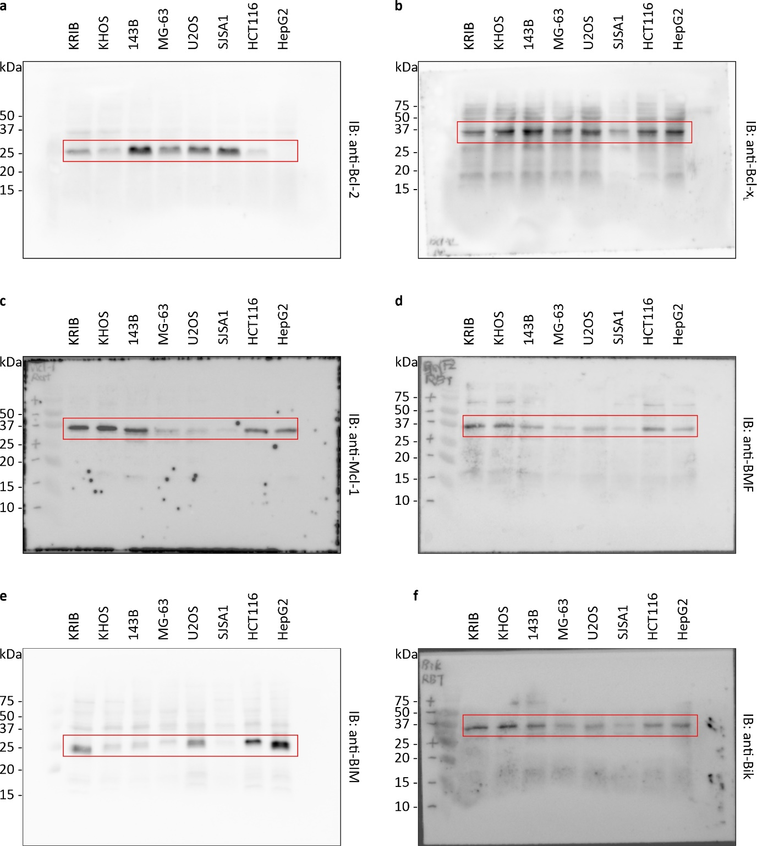
Supplementary Figure 2: Uncropped western blots for Figure 1B. Expression of Bcl-2 family proteins were assessed by western blot. Each membrane was immunoblotted by: a anti-Bcl-2 antibody; b anti Bcl-x_{L} antibody; c anti-Mcl-1 antibody; d anti-BMF antibody; e anti-BIM antibody; and f anti-Bik antibody. The red-outlined rectangle highlights the cropped area shown in Figure 1B. The remaining uncropped figures for Figure 1B are provided in Supplementary Figure 2.
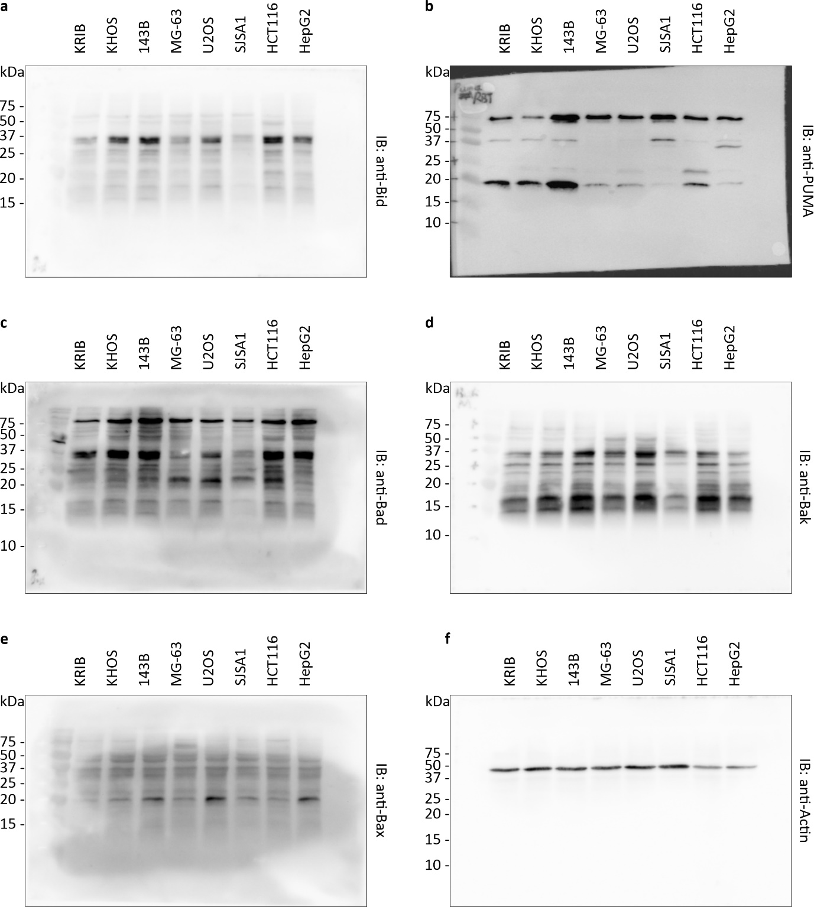
Supplementary Figure 2: Uncropped western blots for Figure 1B. Expression of Bcl-2 family proteins were assessed by western blot. Each membrane was immunoblotted by: a anti-Bid antibody; b anti PUMA antibody; c anti-Bad antibody; d anti-Bak antibody; e anti-Bax antibody; and f anti-Actin antibody. The red-outlined rectangle highlights the cropped area shown in Figure 1B.

