Supplementary materials for

Evaluating Plasma Antinuclear Autoantibody Profile as Prognostic Biomarkers in Lymphoma

The PDF file includes:
Figures S1 to S5
Tables S1 to S3

Supplementary figure 1
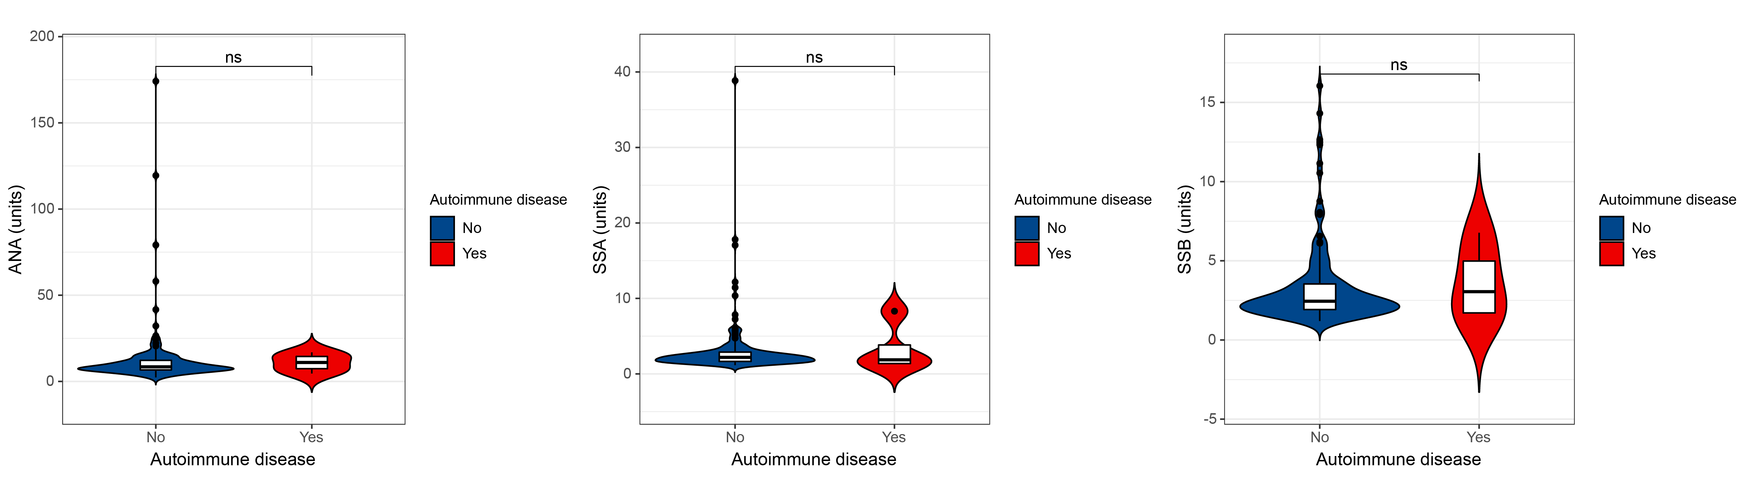
Fig.S1. Comparison of ANA profiles between patients with or without a history of autoimmune diseases.

Supplementary figure 2
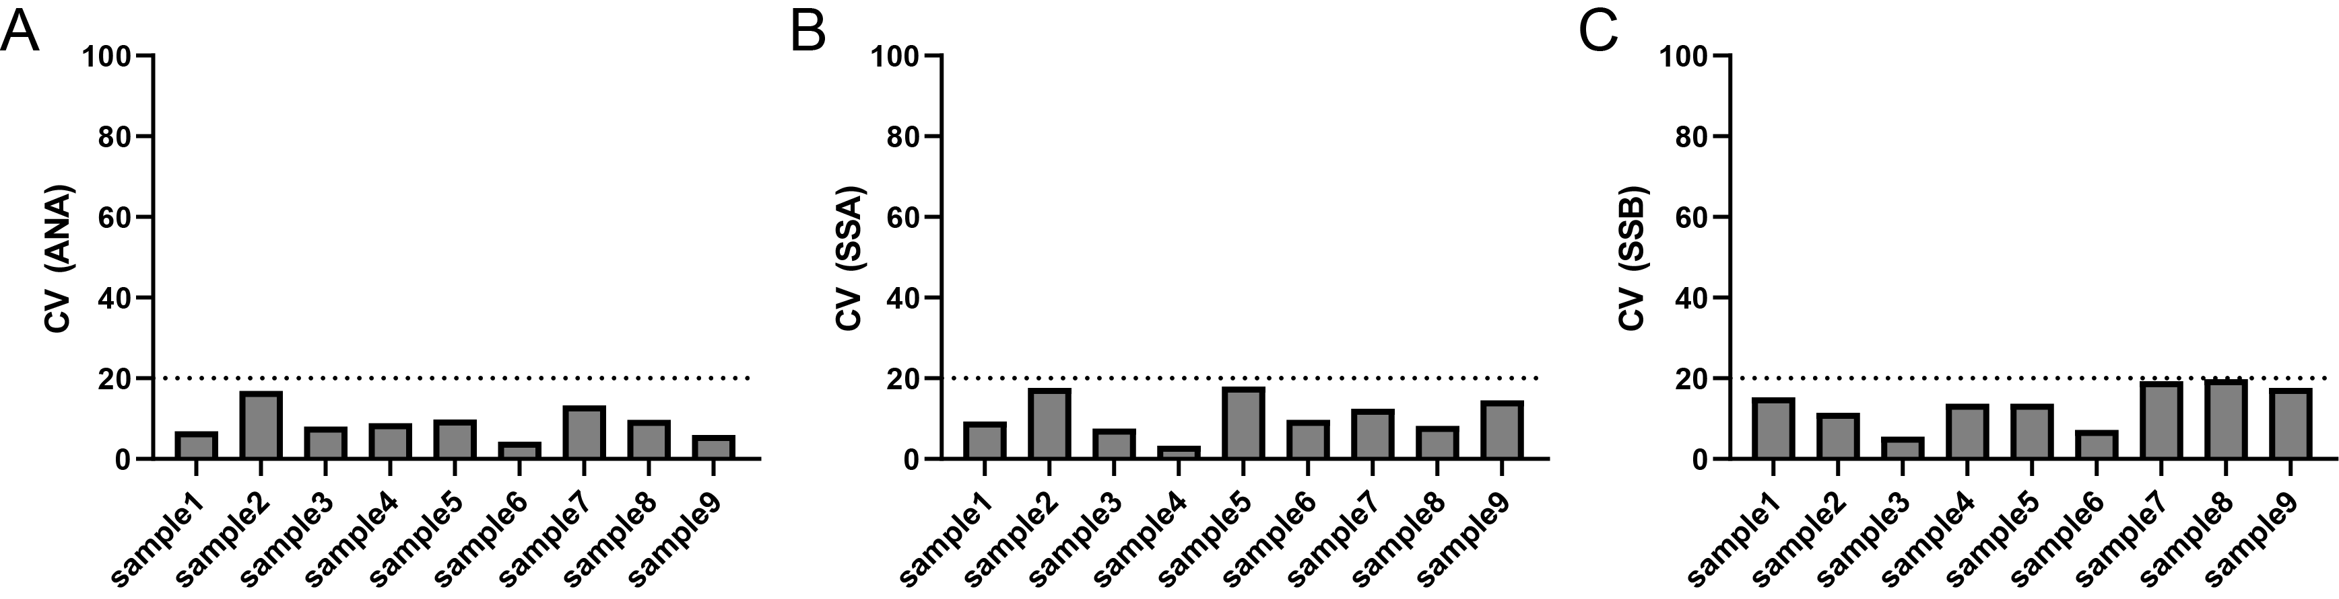
Fig.S2. Quality control of the experiment. (A) Coefficient of variation (CV) of ANA in different plate. (B) CV of SSA in different plate.(C) CV of SSB in different plate.

Supplementary figure 3
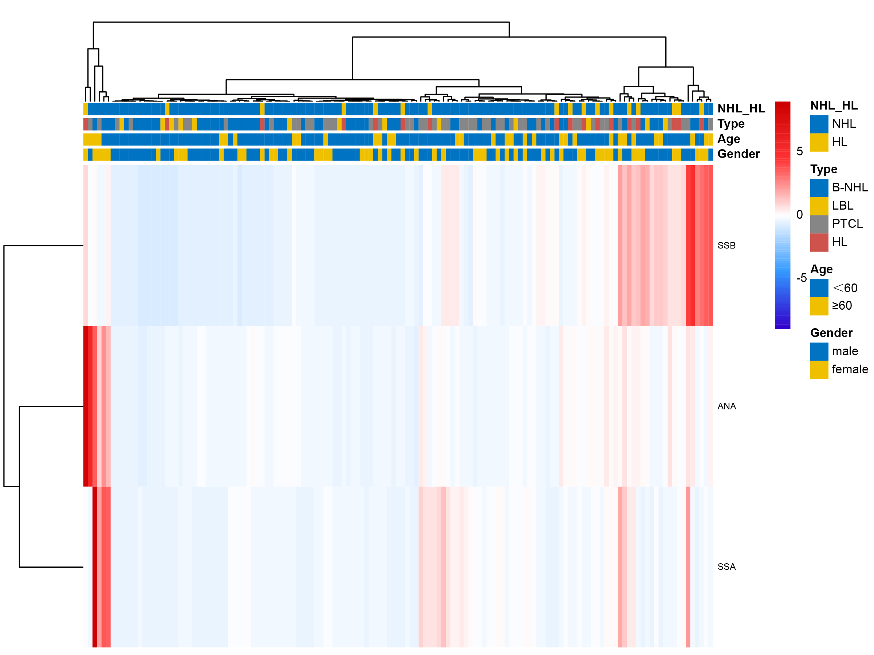
Fig.S3. Heatmap of the ANA profile.

Supplementary figure 4
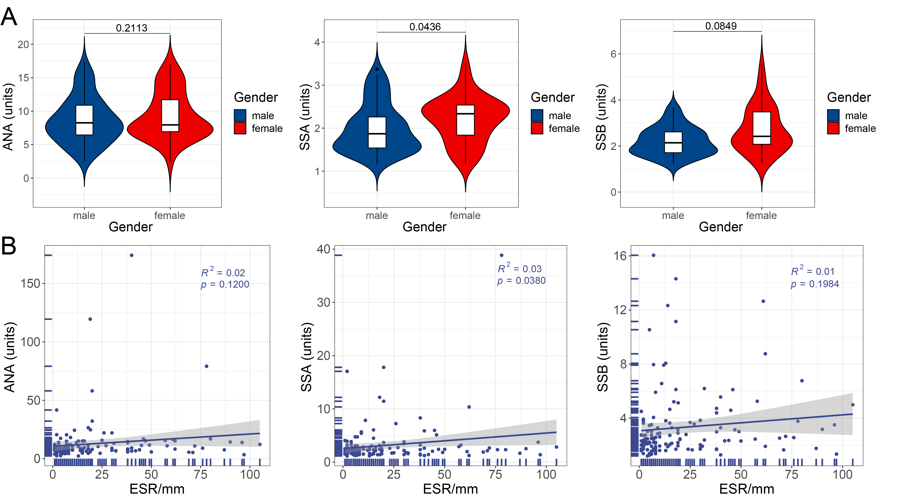
Fig.S4. Association between gender, ESR and antinuclear antibodies profiles. (A) Auto-antibodies comparison between different genders. (B) Simple linear regression of auto-antibodies and ESR.

Supplementary figure 5
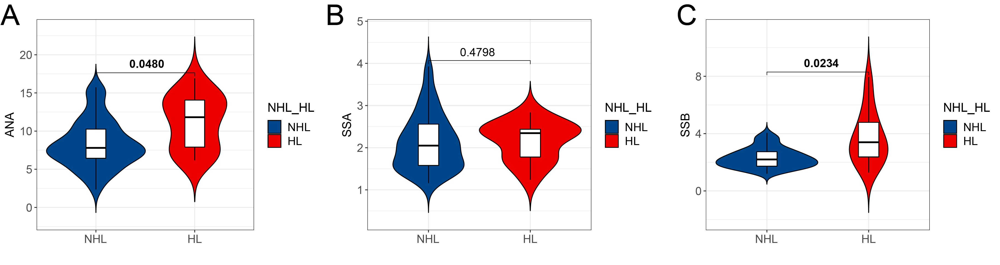
Fig.S5. ANA profile comparison between NHL and HL. (A)-(C) ANA, SSA, and SSB comparison between NHL and HL. Mann-Whitney U-test.
Table S1. Demographics and clinical characterization of the subtypes of lymphoma
Characteristic | HL | B-NHL | PTCL | LBL
Sample size, n | 17 | 60 | 49 | 13
Gender
Male | 7 (41%) | 38 (63%) | 30 (61%) | 10 (77%)
Female | 10 (59%) | 22 (37%) | 19 (39%) | 3 (23%)
Age (year) | 38.41±18.45 | 51.10±14.88 | 48.90±14.59 | 26.46±12.59
IgA (g/L) | 2.61±1.25 | 2.09±1.31 | 2.72±1.47 | 1.86±0.78
IgG (g/L) | 12.55±3.81 | 11.76±4.00 | 12.14±4.60 | 10.17±3.42
IgM (g/L) | 1.66±1.65 | 2.19±7.68 | 1.32±0.89 | 0.91±0.64
Neutrophile granulocyte (%) | 65.90±16.87 | 57.65±15.98 | 63.67±13.48 | 62.43±23.21
ANC(10⁹/L) | 4.82±2.87 | 3.71±2.14 | 4.60±2.88 | 4.41±2.76
Lymphocyte (%) | 22.94±13.74 | 31.49±15.29 | 25.64±11.91 | 28.21±23.53
ALC (10⁹/L) | 1.50±0.78 | 2.08±2.28 | 1.74±1.66 | 1.44±0.70
Monocyte (%) | 6.89±2.93 | 8.24±4.27 | 8.21±4.58 | 6.99±5.21
AMC (10⁹/L) | 0.49±0.28 | 0.49±0.26 | 0.53±0.32 | 0.42±0.32
PLT (10⁹/L) | 254.82±103.06 | 232.05±92.82 | 235.47±89.66 | 247.31±77.92
LDH (U/L) | 206.06±57.65 | 210.62±83.60 | 247.33±190.74 | 314.92±260.68
ESR (mm/h) | 32.00[7.00,60.00] | 8.00[3.25,18.75] | 14.00[6.50,34.00] | 15.00[7.00,37.50]
CRP (mg/L) | 0.30[0.03,3.66] | 0.19[0.01,1.73] | 0.73[0.10,1.54] | 0.44[0.04,3.39]
ALB (g/L) | 43.61±5.90 | 44.10±4.82 | 42.66±4.73 | 44.70±4.75
Therapy
Chemotherapy | 8 (47%) | 35 (58%) | 28 (57%) | 9 (69%)
Chemoradiotherapy | 6 (35%) | 10 (17%) | 13 (27%) | 2 (15%)
Radiotherapy | 1 (6%) | 3 (5%) | 3 (6.1%) | 0 (0%)
Other | 1 (6%) | 7 (12%) | 4 (8.2%) | 1 (7.7%)
Unknown | 1 (6%) | 5 (8%) | 1 (2.0%) | 1 (7.7%)
Abbreviations: Hodgkin's lymphoma, HL; B-cell non-Hodgldn's lymphoma, B-NHL; peripheral T-cell lymphom, PTCL; lymphoblastic lymphoma, LBL; absolute neutrophil count, ANC; absolute lymphocyte count, ALC; absolute monocyte count, AMC; platelet, PLT; lactate dehydrogenase, LDH; erythrocyte sedimentation rate, ESR; C-reactive protein, CRP; albumin, ALB.

Table S2. Demographics and clinical characterization of aggressive and indolent lymphoma.
Characteristic | Aggressive | Indolent | P value
Sample size, n | 79 | 26
Gender
Male | 49 (62%) | 16 (62%) | 0.965
Female | 30 (38%) | 10 (39%)
Age(year) | 50.44±15.49 | 49.65±12.61 | 0.815
IgA (g/L) | 2.64±1.53 | 1.62±0.69 | <0.001
IgG (g/L) | 12.43±4.56 | 10.61±3.31 | 0.064
IgM (g/L) | 1.18±0.83 | 3.66±11.4 | 0.279
Neutrophile granulocyte (%) | 63.28±13.34 | 51.78±17.47 | <0.001
ANC(10⁹/L) | 4.50±2.65 | 2.98±1.80 | 0.008
Lymphocyte (%) | 25.62±11.26 | 35.67±17.63 | <0.001
ALC (10⁹/L) | 1.69±1.51 | 2.58±3.56 | 0.044
Monocyte (%) | 8.03±4.23 | 8.60±5.12 | 0.572
AMC (10⁹/L) | 0.52±0.30 | 0.45±0.22 | 0.286
PLT (10⁹/L) | 236.97±97.71 | 241.27±77.47 | 0.899
LDH (U/L) | 229.03±107.94 | 191.68±61.00 | 0.126
ESR (mm/h) | 10.00[6.00,20.00] | 5.50[2.00,12.25] | 0.002
CRP (mg/L) | 0.73[0.04,1.84] | 0.14[0.00,0.83] | 0.032
ALB (g/L) | 42.83±4.87 | 45.28±4.43 | 0.025
Therapy |  |  | 0.606
Chemotherapy | 46 (58%) | 15 (58%)
Chemoradiotherapy | 17 (22%) | 6 (23%)
Radiotherapy | 3 (4%) | 2 (8%)
Other | 3 (4%) | 2 (8%)
Unknown | 10 (13%) | 1 (4%)
Abbreviations: absolute neutrophil count, ANC; absolute lymphocyte count, ALC; absolute monocyte count, AMC; platelet, PLT; lactate dehydrogenase, LDH; erythrocyte sedimentation rate, ESR; C-reactive protein, CRP; albumin, ALB.

Table S3. Autoantibody profiles of different lymphoma subtypes.
Subtype |  | ANA | SSA | SSB
Pathological Type | HL | 12.26[7.70,14.53] | 2.38[1.79,2.74] | 3.50[2.37,5.28]
Pathological Type | NHL | 8.29[6.60,11.77] | 2.16[1.61,2.96] | 2.39[1.89,3.33]
Pathological Type | B-NHL | 7.83[6.48,10.40] | 2.05[1.54,2.71] | 2.14[1.72,3.11]
Pathological Type | PTCL | 8.86[7.06,14.40] | 2.51[1.88,3.74] | 2.65[2.16,3.51]
Pathological Type | LBL | 8.72[5.57,12.84] | 2.11[1.68,2.34] | 2.30[1.67,3.23]
Aggressive or Indolent | Aggressive | 8.37[6.71,11.70] | 2.31[1.80,3.17] | 2.46[1.94,3.54]
Aggressive or Indolent | Indolent | 7.21[5.15,9.03] | 1.64[1.51,2.30] | 2.07[1.71,2.66]

