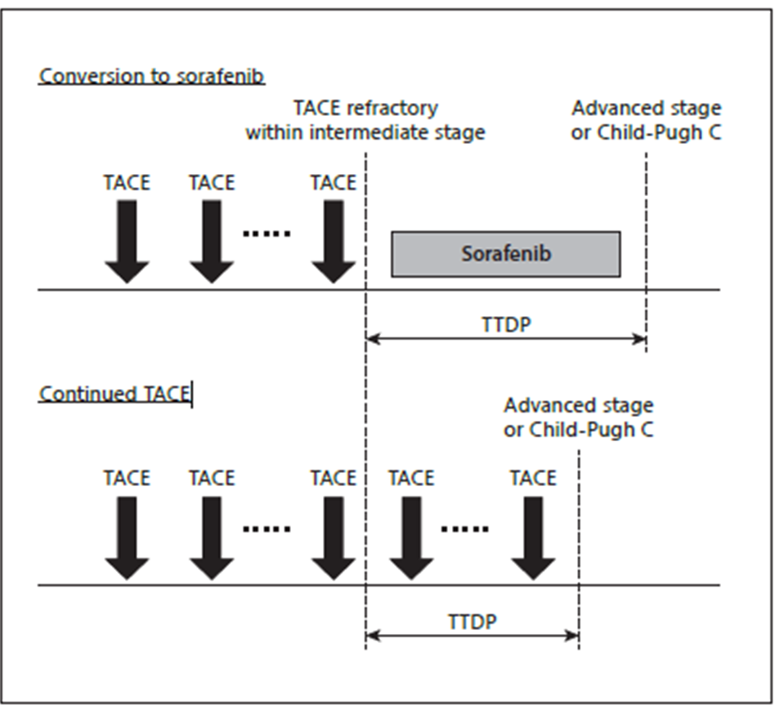
Supplementary Figure: Overview of the clinical course of enrolled patients, Ogasawara et al, 2014 [5].

