1. The selected lambda values of the lasso models
Table S1. The selected lambda values of the lasso models used for feature selection based on unenhanced images.
 | 40 features | 37 features | 40 features | 37 features
Lasso models | 0.017 | 0.017 | 0.010 | 0.017

Table S2. The selected lambda values of the lasso models used for feature selection based on cortical images.
 | 12 features | 31 features | 23 features | 28 features
Lasso models | 0.039 | 0.017 | 0.022 | 0.017

Table S3. The selected lambda values of the lasso models used for feature selection based on unenhanced images in Bosniak IIF-III subgroup.
 | 21 features | 12 features | 28 features | 60 features
Lasso models | 0.039 | 0.052 | 0.022 | 0.001

Table S4. The selected lambda values of the lasso models used for feature selection based on cortical images in Bosniak IIF-III subgroup.
 | 8 features | 25 features | 10 features | 19 features
Lasso models | 0.091 | 0.029 | 0.069 | 0.052

2. The selected hyperparameters of the models.
2.1 The selected hyperparameters of the models based on the unenhanced images:
40 features:
LR: C = 0.5
RF：n_estimators = 250, criterion = entropy, max features = 3, max depth = 10, min_samples_split = 2
SVM：C = 0.5， gamma = 0.062
37 features:
LR: C = 0.5
RF：n_estimators = 250, criterion = gini, max features = 3, max depth = 10, min_samples_split = 2
SVM: C = 0.5, gamma = 0.062
40 features:
LR: C = 0.25
RF：n_estimators = 200, criterion = entropy, max features = 3, max depth = 10, min_samples_split = 4
SVM: C = 0.5, gamma = 0.062
37 features:
LR: C = 0.062
RF：n_estimators = 250, criterion = gini, max features = 3, max depth = 10, min_samples_split = 4
SVM: C = 0.5, gamma = 0.062

2.2 The selected hyperparameters of the models based on the cortical images:
12 features:
LR: C =1.000
RF：n_estimators = 250, criterion = entropy, max features = 3, max depth = 10, min_samples_split = 2
SVM: C = 0.680, gamma = 0.062
31 features:
LR: C = 0.500
RF：n_estimators = 250, criterion = entropy, max features = 3, max depth = 10, min_samples_split = 2
SVM: C = 0.680, gamma = 0.062
23 features:
LR: C = 0.500
RF：n_estimators = 300, criterion = gini, max features = 3, max depth = 10, min_samples_split = 4
SVM: C = 0.5, gamma = 0.062
28 features:
LR: C = 0.016
RF：n_estimators = 300, criterion = entropy, max features = 3, max depth = 10, min_samples_split = 4
SVM: C = 0.5, gamma = 0.062

2.3 The selected hyperparameters of the models based on the unenhanced images in Bosniak IIF-III subgroup:
21 features:
LR: C = 0.004
SVM: C = 0.5, gamma = 0.062
RF: n_estimators = 300, criterion = gini, max features = 3, max depth = 10, min_samples_split = 2
12 features:
LR: C = 0.250
SVM: C = 0.5, gamma = 0.062
RF: n_estimators = 300, criterion = entropy, max features = 3, max depth = 10, min_samples_split = 2
28 features:
LR: C = 0.031
SVM: C = 0.5, gamma = 0.062
RF: n_estimators = 300, criterion = gini, max features = 3, max depth = 10, min_samples_split = 2
60 features:
LR: C = 32.0
SVM: C = 0.5, gamma = 0.062
RF: n_estimators = 200, criterion = gini, max features = 5, max depth = 10, min_samples_split = 2

2.4 The selected hyperparameters of the models based on the cortical images in Bosniak IIF-III subgroup:
8 features:
LR: C = 0.039
SVM: C = 0.680, gamma = 0.062
RF: n_estimators = 200, criterion = gini, max features = 3, max depth = 10, min_samples_split = 2
25 features:
LR: C = 0.039
SVM: C = 0.5, gamma = 0.062
RF: n_estimators = 200, criterion = gini, max features = 3, max depth = 10, min_samples_split = 2
10features:
LR: C = 0.039
SVM: C = 0.233, gamma = 0.062
RF: n_estimators = 200, criterion = gini, max features = 3, max depth = 10, min_samples_split = 2
19 features:
LR: C = 0.031
SVM: C = 0.5, gamma = 0.062
RF: n_estimators = 250, criterion = entropy, max features = 3, max depth = 10, min_samples_split = 4

3. The confusion matrices of the models

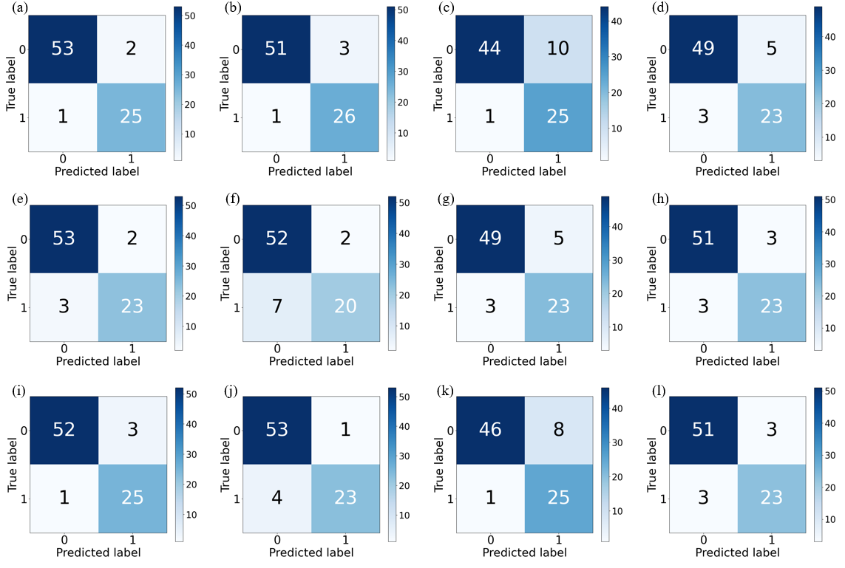
Figure S1. The confusion matrices of the models based on the unenhanced images. The models in the four columns were developed using 40, 37, 40, 37 features, respectively. (a-d) The confusion matrices of the LR models. (e-h) The confusion matrices of the SVM models. (i-l) The confusion matrices of the RF models.

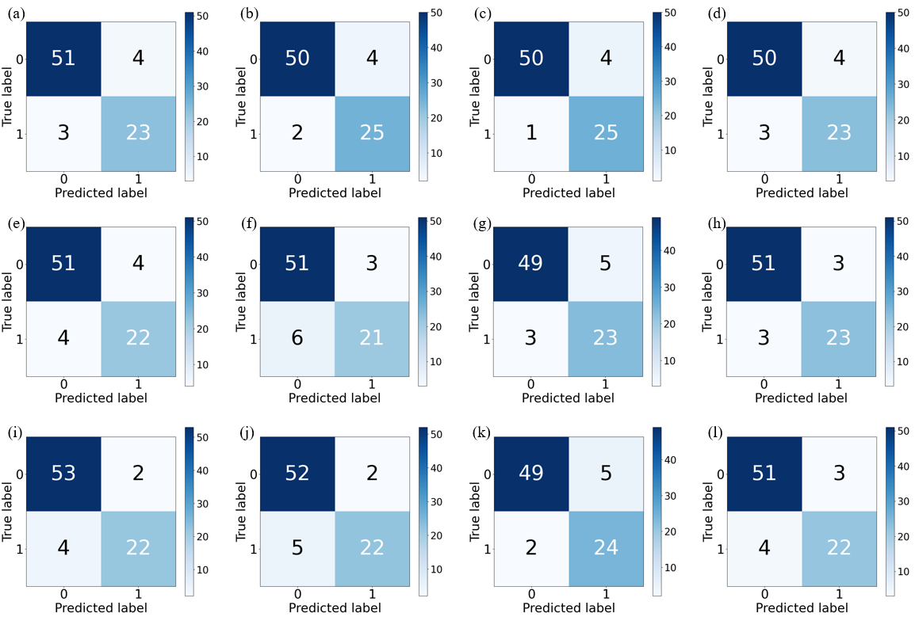
Figure S2. The confusion matrices of the models based on the cortical images. The models in the four columns were developed using 12, 31, 23, 28 features, respectively. (a-d) The confusion matrices of the LR models. (e-h) The confusion matrices of the SVM models. (i-l) The confusion matrices of the RF models.

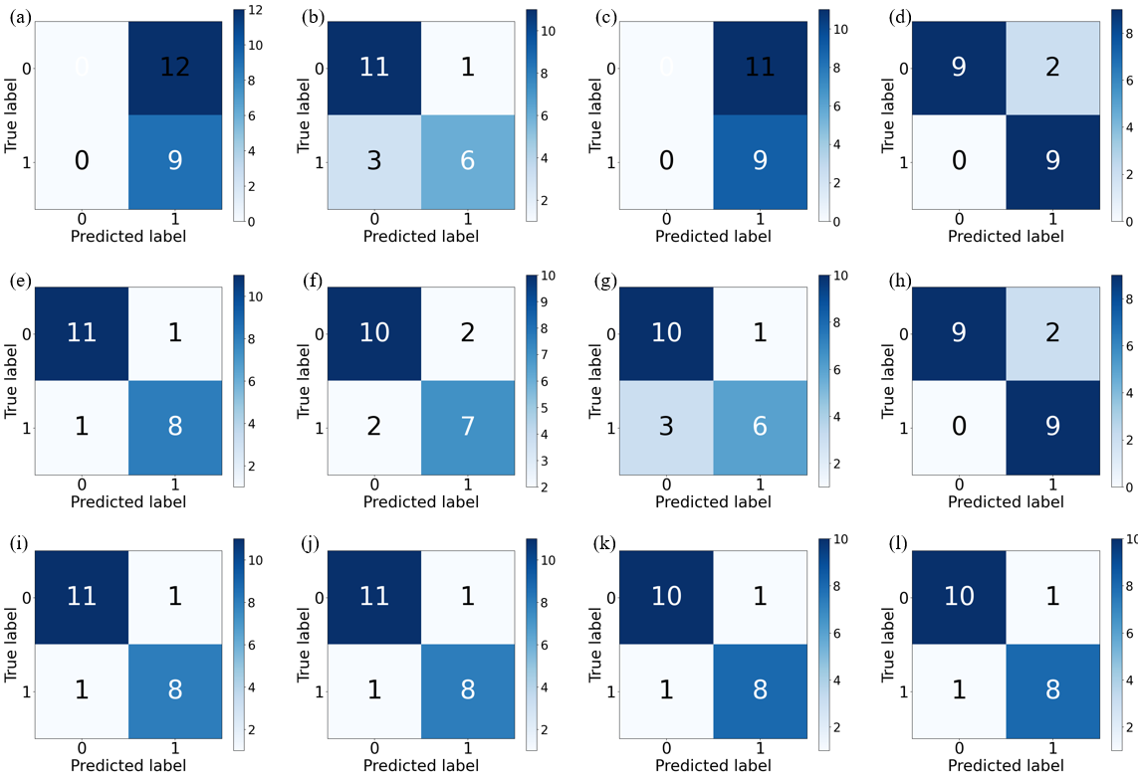
Figure S3. The confusion matrices of the models based on the unenhanced images in Bosniak IIF-III group. The models in the four columns were developed using 21, 12, 28, 60 features, respectively. (a-d) The confusion matrices of the LR models. (e-h) The confusion matrices of the SVM models. (i-l) The confusion matrices of the RF models.

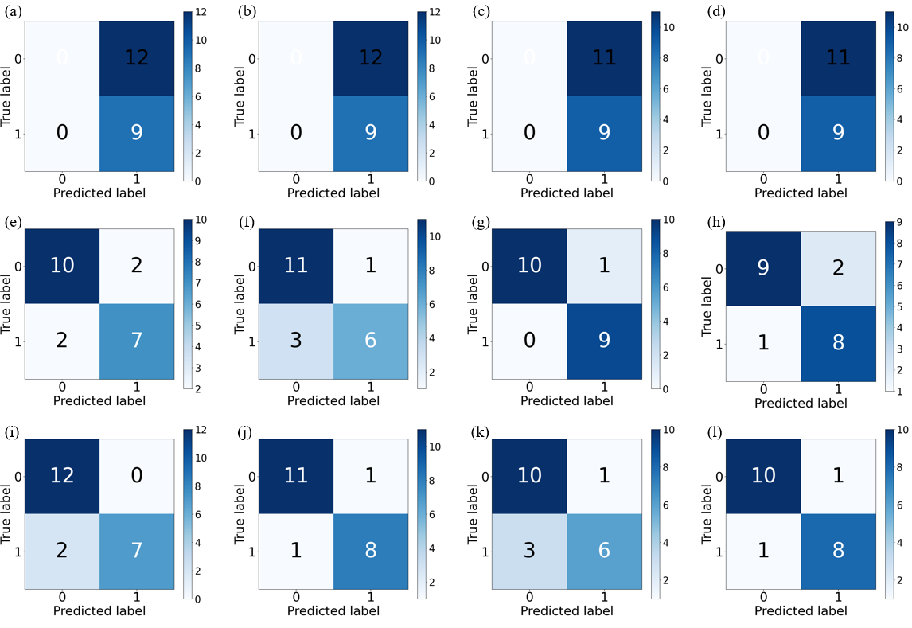
Figure S4. The confusion matrices of the models based on the cortical images in Bosniak IIF-III group. The models in the four columns were developed using 8, 25, 10, 19 features, respectively. (a-d) The confusion matrices of the LR models. (e-h) The confusion matrices of the SVM models. (i-l) The confusion matrices of the RF models.

