Supplementary Material

Plasma mutation profile of precursor lesions and colorectal cancer using the Oncomine Colon cfDNA Assay

Mariana Bisarro dos Reis1, Wellington dos Santos1, Ana Carolina de Carvalho1, Adhara Brandão Lima1, Monise Tadin Reis1,2, Florinda Santos1,3, Rui Manuel Reis1,4,5*, Denise Peixoto Guimarães1*

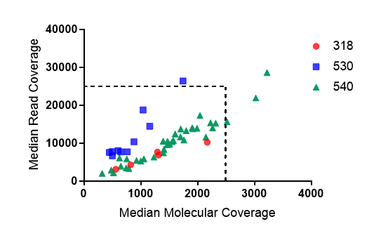
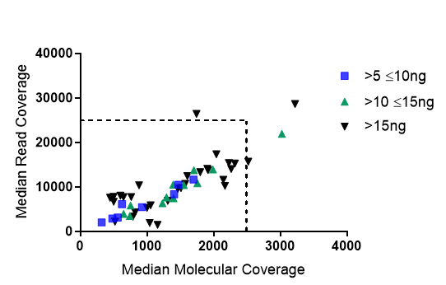
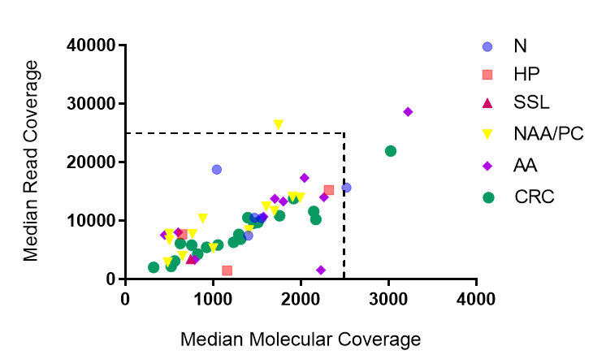
A
B
C

Supplementary Figure 1. Distribution of median read coverage and median molecular coverage according to A) chip used for sequencing, B) input, and C) type of lesion. Dashed lines delimit the values for the limit of detection (LOD) of 0.1%

Supplementary Figure 2. Boxplots reporting the global distribution and median depth of amplicons sequenced across the 14 genes for the lesion samples included in the study. The average depth of all amplicons was 782,3185714x per sample (ranging from 574,524 x to 2,105,431x). The amplicons analyzed by the sequencing panel are plotted on the X-axis, and on the Y-axis, the number of reads generated for each of these amplicons is represented.

Supplementary Table 1. Sequencing metrics per sample
Sample | Median Read Cov | Median Mol Cov | Limit of Detection (LOD) % | Mapped reads | On target percent | Mean depth | Uniformity | Molecular Uniformity | Median Reads per  Functional Molecule | Chip
CV507P | 13744 | 1704 | 0.1756 - 0.2039 | 1,351,942 | 79.58% | 15,331 | 100.00% | 100.00% | 7.6 | 540
CV509P | 13270 | 1798 | 0.1664 - 0.2020 | 1,204,169 | 82.64% | 14,413 | 100.00% | 95.83% | 7.2 | 540
CV277P | 28617 | 3221 | 0.0929 - 0.1127 | 1,860,812 | 91.93% | 30,559 | 100.00% | 95.83% | 8.8 | 540
CV344P | 3332 | 789 | 0.3788 - 0.5146 | 794,432 | 73.49% | 5,025 | 100.00% | 91.67% | 4.3 | 540
CV485P | 10669 | 1574 | 0.1901 - 0.2338 | 906,665 | 97.92% | 11,698 | 100.00% | 97.92% | 6.6 | 540
CV496P | 17311 | 2042 | 0.1466 - 0.1803 | 1,336,681 | 86.25% | 18,944 | 100.00% | 97.92% | 8.3 | 540
CV236P | 14005 | 2264 | 0.1322 - 0.1551 | 1,364,789 | 80.95% | 16,936 | 100.00% | 100.00% | 5.7 | 540
CCRP129 | 8009 | 602 | 0.4966 - 0.6872 | 1,249,952 | 71.10% | 8,536 | 100.00% | 97.92% | 13.7 | 530
CCRP127 | 7544 | 448 | 0.6661 - 0.7690 | 1,486,508 | 71.05% | 8,502 | 100.00% | 100.00% | 16.3 | 530
CV536P | 2896 | 481 | 0.6213 - 0.7426 | 727,14 | 66.76% | 3,423 | 100.00% | 100.00% | 5.9 | 540
CV581P | 11652 | 1698 | 0.1762 - 0.1939 | 1,240,068 | 78.42% | 13,565 | 100.00% | 100.00% | 6.6 | 540
CV482P | 8343 | 1407 | 0.2127 - 0.2360 | 1,110,001 | 74.82% | 10,205 | 100.00% | 100.00% | 5.6 | 540
CV90P | 13923 | 1990 | 0.1504 - 0.1675 | 1,283,036 | 83.20% | 16,979 | 100.00% | 100.00% | 6.6 | 540
CV435P | 3942 | 650 | 0.4600 - 0.5560 | 1,158,246 | 68.70% | 4,517 | 100.00% | 95.83% | 6.0 | 540
CV554P | 12421 | 1606 | 0.1863 - 0.2211 | 1,627,565 | 87.98% | 14,219 | 100.00% | 100.00% | 7.4 | 540
CV571P | 5291 | 1001 | 0.2988 - 0.3881 | 719,228 | 75.29% | 6,294 | 100.00% | 95.83% | 5.1 | 540
CV285P | 14055 | 1905 | 0.1571 - 0.1810 | 1,155,712 | 84.72% | 15,692 | 100.00% | 100.00% | 7.4 | 540
CCRP131 | 26397 | 1743 | 0.1717 - 0.2152 | 2,105,431 | 84.28% | 28,673 | 100.00% | 100.00% | 14.7 | 530
CCRP126 | 10336 | 882 | 0.3389 - 0.4031 | 1,415,339 | 72.83% | 11,398 | 100.00% | 100.00% | 11.6 | 530
CCRP136 | 7703 | 763 | 0.3919 - 0.4759 | 1,242,940 | 70.77% | 8,479 | 100.00% | 97.92% | 10.2 | 530
CCRP132 | 6663 | 500 | 0.5977 - 0.6877 | 1,322,760 | 68.66% | 7,004 | 100.00% | 100.00% | 12.3 | 530
CCRP73 | 7745 | 499 | 0.5983 - 0.7032 | 1,398,165 | 68.43% | 8585 | 100.00% | 100.00% | 15.6 | 530
CV166P | 3444 | 744 | 0.4017 - 0.5842 | 727,782 | 68.99% | 4,363 | 100.00% | 91.67% | 4.7 | 540
CR24 | 3105 | 560 | 0.2679 - 0.3201 | 606,455 | 62.97% | 4,258 | 99.96% | - |  | 318
CV383P | 2021 | 320 | 0.9314 - 1.1131 | 871,578 | 64.01% | 2,386 | 100.00% | 95.83% | 6.3 | 540
CV292P | 2100 | 324 | 0.9215 - 1.1225 | 705,02 | 64.58% | 2,405 | 100.00% | 100.00% | 6.3 | 540
CV83P | 6119 | 625 | 0.4783 - 0.5736 | 909,687 | 74.61% | 6,641 | 100.00% | 95.83% | 9.6 | 540
CV300P | 5465 | 926 | 0.3230 - 0.3696 | 980,619 | 68.97% | 6,761 | 100.00% | 100.00% | 5.7 | 540
CV321P | 6308 | 1232 | 0.2429 - 0.2882 | 1,059,991 | 73.41% | 8,240 | 100.00% | 100.00% | 5.1 | 540
CV398P | 5821 | 755 | 0.3962 - 0.4605 | 810,855 | 75.75% | 6,395 | 100.00% | 100.00% | 7.4 | 540
CV63P | 10841 | 1758 | 0.1703 - 0.2006 | 1,160,283 | 79.00% | 13,358 | 100.00% | 100.00% | 6.0 | 540
CV319P | 10531 | 1395 | 0.2144 - 0.2630 | 1,164,726 | 79.54% | 11,819 | 100.00% | 100.00% | 7.7 | 540
CR085 | 7642 | 1292 | 0.1161 - 0.1319 | 937,370 | 69.78% | 9,300 | 99.96% | - |  | 318
CV553P | 21931 | 3024 | 0.0990 - 0.1192 | 1,743,905 | 85.72% | 24,785 | 100.00% | 100.00% | 6.8 | 540
CV470P | 15350 | 2227 | 0.1346 - 0.1630 | 1,238,277 | 87.19% | 16,739 | 100.00% | 95.83% | 6.6 | 540
CV363P | 4298 | 824 | 0.1819 - 0.2361 | 574,524 | 72.24% | 6,937 | 99.96% | - |  | 318
CV81P | 5848 | 1054 | 0.2839 - 0.3424 | 876,415 | 73.65% | 7,07 | 100.00% | 100.00% | 5.3 | 540
CV222P | 2193 | 522 | 0.5725 - 0.6775 | 633,403 | 74.63% | 3,424 | 100.00% | 93.75% | 4.3 | 540
CV279P | 9730 | 1510 | 0.1982 - 0.2374 | 1,017,740 | 80.63% | 11,139 | 100.00% | 97.92% | 6.4 | 540
CV389P | 13777 | 1917 | 0.1561 - 0.1804 | 1,198,873 | 84.90% | 15,539 | 100.00% | 100.00% | 7.0 | 540
CV441P | 9586 | 1463 | 0.2045 - 0.2441 | 1,031,948 | 79.78% | 11,18 | 100.00% | 100.00% | 6.6 | 540
CV189P | 11595 | 2146 | 0.1395 - 0.1637 | 1,152,209 | 82.98% | 14,308 | 100.00% | 97.92% | 5.5 | 540
CV49P | 6844 | 1313 | 0.1142 - 0.1376 | 715,112 | 77.59% | 9,655 | 97.31% | - |  | 318
CR129 | 10215 | 2169 | 0.0692 - 0.079 | 1,036,576 | 78.72% | 14,194 | 99.96% | - |  | 318
CV155P | 10474 | 1472 | 0.2032 - 0.2326 | 1,198,763 | 77.08% | 12,259 | 100.00% | 100.00% | 7.0 | 540
CV526P | 10401 | 1553 | 0.1926 - 0.2149 | 1,140,060 | 79.57% | 12,061 | 100.00% | 100.00% | 6.3 | 540
CV573P | 7436 | 1399 | 0.2138 - 0.2384 | 1,347,523 | 86.45% | 9,572 | 100.00% | 100.00% | 5.2 | 540
CV255P | 15646 | 2518 | 0.1188 - 0.1434 | 1,812,757 | 89.49% | 18,417 | 100.00% | 100.00% | 6.1 | 540
CCRP135 | 18740 | 1041 | 0.2874 - 0.3316 | 1,864,214 | 78.51% | 20,543 | 100.00% | 100.00% | 17.6 | 530
CV445P | 15243 | 2318 | 0.1291 - 0.1495 | 1,147,916 | 87.85% | 17,283 | 100.00% | 97.92% | 6.4 | 540
CCRP137 | 7693 | 647 | 0.4617 - 0.5222 | 1,243,964 | 70.17% | 8,53 | 100.00% | 100.00% | 12.0 | 530
CCRP139 | 14460 | 1158 | 0.2584 - 0.3036 | 1,496,497 | 78.67% | 16,418 | 100.00% | 100.00% | 12.7 | 530

