Supplementary
Detection of a Novel DNA Methylation Marker Panel for Esophageal Cancer Diagnosis using Circulating Tumor DNA
Yan Zheng^{a†}, Wenqun Xing^{a†}, BingWei^{b,c}, Xianben Liuª, Guanghui Liangª, Dongfeng Yuanª, Ke Yang^{b,c}, Weizhen Wang^{b,c}, Dongxu Chen^{b,c}, Jie Ma^{b,c}*
ªDepartment of Thoracic Surgery, Affiliated Cancer Hospital of Zhengzhou University, Henan Cancer Hospital, Zhengzhou, Henan, China
^{b}Department of Molecular Pathology, Affiliated Cancer Hospital of Zhengzhou University, Henan Cancer Hospital, Zhengzhou, Henan, China
^{c}Henan Key Laboratory of Molecular Pathology, Zhengzhou, Henan, China
†These authors contributed equally to this work.
* Correspondence:
Jie Ma, Department of Molecular Pathology, Affiliated Cancer Hospital of Zhengzhou University, Henan Cancer Hospital, No 127, Dongming Road, Zhengzhou, Henan 450008, China
Fax: +86-0371-65587686
Tel: +86-0371-65587686
E-mails: majie_fzbl@163.com

SEPTIN9
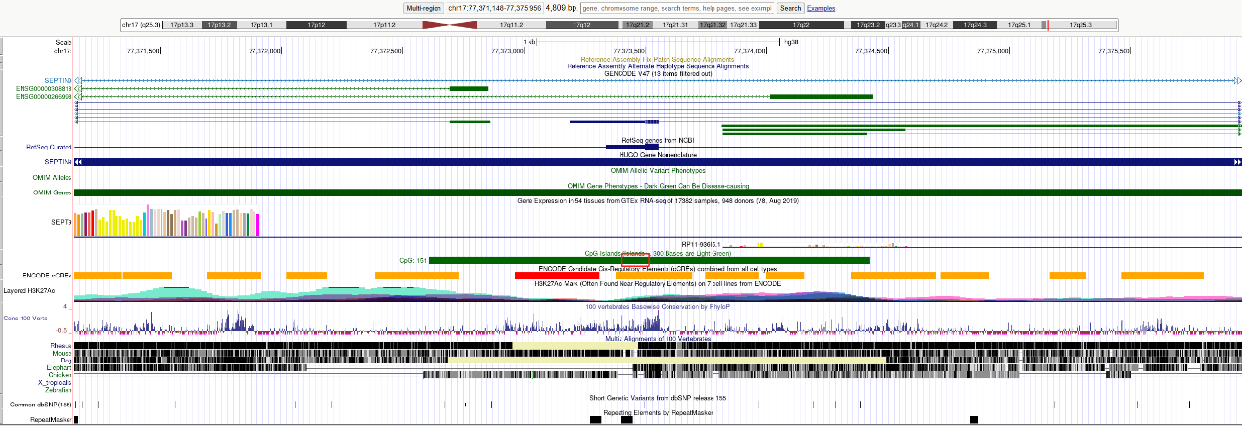

TFPI2
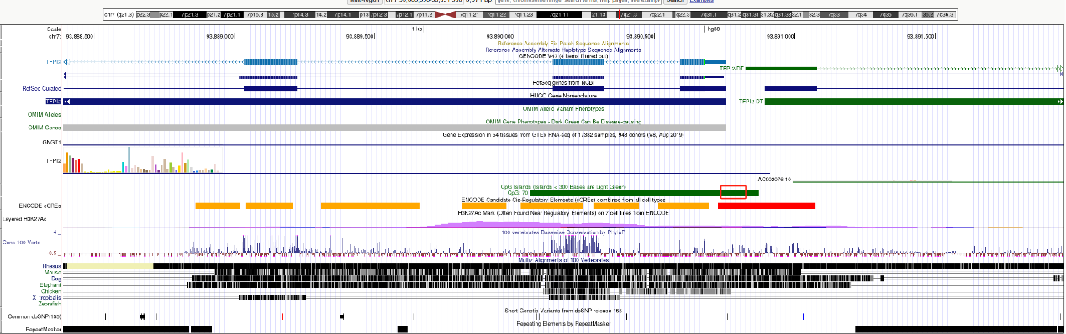

FHIT
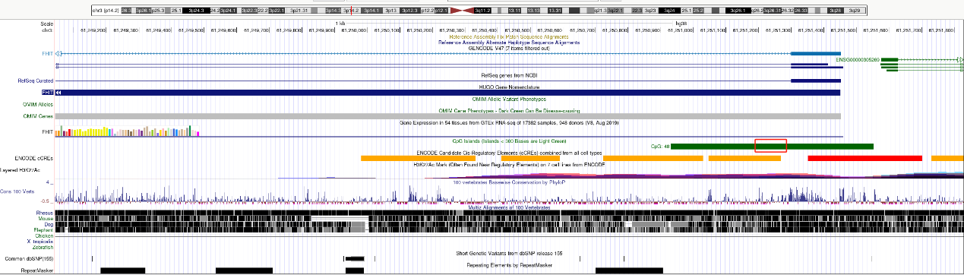
Supplementary Figure S1: Genomic organization of the SEPTIN9, TFPI2, and FHIT genes and regions targeted for methylation analyses. The qPCR target regions within the genome SEPTIN9: chromosome 17:77373476-77373540, TFPI2: chromosome 7:93890713-93890811, and FHIT: chromosome 3:61251169-61251258 indicated by red boxes. All information was taken from human genome assembly GRCh38/hg38 (http://genome.ucsc.edu).

Supplementary Table S1. The primer and the fluorescent probe sequences used in this study.
Gene | Forward primer (5´-3´) | Probe (5´-3´) | Reverse primer (5´-3´)
SEPTIN9 | GATTCGTTGTTTATTAGTTATTATGT | FAM- TTAACCGCGAAATCCGAC-BHQ1 | AAATAATCCCATCCAACTA
TFPI2 | GTTCGAGAAAGCGTTTGG | JOE-CGAACACCCGAACCGCCTAA-BHQ1 | GACGAAAATCGACCGAAC
FHIT | GGGATAGAAGTTTATCGTTTCG | Texas Red-CGCGCGTCAAATCATCACCCCGAA -BHQ2 | AACGCGAATCTAAATTTCC
ACTB | GTGATGGAGGAGGTTTAGTAAGT | CY5-CGCGCGTCAAATCATCACCCCGAA-BHQ2 | CCAATAAAACCTACTCCTCCCTT

